Physical configuration
- Cabinet
- Each row in Rack table (<TABLE attrname="Rack">) or “Cabinet” (<TABLE attrname="Cabinet">) represents a cabinet, and all the below attributes to be get from each one of these rows.

- A network element could have one or more than cabinet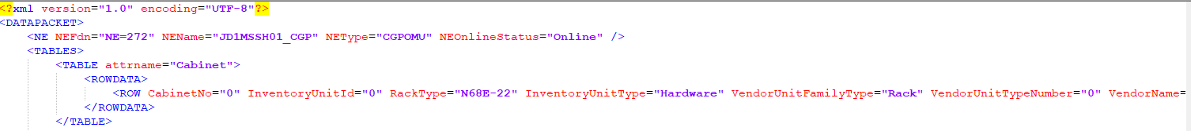
- The cabinet attributes are extracted as follow:

Attribute | Importance | Comments
NE External code | [Mandatory] | - Same as NodeID
Cabinet index | [Mandatory] | - The value of “RackNo” or “CabinetNo” attribute  - Eg: RackNo="0" Cabinet index=0  - If “RackNo” is empty, then ignore the line.
Cabinet id | [Mandatory] | - = NE External code_cabinet index  - E.g.: JD1MSSH01_CGP_0
Cabinet Type | [Mandatory] | - =”RackType” attribute  - Else If “RackType” attribute is empty, the cabinet type will be “Virtual_Cabinet”
Cabinet Model | Mandatory | - =Cabinet Type
Part Number | [optional] | - =Value of “BOMCode” attribute  - Eg: BOMCode="01071087”
Date Of Manufacturer | [optional] | - =Value of “DateOfManufacture” attribute  - Eg: DateOfManufacture="2011-03-10" DateOfManufacture=2011-03-10
Issue Number | [optional] | - The value of “IssueNumber” attribute  - Eg: IssueNumber="00" IssueNumber=00  - If empty = null
Description | [optional] | - =Value of “ManufacturerData” attribute  - If empty = null
Serial Number | [optional] | - =Value of “SerialNumber” attribute  - E.g.:SerialNumber="21010710876TB3000615
Manufacturer | [Mandatory] | - =HUAWEI
Power Consumption | [optional] | - =null
Additional Information | [optional] | - =null
Dimensions and Weight | [optional] | - =null
- Shelf
- From each XML files, each row in Frame table (<TABLE attrname="Frame">) or “Subrack” table (<TABLE attrname="Subrack">) represents a shelf, and all the below attributes to be get from each one of these rows.

- The below table describes how to parse the shelf attributes:

- 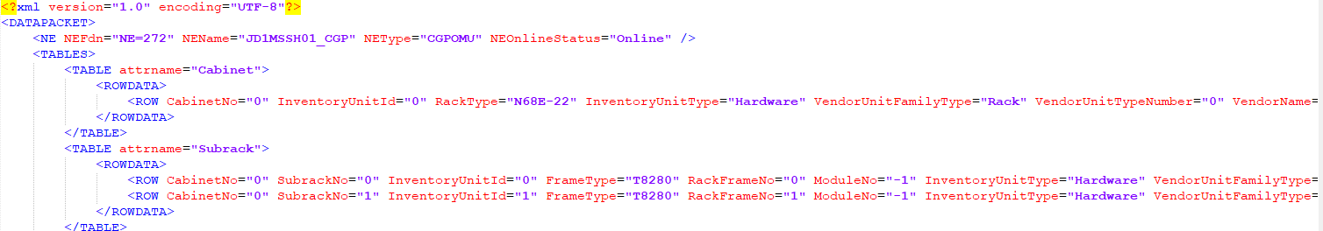

Attribute | Importance | Comments
Cabinet id | [Mandatory] | - Concatenation between NEName, “_” and RackNo in related row or Concatenation between NEName, “_” and CabinetNo in related row  - E.g.: Cabinet id=JD1MSSH01_CGP_0
Shelf index | [Mandatory] | - =Value of “FrameNo” or SubrackNo attribute  - E.g.: FrameNo="0" , Shelf Index=0  - If empty, then ignore the line.
Shelf id | [Mandatory] | - =cabinet id_shelf index  - E.g.: JD1MSSH01_CGP_0_0
Part Number | [Optional] | - =Value of “BOMCode” attribute  - Eg: BOMCode="02112722
Shelf Type | [Mandatory] | - =”FrameType” attribute under “Frame” table.  - E.g.: FrameType="T8280"  - If “FrameType” attribute under “Frame” table are empty, the shelf model will be then as follow:  - Virtual_Shelf  For Airtel :If one or two “FrameType” attribute under “Frame” table are empty among all Frames for CoreElemnets, then shelf model will be same as the one found.  For Ex:  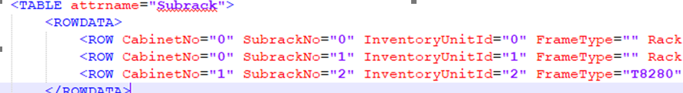  In the above screenshot 3 shelfs are there but only Subrack 2 line having value “T8280” so take other shelfs also as T8280.
Date Of Manufacture | [Optional] | - =Value of “DateOfManufacture” attribute  - E.g.: DateOfManufacture="2011-03-03”
Issue Number | [Optional] | - =Value of ”IssueNumber” attribute  - Eg: IssueNumber="00”
Description | [Optional] | - =Value of “ManufacturerData” attribute
Serial Number | [Optional] | - =Value of “SerialNumber” attribute  - E.g.: SerialNumber="21021127229TB3001578”
Power Consumption | [Optional] | - Null
Additional Information | [Optional] | - Null
Dimensions and Weight | [Optional] | - Null

- Boards
- From each XML file, each row in Board table (<TABLE attrname="Board">) represents a board, and all the below attributes to be get from each one of these rows.

Note: Each row with BoardName="FModule" under row tag within Board Table is to be ignored.
Note: Ignore all boards with SubSlotNo doesn’t equal -1 except for boardtype "CH8E01FAN" and "CH8MDCPSUA".

Note: Each row with Subrack=”40 and ”BoardName="POWER_SWITCH" within Board Table is to be ignored

If boardtype="CH8E01FAN" then take slot index=slot index + 27
If boardtype=" CH8MDCPSUA" then take slot index=slot index + 35

Attribute | Importance | Comments
Shelf id | [Mandatory] | - Concatenation between NEName, “_”,RackNo,”_” and FrameNo or Concatenation between NEName, “_”,CabinetNo,”_” and SubrackNo  - E.g.: Shelf id= JD1MSSH01_CGP_0_0
Board Id | [Mandatory] | - Concatenation between NEName, “_”,RackNo,”_”, FrameNo,”_”, SlotNo,”_” and Index on slot or Concatenation between NEName, “_”,CabinetNo,”_”, SubrackNo,”_”, SlotNo,”_” and Index on slot  - E.g.: Board Id= JD1MSSH01_CGP_0_0_1_0
Slot index | [Mandatory] | - If BoardType=” CN21SMU1” has slot index=14 , then consider its Slot index=16  - Else if has slot index=15, then consider it on slot index=17  - If BoardType=”CN21SDMC0” has slot index=0 , then consider its Slot index=16  - Else if has slot index=1, then consider it on slot index=17  - If Boardtype=”CN2E02FFB” has slot index =0 , consider it on slot index=14  - Else if has slot index=1 , consider it on slot index=15  - If Boardtype=”CN2E00PEM” with slot Index=0 , consider it on slot 14, else if has index on slot=1 , consider it on slot 15  - If SlotNo=221 then ignore this board.
Index on slot | [Mandatory] | - If BoardType=” CN21SMU1” then Index on Slot =0.  - If BoardType=”CN21SDMC0” then Index on Slot =1.  - If Boardtype=”CN2E02FFB” then Index on Slot =0.  - If Boardtype=”CN2E00PEM” with slot Index=1.  - Else, = “SlotPos” attribute  - Note: if “SlotPos” is empty, consider the index on slot=0.
Board Type | [Mandatory] | - If BoardName="UPIU" then:  - Find other boards having same RackNo, FrameNo, SlotNo and SlotPos but with SubSlotNo="2" or SubSlotNo="3".  - Board type is the concatenation of “UPIU”, “/”, BoardName of board with SubSlotNo="2", “/” and BoardName of board with SubSlotNo="3".  - E.g:  - BoardName="UAIC" BoardType="KW31UAIC0" UnitPosition="RackNo=0,FrameNo=3,SlotNo=0,SlotPos=1,SubSlotNo=2"  - BoardName="UAIC" BoardType="KW31UAIC0" UnitPosition="RackNo=0,FrameNo=3,SlotNo=0,SlotPos=1,SubSlotNo=3"  - BoardName="UPIU" BoardType="KW31UPIU0" UnitPosition="RackNo=0,FrameNo=3,SlotNo=0,SlotPos=1,SubSlotNo=-1"  - Board Type = UPIU/UAIC/UAIC.  - Else,  - Ignore all boards with SubSlotNo<> -1.  - =”Boardtype” attribute  - If boardtype” attribute is empty, take the value of BoardName attribute and match its value inside the board matching.  - If no matching was found, take the board type as it is mentioned inside “BoardType” attribute.
Part Number | [Optional] | - =Value of “BOMCode” attribute  - If “BOMcode” doesn’t not exist or empty, take the value of =”Item” attribute.  - If the part number not found in dumps then set it  - Boardname (Undefined Part Number)  - Else, if no board name also so report an error as missing board information and present the available information  - Eg: BOMCode=" 03030LPM" Part Number= 03030LPM  - Item="02112722" Part Number =0211722
Description | [Optional] | - =Value of “ManufacturerData” attribute  - Eg: ManufacturerData=" HERT BBU, WD22GTMUb, GBTS Main Processing &amp; Transmission Unit (4E1 + 2FE + 6CPRI + 1EXT)" Description= HERT BBU, WD22GTMUb, GBTS Main Processing &amp; Transmission Unit (4E1 + 2FE + 6CPRI + 1EXT)
Date Of Manufacture | [Optional] | - =Value of “DateOfManufacture” attribute  - Eg: DateOfManufacture="2011-03-03" DateOfManufacture=2011-03-03
Serial number | [Optional] | - =Value of “SerialNumber” attribute  - Eg:SerialNumber="030LPM4MB5618639" SerialNumber=030LPM4MB5618639
Issue Number | [Optional] | - =Value of ”IssueNumber” attribute  - Eg: IssueNumber="00" Issue Number=00
Power Consumption | [Optional] | - =null
Additional Information | [Optional] | - =null
Dimensions and Weight | [Optional] | - =null

