
Service Request Design Flow

Authors and responsible of document:

AUTHORS | NAME | COMPANY | DATE
Written by: | Salem Dannawi | Mobinets | 29/5/2024
Reviewed by: | Abir Messaikeh | Mobinets

SRD is Service Request Design Platform that designs the requested services of Omantel’s customers.

Mobile Coverage Services (Wi-Fi, IBS, Mobile Coverage)

Mobile Coverage flow is applicable for below services:
- Mobile coverage
- Wi-Fi
- IBS services.

Below the high flow chart:

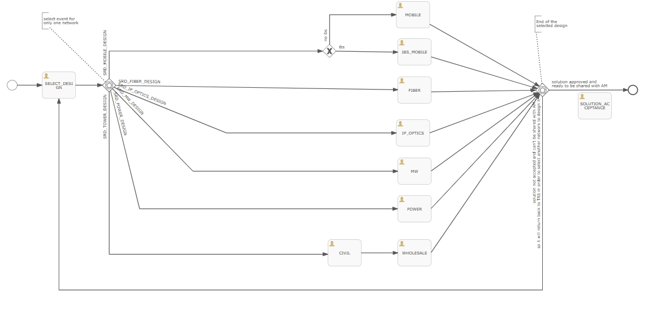

As the current flow, the 1st task is to select design ( 1 design ) from all available options listed in the above chart:
- Mobile
- IBS_Mobile
- Fiber
- IP_OPTICS
- MW
- POWER
- TOWER

In addition, every design task (ex: fiber) is mapped to specific milestones, every team should do his own mission.

TAS team is responsible for selecting the design and submit it to AM.

Once the selected design task is completed , you have 2 choices:

- Complete select design task and move it to Solution acceptance task.
- Reselect another design.
Mobile Coverage Flow

The new request is to select more than one design in parallel.

SELECT_DESIGN Task:
Considering below the designs that can be selected in parallel:
- SRD_MOBILE_DESIGN ( MAD Team )
  - If ibs IBS_MOBILE task
  - Else MOBILE task

- SRD_FIBER_DESIGN ( FADI Team )
- SRD_IP_OPTICS_DESIGN ( IP & OPTICS design Team )
- SRD_MW_DESIGN ( MW DESIGN Team )
- SRD_POWER_DESIGN ( design team )
- SRD_TOWER_DESIGN
  - CIVIL task ( CIVIL Team )
  - WHOLESALE task ( WHOLESALE Team )

We need the confirmation that the new processing will be as below:
if one or more than 1 design are not completed, the request will not move to the step of Solution acceptance or selecting new designs until all previous selected designs tasks are completed .
For example:
If MW design and Fiber design are selected at same time,
Fiber design is done and the MW design still pending, is it required to wait both MW and FIBER tasks to be completed and then TAS team can reselect another list of designs ( even from the previous one selected) adding comments OR TAS team can complete select design phase and move it to solution acceptance phase same as current implementation.

