Omantel new branding
MOB-6789
This document highlights all the updated styles in SRD.

- Login Page:
- Logo changed from mobinets to omantel.
- Color of sign in button changed.

Before:
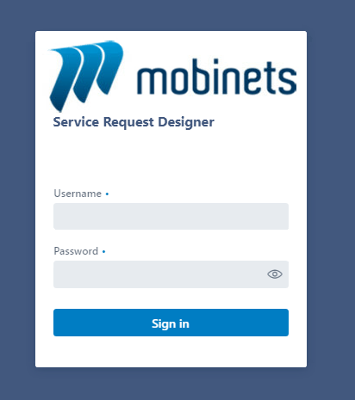

After:
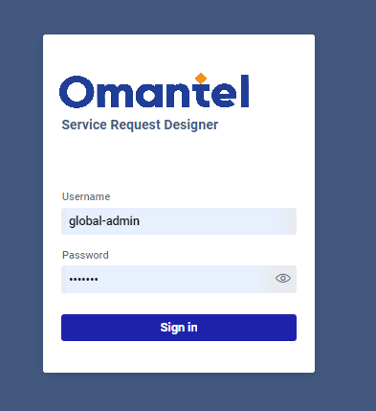

- Menu Bar:
- The color of menu bar changed.
Before:
After:

- Selected main Item:
- The selected tab was changed from blue to orange.
Before:
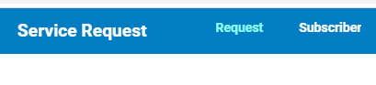
After:



- Items (sub menu)
- From blue to orange.

Before:
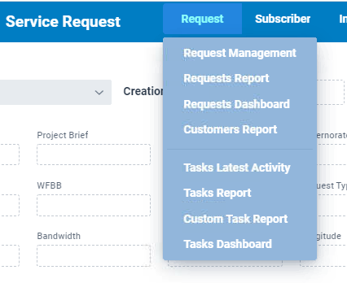

After:
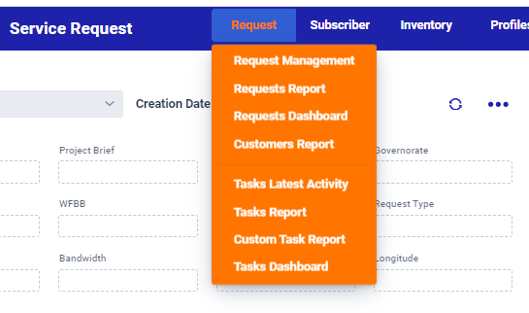
Before:
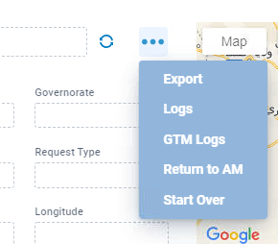
After:
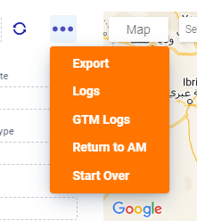
- Request Status:
- Request status: REQUEST_INFO changed from red to orange.

Before:

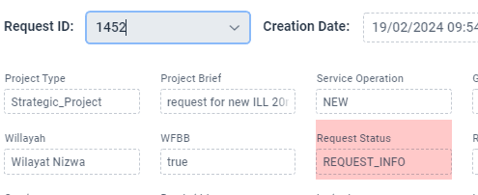
After:
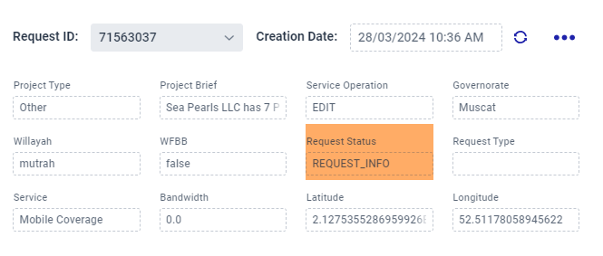

- Request status: BOQ_COMPLETED changed from old green to new one.

Before:
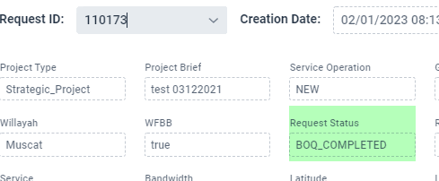

After:
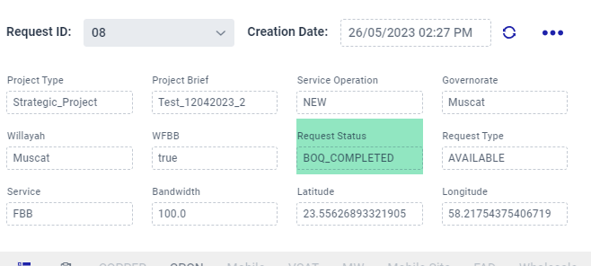

- Task Status:
- Active task status: color changed from red to orange.

Before:
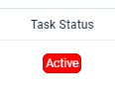
After:
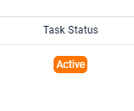

- Completed task status: color changed from old green to new one.

Before:
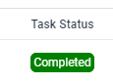
After:
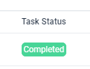

- On Hold task status: color changed from old grey to new one.

Before:
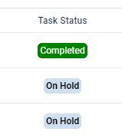
After:
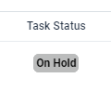

- Task assigned: color changed from old yellow to new one.

Before:
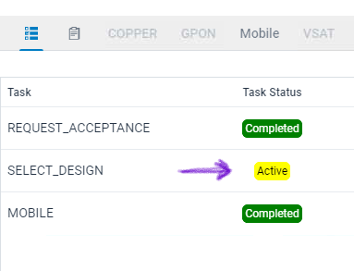

After:

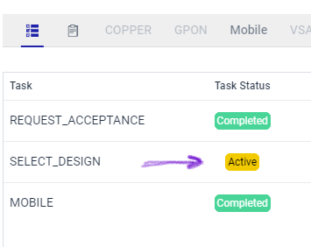

- Assign to me – Assign task – Complete task.

Before:
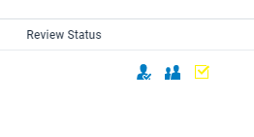
After:
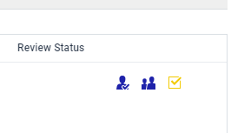
Before:
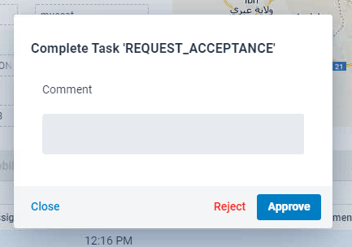
After:
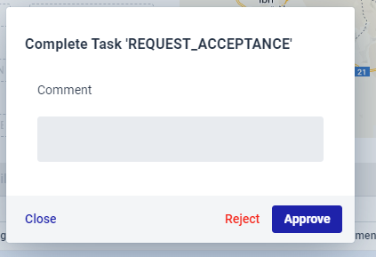
- Service Resources
- Selected Solution: color changed.
- Notification: color changed.
Before:
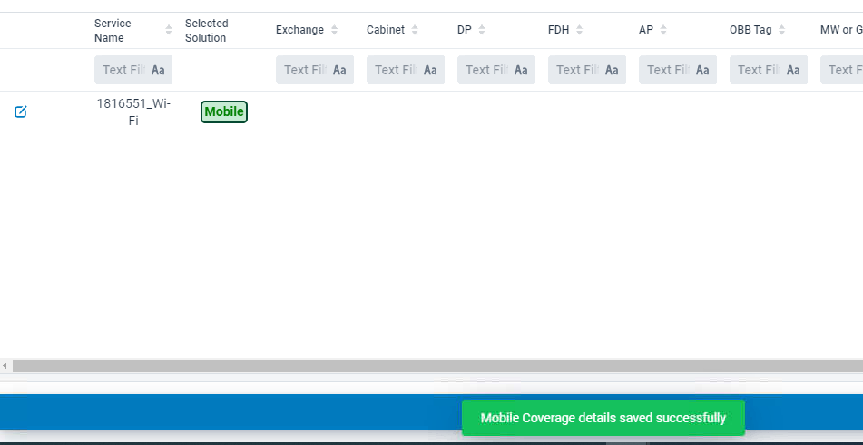

After:
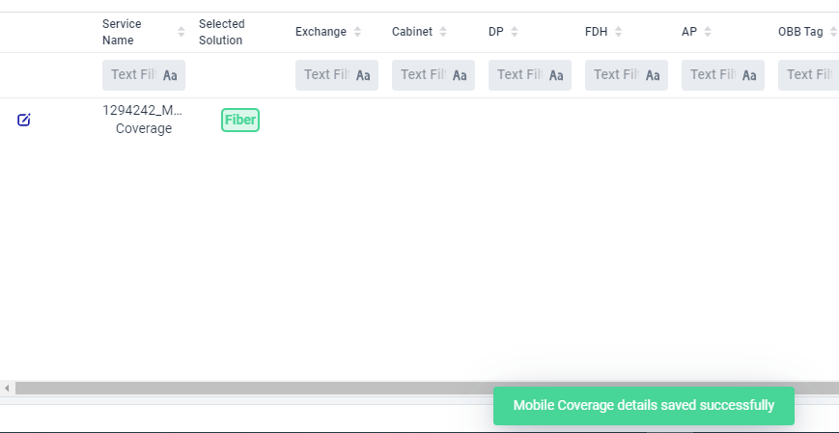

- No selected solution is selected (Nothing): color changed.
- Save button: color changed.

Before:
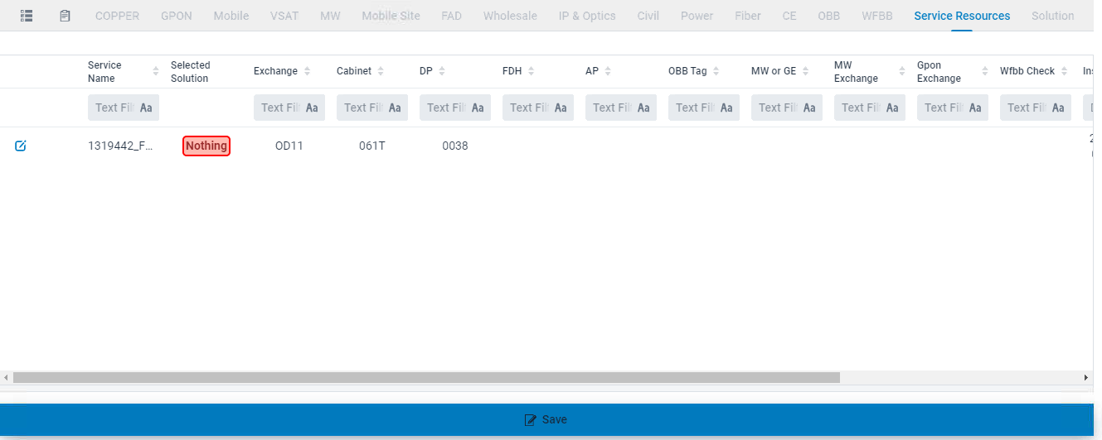

After:
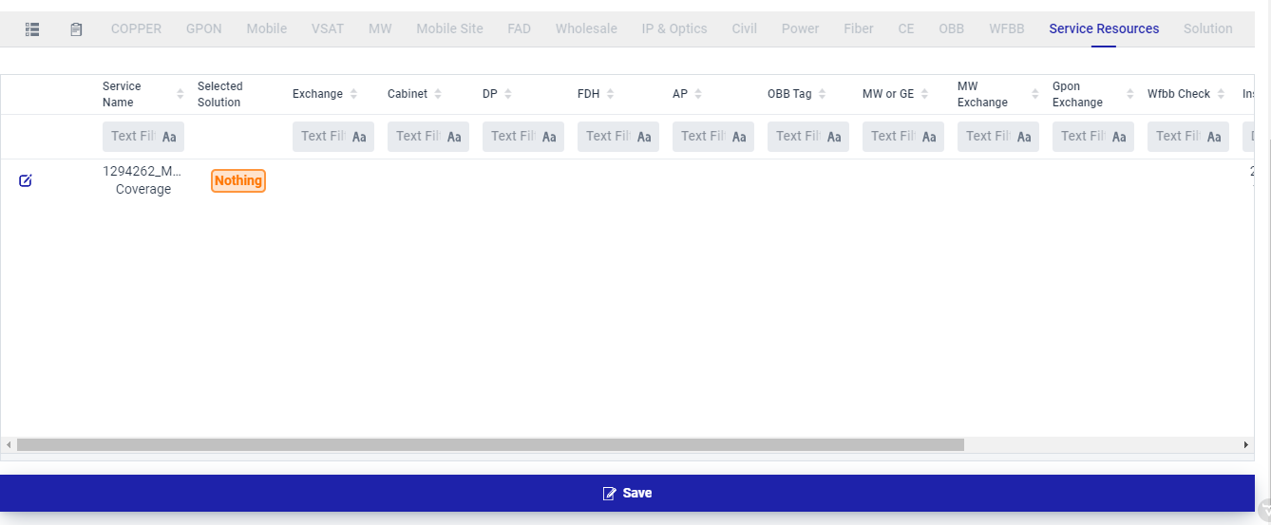

- Whole pages.

