
Service Request Design Flow
Multiple Design Selection Request for Mobile Flow

Authors and responsible of document:

AUTHORS | NAME | COMPANY | DATE
Written by: | Salem Dannawi | Mobinets | 29- May- 2024
Reviewed by: | Abir Messaikeh | Mobinets | 11-June- 2024

SRD is Service Request Design Platform that designs the requested services of Omantel’s customers.

Mobile Coverage Services (Wi-Fi, IBS, Mobile Coverage)

Mobile Coverage flow is applicable for below services:
- Mobile coverage
- Wi-Fi
- IBS services.

Below the high flow chart:

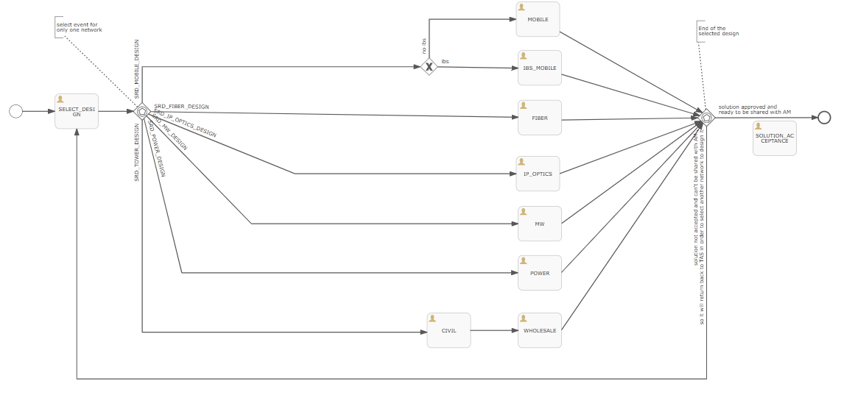

As the current flow, the 1st task is to select design (1 design ) from all available options listed in the above chart:
- Mobile
- IBS_Mobile
- Fiber
- IP_OPTICS
- MW
- POWER
- TOWER

In addition, every design task (ex: fiber) is mapped to specific milestones, every team should do his own mission.

TAS team is responsible for selecting the design and submit it to AM.

Once the selected design task is completed , you have 2 choices:

- Complete select design task and move it to Solution acceptance task.
- Reselect another design.
Mobile Coverage Flow
The new request is to select more than one design in parallel.

SELECT_DESIGN Task:
Considering below the designs that can be selected in parallel:
- SRD_MOBILE_DESIGN (MAD Team )
  - If ibs IBS_MOBILE task
  - Else MOBILE task

- SRD_FIBER_DESIGN (FADI Team)
- SRD_IP_OPTICS_DESIGN (IP & OPTICS design Team)
- SRD_MW_DESIGN (MW DESIGN Team)
- SRD_POWER_DESIGN (design team)
- SRD_TOWER_DESIGN
  - CIVIL task (CIVIL Team)
  - WHOLESALE task (WHOLESALE Team)

We need the confirmation that the new processing will be as below:
If one or more than 1 design are not completed, the request will not move to the step of Solution acceptance or selecting new designs until all previous selected designs tasks are completed.
For example:
If MW design and Fiber design are selected at same time,
Fiber design is done and the MW design still pending, is it required to wait both MW and FIBER tasks to be completed and then TAS team can reselect another list of designs (even from the previous one selected) adding comments OR TAS team can complete select design phase and move it to solution acceptance phase same as current implementation.
Second clarification required:
When the solution is accepted by TAS team and all selected designs are sent to AM in GTM system, shall we give the option to AM to choose only one of the designs received to him or multiple (accept some and reject others) , or we keep same as per current setup which is AM will accept or reject all solutions received in one shot. We will need to update the API integrated with GTM accordingly.
Talal Comment: To clarify both 2 questions, from TAS side we will only send the Final solution once I received all designs I have selected. So GTM will receive one solution file that includes all design information attached. I already have the ability to close any of the other department solutions in case it gets delayed or not needed any more.
Please find below how I need the system (Mobile Requests) to be:

Talal Al Fannah – Comment:
- I want to be able to select multiple “Select Design” at the same time in “Service Resources”.
For example, the system should allow me to tick “Mobile” & “Fiber” & “MW” at the same time and the system should send the request simultaneously. This is to reduce the time.
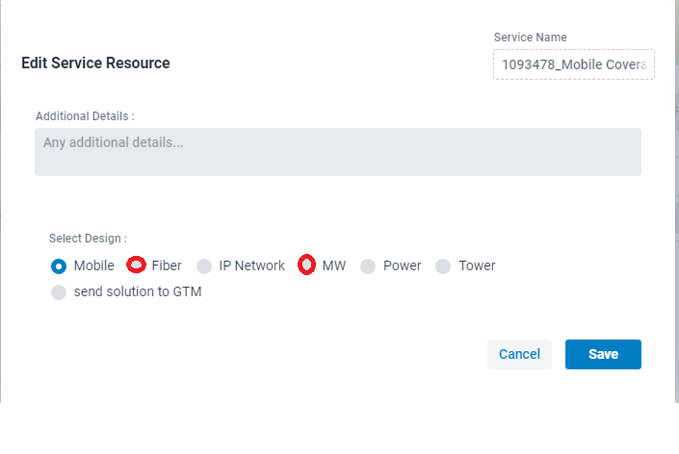
Once I receive all the designs that I have requested. I should have the choice to close my ticket & submit the final solution or select another design in “Select Design” in “Service Resources”. only then I should be able to send the final “Solution” to GTM and close the ticket.
For example, I initially selected “Mobile” & “Fiber” & “MW”. Once received the design from the 3 departments. I found out that it may require “Civil” design. I should be able to send it too “Civil” design team or close the ticket and submit the final design to GTM.
- We need to change the following process:
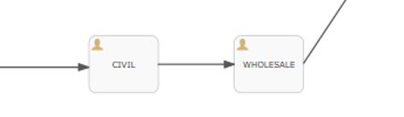
“Civil” (Should be an independent entity). Once “Civil” is selected and solution is submitted by civil team it should come to TAS team.
“WHOLESALE” (Should be an independent entity). And should be added & is selectable from the list below:

- The word “Tower” is actually “Civil”. We prefer to change the wording to “Civil” as it includes different activity not only building Towers:
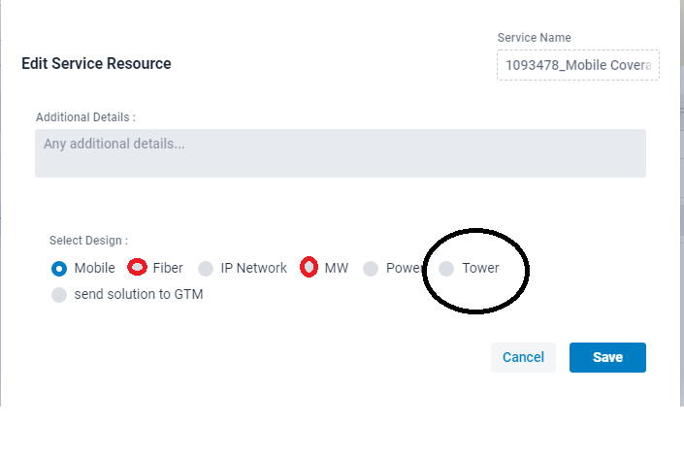

The END Thank You.

