For RNC:
Sample Node Check: RNC-504 (Given Rule in FRS is Okay)
Total Node Count=12
Model/Type= cabinet & shelf model should be “Nokia RNC” instead of “Nokia RNC Cabinet” and “Nokia RNC Shelf”.
Total Cabinet Count=12
Total Shelf Count=64
Total Board Count= 920
Total Board Count with unique serial number=920
Total Board Type/Model=6
BMFU-B
BAFU-A
BCNMB-B
BCNDP-A
BMPP2-B
HDSAM-A

Total Antenna Count=0
- Total RNC is 12 i.e., ok but cabinet & shelf model should be “Nokia RNC” instead of “Nokia RNC Cabinet” and “Nokia RNC Shelf”.

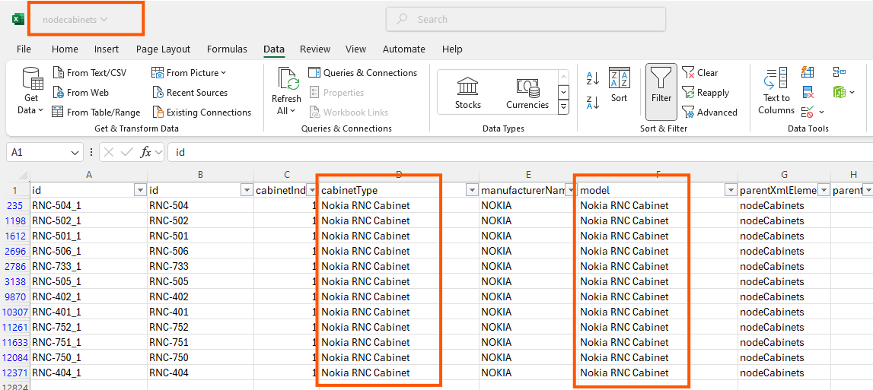
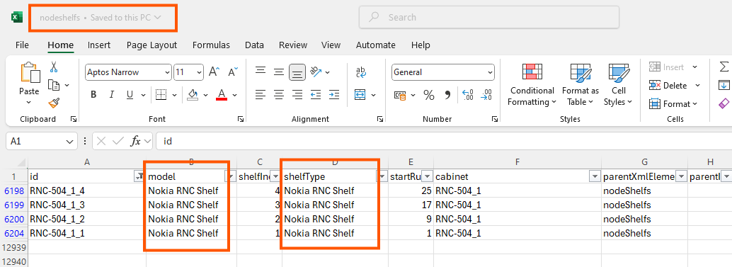

In board “external code should be same value as like “id”.
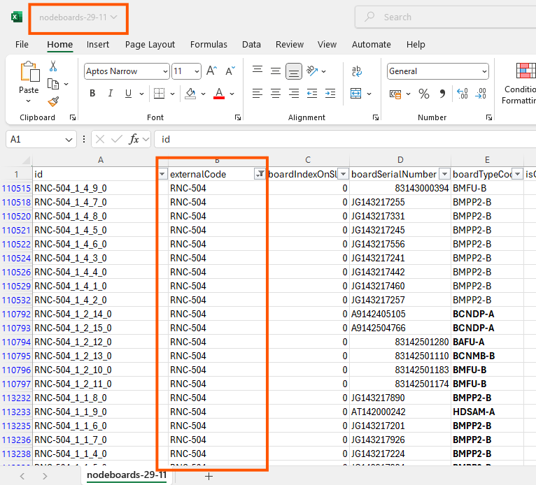

For NodeB:
Sample check node: RNC-733/WBTS-6403 (Given Rule in FRS is Okay)
Total Node Count=3441
Model/Type=Nokia Flexi WCDMA Base Station i.e. Ok in cabinet & shelf.
Total Cabinet Count=3441
Total Shelf Count=3441
Total Board Count=19200 (Including tilt count-205)
Total unique Serial Number Count=13292 (Including tilt count)
Total Board Type/Model=45 (Some boards have missing type/model “COMMRET2” but has serial numbers)
FSMF
FRGT
CORE_FSMF
WMHD
FTIB
CORE_FSMD
FSMD
FRGU
FBBA
FXDB
FRGP
CORE_FRGP
CORE_FSME
FSME
MHA
WMHC
FYGC
FRGQ
CORE_FRGQ
FRGX
FTLB
MDGA
FWGP
FWGP_FRGP
CORE_FWGP
MHAA
FWGL_FRGL
CORE_FWGL
FWGL
CORE_FRGL
CORE_FRGF
TILT
CORE_FRGM
CORE_FWGM
FWGM
FWGM_FRGM
CORE_FRGY
FRGY
WMHB
FRGF
WMHA
FADB
FTIA
FTIF
FYGB

Total Node count which has Antenna= 31

Below highlighted data should be parsed in “radioantenna” only, currently it is parsing in board as well as radioantenna. As I checked & validate with serial numbers.

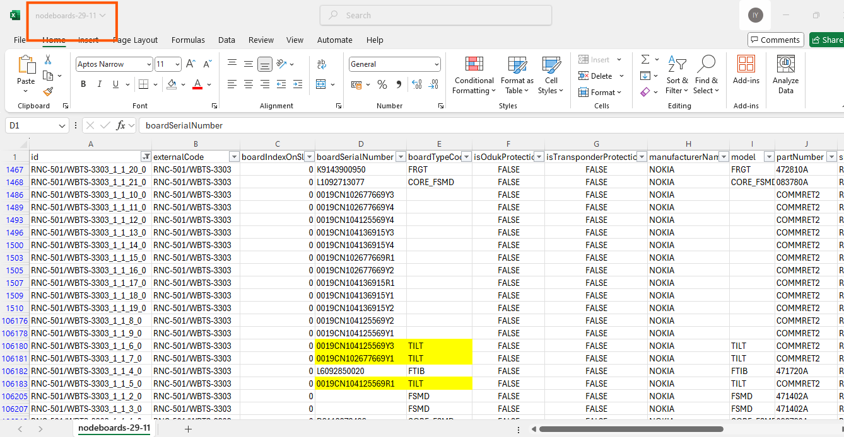

For BSC:
Sample Node Check: BSC-395036 (Given Rule in FRS is Okay)
Total Node Count=18
Model/Type=GCBV & BCNC i.e. Ok in cabinet & shelf respectively.
Total Cabinet Count=18
Total Shelf Count=81
Total Board Count=1156
Total Board Count with unique serial number=954
Total Board Type/Model=8
BOC_A
BPSU_A
HDSAM_A
BCN_A
BFAN_A
BJC_A
BMPP2_B
BCNMB_B

Total Antenna Count=0

For BTS:
Sample Node Check: BSC-395037/BCF-171 (Given Rule in FRS is Okay)
Total Node Count=3612
Model/Type= Flexi Multiradio-Ok in cabinet & in shelf it should be same as cabinet instead of Subrack NSN BTS (SS given below).
Total Cabinet Count=3612
Total Shelf Count=3612
Total Board Count=12504
Total Board Count with unique serial number=12291
Total Board Type/Model=20
FXDB
FTIF
FSMF
FXEB
FIQB
ESMC
ESMB
BBU
TMA
FPMA
FHDB
FXED
EWGB
FSEB
MHA
FIYB
FXEF
FXDA
FCIA
FXX

Total Antenna Count=0

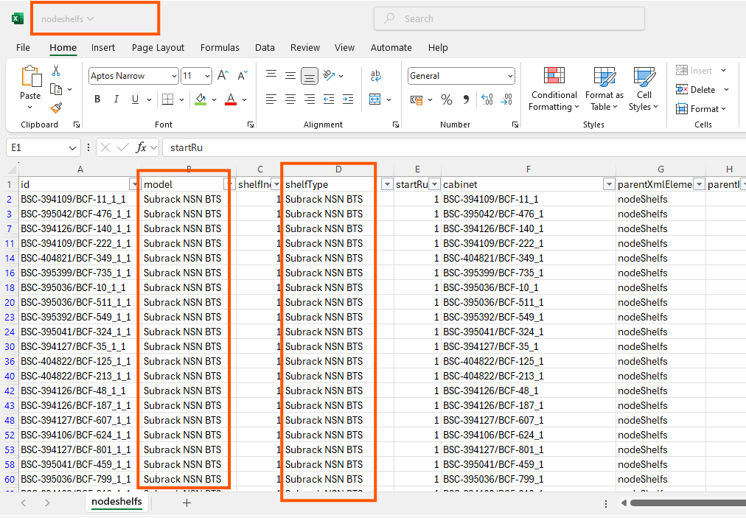

For eNodeB:
Sample Node Check: MRBTS-747012 (Given Rule in FRS is Okay)
Total Node Count=341
Model/Type= as given below:
FlexiZoneMicro System
AirScale LTE Base Station
Flexi LTE Base Station

Above model/type is okay in cabinet & shelf.
Total Cabinet Count=341
Total Shelf Count=341
Total Board Count=823
Total Board Count with unique serial number=199
Total Board Type/Model=13
CORE_FSM
FT
CORE_FR
FSM_FANA
ABIA
CORE_ASIA
CORE_FRGX
CORE_FXED
Nokia
FSPD
CORE_FSMF
CORE_FXEB
CORE_FXEF

Total Antenna Count=0

Board type/model is showing blank while it is available in dump.
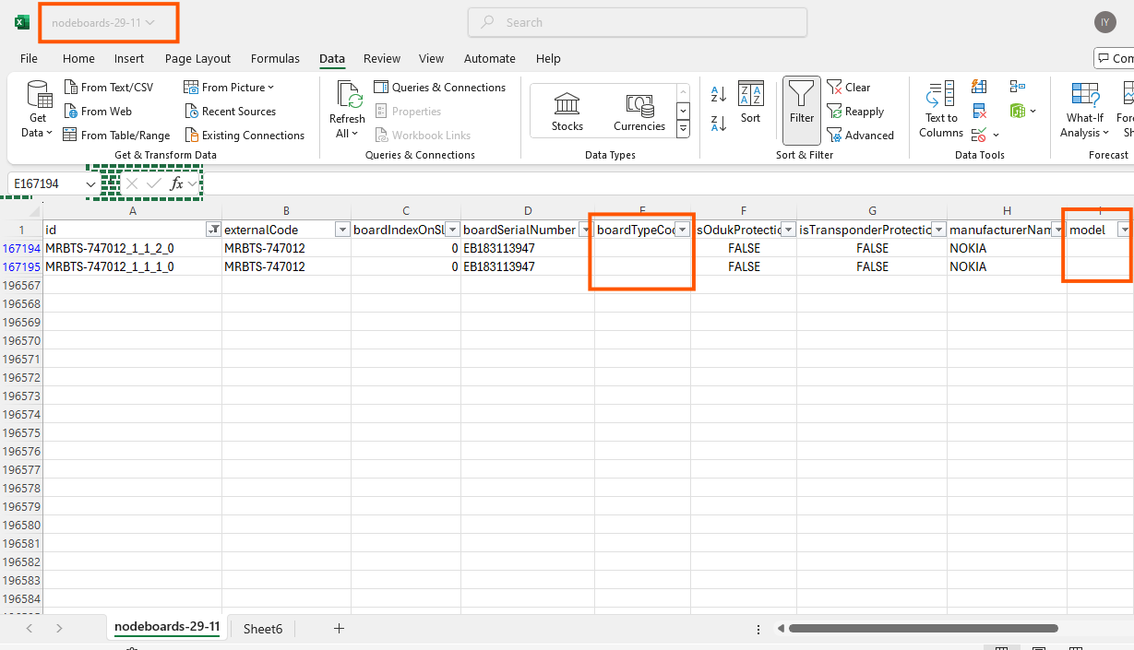

For another node MRBTS-516074, board type/model is available in dump while missing in XML.

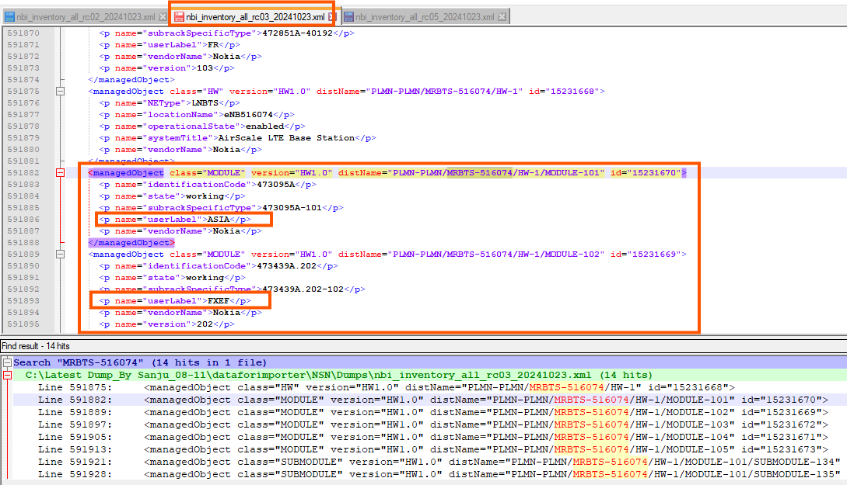

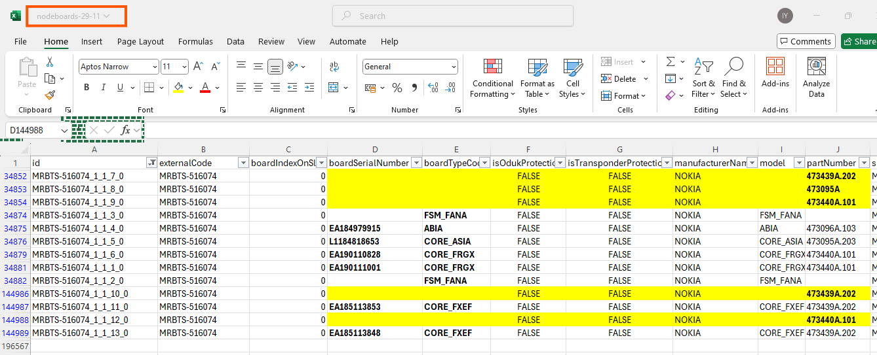
For SRAN:
Sample Node Check: MRBTS-417400 (Need to modify the rule for SRAN only)
Total Node Count=5398
Model/Type= Not coming as like given in FRS. (Need to modify the rule for SRAN only)
Total Cabinet Count=5398
Total Shelf Count=5398
Total Board Count=88047
Total Board Count with unique serial number=159
Total Board Type/Model=159

FXEB
FAN
FRGT
ARMA
RET
FXEF
ASIA AirScale Common
CORE_ASIA AirScale Common
AMIA AirScale Indoor Subrack
ABIA AirScale Capacity
FXDB
AEHC
CABINET
Flexi Baseband Sub-Module FBBC
ASIK AirScale Common
CORE_ASIK AirScale Common
ABIL AirScale Capacity
FYGC
FPFD
Flexi System Module Outdoor FSMF
CORE_Flexi System Module Outdoor FSMF
FRGU
FTIF
LNA
MDDA
FXED
FRMF
AHEGC
AZHA
AYGD
ASIB AirScale Common
CORE_ASIB AirScale Common
ABIO AirScale Capacity
FYGB
BB Extension Outdoor Sub-Module FBBA
AHPMDA
FPFD-ODM
AQQT
AAHF
AYGE
FXEA
AMIAAirScale Indoor Subrack
AEQA
FHDB
WMHD
Nokia
AHPMDG
5G
AKQZ
AHPMDB
GNSSE
AHEGG
AREA
ASIAAirScale Common
ABIAAirScale Capacity
AMOB AirScale Outdoor Subrack
AMIA AirScaleIndoor Subrack
Ant1
Ant6
Other
Not available
MDPA
1
2
4
3
MDA
ant3
ant5
FHEB
ARGA
ABILAirScale Capacity
AHGB
AZRC
AMIA AirScale IndoorSubrack
FXDA
FRGX
Ant4
Ant2
LTE
ASIA AirScaleCommon
ABIOAirScale Capacity
FRGP
6
5
FRGY
WMHC
21ANT4
21ANT6
BBMOD
18ANT5
18ANT6
21ANT2
21ANT3
21ANT5
18ANT3
18ANT1
18ANT4
ASIB AirScaleCommon
UNKNOWN
AMOD AirScale Outdoor Subrack
21Ant1
Flexi System ModuleOutdoor FSMF
FlexiSystem Module Outdoor FSMF
ABIL AirScaleCapacity
4G_L2100
4G_L1800
CORE_ASIA AirScaleCommon
ARDA
CORE_ASIK AirScaleCommon
TRMOD
AWHHF
CORE_FlexiSystem Module Outdoor FSMF
2300
L1800 SEC A
L2100 SEC C
L1800 SEC C
FRGQ
CORE_ASIBAirScale Common
7
12
10
9
8
11
ABIA AirScaleCapacity
Flexi System Module OutdoorFSMF
CORE_Flexi System ModuleOutdoor FSMF
18ANT2
CORE_ASIB AirScaleCommon
Not Avilable
Gain
MDGA
FlexiBaseband Sub-Module FBBC
AMOB AirScale OutdoorSubrack
ASIBAirScale Common
18AN
MALD
AZQI
L1800 SEC B
L2100 SEC A
L2100 SEC B
AHEJ
Flexi BasebandSub-Module FBBC
SEC B
SEC A
SEC D
Sec E
SEC C
SEC F
CORE_ASIAAirScale Common
Flexi SystemModule Outdoor FSMF
ABIC AirScale Capacity
WMHA
FR
ABIO AirScaleCapacity
LTE2100
2G
LTE1800

Total SRAN Node which has Antenna Count=2396
Antenna node count is matched of radioantenna & addinfo.
LNA & MDDA should be parse as board instead of radioantenna, currently MDDA same count is available in board as well as in radioantenna while 40 LNA are in radioantenna while in board it is around 1359.
<p name="inventoryUnitType">MDDA</p> total 959 MDDA should be parse as boards.
<p name="inventoryUnitType">LNA</p> total 1371 LNA should be parse as boards.

Sample Node Check: MRBTS-417400/MRBTS-417653/MRBTS-418148/MRBTS-518445
Cabinet model/type should be come “
I have updated the FRS and sharing on JIRA as well as over an email.

@Juned you need to check only yellow highlighted issue if you will face any issue call me will explain you.

