

NSN Connector

FRS (Functional Requirement Specifications)
Auto-Import connector

Draft version

Change History

Version | Change Description | Author | Date
0.1 | First draft | Indrasan | 12-11-2024
0.2 | Changes rule to parse cabinet & shelf under 2.1.1 & 2.1.2 & 2.1.3 & 3.1.3 marked with pink color. | Indrasan | 02-12-2024

Table of Contents
Introduction 4
1 EnodeB 5
1.1 Physical configuration 5
1.1.1 Cabinet 5
1.1.2 Shelf 6
1.1.3 Boards 6
2 SRAN: 8
2.1 Physical configuration 8
2.1.1 Cabinet 8
2.1.2 Shelf 9
2.1.3 Boards 9
3 BSC: 12
3.1 Physical configuration 12
3.1.1 Cabinet 12
3.1.2 Shelf 13
3.1.3 Boards 14
4 RNC: 15
4.1 Physical configuration 15
4.1.1 Cabinet 15
4.1.2 Shelf 16
4.1.3 Boards 16
5 BTS 18
5.1 Physical configuration 18
5.1.1 Cabinet 18
5.1.2 Shelf 19
5.1.3 Boards 19
6 NodeB: 23
6.1 Physical configuration 22
6.1.1 Cabinet 22
6.1.2 Shelf 23
6.1.3 Boards 23
7 Antenna: 25
7.1 Antenna Data 25

Introduction

- This FRS is intended for NSN Nodes extraction.
- It describes how to parse the sites, nodes and their correspondent physical configuration.
- The dump files provided are just one .xml contains the configuration of all nodes.
- The folder location to be specified later.

EnodeB
- Each class="HW" which includes MRBTS in attribute “distname” represents one eNodeB and in same class NEType will be LNBTS.

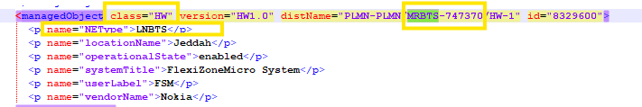

- The following attributes are defined at node level:

Attribute | Importance | Comment
NE ID | [Mandatory] | - From class="HW" ,distName attribute  - The distName attribute context is as follows:  class="HW" version="HW1.0" distName="PLMN-PLMN/MRBTS-747370/HW-1" id="8329600">  - E.g distName="PLMN-PLMN/MRBTS-747370" NE ID = MRBTS-747370
NE Name | [Mandatory] | - Same as NE ID
Site id | [Mandatory] | Follow the site matching sheet
Site Name | [Mandatory] | - = Site id
Type | [Mandatory] | - = eNodeB
Model |  | - = “systemTitle” attribute under the correspondent Class=” HW”  - E.g.  <p name="systemTitle">FlexiZoneMicro System</p>
Manufacturer | [Optional] | - = Nokia

Physical configuration for MRBTS (eNodeB)

Cabinet
- Each class="HW" which includes MRBTS in attribute “distname” represents one eNodeB and in same class NEType will be LNBTS. Here HW-1 represents one cabinet.

<managedObject class="HW" version="HW1.0" distName="PLMN-PLMN/MRBTS-747370/HW-1" id="8329600">
<p name="NEType">LNBTS</p>
<p name="locationName">Jeddah</p>
<p name="operationalState">enabled</p>
<p name="systemTitle">FlexiZoneMicro System</p>

Attribute | Importance | Comments
Cabinet id | [Mandatory] | - = 1 to be assigned by default
Model | [Mandatory] | - = systemtitle  <p name="systemTitle">FlexiZoneMicro System</p>
Manufacturer | [Mandatory] | - To be assigned by default  - E.g.: Manufacturer = Nokia
Serial Number | [Optional] | - As per availability

Shelf
- The Shelf should be same as cabinet.

- The below table describes how to parse the shelf attributes:

Attribute | Importance | Comments
Cabinet id | [Mandatory] | - = the id of correspondent cabinet
Shelf index | [Mandatory] | - = shelf id
Shelf Id | [Mandatory] | - = Cabinet id
Model | [Mandatory] | Same as Cabinet Model
RU Index | [Mandatory] | - =[(Shelf id -1)*2]+1  - E.g. Shelf id =1 → RU index =1  - E.g. Shelf id =2 → RU index =3
Description | [Optional] | - Null
Serial Number | [Optional] | - As per availability

Boards
- Each class="Module" and class=" SUBMODULE” represents one board
- The below table describes how to parse the boards attributes:

Attribute | Importance | Comments
Shelf Id | [Mandatory] | - the id of correspondent shelf
Index on slot | [Mandatory] | - = Default index on slot = 0
Slot index | [Mandatory] | - Start with 1. Increased with +1 for every new Board.
Board Type and Model | [Mandatory] | - = <p name="userLabel"> attribute under the same class  - E.g.  <p name="userLabel">FSM</p>  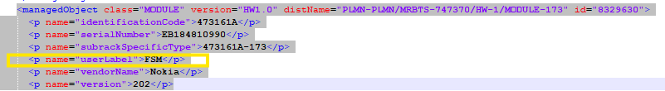
Part Number | [Optional] | - = “identificationCode” attribute  - E.g. <p name="identificationCode">473161A</p>
Description | [Optional] | - = Null
Date Of Manufacture | [Optional] | - = Null
Serial Number | [Optional] | - = "serialNumber" attribute under the same class  <p name="serialNumber">EB184810990</p>
Issue Number | [Optional] | - Version in same class  - <p name="version">202</p>
Power Consumption | [Optional] | - = Null
Additional Information | [Optional] | - = Null
Dimensions and Weight | [Optional] | - = Null

SRAN
A node is classified as SRAN in class=’HW’ under attributes distName="PLMN-PLMN/MRBTS-627397/HW-1" which does not contains NEType=WBTS Or LNBTS.

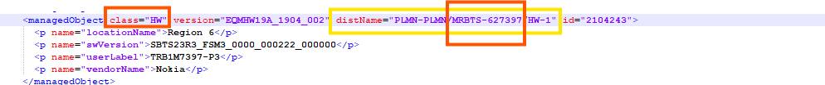

Attribute | Importance | Comment
NE ID | [Mandatory] | - It is extracted from class=’HW’ under attributes below.  - E.g class="HW" version="EQMHW19A_1904_002" distName="PLMN-PLMN/MRBTS-627397/HW-1" id="2104243"> NE ID= MRBTS-627397
NE Name | [Mandatory] | - Same as NE ID
Site id | [Mandatory] | - Follow the site matching sheet
Site Name | [Mandatory] | - = Site id
Type | [Mandatory] | - = SRAN
Model |  | - = Nokia SRAN
Manufacturer | [Optional] | - = Nokia

Physical configuration for SRAN

Cabinet
- In class="INVUNIT" we will get cabinet details from as given below:

<managedObject class="INVUNIT" version="EQMHW19A_1904_002" distName="PLMN-PLMN/MRBTS-518743/HW-1/INVUNIT-1" id="34283823">
<p name="configDN">MRBTS-518743/EQM-1/APEQM-1/CABINET-1</p>
<p name="inventoryUnitType">AMOD AirScale Outdoor Subrack</p>
<p name="runtimeDN">MRBTS-518743/EQM_R-4/APEQM_R-1/CABINET_R-1</p>
<p name="vendorName">Nokia</p>
<p name="vendorUnitFamilyType">CABINET</p>
<p name="vendorUnitTypeNumber">474930A</p>

- The mapping between the cabinet and the node will be depending on distName attribute, which will contain the node ID
E.g
class="HW" version="EQMHW19A_1904_002" distName="PLMN-PLMN/MRBTS-627397/HW-1" id="2104243">
- the node ID for this cabinet is: MRBTS-627397
- The cabinet attributes are extracted as follow:

Attribute | Importance | Comments
Cabinet id | [Mandatory] | - = 1 to be assigned by default
Model | [Mandatory] | = <p name="inventoryUnitType">AMOD AirScale Outdoor Subrack</p>  - We will get cabinet model from above attribute under class “INVUNIT”  - 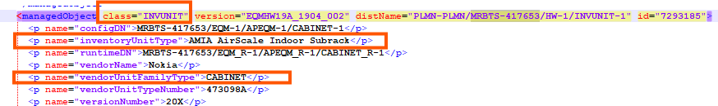
Manufacturer | [Mandatory] | - To be assigned by default  - E.g.: Manufacturer = Nokia
Serial Number | [Optional] | - As per availability

Shelf

- Same as cabinet.
- The below table describes how to parse the shelf attributes:

Attribute | Importance | Comments
Cabinet id | [Mandatory] | - =1
Shelf index | [Mandatory] | - =from class= “HW” from the distName="PLMN-PLMN/MRBTS-627397/HW-1  - Shelf index= 1  - E.g distName="PLMN-PLMN/SBTS-627397/HW-1  - Shelf index =1
Shelf Id | [Mandatory] | - = shelf index
Model | [Mandatory] | - = Same as cabinet
RU Index | [Mandatory] | - =[(Shelf id -1)*3]+1  - E.g. Shelf id =1 → RU index =1  - E.g. Shelf id =2 → RU index =4

Boards
- Each class equal to “INVUNIT” represents one board
- The mapping between the boards and the node will be depending on distName attribute, which will contain the node ID
E.g
class="INVUNIT" version="EQMHW19A_1904_002" distName="PLMN-PLMN/MRBTS-627397/HW-1/INVUNIT-1"
- Node ID= MRBTS-627397
- e.g.

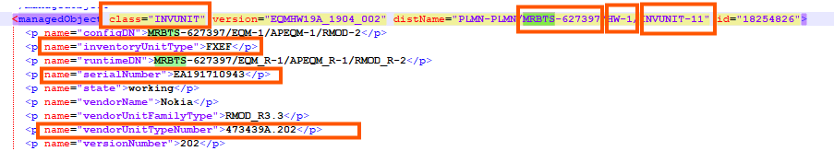
Note: In same class="INVUNIT" if attribute <p name="configDN"> contains “PASSDEV- “then need to ignore this one.

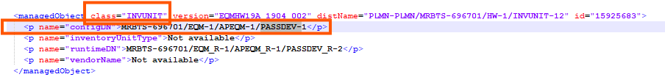

Index on slot is start with 0 & increment by 1 for same cabinet, shelf & slot.

- The below table describes how to parse the boards attributes:

Attribute | Importance | Comments
Shelf Index | [Mandatory] | - the index of the related shelf
Index on slot | [Mandatory] | = Default index on slot = 0 & increment by 1 for same cabinet, shelf & slot.
Slot index | [Mandatory] | - To be taken from class=INVUNIT, numerical value in front of INVUNIT.  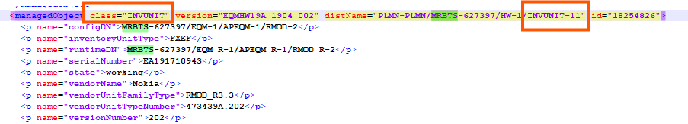
Board Type | [Mandatory] | - = “inventoryUnitType” attribute under the same class  - E.g.  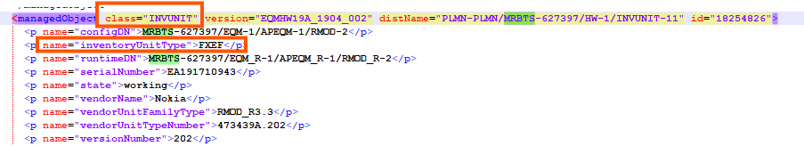
Part Number | [Optional] | - = " vendorUnitTypeNumber" attribute under the same class  - E.g.  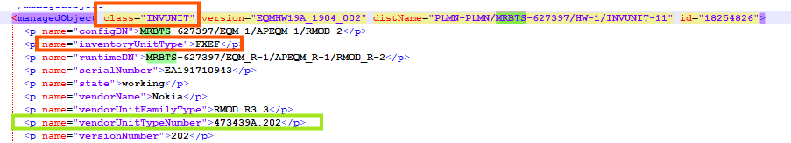
Serial Number | [Optional] | - = "serialNumber" attribute under the same class  - E.g.  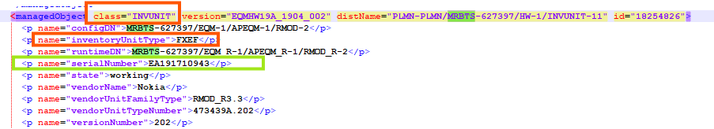
Issue Number | [Optional] | - = “version" attribute under the same class  - E.g.  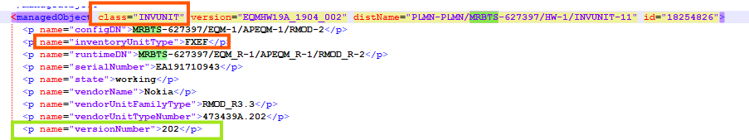

BSC
- Each class="HW" under attributes distName="PLMN-PLMN/BSC-404822/HW-1" represent one BSC
- class="HW" version="1.0" distName="PLMN-PLMN/BSC-404822/HW-1"

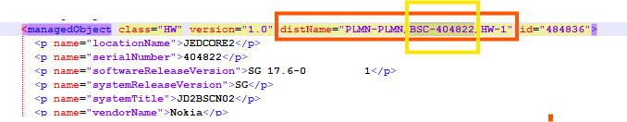

- The following attributes are defined at node level:

Attribute | Importance | Comment
NE ID | [Mandatory] | - From class="HW", distName attribute  distName="PLMN-PLMN/BSC-404822/HW-1"  - The distName attribute context is as follows:  "PLMN-PLMN/BSC-ID"  - E.g distName="PLMN-PLMN/BSC-404822" ID = 404822
NE Name | [Mandatory] | Need to take from attribute: <p name="systemTitle">  <p name="systemTitle">
Site id | [Mandatory] | Follow the site matching sheet
Site Name | [Mandatory] | - = Site id
Type | [Mandatory] | - = BSC
Model | [Mandatory] | - Default “Nokia BSC”
Manufacturer | [Optional] | - = Nokia

Physical configuration for BSC

Cabinet
- Each class="CABINET" represents one cabinet
- The mapping between the cabinet and the node will be depending on distName attribute, which will contain the node ID
E.g
class="CABINET" version="1.0" distName="PLMN-PLMN/BSC-404822/HW-1/CABINET-11"
the node ID for this cabinet is: BSC-404822.
- The cabinet attributes are extracted as follow:

Attribute | Importance | Comments
Cabinet id | [Mandatory] | - = from “distName” attribute take Cabinet ID and subtract 10 from it  - E.g. distName="PLMN-PLMN/BSC-404822/HW-1/CABINET-11" cabinet ID= 1
Model | [Mandatory] | - = "cabinetType" attribute  - E.g. <p name="cabinetType">GCBV</p>  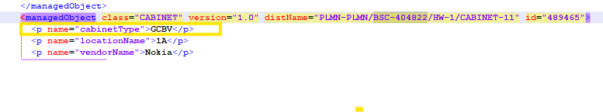
Manufacturer | [Mandatory] | - Nokia
Serial Number | [Optional] | - As per availability

Shelf

- Each Class="CARTRIDGE" in attributes represents one shelf
- The mapping between the shelf and the node will be depending on distName attribute, which will contain the node ID
E.g

- the node ID for this cabinet is: BSC-404822

- The below table describes how to parse the shelf attributes:

Attribute | Importance | Comments
Cabinet id | [Mandatory] | - = the id of correspondent cabinet
Shelf index | [Mandatory] | - = shelf id
Shelf Id | [Mandatory] | - = 1 for the first shelf found for a specific node, and to be incremented by one for each additional shelf.  For above shelf ID=1  Note: We will consider 3rd digit in the value of Cartridge.
Model | [Mandatory] | - = “cartridgeType" attribute for the same class  <p name="cartridgeType">BCNC</p>
RU Index | [Mandatory] | - =[(Shelf id -1)*8]+1  - E.g. Shelf id =1 → RU index =1  - E.g. Shelf id =2 → RU index =9
Description | [Optional] | - Null
Serial Number | [Optional] | - As per availability

Boards
- Each class="UNIT" represents one board
- The mapping between the boards and the node will be depending on distName attribute, which will contain the node ID
E.g
class="UNIT" version="1.0" distName="PLMN-PLMN/BSC-404822/HW-1/CABINET-11/CARTRIDGE-11100/UNIT-BCNMB_B_1_1_SHM-1"
- Node ID= 404822
- The mapping between the boards and the shelves will be based on distName attribute, which will contain the shelf
e.g.
  - Class="UNIT" version="1.0" distName="PLMN-PLMN/BSC-404822/HW-1/CABINET-11/CARTRIDGE-11100/UNIT-BCNMB_B_1_1_SHM-1"
  - class="UNIT" version="1.0" distName="PLMN-PLMN/BSC-404822/HW-1/CABINET-11/CARTRIDGE-11100/UNIT-BFAN_A_1_1_FAN-1"
  - these two boards belong to the same shelf (CARTRIDGE-11100)
- Each class="FUUNIT" represents one board
- In “class=FUUNIT” BSC node will find as already existing rule from attribute distname=
- Board model/type will take from attribute <p name="functionalUnitType"> under same class.
- Cabinet, shelf details will be taken from attribute <list name="supportedByUnit"> under same class.
- Slot ID will be taken default with start 1 & increment by 1 for next board.
- Index on slot will be 0 for first board then increment by 1 if any other board will be available on same cabinet, shelf & slot.
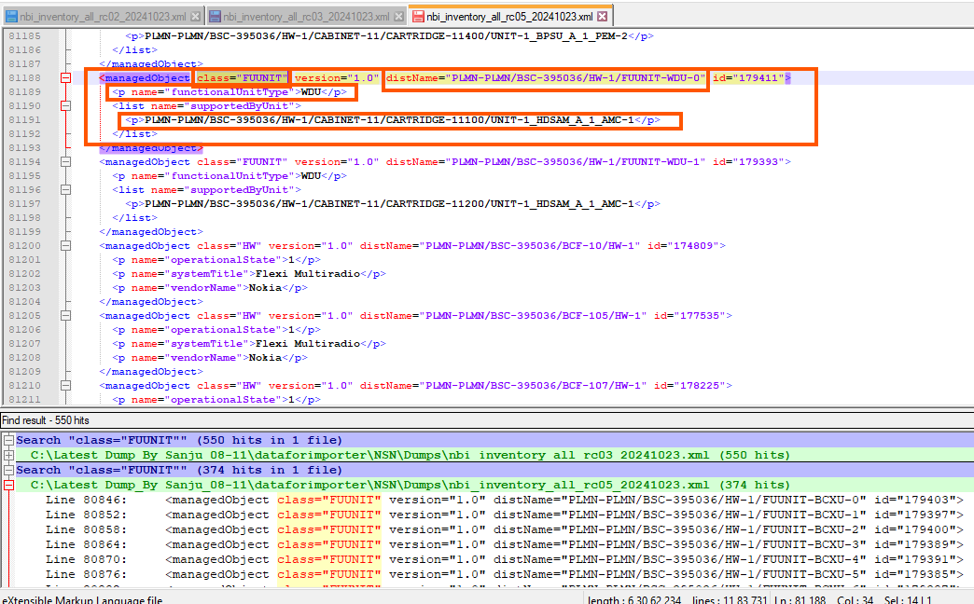
- The below table describes how to parse the boards attributes:

Attribute | Importance | Comments
Shelf Id | [Mandatory] | - the id of the related shelf
Index on slot | [Mandatory] | - = Default index on slot = 0
Slot index | [Mandatory] | - = “position” attribute under the same class  - E.g. <p name="position">1</p> slot index =1
Board Type and Model | [Mandatory] | - = “unitTypeExpected” attribute under the same class  - E.g.  <p name="unitTypeExpected">BCNMB_B</p>
Manufacturer |  | - = “vendorName” attribute under the same class  - E.g  - <p name="vendorName">Nokia</p>
Part Number | [Optional] | - = Null
Description | [Optional] | - = Null
Date Of Manufacture | [Optional] | - = Null
Serial Number | [Optional] | - = Null
Issue Number | [Optional] | - = Null
Power Consumption | [Optional] | - = Null
Additional Information | [Optional] | - = Null
Dimensions and Weight | [Optional] | - = Null

RNC
RNC node will be find in class “HW” as below given in snap: RNC will be “RNC-752” under attributes distName="PLMN-PLMN/RNC-752/HW-1"
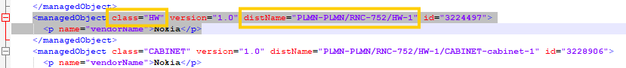

- The following attributes are defined at node level:

Attribute | Importance | Comment
NE ID | [Mandatory] | - = distName attribute within each line containing class="HW"  - E.g.: distName="PLMN-PLMN/RNC-752"  Node ID = RNC-752
NE Name | [Mandatory] | Same as NE ID
Site id | [Mandatory] | - Follow the site matching sheet
Site Name | [Mandatory] | - = Site id
Type | [Mandatory] | - = RNC
Model |  | - = Nokia RNC
Manufacturer | [Optional] | - = Nokia

Physical configuration

Cabinet
- Each class="CABINET" represents one cabinet
- The mapping between the cabinet and the node will be depending on distName attribute, which will contain the node ID
E.g
class="CABINET" version="1.0" distName="PLMN-PLMN/RNC-752/HW-1/CABINET-cabinet-1"
- 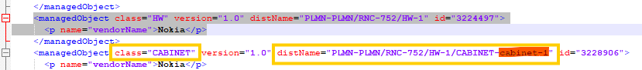
the cabinet ID for this cabinet is: 1
- The cabinet attributes are extracted as follow:

Attribute | Importance | Comments
Cabinet id | [Mandatory] | - = Cabinet ID from “distName” attribute take Cabinet ID  - E.g. distName distName="PLMN-PLMN/RNC-752/HW-1/CABINET-cabinet-1" cabinet ID= 1
Model | [Mandatory] | - Default: Nokia RNC
Manufacturer | [Mandatory] | Nokia
Serial Number | [Optional] | As per availability

Shelf

- Each class="Rack" represents one shelf
- The mapping between the shelf and the node will be depending on distName attribute, which will contain the node ID
E.g
class="RACK" version="1.0" distName="PLMN-PLMN/RNC-752/HW-1/CABINET-cabinet-1/RACK-c1"
the node ID for this shelf is: RNC-752

- The below table describes how to parse the shelf attributes:

Attribute | Importance | Comments
Cabinet id | [Mandatory] | - = the id of correspondent cabinet
Shelf index | [Mandatory] | - = shelf id
Shelf Id | [Mandatory] | - =Rack from “distName” attribute take Rack ID  - E.g. PLMN-PLMN/RNC-752/HW-1/CABINET-cabinet-1/RACK-c1 Shelf ID=1
Model | [Mandatory] | - Nokia RNC
RU Index | [Mandatory] | - =[(Shelf id -1)*8]+1  - E.g. Shelf id =1 → RU index =1  - E.g. Shelf id =2 → RU index =9
Description | [Optional] | - Null
Serial number | [Optional] | - As per availability

Boards
- Each class="UNIT" represents one board
- The mapping between the boards and the node will be depending on distName attribute, which will contain the node ID
E.g
class="UNIT" version="1.0" distName="PLMN-PLMN/RNC-752/HW-1/CABINET-cabinet-1/RACK-c1/UNIT-AMC-1" id="3307609">
- <p name="identificationCode">MIC-5401-0000E</p>
- <p name="serialNumber">AT142400153</p>
- <p name="unitType">HDSAM-A</p>
- <p name="vendorName">ADVANTEC</p>
- <p name="version">C110598.B3A</p>

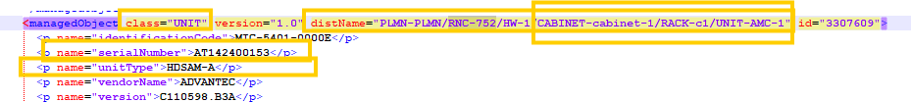

- The mapping between the boards and the shelves will be based on distName attribute, which will contain the shelf
e.g.
  - class="UNIT" version="1.0" distName="PLMN-PLMN/RNC-752/HW-1/CABINET-cabinet-1/RACK-c1/UNIT-AMC-1" id="3307609"> the board belongs to cabinet 1 and shelf 1.
- The below table describes how to parse the boards attributes:

Attribute | Importance | Comments
Shelf Id | [Mandatory] | - the id of the related shelf
Index on slot | [Mandatory] | - = Default index on slot = 0 (For one shelf it will start from 0 & incremented by 1 till max. 9)
Slot index | [Mandatory] | - Slot index will be taken from the numeric value of Unit under attributes:  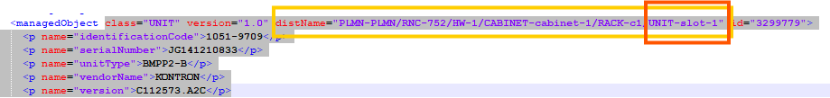
Board Type | [Mandatory] | - = “unitType” attribute under the same class  - E.g.  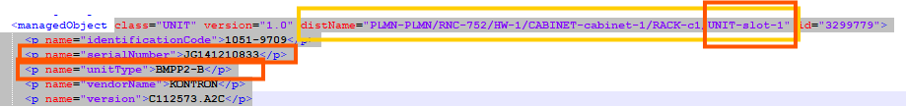
Part Number | [Optional] | - = “identificationCode” attribute under the same class
Serial Number | [Optional] | - = “serialNumber” attribute under the same class

BTS:
- Each class="HW" where BCF coming under attributes “distName="PLMN-PLMN/BSC-395041/BCF-158/HW-1 “represents one BTS node.

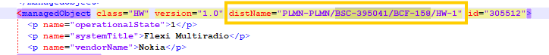

- The following attributes are defined at node level:

Attribute | Importance | Comment
NE ID | [Mandatory] | - From class="HW", distName attribute  - = distName attribute  - E.g distName="PLMN-PLMN/BSC-395041/BCF-158/HW-1" ID= PLMN-PLMN/BSC-395041/BCF-158
NE Name | [Mandatory] | - Same as NE ID
Site id | [Mandatory] | - Follow the site matching sheet
Site Name | [Mandatory] | - = Site id
Type | [Mandatory] | - = BTS
Model |  | - = “systemTitle” attribute under the correspondent Class=”HW”  - E.g.  <managedObject class="HW" version="1.0" distName="PLMN-PLMN/BSC-395041/BCF-158/HW-1" id="305512">  <p name="operationalState">1</p>  <p name="systemTitle">Flexi Multiradio</p>  <p name="vendorName">Nokia</p>  - The Model for “PLMN-PLMN/BSC-395041/BCF-158” = Flexi Multiradio  - If no systemTitle found keep Default model as “Flexi Multiradio”
Manufacturer | [Optional] | - = Nokia

Physical configuration

Cabinet
- Each class="HW" represents one cabinet
- The mapping between the cabinet and the node will be depending on distName attribute,
E.g
<managedObject class="HW" version="1.0" distName="PLMN-PLMN/BSC-395041/BCF-158/HW-1"
the node ID for this cabinet is: BSC-395041/BCF-158
- The cabinet attributes are extracted as follow:

Attribute | Importance | Comments
Cabinet id | [Mandatory] | - = from “distName” attribute  - E.g. distName="PLMN-PLMN/BSC-395041/BCF-158/HW-1" cabinet ID= 1
Model | [Mandatory] | - If the value of “unitType” attribute of one UNIT is equal to FCIA Model = FCIA  - If the value of “unitType” attribute of one UNIT is equal to FCOA Model = FCOA  - If “FCIA” and “FCOA” are not found, Model = Flexi Multiradio
Manufacturer | [Mandatory] | - To be assigned by default  - E.g.: Manufacturer = Nokia
Serial Number | [Optional] | - As per availability

Shelf

- Each class="SUBRACK" represents one shelf
- The mapping between the shelf and the node will be depending on distName attribute,
E.g
<managedObject class="SUBRACK" version="1.0" distName="PLMN-PLMN/BSC-395041/BCF-158/HW-1/SUBRACK-1"
the node ID for this cabinet is: BSC-395041/BCF-158

- The below table describes how to parse the shelf attributes:

Attribute | Importance | Comments
Cabinet id | [Mandatory] | - = the id of correspondent cabinet
Shelf index | [Mandatory] | - = shelf id
Shelf Id | [Mandatory] | - = 1 for the first shelf found for a specific node, and to be incremented by one for each additional shelf  (Subrack-1) is shelf id for below exp:  class="SUBRACK" version="1.0" distName="PLMN-PLMN/BSC-395041/BCF-158/HW-1/SUBRACK-1"
Model | [Mandatory] | - “Model = Flexi Multiradio” to add by default
RU Index | [Mandatory] | - =[(Shelf id -1)*8]+1  - E.g. Shelf id =1 → RU index =1  - E.g. Shelf id =2 → RU index =9
Description | [Optional] | - Null
Serial Number | [Optional] | - As per availability

Boards
- Each class="UNIT" represents one board
- The mapping between the boards and the node will be depending on distName attribute,
E.g
class="UNIT" version="1.0" distName="PLMN-PLMN/BSC-395041/BCF-158/HW-1/SUBRACK-1/UNIT-ESMB_1_1"
Node ID= PLMN-PLMN/BSC-395041/BCF-158
- The mapping between the boards and the shelves will be based on distName attribute, which will contain the shelf
e.g.
  - class="UNIT" version="1.0" distName="PLMN-PLMN/BSC-395041/BCF-158/HW-1/SUBRACK-1/UNIT-ESMB_1_1"
  - class="UNIT" version="1.0" distName="PLMN-PLMN/BSC-395041/BCF-158/HW-1/SUBRACK-1/UNIT-ESMB_1_1"
  - class="UNIT" version="1.0" distName="PLMN-PLMN/BSC-395041/BCF-158/HW-1/SUBRACK-1/UNIT-FIQB_1_4"
  - These above two boards belong to the same shelf (SUBRACK-1)
- The below table describes how to parse the boards attributes:

Attribute | Importance | Comments
Shelf Id | [Mandatory] | - the id of the related shelf (SUBRACK-1 i.e. 1)
Index on slot | [Mandatory] | - = Default index on slot = 0
Slot index | [Mandatory] | - = “position” attribute under the same class  - E.g. <p name="position">1</p> slot index =1  <p name="identificationCode">472109A</p>  <p name="operationalState">1</p>  <p name="position">1</p>  <p name="serialNumber">TY134308837</p>  <p name="unitId">1</p>  <p name="unitType">ESMB</p>  <p name="vendorName">Nokia</p>  <p name="version">102</p>
Board Type | [Mandatory] | - = “unitType” attribute under the same class  - E.g.  <p name="identificationCode">472109A</p>  - <p name="operationalState">1</p>  - <p name="position">1</p>  - <p name="serialNumber">TY134308837</p>  - <p name="unitId">1</p>  - <p name="unitType">ESMB</p>  - <p name="vendorName">Nokia</p>  - <p name="version">102</p>
Part Number | [Optional] | - = “identificationCode” attribute  - E.g.  <p name="identificationCode">472109A</p>  <p name="operationalState">1</p>  <p name="position">1</p>  <p name="serialNumber">TY134308837</p>  <p name="unitId">1</p>  <p name="unitType">ESMB</p>  <p name="vendorName">Nokia</p>  <p name="version">102</p>
Description | [Optional] | - = Null
Date Of Manufacture | [Optional] | - = Null
Serial Number | [Optional] | - = “serialNumber” attribute  - E.g.  <p name="identificationCode">472109A</p>  <p name="operationalState">1</p>  <p name="position">1</p>  <p name="serialNumber">TY134308837</p>  <p name="unitId">1</p>  <p name="unitType">ESMB</p>  <p name="vendorName">Nokia</p>  <p name="version">102</p>
Issue Number | [Optional] | - = Null
Power Consumption | [Optional] | - = Null
Additional Information | [Optional] | - = Null
Dimensions and Weight | [Optional] | - = Null

NodeB:
- Each class="HW" which includes WBTS in attribute “distname” represents one NodeB.

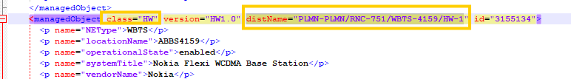

- The following attributes are defined at node level:

Attribute | Importance | Comment
NE ID | [Mandatory] | - E.g distName="PLMN-PLMN/RNC-751/WBTS-4159  ID= RNC-751/WBTS-4159  distName="PLMN-PLMN/RNC-751/WBTS-4159/HW-1
NE Name | [Mandatory] | Same as NE ID
Site id | [Mandatory] | - Follow the site matching sheet
Site Name | [Mandatory] | - = Site id
Type | [Mandatory] | - = NodeB where NE Type will be “WBTS” we will consider it as NodeB  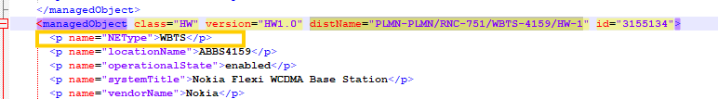
Model |  | - = “systemTitle” attribute under the correspondent Class=”HW”  - E.g.  - <p name="systemTitle">Nokia Flexi WCDMA Base Station</p>
Manufacturer | [Optional] | - = Nokia

Physical configuration

Cabinet
- Each class="HW" represents one cabinet
- The mapping between the cabinet and the node will be depending on distName attribute,
E.g. distName="PLMN-PLMN/RNC-751/WBTS-4159/HW-1”
- The cabinet attributes are extracted as follow:

Attribute | Importance | Comments
Cabinet id | [Mandatory] | - = from “distName” attribute  - E.g. distName=" distName="PLMN-PLMN/RNC-751/WBTS-4159/HW-1" cabinet ID= 1
Model | [Mandatory] | - = “systemTitle” attribute under the correspondent Class=”HW”  - E.g.  - <p name="systemTitle">Nokia Flexi WCDMA Base Station</p>
Manufacturer | [Mandatory] | - To be assigned by default  - E.g.: Manufacturer = Nokia
Serial Number | [Optional] | - As per availability

Shelf

- The below table describes how to parse the shelf attributes:

Attribute | Importance | Comments
Cabinet id | [Mandatory] | - = the id of correspondent cabinet
Shelf index | [Mandatory] | - = shelf id
Shelf Id | [Mandatory] | - = 1 for the first shelf found for a specific node, and to be incremented by one for each additional shelf
Model | [Mandatory] | - (Nokia Flexi WCDMA Base Station) by default
RU Index | [Mandatory] | - =[(Shelf id -1)*2]+1  - E.g. Shelf id =1 → RU index =1  - E.g. Shelf id =2 → RU index =3
Description | [Optional] | - Null
Serial Number | [Optional] | - As per availability

Boards
- Each class="Module" and class=" SUBMODULE” represents one board
- The below table describes how to parse the boards attributes:

Attribute | Importance | Comments
Shelf Id | [Mandatory] | - Shelf ID to be deduced from distname.  - E.g., Shelf ID to be deduced from distname.  E.g., distName="PLMN-PLMN/RNC-402/WBTS-4159/HW-1/MODULE-173/SUBMODULE-225" → Shelf ID is the shelf deduced from ="PLMN-PLMN/RNC-402/WBTS-4159/HW-1/MODULE-173”
Index on slot | [Mandatory] | - = Default index on slot = 0
Slot index | [Mandatory] | - Slot index of the first board on the shelf is 1 and to be incremented by 1 automatically for each new board.
Board Type | [Mandatory] | - <p name="unitType"> attribute under the same class SUBMODULE.  - E.g.  <p name="unitType">FTIB</p>
Part Number | [Optional] | - = “identificationCode” attribute  - E.g. <p name="identificationCode">472182A</p>
Description | [Optional] | - = Null
Date Of Manufacture | [Optional] | - = Null
Serial Number | [Optional] | - = “serialNumber” attribute  - E.g.  <p name="serialNumber">K9153917272</p>  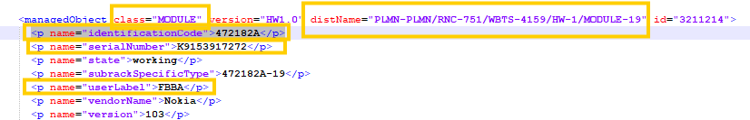
Issue Number | [Optional] | - = Null
Power Consumption | [Optional] | - = Null
Additional Information | [Optional] | - = Null
Dimensions and Weight | [Optional] | - = Null

Antenna:

Antenna data
We need to parse antenna details in radioantenna csv sheet.

- The following attributes are defined at antenna node level in radioantenna csv & serial number will be parsed under addinfo csv.

Attribute | Importance | Comment
NE ID | [Mandatory] | - Concatenate of Parent Node & last integer value in attribute distName:  Example:1  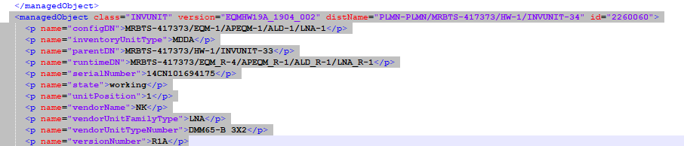  distName="PLMN-PLMN/MRBTS-417373/HW-1/INVUNIT-34"  NE ID: MRBTS-417373_34  Example:2  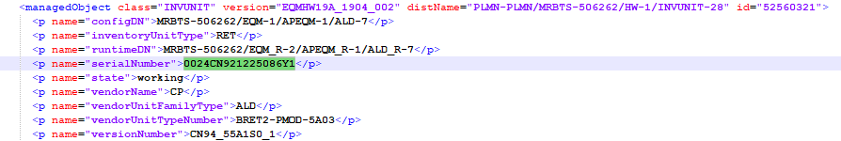  distName="PLMN-PLMN/MRBTS-506262/HW-1/INVUNIT-28"  NE ID: MRBTS-506262_28  Example:3  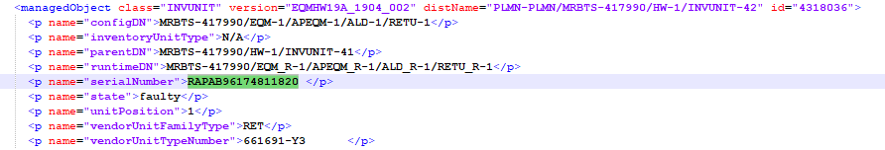  distName="PLMN-PLMN/MRBTS-417990/HW-1/INVUNIT-42"  NE ID: MRBTS-417990_42  Example:4  distName="PLMN-PLMN/RNC-504/WBTS-3343/HW-1/MODULE-40192/SUBMODULE-34817"  NE ID: RNC-504/WBTS-3343_34817
NE Name | [Mandatory] | Same as NE ID
Site id | [Mandatory] | - Follow the site matching sheet & Rule
Site Name | [Optional] | - = Site id
Type | [Mandatory] | - = Antenna where attribute <p name="inventoryUnitType"> contains “SingleAntennaDevice” or “MultiAntennaDevice” or “RET” under class="INVUNIT".  - if attribute <p name="inventoryUnitType"> contains “N/A” under class class="INVUNIT" then match it with the value of given attribute “<p name="vendorUnitFamilyType">RET</p> in same class if it will be “RET” the parse it as radio antenna type “RET”.  - And <p name="unitType"> (In case of TILT) under class “SubModule” then parse under antenna.  <p name="unitType">TILT</p>  If above given type is found anywhere in dump these all should be parse under “radioantenna” only.
Model | [Optional] | Same as Type if require
Serial Number | [Mondatory] | Serial number will get from below attribute:  <p name="serialNumber" within above mentioned type only.
Manufacturer | [Optional] | - = Nokia  will need to take from below attribute:  <p name="vendorName">

