

NSN Connector

FRS (Functional Requirement Specifications)
Auto-Import connector

Draft version
Indrasan Yadav

Change History

Version | Change Description | Author | Date
0.1 | First draft | Indrasan Yadav | 12-11-2024
0.2 | Changes rule to parse cabinet & shelf under 2.1.1 & 2.1.2 & 2.1.3 & 3.1.3 marked with pink color. | Indrasan Yadav | 02-12-2024
0.3 | Changes rule to parse boards for all node types where board type information is not available in dump in section 1.1.3/2.1.3/3.1.3/4.1.3/5.1.3/6.1.3 marked with pink color | Indrasan Yadav | 18-12-2024
0.4 | Added the rule to parse node name (NE Name) for node type BSC, SRAN in section 2/3 marked with pink color | Indrasan Yadav | 30-12-2024
0.5 | Added the rule to parse site id for all node type which is described in section 8/8.1 | Indrasan Yadav | 31-12-2024
0.6 | Added the rule to parse node name (NE Name) for node type eNodeB, RNC, NodeB in section 1/4/6 marked with pink color | Indrasan Yadav | 06-01-2025
0.7 | Added the rule to parse only one time for one board where duplicate serial numbers will find for same node & same board type under section boards in 1.1.3/2.1.3/3.1.3/4.1.3/5.1.3/6.1.3 marked with green color | Indrasan Yadav | 07-01-2025

Table of Contents
Introduction 4
1 EnodeB 5
1.1 Physical configuration 5
1.1.1 Cabinet 5
1.1.2 Shelf 6
1.1.3 Boards 6
2 SRAN: 8
2.1 Physical configuration 8
2.1.1 Cabinet 8
2.1.2 Shelf 9
2.1.3 Boards 9
3 BSC: 12
3.1 Physical configuration 12
3.1.1 Cabinet 12
3.1.2 Shelf 13
3.1.3 Boards 14
4 RNC: 15
4.1 Physical configuration 15
4.1.1 Cabinet 15
4.1.2 Shelf 16
4.1.3 Boards 16
5 BTS 18
5.1 Physical configuration 18
5.1.1 Cabinet 18
5.1.2 Shelf 19
5.1.3 Boards 19
6 NodeB: 23
6.1 Physical configuration 22
6.1.1 Cabinet 22
6.1.2 Shelf 23
6.1.3 Boards 23
7 Antenna: 25
  - Antenna Data 25

NSN Connector for Physical Inventory (ZAIN-KSA)

NSN Connector

FRS (Functional Requirement Specifications)
Auto-Import connector

Draft version
Indrasan Yadav

Introduction

- This FRS is intended for NSN Nodes extraction.
- It describes how to parse the sites, nodes and their correspondent physical configuration.
- The dump files provided are just one .xml contains the configuration of all nodes.
- The folder location to be specified later.

Change History

Version | Change Description | Author | Date
0.1 | First draft | Indrasan Yadav | 12-11-2024
0.2 | Changes rule to parse cabinet & shelf under 6.1.1 & 6.1.2 & 6.1.3 & 7.1.3 marked with pink color. | Indrasan Yadav | 02-12-2024
0.3 | Changes rule to parse boards for all node types where board type information is not available in dump in section 5.1.3/6.1.3/7.1.3/8.1.3/9.1.3/10.1.3 marked with pink color | Indrasan Yadav | 18-12-2024
0.4 | Added the rule to parse node name (NE Name) for node type SRAN, BSC in section 6/7 marked with pink color | Indrasan Yadav | 30-12-2024
0.5 | Added the rule to parse site id for all node type which is described in section 12/12.1 | Indrasan Yadav | 31-12-2024
0.6 | Added the rule to parse node name (NE Name) for node type eNodeB, RNC, NodeB in section 5/8/10 marked with pink color | Indrasan Yadav | 06-01-2025
0.7 | Added the rule to parse only one time for one board where duplicate serial numbers will find for same node & same board type under section boards in 5.1.3/6.1.3/7.1.3/8.1.3/9.1.3/10.1.3 marked with green color | Indrasan Yadav | 07-01-2025

Table of Contents

5 EnodeB 8
5.1 Physical configuration 9
5.1.1 Cabinet 9
5.1.2 Shelf 9
5.1.3 Boards 9
6 SRAN: 12
6.1 Physical configuration 12
6.1.1 Cabinet 12
6.1.2 Shelf 13
6.1.3 Boards 13
7 BSC: 16
7.1 Physical configuration 17
7.1.1 Cabinet 17
7.1.2 Shelf 17
7.1.3 Boards 18
8 RNC: 21
8.1 Physical configuration 21
8.1.1 Cabinet 21
8.1.2 Shelf 22
8.1.3 Boards 23
9 BTS 25
9.1 Physical configuration 25
9.1.1 Cabinet 25
9.1.2 Shelf 26
9.1.3 Boards 26
10 NodeB: 29
10.1 Physical configuration 30
10.1.1 Cabinet 30
10.1.2 Shelf 30
10.1.3 Boards 31
11 Antenna: 33
11.1 Antenna Data 33
12 Site ID Parsing Rule: 35
12.1 Example Of One SRAN Node To Parse Site Id: 36

EnodeB
- Each class="HW" which includes MRBTS in attribute “distname” represents one eNodeB and in same class NEType will be LNBTS.

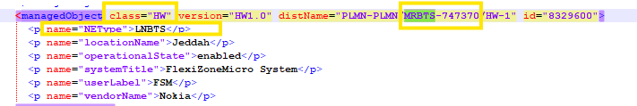

- The following attributes are defined at node level:

Attribute | Importance | Comment
NE ID | [Mandatory] | - From class="HW" ,distName attribute  - The distName attribute context is as follows:  class="HW" version="HW1.0" distName="PLMN-PLMN/MRBTS-747370/HW-1" id="8329600">  - E.g distName="PLMN-PLMN/MRBTS-747370" NE ID = MRBTS-747370
NE Name | [Mandatory] | - Take the value of <p name="userLabel"> from class=HW to parse the node name. (same class from which node id is parsing for eNodeB)  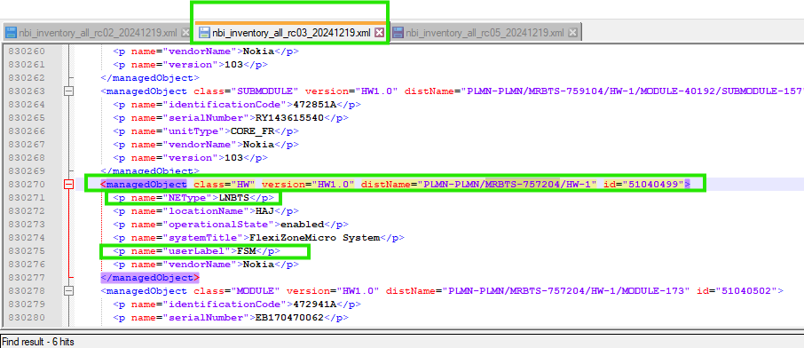  Note: “FSM” will come for all eNodeB as same is available in dump and same was parsing in .2.X so we are considering the same rule as confirmed with @Ahad.
Site id | [Mandatory] | Explained in the section 8
Site Name | [Mandatory] | - = Site id
Type | [Mandatory] | - = eNodeB
Model |  | - = “systemTitle” attribute under the correspondent Class=” HW”  - E.g.  <p name="systemTitle">FlexiZoneMicro System</p>
Manufacturer | [Optional] | - = Nokia

Physical configuration for MRBTS (eNodeB)

Cabinet
- Each class="HW" which includes MRBTS in attribute “distname” represents one eNodeB and in same class NEType will be LNBTS. Here HW-1 represents one cabinet.

<managedObject class="HW" version="HW1.0" distName="PLMN-PLMN/MRBTS-747370/HW-1" id="8329600">
<p name="NEType">LNBTS</p>
<p name="locationName">Jeddah</p>
<p name="operationalState">enabled</p>
<p name="systemTitle">FlexiZoneMicro System</p>

Attribute | Importance | Comments
Cabinet id | [Mandatory] | - = 1 to be assigned by default
Model | [Mandatory] | - = systemtitle  <p name="systemTitle">FlexiZoneMicro System</p>
Manufacturer | [Mandatory] | - To be assigned by default  - E.g.: Manufacturer = Nokia
Serial Number | [Optional] | - As per availability

Shelf
- The Shelf should be same as cabinet.

- The below table describes how to parse the shelf attributes:

Attribute | Importance | Comments
Cabinet id | [Mandatory] | - = the id of correspondent cabinet
Shelf index | [Mandatory] | - = shelf id
Shelf Id | [Mandatory] | - = Cabinet id
Model | [Mandatory] | Same as Cabinet Model
RU Index | [Mandatory] | - =[(Shelf id -1)*2]+1  - E.g. Shelf id =1 → RU index =1  - E.g. Shelf id =2 → RU index =3
Description | [Optional] | - Null
Serial Number | [Optional] | - As per availability

Boards
- Each class="Module" and class=" SUBMODULE” represents one board
- The below table describes how to parse the boards attributes:

Attribute | Importance | Comments
Shelf Id | [Mandatory] | - the id of correspondent shelf
Index on slot | [Mandatory] | - = Default index on slot = 0
Slot index | [Mandatory] | - Start with 1. Increased with +1 for every new Board.
Board Type and Model | [Mandatory] | - = <p name="userLabel"> attribute under the same class  - E.g.  <p name="userLabel">FSM</p>  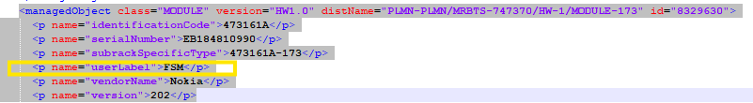  Note: if there is not any information regarding board type as below:  “unitTypeExpected”  “inventoryUnitType”  “unitType”  <p name="userLabel">  then we will give name “Dummy_Nokia Unit”.  Note: Please ensure that each duplicate serial number is parsed only once for the same node and board. However, if the serial numbers are duplicates across different nodes, they should be  parsed accordingly.  Here same serial numbers are coming for same node & same board type multiple time so you will parse it only one time.  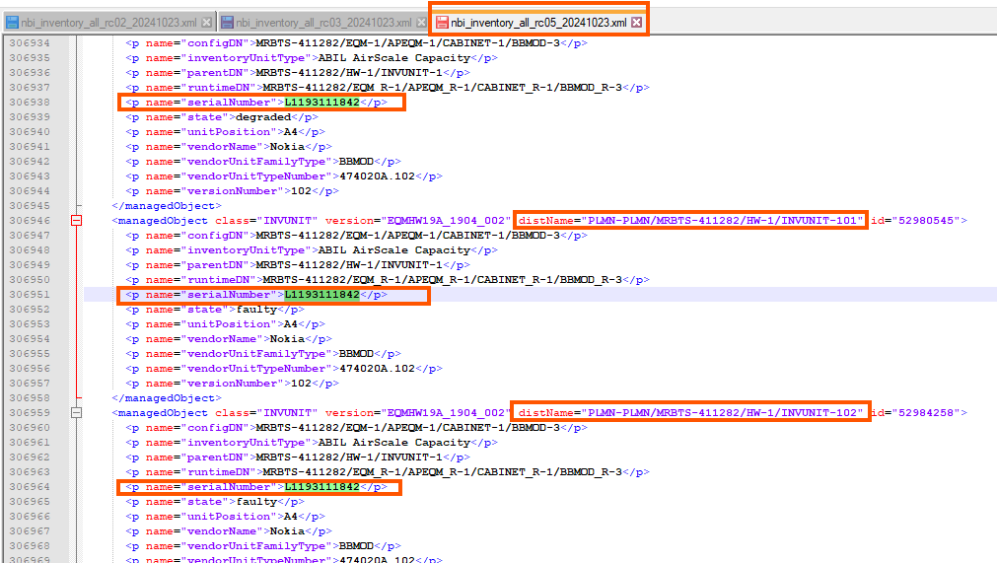
Part Number | [Optional] | - = “identificationCode” attribute  - E.g. <p name="identificationCode">473161A</p>
Description | [Optional] | - = Null
Date Of Manufacture | [Optional] | - = Null
Serial Number | [Optional] | - = "serialNumber" attribute under the same class  <p name="serialNumber">EB184810990</p>
Issue Number | [Optional] | - Version in same class  - <p name="version">202</p>
Power Consumption | [Optional] | - = Null
Additional Information | [Optional] | - = Null
Dimensions and Weight | [Optional] | - = Null

SRAN
A node is classified as SRAN in class=’HW’ under attributes distName="PLMN-PLMN/MRBTS-627397/HW-1" which does not contains NEType=WBTS Or LNBTS.

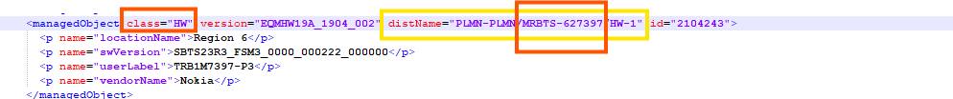

Attribute | Importance | Comment
NE ID | [Mandatory] | - It is extracted from class=’HW’ under attributes below.  - E.g class="HW" version="EQMHW19A_1904_002" distName="PLMN-PLMN/MRBTS-627397/HW-1" id="2104243"> NE ID= MRBTS-627397
NE Name | [Mandatory] | - Take the value of <p name="userLabel"> from class=HW to parse the node name.  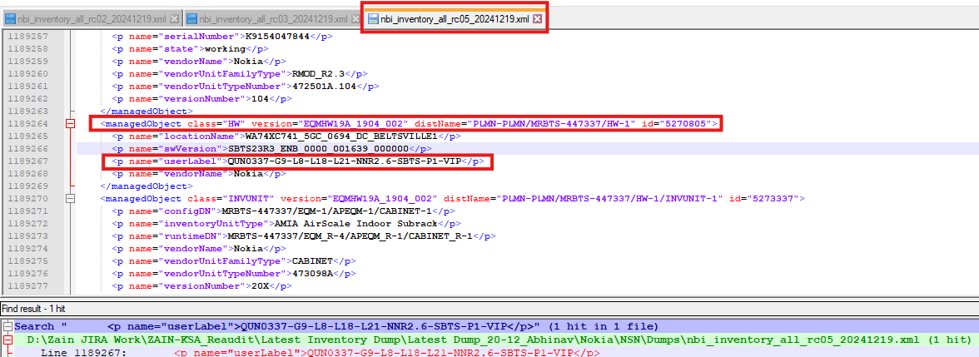
Site id | [Mandatory] | - Explained in the section 8
Site Name | [Mandatory] | - = Site id
Type | [Mandatory] | - = SRAN
Model |  | - = Nokia SRAN
Manufacturer | [Optional] | - = Nokia

Physical configuration for SRAN

Cabinet
- In class="INVUNIT" we will get cabinet details from as given below:

<managedObject class="INVUNIT" version="EQMHW19A_1904_002" distName="PLMN-PLMN/MRBTS-518743/HW-1/INVUNIT-1" id="34283823">
<p name="configDN">MRBTS-518743/EQM-1/APEQM-1/CABINET-1</p>
<p name="inventoryUnitType">AMOD AirScale Outdoor Subrack</p>
<p name="runtimeDN">MRBTS-518743/EQM_R-4/APEQM_R-1/CABINET_R-1</p>
<p name="vendorName">Nokia</p>
<p name="vendorUnitFamilyType">CABINET</p>
<p name="vendorUnitTypeNumber">474930A</p>

- The mapping between the cabinet and the node will be depending on distName attribute, which will contain the node ID
E.g
class="HW" version="EQMHW19A_1904_002" distName="PLMN-PLMN/MRBTS-627397/HW-1" id="2104243">
- the node ID for this cabinet is: MRBTS-627397
- The cabinet attributes are extracted as follow:

Attribute | Importance | Comments
Cabinet id | [Mandatory] | - = 1 to be assigned by default
Model | [Mandatory] | = <p name="inventoryUnitType">AMOD AirScale Outdoor Subrack</p>  - We will get cabinet model from above attribute under class “INVUNIT”  - 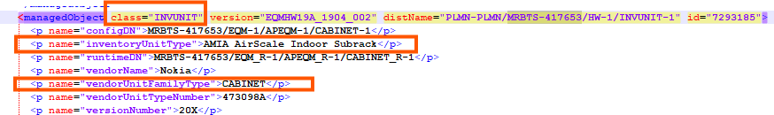  Note: Cabinet will parse only where attribute “<p name="vendorUnitFamilyType">CABINET</p>” will available under same class.
Manufacturer | [Mandatory] | - To be assigned by default  - E.g.: Manufacturer = Nokia
Serial Number | [Optional] | - As per availability

Shelf

- Same as cabinet.
- The below table describes how to parse the shelf attributes:

Attribute | Importance | Comments
Cabinet id | [Mandatory] | - =1
Shelf index | [Mandatory] | - =from class= “HW” from the distName="PLMN-PLMN/MRBTS-627397/HW-1  - Shelf index= 1  - E.g distName="PLMN-PLMN/SBTS-627397/HW-1  - Shelf index =1
Shelf Id | [Mandatory] | - = shelf index
Model | [Mandatory] | - = Same as cabinet
RU Index | [Mandatory] | - =[(Shelf id -1)*3]+1  - E.g. Shelf id =1 → RU index =1  - E.g. Shelf id =2 → RU index =4

Boards
- Each class equal to “INVUNIT” represents one board
- The mapping between the boards and the node will be depending on distName attribute, which will contain the node ID
E.g
class="INVUNIT" version="EQMHW19A_1904_002" distName="PLMN-PLMN/MRBTS-627397/HW-1/INVUNIT-1"
- Node ID= MRBTS-627397
- e.g.

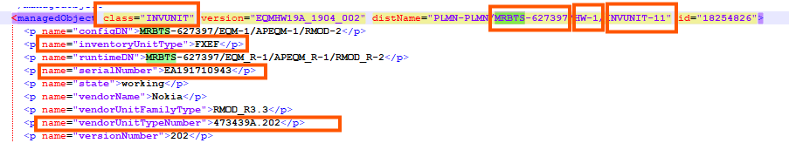
Note: In same class="INVUNIT" if attribute <p name="configDN"> contains “PASSDEV- “then need to ignore this one.

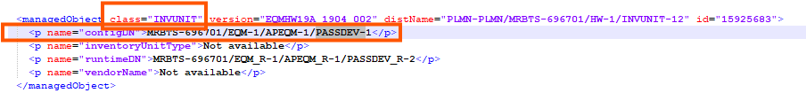

Index on slot is start with 0 & increment by 1 for same cabinet, shelf & slot.

- The below table describes how to parse the boards attributes:

Attribute | Importance | Comments
Shelf Index | [Mandatory] | - the index of the related shelf
Index on slot | [Mandatory] | = Default index on slot = 0 & increment by 1 for same cabinet, shelf & slot.
Slot index | [Mandatory] | - To be taken from class=INVUNIT, numerical value in front of INVUNIT.  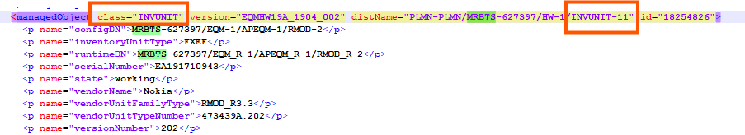
Board Type | [Mandatory] | - = “inventoryUnitType” attribute under the same class  - E.g.  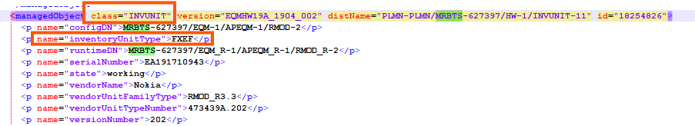  Note: if there is not any information regarding board type as below:  “unitTypeExpected”  “inventoryUnitType”  “unitType”  <p name="userLabel">  then we will give name “Dummy_Nokia Unit”.  Note: Please ensure that each duplicate serial number is parsed only once for the same node and board. However, if the serial numbers are duplicates across different nodes, they should be  parsed accordingly.  Here same serial numbers are coming for same node & same board type multiple time so you will parse it only one time.
Part Number | [Optional] | - = " vendorUnitTypeNumber" attribute under the same class  - E.g.  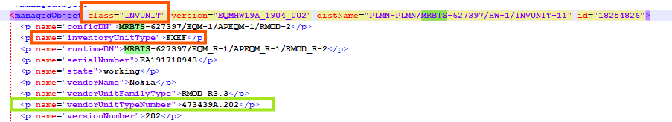
Serial Number | [Optional] | - = "serialNumber" attribute under the same class  - E.g.  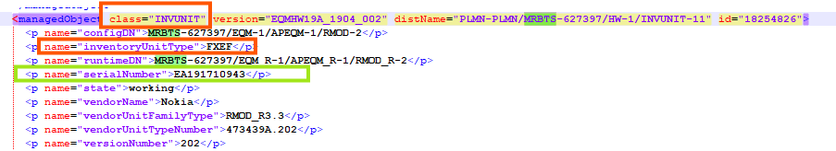
Issue Number | [Optional] | - = “version" attribute under the same class  - E.g.  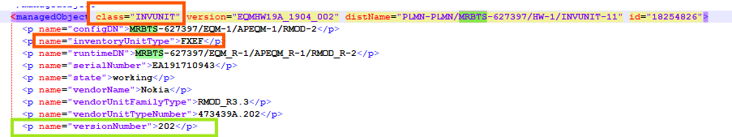

BSC
- Each class="HW" under attributes distName="PLMN-PLMN/BSC-404822/HW-1" represent one BSC
- class="HW" version="1.0" distName="PLMN-PLMN/BSC-404822/HW-1"

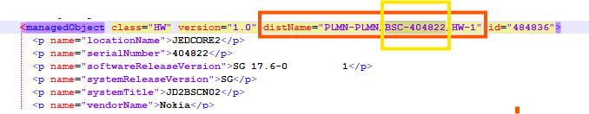

- The following attributes are defined at node level:

Attribute | Importance | Comment
NE ID | [Mandatory] | - From class="HW", distName attribute  distName="PLMN-PLMN/BSC-404822/HW-1"  - The distName attribute context is as follows:  "PLMN-PLMN/BSC-ID"  - E.g distName="PLMN-PLMN/BSC-404822" ID = 404822
NE Name | [Mandatory] | Take the value of <p name="systemTitle"> from class=HW to parse the node name.  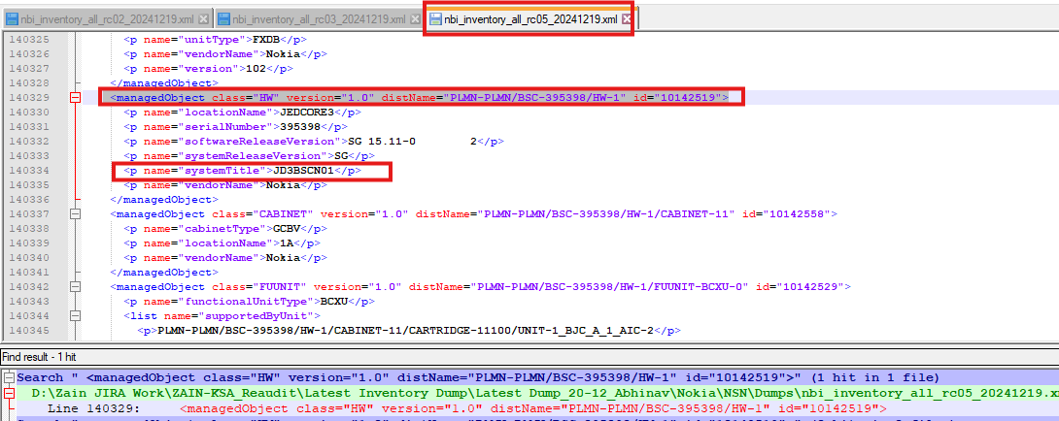
Site id | [Mandatory] | Explained in the section 8
Site Name | [Mandatory] | - = Site id
Type | [Mandatory] | - = BSC
Model | [Mandatory] | - Default “Nokia BSC”
Manufacturer | [Optional] | - = Nokia

Physical configuration for BSC

Cabinet
- Each class="CABINET" represents one cabinet
- The mapping between the cabinet and the node will be depending on distName attribute, which will contain the node ID
E.g
class="CABINET" version="1.0" distName="PLMN-PLMN/BSC-404822/HW-1/CABINET-11"
the node ID for this cabinet is: BSC-404822.
- The cabinet attributes are extracted as follow:

Attribute | Importance | Comments
Cabinet id | [Mandatory] | - = from “distName” attribute take Cabinet ID and subtract 10 from it  - E.g. distName="PLMN-PLMN/BSC-404822/HW-1/CABINET-11" cabinet ID= 1
Model | [Mandatory] | - = "cabinetType" attribute  - E.g. <p name="cabinetType">GCBV</p>  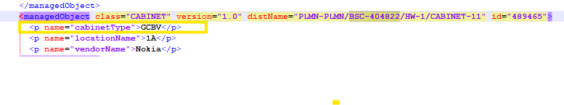
Manufacturer | [Mandatory] | - Nokia
Serial Number | [Optional] | - As per availability

Shelf

- Each Class="CARTRIDGE" in attributes represents one shelf
- The mapping between the shelf and the node will be depending on distName attribute, which will contain the node ID
E.g

- the node ID for this cabinet is: BSC-404822

- The below table describes how to parse the shelf attributes:

Attribute | Importance | Comments
Cabinet id | [Mandatory] | - = the id of correspondent cabinet
Shelf index | [Mandatory] | - = shelf id
Shelf Id | [Mandatory] | - = 1 for the first shelf found for a specific node, and to be incremented by one for each additional shelf.  For above shelf ID=1  Note: We will consider 3rd digit in the value of Cartridge.
Model | [Mandatory] | - = “cartridgeType" attribute for the same class  <p name="cartridgeType">BCNC</p>
RU Index | [Mandatory] | - =[(Shelf id -1)*8]+1  - E.g. Shelf id =1 → RU index =1  - E.g. Shelf id =2 → RU index =9
Description | [Optional] | - Null
Serial Number | [Optional] | - As per availability

Boards
- Each class="UNIT" represents one board
- The mapping between the boards and the node will be depending on distName attribute, which will contain the node ID
E.g
class="UNIT" version="1.0" distName="PLMN-PLMN/BSC-404822/HW-1/CABINET-11/CARTRIDGE-11100/UNIT-BCNMB_B_1_1_SHM-1"
- Node ID= 404822
- The mapping between the boards and the shelves will be based on distName attribute, which will contain the shelf
e.g.
  - Class="UNIT" version="1.0" distName="PLMN-PLMN/BSC-404822/HW-1/CABINET-11/CARTRIDGE-11100/UNIT-BCNMB_B_1_1_SHM-1"
  - class="UNIT" version="1.0" distName="PLMN-PLMN/BSC-404822/HW-1/CABINET-11/CARTRIDGE-11100/UNIT-BFAN_A_1_1_FAN-1"
  - these two boards belong to the same shelf (CARTRIDGE-11100)

- The below table describes how to parse the boards attributes:

Attribute | Importance | Comments
Shelf Id | [Mandatory] | - the id of the related shelf
Index on slot | [Mandatory] | - = Default index on slot = 0
Slot index | [Mandatory] | - = “position” attribute under the same class  - E.g. <p name="position">1</p> slot index =1
Board Type and Model | [Mandatory] | - = “unitTypeExpected” attribute under the same class  - E.g.  <p name="unitTypeExpected">BCNMB_B</p>  Note: if there is not any information regarding board type as below:  “unitTypeExpected”  “inventoryUnitType”  “unitType”  <p name="userLabel">  then we will give name “Dummy_Nokia Unit”.  Note: Please ensure that each duplicate serial number is parsed only once for the same node and board. However, if the serial numbers are duplicates across different nodes, they should be  parsed accordingly.  Here same serial numbers are coming for same node & same board type multiple time so you will parse it only one time.
Manufacturer |  | - = “vendorName” attribute under the same class  - E.g  - <p name="vendorName">Nokia</p>
Part Number | [Optional] | - = Null
Description | [Optional] | - = Null
Date Of Manufacture | [Optional] | - = Null
Serial Number | [Optional] | - = Null
Issue Number | [Optional] | - = Null
Power Consumption | [Optional] | - = Null
Additional Information | [Optional] | - = Null
Dimensions and Weight | [Optional] | - = Null

RNC
RNC node will be find in class “HW” as below given in snap: RNC will be “RNC-752” under attributes distName="PLMN-PLMN/RNC-752/HW-1"
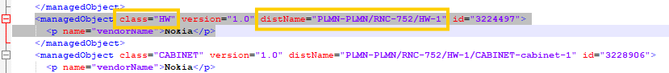

- The following attributes are defined at node level:

Attribute | Importance | Comment
NE ID | [Mandatory] | - = distName attribute within each line containing class="HW"  - E.g.: distName="PLMN-PLMN/RNC-752"  Node ID = RNC-752
NE Name | [Mandatory] | Note: we will follow the static sheet below to parse node name for RNC.  “RAN_Node Name_Matching”.  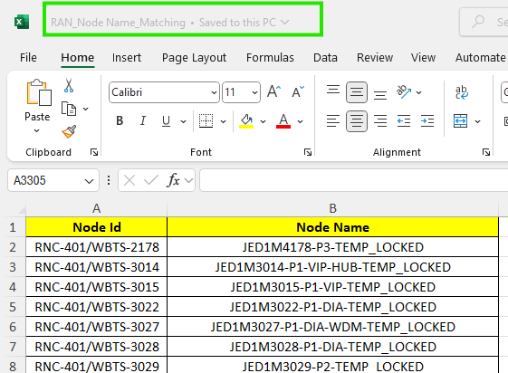
Site id | [Mandatory] | - Explained in the section 8
Site Name | [Mandatory] | - = Site id
Type | [Mandatory] | - = RNC
Model |  | - = Nokia RNC
Manufacturer | [Optional] | - = Nokia

Physical configuration

Cabinet
- Each class="CABINET" represents one cabinet
- The mapping between the cabinet and the node will be depending on distName attribute, which will contain the node ID
E.g
class="CABINET" version="1.0" distName="PLMN-PLMN/RNC-752/HW-1/CABINET-cabinet-1"
- 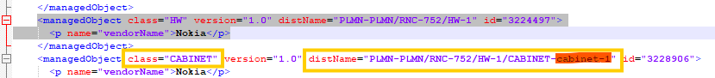
the cabinet ID for this cabinet is: 1
- The cabinet attributes are extracted as follow:

Attribute | Importance | Comments
Cabinet id | [Mandatory] | - = Cabinet ID from “distName” attribute take Cabinet ID  - E.g. distName distName="PLMN-PLMN/RNC-752/HW-1/CABINET-cabinet-1" cabinet ID= 1
Model | [Mandatory] | - Default: Nokia RNC
Manufacturer | [Mandatory] | Nokia
Serial Number | [Optional] | As per availability

Shelf

- Each class="Rack" represents one shelf
- The mapping between the shelf and the node will be depending on distName attribute, which will contain the node ID
E.g
class="RACK" version="1.0" distName="PLMN-PLMN/RNC-752/HW-1/CABINET-cabinet-1/RACK-c1"
the node ID for this shelf is: RNC-752

- The below table describes how to parse the shelf attributes:

Attribute | Importance | Comments
Cabinet id | [Mandatory] | - = the id of correspondent cabinet
Shelf index | [Mandatory] | - = shelf id
Shelf Id | [Mandatory] | - =Rack from “distName” attribute take Rack ID  - E.g. PLMN-PLMN/RNC-752/HW-1/CABINET-cabinet-1/RACK-c1 Shelf ID=1
Model | [Mandatory] | - Nokia RNC
RU Index | [Mandatory] | - =[(Shelf id -1)*8]+1  - E.g. Shelf id =1 → RU index =1  - E.g. Shelf id =2 → RU index =9
Description | [Optional] | - Null
Serial number | [Optional] | - As per availability

Boards
- Each class="UNIT" represents one board
- The mapping between the boards and the node will be depending on distName attribute, which will contain the node ID
E.g
class="UNIT" version="1.0" distName="PLMN-PLMN/RNC-752/HW-1/CABINET-cabinet-1/RACK-c1/UNIT-AMC-1" id="3307609">
- <p name="identificationCode">MIC-5401-0000E</p>
- <p name="serialNumber">AT142400153</p>
- <p name="unitType">HDSAM-A</p>
- <p name="vendorName">ADVANTEC</p>
- <p name="version">C110598.B3A</p>

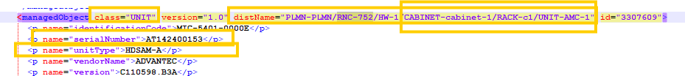

- The mapping between the boards and the shelves will be based on distName attribute, which will contain the shelf
e.g.
  - class="UNIT" version="1.0" distName="PLMN-PLMN/RNC-752/HW-1/CABINET-cabinet-1/RACK-c1/UNIT-AMC-1" id="3307609"> the board belongs to cabinet 1 and shelf 1.
- The below table describes how to parse the boards attributes:

Attribute | Importance | Comments
Shelf Id | [Mandatory] | - the id of the related shelf
Index on slot | [Mandatory] | - = Default index on slot = 0 (For one shelf it will start from 0 & incremented by 1 till max. 9)
Slot index | [Mandatory] | - Slot index will be taken from the numeric value of Unit under attributes:  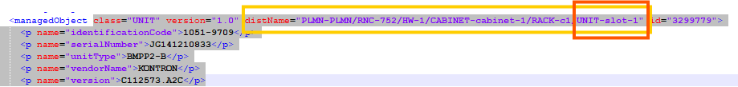
Board Type | [Mandatory] | - = “unitType” attribute under the same class  - E.g.  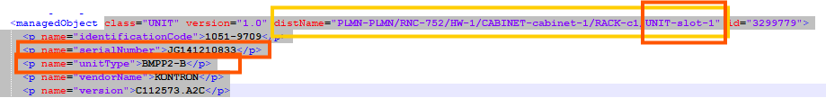  Note: if there is not any information regarding board type as below:  “unitTypeExpected”  “inventoryUnitType”  “unitType”  <p name="userLabel">  then we will give name “Dummy_Nokia Unit”.  Note: Please ensure that each duplicate serial number is parsed only once for the same node and board. However, if the serial numbers are duplicates across different nodes, they should be  parsed accordingly.  Here same serial numbers are coming for same node & same board type multiple time so you will parse it only one time.
Part Number | [Optional] | - = “identificationCode” attribute under the same class
Serial Number | [Optional] | - = “serialNumber” attribute under the same class

BTS:
- Each class="HW" where BCF coming under attributes “distName="PLMN-PLMN/BSC-395041/BCF-158/HW-1 “represents one BTS node.

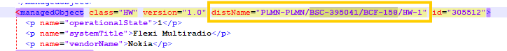

- The following attributes are defined at node level:

Attribute | Importance | Comment
NE ID | [Mandatory] | - From class="HW", distName attribute  - = distName attribute  - E.g distName="PLMN-PLMN/BSC-395041/BCF-158/HW-1" ID= PLMN-PLMN/BSC-395041/BCF-158
NE Name | [Mandatory] | - Same as NE ID
Site id | [Mandatory] | - Explained in the section 8
Site Name | [Mandatory] | - = Site id
Type | [Mandatory] | - = BTS
Model |  | - = “systemTitle” attribute under the correspondent Class=”HW”  - E.g.  <managedObject class="HW" version="1.0" distName="PLMN-PLMN/BSC-395041/BCF-158/HW-1" id="305512">  <p name="operationalState">1</p>  <p name="systemTitle">Flexi Multiradio</p>  <p name="vendorName">Nokia</p>  - The Model for “PLMN-PLMN/BSC-395041/BCF-158” = Flexi Multiradio  - If no systemTitle found keep Default model as “Flexi Multiradio”
Manufacturer | [Optional] | - = Nokia

Physical configuration

Cabinet
- Each class="HW" represents one cabinet
- The mapping between the cabinet and the node will be depending on distName attribute,
E.g
<managedObject class="HW" version="1.0" distName="PLMN-PLMN/BSC-395041/BCF-158/HW-1"
the node ID for this cabinet is: BSC-395041/BCF-158
- The cabinet attributes are extracted as follow:

Attribute | Importance | Comments
Cabinet id | [Mandatory] | - = from “distName” attribute  - E.g. distName="PLMN-PLMN/BSC-395041/BCF-158/HW-1" cabinet ID= 1
Model | [Mandatory] | - If the value of “unitType” attribute of one UNIT is equal to FCIA Model = FCIA  - If the value of “unitType” attribute of one UNIT is equal to FCOA Model = FCOA  - If “FCIA” and “FCOA” are not found, Model = Flexi Multiradio
Manufacturer | [Mandatory] | - To be assigned by default  - E.g.: Manufacturer = Nokia
Serial Number | [Optional] | - As per availability

Shelf

- Each class="SUBRACK" represents one shelf
- The mapping between the shelf and the node will be depending on distName attribute,
E.g
<managedObject class="SUBRACK" version="1.0" distName="PLMN-PLMN/BSC-395041/BCF-158/HW-1/SUBRACK-1"
the node ID for this cabinet is: BSC-395041/BCF-158

- The below table describes how to parse the shelf attributes:

Attribute | Importance | Comments
Cabinet id | [Mandatory] | - = the id of correspondent cabinet
Shelf index | [Mandatory] | - = shelf id
Shelf Id | [Mandatory] | - = 1 for the first shelf found for a specific node, and to be incremented by one for each additional shelf  (Subrack-1) is shelf id for below exp:  class="SUBRACK" version="1.0" distName="PLMN-PLMN/BSC-395041/BCF-158/HW-1/SUBRACK-1"
Model | [Mandatory] | - “Model = Flexi Multiradio” to add by default
RU Index | [Mandatory] | - =[(Shelf id -1)*8]+1  - E.g. Shelf id =1 → RU index =1  - E.g. Shelf id =2 → RU index =9
Description | [Optional] | - Null
Serial Number | [Optional] | - As per availability

Boards
- Each class="UNIT" represents one board
- The mapping between the boards and the node will be depending on distName attribute,
E.g
class="UNIT" version="1.0" distName="PLMN-PLMN/BSC-395041/BCF-158/HW-1/SUBRACK-1/UNIT-ESMB_1_1"
Node ID= PLMN-PLMN/BSC-395041/BCF-158
- The mapping between the boards and the shelves will be based on distName attribute, which will contain the shelf
e.g.
  - class="UNIT" version="1.0" distName="PLMN-PLMN/BSC-395041/BCF-158/HW-1/SUBRACK-1/UNIT-ESMB_1_1"
  - class="UNIT" version="1.0" distName="PLMN-PLMN/BSC-395041/BCF-158/HW-1/SUBRACK-1/UNIT-ESMB_1_1"
  - class="UNIT" version="1.0" distName="PLMN-PLMN/BSC-395041/BCF-158/HW-1/SUBRACK-1/UNIT-FIQB_1_4"
  - These above two boards belong to the same shelf (SUBRACK-1)
- The below table describes how to parse the boards attributes:

Attribute | Importance | Comments
Shelf Id | [Mandatory] | - the id of the related shelf (SUBRACK-1 i.e. 1)
Index on slot | [Mandatory] | - = Default index on slot = 0
Slot index | [Mandatory] | - = “position” attribute under the same class  - E.g. <p name="position">1</p> slot index =1  <p name="identificationCode">472109A</p>  <p name="operationalState">1</p>  <p name="position">1</p>  <p name="serialNumber">TY134308837</p>  <p name="unitId">1</p>  <p name="unitType">ESMB</p>  <p name="vendorName">Nokia</p>  <p name="version">102</p>
Board Type | [Mandatory] | - = “unitType” attribute under the same class  - E.g.  <p name="identificationCode">472109A</p>  - <p name="operationalState">1</p>  - <p name="position">1</p>  - <p name="serialNumber">TY134308837</p>  - <p name="unitId">1</p>  - <p name="unitType">ESMB</p>  - <p name="vendorName">Nokia</p>  - <p name="version">102</p>  Note: if there is not any information regarding board type as below:  “unitTypeExpected”  “inventoryUnitType”  “unitType”  <p name="userLabel">  then we will give name “Dummy_Nokia Unit”.  Note: Please ensure that each duplicate serial number is parsed only once for the same node and board. However, if the serial numbers are duplicates across different nodes, they should be  parsed accordingly.  Here same serial numbers are coming for same node & same board type multiple time so you will parse it only one time.
Part Number | [Optional] | - = “identificationCode” attribute  - E.g.  <p name="identificationCode">472109A</p>  <p name="operationalState">1</p>  <p name="position">1</p>  <p name="serialNumber">TY134308837</p>  <p name="unitId">1</p>  <p name="unitType">ESMB</p>  <p name="vendorName">Nokia</p>  <p name="version">102</p>
Description | [Optional] | - = Null
Date Of Manufacture | [Optional] | - = Null
Serial Number | [Optional] | - = “serialNumber” attribute  - E.g.  <p name="identificationCode">472109A</p>  <p name="operationalState">1</p>  <p name="position">1</p>  <p name="serialNumber">TY134308837</p>  <p name="unitId">1</p>  <p name="unitType">ESMB</p>  <p name="vendorName">Nokia</p>  <p name="version">102</p>
Issue Number | [Optional] | - = Null
Power Consumption | [Optional] | - = Null
Additional Information | [Optional] | - = Null
Dimensions and Weight | [Optional] | - = Null

NodeB:
- Each class="HW" which includes WBTS in attribute “distname” represents one NodeB.

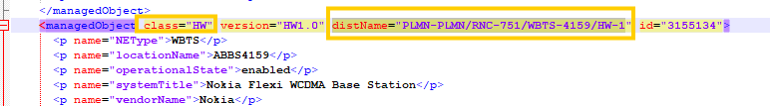

- The following attributes are defined at node level:

Attribute | Importance | Comment
NE ID | [Mandatory] | - E.g distName="PLMN-PLMN/RNC-751/WBTS-4159  ID= RNC-751/WBTS-4159  distName="PLMN-PLMN/RNC-751/WBTS-4159/HW-1
NE Name | [Mandatory] | Note: we will follow the static sheet below to parse node name for RNC.  “RAN_Node Name_Matching”.
Site id | [Mandatory] | - Explained in the section 8
Site Name | [Mandatory] | - = Site id
Type | [Mandatory] | - = NodeB where NE Type will be “WBTS” we will consider it as NodeB  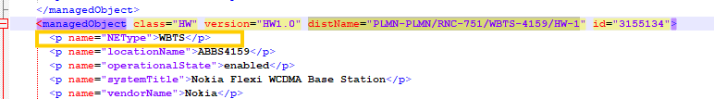
Model |  | - = “systemTitle” attribute under the correspondent Class=”HW”  - E.g.  - <p name="systemTitle">Nokia Flexi WCDMA Base Station</p>
Manufacturer | [Optional] | - = Nokia

Physical configuration

Cabinet
- Each class="HW" represents one cabinet
- The mapping between the cabinet and the node will be depending on distName attribute,
E.g. distName="PLMN-PLMN/RNC-751/WBTS-4159/HW-1”
- The cabinet attributes are extracted as follow:

Attribute | Importance | Comments
Cabinet id | [Mandatory] | - = from “distName” attribute  - E.g. distName=" distName="PLMN-PLMN/RNC-751/WBTS-4159/HW-1" cabinet ID= 1
Model | [Mandatory] | - = “systemTitle” attribute under the correspondent Class=”HW”  - E.g.  - <p name="systemTitle">Nokia Flexi WCDMA Base Station</p>
Manufacturer | [Mandatory] | - To be assigned by default  - E.g.: Manufacturer = Nokia
Serial Number | [Optional] | - As per availability

Shelf

- The below table describes how to parse the shelf attributes:

Attribute | Importance | Comments
Cabinet id | [Mandatory] | - = the id of correspondent cabinet
Shelf index | [Mandatory] | - = shelf id
Shelf Id | [Mandatory] | - = 1 for the first shelf found for a specific node, and to be incremented by one for each additional shelf
Model | [Mandatory] | - (Nokia Flexi WCDMA Base Station) by default
RU Index | [Mandatory] | - =[(Shelf id -1)*2]+1  - E.g. Shelf id =1 → RU index =1  - E.g. Shelf id =2 → RU index =3
Description | [Optional] | - Null
Serial Number | [Optional] | - As per availability

Boards
- Each class="Module" and class=" SUBMODULE” represents one board
- The below table describes how to parse the boards attributes:

Attribute | Importance | Comments
Shelf Id | [Mandatory] | - Shelf ID to be deduced from distname.  - E.g., Shelf ID to be deduced from distname.  E.g., distName="PLMN-PLMN/RNC-402/WBTS-4159/HW-1/MODULE-173/SUBMODULE-225" → Shelf ID is the shelf deduced from ="PLMN-PLMN/RNC-402/WBTS-4159/HW-1/MODULE-173”
Index on slot | [Mandatory] | - = Default index on slot = 0
Slot index | [Mandatory] | - Slot index of the first board on the shelf is 1 and to be incremented by 1 automatically for each new board.
Board Type | [Mandatory] | - <p name="unitType"> attribute under the same class SUBMODULE.  - E.g.  <p name="unitType">FTIB</p>  Note: if there is not any information regarding board type as below:  “unitTypeExpected”  “inventoryUnitType”  “unitType”  <p name="userLabel">  then we will give name “Dummy_Nokia Unit”.  Note: Please ensure that each duplicate serial number is parsed only once for the same node and board. However, if the serial numbers are duplicates across different nodes, they should be  parsed accordingly.  Here same serial numbers are coming for same node & same board type multiple time so you will parse it only one time.
Part Number | [Optional] | - = “identificationCode” attribute  - E.g. <p name="identificationCode">472182A</p>
Description | [Optional] | - = Null
Date Of Manufacture | [Optional] | - = Null
Serial Number | [Optional] | - = “serialNumber” attribute  - E.g.  <p name="serialNumber">K9153917272</p>  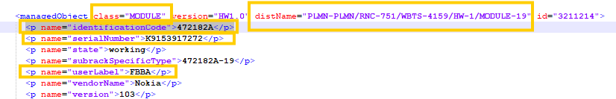
Issue Number | [Optional] | - = Null
Power Consumption | [Optional] | - = Null
Additional Information | [Optional] | - = Null
Dimensions and Weight | [Optional] | - = Null

Antenna:

Antenna data
We need to parse antenna details in radioantenna csv sheet.

- The following attributes are defined at antenna node level in radioantenna csv & serial number will be parsed under addinfo csv.

Attribute | Importance | Comment
NE ID | [Mandatory] | - Concatenate of Parent Node & last integer value in attribute distName:  Example:1  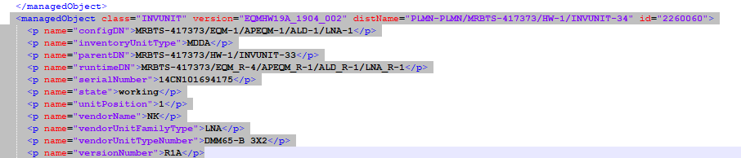  distName="PLMN-PLMN/MRBTS-417373/HW-1/INVUNIT-34"  NE ID: MRBTS-417373_34  Example:2  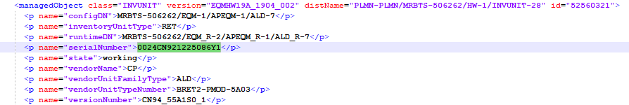  distName="PLMN-PLMN/MRBTS-506262/HW-1/INVUNIT-28"  NE ID: MRBTS-506262_28  Example:3  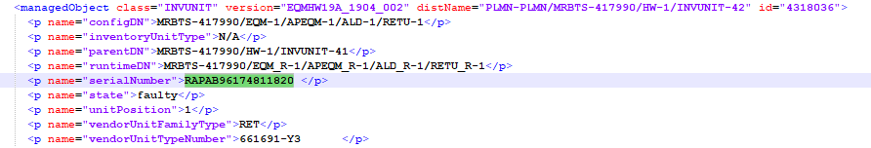  distName="PLMN-PLMN/MRBTS-417990/HW-1/INVUNIT-42"  NE ID: MRBTS-417990_42  Example:4  distName="PLMN-PLMN/RNC-504/WBTS-3343/HW-1/MODULE-40192/SUBMODULE-34817"  NE ID: RNC-504/WBTS-3343_34817
NE Name | [Mandatory] | Same as NE ID
Site id | [Mandatory] | - Follow the site matching sheet & Rule
Site Name | [Optional] | - = Site id
Type | [Mandatory] | - = Antenna where attribute <p name="inventoryUnitType"> contains “SingleAntennaDevice” or “MultiAntennaDevice” or “RET” under class="INVUNIT".  - if attribute <p name="inventoryUnitType"> contains “N/A” under class class="INVUNIT" then match it with the value of given attribute “<p name="vendorUnitFamilyType">RET</p> in same class if it will be “RET” the parse it as radio antenna type “RET”.  - And <p name="unitType"> (In case of TILT) under class “SubModule” then parse under antenna.  <p name="unitType">TILT</p>  If above given type is found anywhere in dump these all should be parse under “radioantenna” only.
Model | [Optional] | Same as Type if require
Serial Number | [Mondatory] | Serial number will get from below attribute:  <p name="serialNumber" within above mentioned type only.
Manufacturer | [Optional] | - = Nokia  will need to take from below attribute:  <p name="vendorName">

Site ID Parsing Rule:

We will parse site id as explain below:

Priority - 1:
- Extract the first string before any special characters (such as ‘-’, ‘_’, or ‘/’) from the node name.
- Search for this extracted value in column ‘C’ of the relevant tab in the “On Air Sheets V13” file, based on the node type (As described below). Retrieve the corresponding value from column “B,” which will be the site ID for the node.

The steps for each node type are as follows:

A. For Node Type BTS:
- (I) Search first in the "2G Huawei" tab.
- (II) If not found, search in the "2G MMM" tab.
- (III) If still not found, search in the "On Air Summary" tab.
- (IV) If not found, search in the "Dismantled Sites" tab.
B. For Node Type NodeB:
- (I) Search first in the "3G Huawei" tab.
- (II) If not found, search in the "3G MMM" tab.
- (III) If still not found, search in the "On Air Summary" tab.
- (IV) If not found, search in the "Dismantled Sites" tab.
C. For Node Type eNodeB:
- (I) Search first in the "LTE Huawei" tab.
- (II) If not found, search in the "LTE MMM" tab.
- (III) If still not found, search in the "On Air Summary" tab.
- (IV) If not found, search in the "Dismantled Sites" tab.
D. For Node Type SRAN:
- (I) Search first in the "2G Huawei / 3G Huawei / LTE Huawei / 5G Huawei" tabs.
- (II) If not found, search in the "2G MMM / 3G MMM / LTE MMM / 5G MMM" tabs.
- (III) If still not found, search in the "On Air Summary" tab.
- (IV) If not found, search in the "Dismantled Sites" tab.

E. For Node Type BSC: Updated in the "site matching sheet."
F. For Node Type RNC: Updated in the "site matching sheet."
G. For Node Type SRANController: Updated in the "site matching sheet."

Priority - 2:
We will prioritize using the “Site matching sheet” for the site ID.

Priority - 3:
The existing rule should be followed for the site ID from the naming convention.

Example Of One SRAN Node To Parse Site Id:

Example for Site ID Parsing:

Let’s consider the example of the SRAN node MRBTS-423373, where the node name is provided in the snippet below:

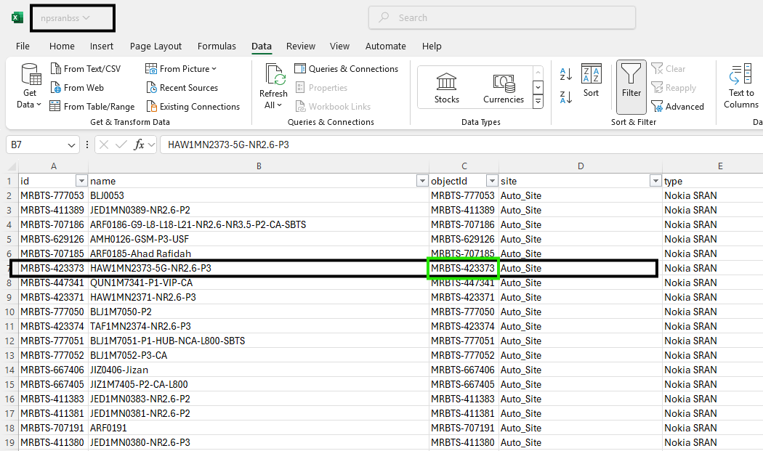

We need to extract the first string from the node name, before the special character ‘-’, which in this case is HAW1MN2373.

Next, we will search for this string in the sheet “On Air Sheets V13” under the tab 2G_NSN/3G_NSN/LTE_NSN/5G_NSN. It will be in the 5G_NSN tab, specifically in column ‘C’, as shown in the snippet below:

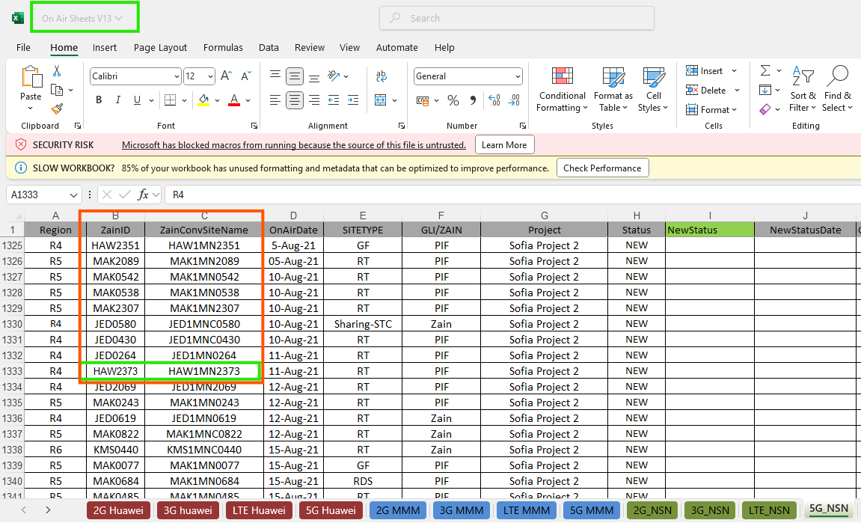

We will then retrieve the value from column ‘B’ against this value “HAW1MN2373, which in this case is HAW2373. This will be the site ID for the node MRBTS-423373.

