



SRD_re-initialize_option

Document Change History

Issue No | Date Issued | Issued By | History Description
1.0 | 8-OCT-24 | Mobinets | Initial version

Contents
Introduction………………………………………………………………………………………………………………………………2
Current flow……………………………………………………………………………………………………………………………2
New Proposed Change…………………………………………………………………………………………………………3,4,5

Introduction
You are requesting to add new tasks for TAS team As PROCEED task for 2 services WFBB
and MW/GE.
In below paragraph, we are proposing to replace those tasks per service by a global
solution that would fulfill your requirement and be used for all type of services.
- Current Flow
A.1 For Fixed services:
After selecting the design it goes to relevant team and once the task is completed,
The solution acceptance task will be created and if TAS team has completed this task
implicitly if any task was rejected it will be reactivated for review, else if approved
the solution will be sent to AM
Complete
AM
Solution_Acceptance
WFBB
GPON

GPO
Select _Solution

MW
…….
..

A.2 For Mobile services:

Every time the assigned team completes the selected design task, select_solution task
will be re-activated and TAS will be able to select another design until TAS team
select ‘send solution to GTM’ , Solution_Acceptance task is created and assigned to TAS , TAS clicks on Complete to send solution to AM.
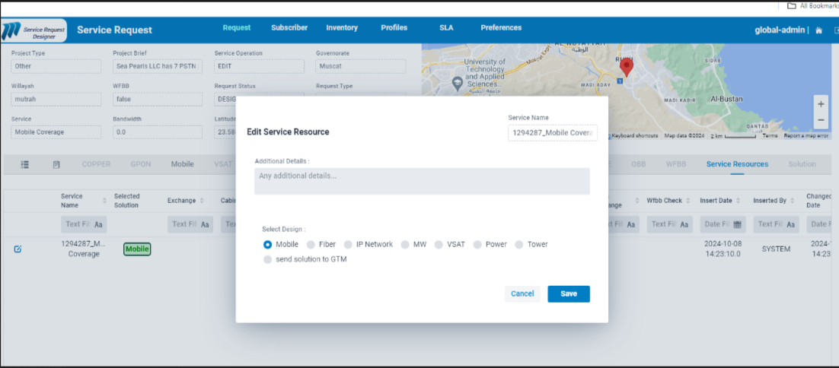
Send Solution to GTM
Solution_Acceptance
Mobile
Coverage

GPO
Complete
Select _Solution
AM

- New Proposed Changes
B.1 For Fixed services:

We are proposing to add additional options to the solution acceptance task created after the service task is completed (ex: WFBB)
When TAS team click on complete task for solution acceptance, the user should select one the actions listed in the new added combo box (shown in snapshot below)
- Complete: If the user chooses complete then the request will be completed, and the solution will be sent to AM.
- Review: If the user chooses review, then only rejected design task will be reactivated , and reassigned to relative team according to design time .
- Re-initialize: If the TAS user chooses re-initialize the request will return back to select_solution task to select another design, and the process will be triggered again accordingly.

Review

Complete
AM
Solution_Acceptance
WFBB
GPON

GPO
Select _Solution

MW
…….
..

Re-initialize

Note: This combo box will be available at solution_acceptance level for all fixed services( WFBB,MPLS,FBB,etc..).

New Combo box:
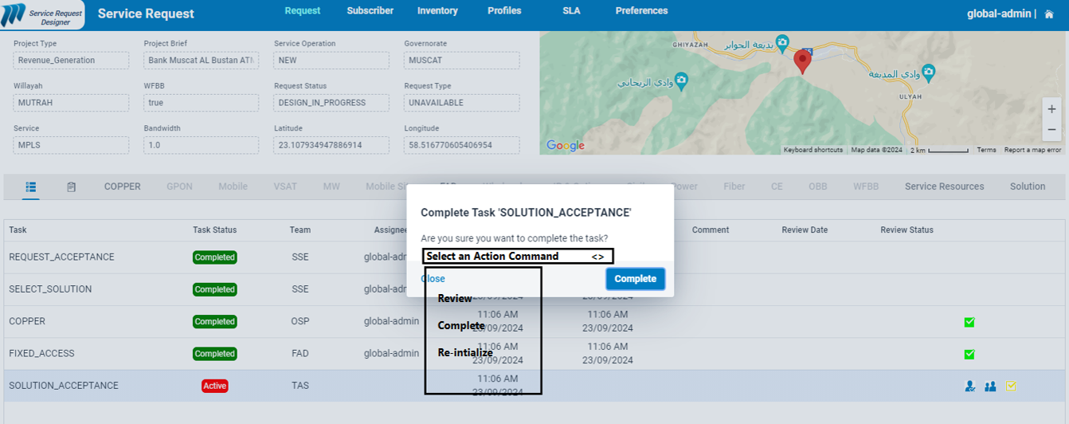

B.2 for Mobile services:

Instead of re-initializing automatically the design phase, we are adding the solution_acceptance task assigned to TAS team with ability to choose 1 of 3 options complete from combo box same as described in fixed services section
Also for Mobile services, solution acceptance task will have same options (Complete, Review, Re-initialize) to maintain the similarity for all services.

Review

Mobile
Coverage

GPO
Complete
AM
Solution_Acceptance
Select _Solution

Re-initialize

New Combo box:

