

Huawei 2G Parsing

FRS (Functional Requirement Specifications)
Auto-Import

Change History

Version | Change Description | Author | Date
0.1 | First draft. | Indrasan Yadav | 08-05-2025

Preamble

Logical

- This document specifies how to parse the logical inventory attributes for the BSC, BTS and 2G cell logical inventory.
- It covers the parameters defined for 2G RAN Logical attributes.
- For CFGMML:
  - The provided dump files are of “.txt”, named as “CFGMML-BSCxxxxxxxxx” or “CFGMML-xxxxxxxxx”.
  - E.g.: CFGMML-BSC0-20130315040021
  - Only files with “//MBSC Mode:” attribute is equal to “GO” or “GU” are to be taken into consideration for this connector. The file Names is subject to change.
  - Each “.txt” file represents the whole configuration network per each BSC.
  - All the “.txt” files are expected to exist in one location folder; folder Location and name will be defined later.
- For CMExport: Each XML consists of several classes, and each class contains several attributes.

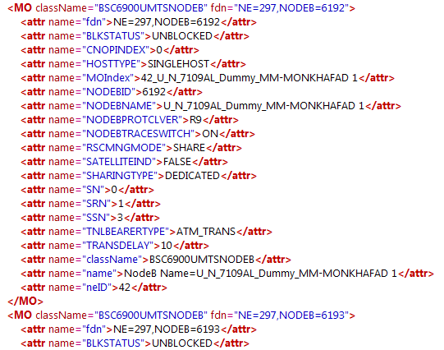
Attributes
Classes

Interfaces

- This document specifies how to parse the Huawei RAN logical Interfaces.
- In addition to inventory dumps, we will CFGDATA XML dump files available under \HuaweiM2000V2R0\LogicalDumps\BTS3900 directory.
- Each folder represents one node.
- Under the folder with NE name you will find one or multiple folders starting with BAKDATA, take the one with last updated time stamp.

Connector Information

- The CFG file is a “.txt” file composed of set of commands.
- Each Dump file is structured of different set of commands, where each line can start with one of the below commands :
  - “ADD xxx:”
  - “SET xxx:”
  - “UIN xxx:”
  - “DEA xxx:”
- Each attributes followed by one of the above tag can have the below naming structure:
  - Attribute=value, where the comma “,” indicates the beginning of the following attribute (to be discard at parsing)
    - e.g. PATHID=”1",
  - Attribute=”value”, where the comma “,” indicates the beginning of the following attributes. (to be discard at parsing)
    - e.g. IPADDR="10.100.10.14",
- Note: Sometime after a command line you may face spaces between one command line and the other, make sure to ignore the spaces between the command lines.

- 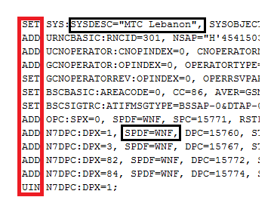

BSC logical parameters

The BSC logical inventory attributes are classified as per the below categories:
  - Global Parameters
  - Networking Parameters

- Priority1: The mapping between the Physical and Logical parameters will be based on the Node Name.
- Priority2:
  - Count CellName under ROWDATA under GCELL TABLE in physical.
  - Find Logical BSC with CELLNAME under ADD GCELL in logical is matching with CellName in physical.
  - If at least 50% of the cells in physical are matching with logical then consider the matching, else ignore.
- Note: In case of SRAN Controller, if matching to physical BSC failed then try to match to BSC under SRANController.

Global Parameters

The global attributes below are defined at BSC level are as follows:

Attributes | Importance | Example
Site Name | [Mandatory] | - It will be described later.
Node ID | [Mandatory] | - = Appears once in the file  - =value following “//System BSCID: “.  - E.g.: //System BSCID: 0→ Node ID= 0.
Node Name | [Mandatory] | - Appears once in the file  - = “SYSOBJECTID” attribute under “SET SYS” tag  - E.g.: SYSOBJECTID =" 2G_VN12_JMR_SGS"
Type | [Mandatory] | - BSC
OAM IP | [Optional] | - =” OMUIP” under “ADD EMSIP” tag  - E.g.: OMUIP=”10.100.1.1”
OAM Subnet Mask | [Mandatory] | - =” OMUMASK” under “ADD EMSIP” tag  - E.g.: OMUMASK="255.255.255.240"

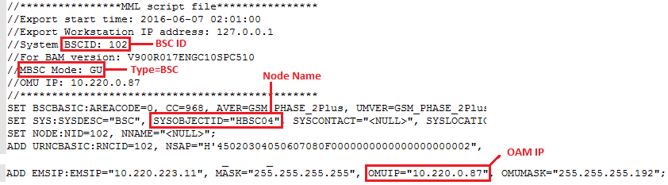

Networking Parameters

The networking attributes below defined at BSC level are as follows:

Attributes | Importance | Example
MCC | [Mandatory] | - ="MCC" value under " ADD GCNOPERATOR " tag  - E.g.: MCC="655"
MNC | [Mandatory] | - ="MNC" value under " ADD GCNOPERATOR " tag  - E.g.: MNC="01"
Parent MGW | [Optional] | - = Destination MGWs from “A-U” interfaces.
Parent MSS | [Optional] | - = Destination MSSs from “A-C” interfaces.
Parent SGSN | [Optional] | - = Destination SGSNs from “Gb” interfaces.
SPC | [Optional] | - Find ADD N7DPC in BSC where DPCT=A.  - Get DPC under above deduced ADD N7DPC and convert it to Hexadecimal.  - Find ADD M3DE in BSC where DPX under ADD M3DE and under ADD N7DPC (DPCT=A) are matching.  - Find ADD M3LE in BSC where LENO under ADD M3LE and under ADD M3DE are matching.  - Find ADD OPC in BSC where SPX under ADD OPC and under ADD M3LE are matching.  - Get SPC under above deduced ADD OPC.  - Convert above SPC from decimal to Hexadecimal.  - Connected MGW should fulfil below 2 conditions:  - MGW should have ADD M3LE where OPC under ADD M3LE in MGW is matching with DPC (in Hex) under ADD N7DPC (DPCT=A) in BSC (e.g. DPC = 1055 → OPC=H'41f).  - MGW should have ADD M3DE where DPC under ADD M3DE in MGW is matching with SPC (in Decimal) under ADD OPC in BSC (e.g. SPC=1822→ OPC=H' 71e).  - MGW Name is the name of above found MGW.
SPC type | [Optional]
TRAU Boards | [Optional] | - Refer to TRAU Logical attributes section.  - All TRAU boards parsed from a BSC dump file to be assigned to the same BSC.
PCU Card Type | [Optional] | - To be parsed from Logical dumps.  - = “BRDTYPE” attribute where “LGCAPPTYPE” attribute is equal to “GPCU” Or “GCUP” under “ADD BRD” function.  - Each BSC might have multiple PCU Cards.  - E.g. “DPUd”.
PCU Card ID | [Optional] | - Is the concatenation of below attributes separated with “_”:  - BSC Name.  - “Subrack Number”.  - “Slot Number”.  - “Subrack Number “= “SRN” attribute where “LGCAPPTYPE” is equal to “GPCU” Or “GCUP” Column under “ADD BRD” function.  - “Slot Number “= “SN” attribute where “LGCAPPTYPE” is equal to “GPCU” Or “GCUP” Column under “ADD BRD” function.  - E.g. “2G_BK06_PSL_MPU_0_14”  - E.g. “BSC02_BirHassan_0_0”
PCU Card Name | [Optional] | - =PCU Card Type
PCU Card Parent SGSN | [Optional] | - =Null
Operator | [Optional] | - =”OPNAME” under “ADD GCNOPERATOR”.

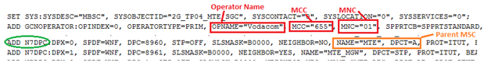

BTS 2G Logical Attributes

Global Parameters

The global attributes at BTS level are to be extracted as follow:

- Priority1: The internal mapping between the Physical and Logical parameters will be based on the Node Name.

- Priority2: Try to match to NodeB under SRAN-BS.

- Priority3: (For Touch)

- For BTS3900 Sran-BS nodes:
  - From physical dump “AIM_BTS3900_xxx.xml” and “ take value under NEName attribute under NE tag
  - In logical dump “CFGMML-BSCxxx-xxxx-xxxx” , match NEName value with values under BTSNAME under ADD BTS command
  - From Logical Dump “CFGMML-BSCxxx-xxxx-xxxx” match the
- From Logical dump (CFGMML-BSCxxx-xxxx-xxxxx) , read BTSNAME under ADD BTS and get the value of SYSOBJECTID under SET SYS.
- In physical dump (AIM_BSC6910GSM_BSCxx_xxxx.xml) , Match SYSOBJECTID with NEName under NE tag
- In physical dump (AIM_BTS3900xxxx.xml) , Match BTSNAME with NEName under NE tag.
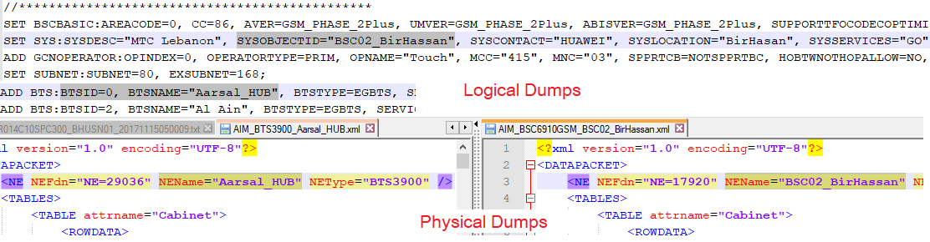

- Priority3:
  - In case of matching failure, need to Match (BTSID and parent BSC ID) of logical with (SiteIndex and Parent BSC ID) of physical following the below rule:
  - Fetch “BTSID” attribute of concerned Logical BTS Name under “ADD BTS” tag.
  - Fetch Parent BSC ID of concerned Logical BTS Name.
  - Fetch in the physical dumps under same BSC name the physical site with “SiteIndex” attribute under "BTS" table matching with “BTSID”.
  - Matching Physical BTS Name=” SiteName” attribute on the same line

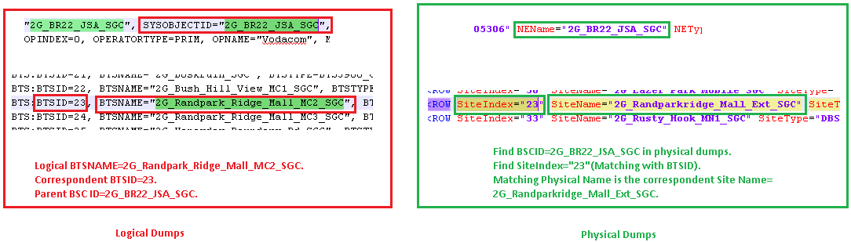

- Priority 3 (For Omantel)
- From Logical dump (CFGMML-BSCxxx-xxxx-xxxxx) , read BTSID and the corresponding BTSNAME under ADD BTS and get the value of SYSOBJECTID under SET SYS
- In physical dump (DIM_BSC6900GU_BTS.xml) , Match SYSOBJECTID with NEName under NE tag
- Under the matched NEName , search for a row that contains SiteIndex=BTSID and SiteName=BTSNAME

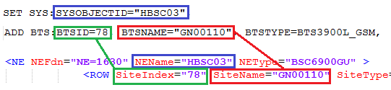

- For BTS3900 SRAN nodes:
- Priority1
  - From physical dump “DIM_BTS3900_Rack” take value under NEName attribute under NE tag
  - Append letter “G” as prefix and number “0” as suffix to NEName value
  - In logical dump “CFGMML-BSCxxx-xxxx-xxxx” , match NEName appended to the characters “G” and “0” with values under BTSNAME under ADD BTS command
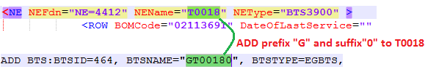
- For MBTS SRAN nodes
- From file “DIM_MBTS(GU)_MBTSRack”, read NEName attribute under NE tag and take characters after “MBTS-“
- If characters start with “G” match with value under BTSNAME under ADD BTS command
- Else append “G” as prefix and “0” as suffix to the extracted characters and match with value under BTSNAME under ADD BTS command

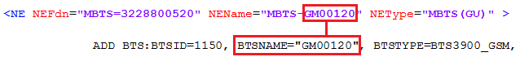
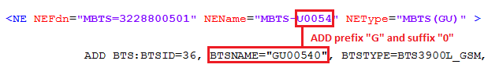
- Priority4:
    - Match logical BTS name to an SRAN-BS physical name excluding “MBTS-“prefix (e.g. BTS logical name= RIY2M1399-P2 and SRAN-BS physical name= MBTS-RIY2M1399-P2).
    - If SRAN-BS doesn’t have a BTS under it then create a BTS with same BTS logical name.

- Priority5:
    - Match BTSNAME from Logical dumps with the BTSNAME

Attribute | Importance | Example
Node ID | [Mandatory] | - =”BTSID” attribute under “ADD BTS” tag of each line.  - E.g.: ADD BTS:BTSID=0
Node Name | [Mandatory] | - =”BTSNAME” attribute under “ADD BTS” tag of each line.  - Note: If repeated “BTSNAME” under “ADD BTS” take only the 1st one.  - E.g.: BTSNAME=" Aarsal_HUB “
Site Name | [Mandatory] | - If feasible to be deduced from nodes configuration (physical configuration) at saving)  - For Vodacom:  - Match the “Node Name” with the static file “all_sites_TCS_Jack” as follow :  - The “all_sites_TCS_Jack” is composed from multiple sheets, Lookup for the “Node Name” attribute inside sheet “2G”  - Once “Node Name” is matched, get the site ID from column A (ATOLL_SITE_ID).  - E.g.: NodeB Name= 3G_Ravenswood_SGC has a site ID=SGC_15701  - Else if “Node Name” couldn’t match inside the file, match it through sites matching file.  - For Touch:  - Match the node name with the static file “siteMatching.xls” file under “External Files” folder in Dumps and get the site name from Column B.  - From Logical dumps “CFGMML_BSCxx_xxx.xml”: Get the “CI” under ADD GCELL tag and ignore the last digit from right side of the value, for reference excel formula (=LEFT(I2, LEN(I2)-1)) ; I2 column and row number.  E.g, CI=”6251” - Site ID=625  After getting the Site ID search for the site Name from “npssites” folder in XML parsed before.
Type | [Mandatory] | - =Deduced from node configuration at saving (physical configuration)
PS Technology | [Optional] | - The PS Technology can have the following values: GPRS, EDGE, None or both GPRS and EDGE.  - This can be deduced from the children Cell Level, where in case one of the Node’s children Cell has both GPRS and EDGE Enabled, hence the parent node would have GPRS and EDGE as PS Technology.  - Else if all the children Cell have only EDGE enabled and GPRS is not enabled, then PS technology will be set to “EDGE”.  - Else if all the children Cell have only GPRS enabled, whereas EDGE is not enabled, the PS technology will be in this case set to “GRPS”.  - Else none of GPRS or EDGE is enabled; the PS Technology will be then set to “NONE”.
OAM IP | [Optional] | - =Null
OAM Mask | [Optional] | - =Null

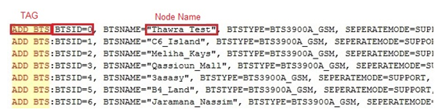

Networking Parameters

The following table summarizes the Networking attributes at BTS level:

Attributes | Importance | Example
MCC | [Mandatory] | - (NEP tool calculated)
MNC | [Mandatory] | - (NEP tool calculated)
Parent BSC | [Mandatory] | - All the BTS names found under the same CFG file will have the same Parent BSC which is deduced as follow:  - ="SYSOBJECTID" attribute under "SET SYS" tag  - E.g. : SYSOBJECTID= "2G_DR11_JBM_SGS"
Operator | [Optional] | - =“OPNAME” attribute under “ADD GCNOPERATOR” tag  - E.g.: OPNAME="Vodacom"

Cell Logical Parameters (CFGMML)

Attributes | Importance | Example
Cell Name | [Optional] | - =”CELLNAME” attribute under “ADD GCELL” or “ADD UCELLSETUP“ tag  - E.g.: ADD GCELL:CELLID=5, CELLNAME="Jeroud_1"
Cell ID | [Mandatory] | - The “Cell ID” is equal to the concatenation of :  “LAC”, “_” and “CI”  - Get the ”CI” attribute under “ADD GCELL” tag  - Get the "LAC" value under "ADD GCELL" tag of each line.  - Note: if the “LAC” value is in hexadecimal (e.g. H’213), a conversion into decimal value is required.  Note:Get the attribute of of “CELLID” which will be used for internal mapping between the commands in the Huawei BSC/RNC cfgmml files.
Cell Technology | [Mandatory] | - =GSM
Node ID | [Mandatory] | To be deduced as per below:  - BTSID of the cell=”BTSID” attribute under “CELLBIND2BTS” tag, the obtained value refers to the cell ID value of "CELLID" attribute.  - Node ID=”BTSNAME” attribute under “ADD BTS” tag matching with same BTSID.  - Please refer to below Snapshot  - For Touch:  - Take the BTSID under ADD CELLBIND2BTS tag and match it with BTSID under ADD BTS tag then take the BTSNAME in the same line.  - Match BTSNAME with value under GbtsFunctionName under Row tag in file (AIM_BTS3900_xxxx.xml)  - Node ID = value under GbtsFunctionName under ROW tag  - For Omantel  - To be deduced as per below:  - read the value of BTSID attribute under “CELLBIND2BTS” tag, and read the value of SYSOBJECTID under SET SYS command  - in physical dump (DIM_BSC6900GU_BTS.xml) , Match BTSID with SiteIndex under ROW tag and match of SYSOBJECTID with NEName under NE tag  - Node ID = value of SiteName under ROW tag  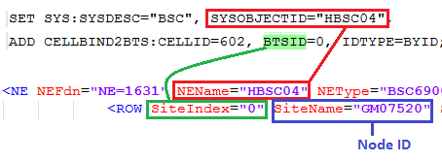  - If no matching is found in previous step, take BTSID under ADD CELLBIND2BTS tag and match it with BTSID under ADD BTS tag and take the correspondent value of BTSNAME on the same line  - Match BTSNAME with value under GbtsFunctionName under Row tag in file (DIM_BTS3900_GCELL)  - Node ID = value under GbtsFunctionName under ROW tag  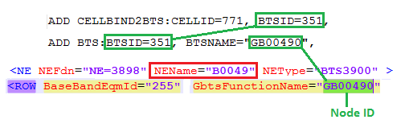
Parent Site ID | [Mandatory] | (NEP tool calculated)
MCC | [Mandatory] | (NEP tool calculated)
MNC | [Mandatory] | (NEP tool calculated)
Neighbor Cells 2G | [Optional] | - Get the value of”NBR2GNCELLID” attribute under “ADD G2GNCELL” tag and match it under “ADD GEXT2GCELL”.  - If the value was matched,  - then get the correspondent “LAC” and “CI” value within the same line of “ADD GEXT2GCELL” to get the “Neighbor cells 2G” which is a concatenation of “LAC”, ”_” and the “CI” value..  - Else  - if value not matched under “ADD GEXT2GCELL” , look up for the same value under the attribute “CELLID” mentioned under the command line “ADD GCELL”.  - Once matched, get the correspondent “LAC” and “CI” value under the same command line (ADD GCELL) to get the Neighbor Cells 2G which is concatenation of concatenation of “LAC”, “_” ,”CI”..  Note: The “SRC2GNCELLID” represents the parent “CELLID” attribute, thus you have to match “SRC2GNCELLID” with the value of “CELLID” under “ADD GCELL” and then get the “LAC” and “CI” value to get the parent cell ID.
Neighbor Cells 3G | [Optional] | - Get the value of” NBR3GNCELLID” attribute under “ADD G3GNCELL” tag and match it under “ADD GEXT3GCELL”.  - If the value was matched, then get the correspondent “LAC” and “CI” value within the same line of “ADD GEXT3GCELL” to get the “Neighbor cells 3G” which is a concatenation of “LAC”, ”_” “CI”..  - Note: If the LAC value is in hexadecimal format (e.g. H'0385) then take only the value followed by “’” and convert the followed digits into decimal format.  Note: The “SRC3GNCELLID” represents the parent “CELLID” attribute, thus you have to match “SRC3GNCELLID” with the value of “CELLID” under “ADD GCELL” and then get the “LAC” and “CI” value to get the parent cell ID.
Neighbor Cells 4G | [Optional] | - Get the value of “NBRLTENCELLID” attribute under “ADD GLTENCELL” tag , where for each “SRCLTENCELLID” attribute which represents the “CellID” there are a set of neighbor cells 4G.  - Lookup for the same value of “NBRLTENCELLID” under “EXTLTECELLID” under tag “ADD GEXTLTECELL”.  - Once matched, take the value of “EXTLTECELLNAME” and lookup for the same value under Cell→attributes→LocalCellID→CellName within the 4G dump files.  - Once matched, the “neighbor 4G cell ID” will be the concatenation of the “enodeB Name” with the “CellId” attribute .  - Note: If once getting the “EXTLTECELLNAME” the cell ID can be deduced at saving , no need then for the last two steps
Operators | [Optional] | (NEP Tool Calculated)
Last Audit Date | [Optional] | - =Null
Additional Information | [Optional] | - =Null
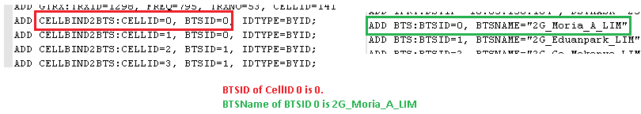

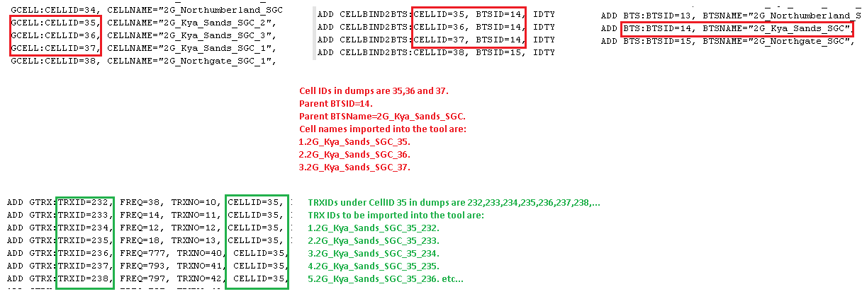

Below are the specific attributes to be parsed in case the cell technology is GSM

- Specific attributes for 2G cells

Attributes | Importance | Example
Parent BSC ID | [Optional] | (NEP tool Calculated)
BCCH ARFCN | [Optional] | - (NEP tool calculated)
#TRX installed | [Optional] | - (NEP tool calculated)
BSIC | [Optional] | - NEP Tool calculated.
NCC | [Optional] | - = "NCC" value under "ADD GCELL" tag of each line.  E.g. : NCC=1  - The obtained value refers to the cell ID value of "CELLID" attribute.
BCC | [Optional] | - = "BCC" value under "ADD GCELL" tag of each line.  E.g. : BCC=5  - The obtained value refers to the cell ID value of "CELLID" attribute.
HSN | [Optional] | - = "HSN" value under "ADD GCELLMAGRP" tag of each line.  E.g. : HSN=7  - The obtained value refers to the cell ID value of "CELLID" attribute.
MAIO List | [Optional] | NEP tool calculated.
LAC | [Optional] | - = "LAC" value under "ADD GCELL" tag of each line.  E.g. : LAC=3210  - The obtained value refers to the cell ID value of "CELLID" attribute.
RAC | [Optional] | - = "RA" value Under " SET GCELLGPRS " tag of each lineE.g. : RA=100  - The obtained value refers to the cell ID mentioned on the same line.
GPRS enabled | [Optional] | - A Cell has GPRS Enabled if "GPRS" attribute under "SET GCELLGPRS" tag is equal to “SupportAsInnPcu” or “SupportAsExtPcu”.  - Else if the Value is equal to “NO”, then the cell doesn’t support GPRS.  - The obtained value refers to the cell ID value of "CELLID” attribute on the same line.
EDGE enabled | [Optional] | - A cell has Edge enabled if “EDGE” attribute under “SET GCELLGPRS” is equal to “YES”.  - Else if equal to “NO”, hence this specific cell doesn’t support EDGE.  - The obtained value refers to the cell ID value of "CELLID” attribute.
Frequency band | [Optional] | - =”TYPE” value under “ADD GCELL” tag of each line.  - The obtained value refers to the cell ID value of “CELLID” attribute on the same line.
AMR support | [Optional] | - To be deduced ass follow :  - Check if the attribute “RATECTRLSW” found under “SET GCELLCCAMR” tag is equal to “ALG1” or “ALG2”, then AMR support = YES,  - Else If equal to “NONE” => AMR support = NO  - The obtained value refers to the cell ID value of “CELLID” attribute on the same line.

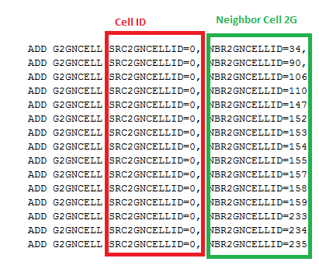
Attributes | Importance | comments
Antenna ID | Mandatory | - =Null
Antenna Type | Mandatory | - =Null
Antenna Height [m] | Optional | - =Null
Gain [dBi] | Optional | - =Null
Antenna Azimuth | Optional | - =Null
M-Tilt | Optional | - =Null
900 E-Tilt | Optional | - =Null
1800 E-Tilt | Optional | - =Null
Tower Type | Optional | - =Null
Tower Height [m] | Optional | - =Null
Length of Feeder Cables [m] | Optional | - =Null
Diameter of Feeder Cables | Optional | - =Null

TRx Logical Parameters

Attributes | Importance | comments
TRX ID | Mandatory | - The “TRX ID” is equal to the concatenation of : “Cell ID”, “_” and “TRXID”  - =”TRXID” under “ADD GTRX” tag of each line.  - The obtained value refers to the cell ID value of “CELLID” attribute on the same line
TRX Name | Mandatory | - =TRXNAME value under ADD GTRX tag.  - The obtained value refers to the TRXID on the same line.  - If TRXNAME is empty then consider parent cell name + TRXID under ADD GTRX (e.g. CELLNAME="Kais_5" and TRXID=2→TRXName= Kais_52.
ARFCN | Mandatory | - =”FREQ” value under “ADD GTRX”” tag the obtained values of each line refer to the TRXID value on the same line.
Type | Optional | - Per each “TRX ID” , check the attribute “GPRSCHPRI” whenever exits per each “TRXID” under “SET GTRXCHAN”:  - If all the values of “GPRSCHPRI” within the same “TRX ID” are equal to “GPRS” , then Type=GPRS  - Else if at least one of the value of “GPRSCHRPI” is equal to “EGPRSNORCH” or “EGPRSPRICH” or “EGPRSSPECH“ , then type = EDGE  - Else if all the values are equal to “NONGPRS” , then type=None  (check below snapshot)
MAIO | Optional | - Deduced from “TRXMAIO” attribute under “SET GTRXCHANHOP” tag of each line.  - The obtained value refers to the TRX ID value of "TRXID" attribute.
Half rate supported | Optional | - To be deduced as follow:  - Check if under the “SET GCELLCCACCESS” tag , the key-word “HALF_RATE” exists within the attribute “VOICEVER” ,hence the “Half rate supported” should be checked on all the TRXID belonging to the mentioned “CELLID”  - Else if “HALF_RATE” doesn’t exist, hence all the “TRXID” belonging to the mentioned “CELLID”.
Channel type | Optional | - Per each TRX ID, up to 8 channels having the attribute “CHNO” can be configured.  - if the attribute "ISMAINBCCH" mentioned under "ADD GTRX" is equal to "YES”, then by default Channeltype1 in NEP will be equal to BCCH and channeltype2 to channeltype8 will be deduced from “CHNO” under “SET GTRXCHAN” as clarified below.  - Else, channeltype1 to channeltype8 will be deduced from “CHNO” under “SET GTRXCHAN”.  - “CHNO” in dumps refers to channel type number in NEP equal to “CHNO”+1(e.g. channel type number 1 in NEP refers to “CHNO”=0 in dumps, channel type number 4 in NEP refers to “CHNO”=3 in dumps, etc.) The “Channel Type” attribute is to be deduced following the below mapping rule :  - “TCHFR” Channel type=TCHFR  - “TCHHR” Channel type=TCHHR  - “SDCCH8” or “SDCCH_CBCH” Channel type=SDCCH  - “MBCCH” or “CBCCH” or “BCCH_CBCH” Channel type=BCCH  - “PBCCH_PDTCH” or “PCCCH_PDTCH” or “PDTCH” Channel type=Fixed-GPRS  - “DPDCH” Channel Type=Shared-GPRS  - “BCH” Channel Type=Extended BCCH.
Number of PDCH | Optional | - (NEP tool Calculated)
Number of BCCH/SDCCH | Optional | - (NEP tool Calculated)
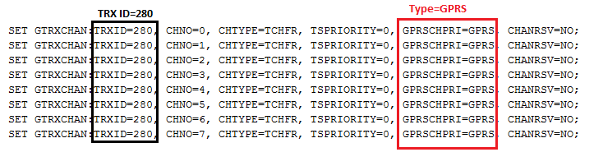

Cell Logical Parameters (CM Export)

- The BSC logical dumps are the dumps that have “BSC6900GSMNE” class
- Each " BSC6900GSMCell" class in BSC logical dump represents one cell

Attributes | Importance | Example
Cell Name | [Optional] | - =”CELLNAME” attribute under “BSC6900GSMCell” class
Cell ID |  | - =”CI” attribute under “BSC6900GSMCell” class
Object ID | [Mandatory] | - The “Cell ID” is equal to the concatenation of :  “LAC”, “_” and “Cell ID”
Cell Technology | [Mandatory] | - =GSM
Node name | [Mandatory] | - Get BTSID attribute under BSC6900GSMCell  - Find BSC6900GSMBTS” class with BTSID matching with BTSID under BSC6900GSMCell  - Node name = BTSNAME under BSC6900GSMBTS
NCC | [Optional] | - = "NCC" value under "BSC6900GSMCell" class
BCC | [Optional] | - = "BCC" value under "BSC6900GSMCell" class
HSN | [Optional] | - = "HSN" value under "BSC6900GSMGCELLMAGRP" class  - The obtained value refers to the cell ID with Cell ID= "CELLID" under "BSC6900GSMGCELLMAGRP" under same BSC.
LAC | [Optional] | - = "LAC" value under "BSC6900GSMCell" class
RAC | [Optional] | - = "RA" value Under “BSC6900GSMGCELLGPRS " class  - The obtained value refers to the cell ID with Cell ID= "CELLID" under "BSC6900GSMGCELLGPRS" under same BSC.
GPRS enabled | [Optional] | - A Cell has GPRS Enabled if "GPRS" attribute under "BSC6900GSMGCELLGPRS” class equals “SUPPORTASINNPCU” or “SUPPORTASEXTPCU”.  - Else if the Value is equal to “NO”, then the cell doesn’t support GPRS.  - The obtained value refers to the cell ID with Cell ID= "CELLID" under "BSC6900GSMGCELLGPRS" under same BSC.
EDGE enabled | [Optional] | - A cell has Edge enabled if “EDGE” attribute under "BSC6900GSMGCELLGPRS” class equals “YES”.  - Else if equal to “NO”, hence this specific cell doesn’t support EDGE.  - The obtained value refers to the cell ID with Cell ID= "CELLID" under "BSC6900GSMGCELLGPRS" under same BSC.
Frequency band 1 & Frequency band 2 | [Optional] | - To be deduced from ”TYPE” value under "BSC6900GSMCell" class as per below rules:  - TYPE =GSM900 → Frequency band 1=”P-GSM-900” and Frequency band 2=”none”  - TYPE = DCS1800→ Frequency band 1=”DCS-1800” and Frequency band 2=”none”  - TYPE =GSM900_DCS1800→ Frequency band 1=” P-GSM-900” and Frequency band 2=” DCS-1800”
AMR support | [Optional] | - Check if the attribute “RATECTRLSW” found under “BSC6900GSMGCELLCCAMR” class equals “ALG1” or “ALG2”, then AMR support = YES,  - Else If equal to “NONE” => AMR support = NO  - The obtained value refers to the cell ID with Cell ID= "CELLID" under "BSC6900GSMGCELLCCAMR" under same BSC.

TRx Logical Parameters

Each "BSC6900GSMGTRX" class in BSC logical dump represents one TRX

Attributes | Importance | comments
TRX ID | Optional | - =”TRXNO under “BSC6900GSMGTRX” class
Object ID | Mandatory | - The “TRX ID” is equal to the concatenation of : “Cell ID”, “_” and “TRXID”
Cell ID | Mandatory | - The cell ID with Cell ID= "CELLID" under "BSC6900GSMGTRX" under same BSC.
TRX Name | Mandatory | - From “name” attribute value under “BSC6900GSMGTRX” class take the value after “TRX Name=”  - E.g  name="name">TRX Index=1, TRX Name=G_RS-AZ-ZAFARANAH_60550_S1_D0< TRX Name = G_RS-AZ-ZAFARANAH_60550_S1_D0
ARFCN | Mandatory | - =”FREQ” attribute under “BSC6900GSMGTRX” class
Type | Optional | - Per each “TRX ID” , check the attribute “GPRSCHPRI” whenever exits per each “TRXID” under “BSC6900GSMGTRXCHAN” class:  - If all the values of “GPRSCHPRI” within the same “TRX ID” are equal to “GPRS” , then Type=GPRS  - Else if at least one of the value of “GPRSCHRPI” is equal to “EGPRSNORCH” or “EGPRSPRICH” or “EGPRSSPECH“ , then type = EDGE  - Else if all the values are equal to “NONGPRS” , then type=None  (check below snapshot)
MAIO | Optional | - Deduced from “TRXMAIO” attribute under “BSC6900GSMGTRXCHANHOP” class  - The obtained value refers to the TRX with TRX ID= "TRXID" under "BSC6900GSMGTRXCHANHOP" under same BSC.
Channel type | Optional | - Per each TRX ID, up to 8 channels having the attribute “CHNO” can be configured.  - if the attribute "ISMAINBCCH" under "BSC6900GSMGTRX" equals "YES”, then by default Channeltype1 in NEP will be equal to BCCH and channeltype2 to channeltype8 will be deduced from “CHNO” under “BSC6900GSMGTRXCHAN” class as clarified below.  - Else, channeltype1 to channeltype8 will be deduced from “CHNO” under “BSC6900GSMGTRXCHAN” class  - “CHNO” in dumps refers to channel type number in NEP equal to “CHNO”+1(e.g. channel type number 1 in NEP refers to “CHNO”=0 in dumps, channel type number 4 in NEP refers to “CHNO”=3 in dumps, etc.) The “Channel Type” attribute is to be deduced based on “CHTYPE” attribute under “BSC6900GSMGTRXCHAN” class as follows:  - “TCHFR” Channel type=TCHFR  - “TCHHR” Channel type=TCHHR  - “SDCCH8” or “SDCCH_CBCH” Channel type=SDCCH  - “MBCCH” or “CBCCH” or “BCCH_CBCH” Channel type=BCCH  - “PBCCH_PDTCH” or “PCCCH_PDTCH” or “PDTCH” Channel type=Fixed-GPRS  - “DPDCH” Channel Type=Shared-GPRS  - “BCH” Channel Type=Extended BCCH.

TRAU Logical Attributes

Attributes | Importance | Example
TRAU ID | [Mandatory] | - To be parsed from Physical Dumps.  - =Shelf id of shelves with “FrameType="TCS"”.  - Shelf id parsing is clarified in Physical connector.  - Each BSC might be having multiple TRAUs.  - E.g. “2G_BR20_JSA_SGC_1_3” where “2G_BR20_JSA_SGC” is the NE Name, 1 is the Cabinet ID and 3 is the Shelf Index.
TRAU Name | [Optional] | - =Frame Type, e.g. “TCS”.
TRAU Type | [Mandatory] | - =”TCS”

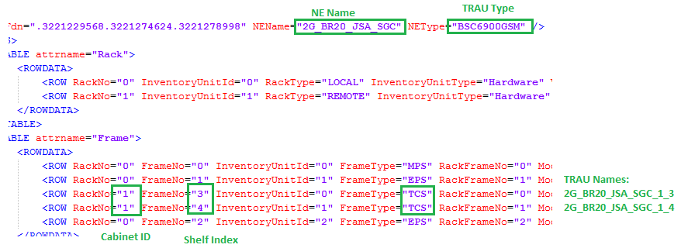

Attributes | Importance | Example
TRAU Board Type | [Mandatory] | - To be deduced from Logical Dumps.  - = “BRDTYPE” attribute where “ISTCBRD” attribute is equal to “Yes” and “LGCAPPTYPE” is equal to “GTC” under “ADD BRD” function .  - E.g. “DPUc”.
TRAU Board ID | [Mandatory] | - Get “SRN” and “SN” values of boards with “ISTCBRD” attribute is equal to “Yes” and “LGCAPPTYPE” is equal to “GTC” under “ADD BRD” function from Logical Dumps.  - Find Board with “FrameNo”= “SRN” and “SlotNo”= “SN” under “Board” table in physical dumps.  - TRAU Board ID= Board ID of the board found.  - Please refer to physical connector for further details.  - E.g. “2G_BR20_JSA_SGC_1_3_14”
TRAU Board Name within Parent | [Mandatory] | - = TRAU Board ID

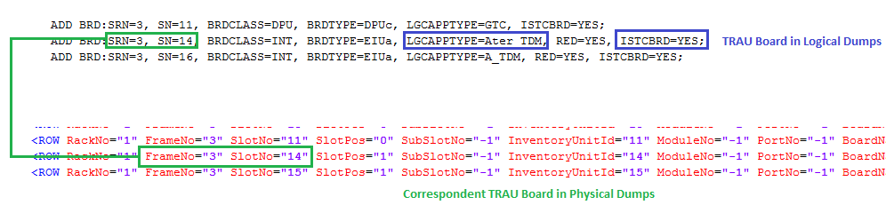

IP, VLAN, GW Parsing

BSC Physical port IP

- Deduced from ADD ETHIP tags.
- If more than one IP were found on a physical interface, consider them as sub-interfaces
Attributes | Importance | Parsing
Interface Name | [Mandatory] | - =Node Name_Shelf_Slot_Port_SubInterface.
Physical Sub-interface C/Sh/S/I/P | [Mandatory] | - Shelf, Slot, Index on Slot and Port are equal to SRN, SN, 0 and PN under ADD ETHIP.  - Sub-interface index = IPINDEX under ADD ETHIP.
IP address | [Optional] | - = IP under ADD ETHIP
VLAN | Optional | - Match the IP with the value of IPADDR under ADD VLANID tag  - Take the value of VLANID attribute  - Else = Null
Subnet Mask | [Optional] | - = MASK under ADD ETHIP
Description | Optional | - = the value of REMARK attribute under ADD ETHIP

BSC Device IP

- Deduced from ADD DEVIP tags.

Attributes | Importance | Parsing
Interface Name | [Mandatory] | - =Node Name_SRN_SN  - SRN and SN are under ADD DEVIP
IP address | [Optional] | - = IPADDR under ADD DEVIP.
Mask | [Optional] | - 255.255.255.248
Description | Optional | - = the value of REMARK attribute under ADD DEVIP

BSC Ethernet Trunk IP

- Deduced from ADD ETHTRKIP tags.

Attributes | Importance | Parsing
Interface Type | [Mandatory] | - Ethernet Trunk
Interface Name | [Mandatory] | - =ETHTRKIP_SRN_SN_TRKN_IPINDEX.  - SRN, SN, TRKN and IPINDEX under ADD ETHTRKIP
IP address | [Optional] | - = IP under ADD ETHTRKIP
Subnet Mask | [Optional] | - = MASK under ADD ETHTRKIP
Physical C/Sh/S/I/P/Sub-Interface | [Mandatory] | - Shelf, Slot, Index on Slot and Port are equal to SRN, SN, 0 and TRKN under ADD ETHIP.  - Sub-interface index = IPINDEX under ADD ETHIP  OR  - Match SRN, SN and TRKN under ADD ETHTRKIP with SRN, SN and TRKN under ADD ETHTRKLNK.  - Multiple ADD ETHTRKLNK would be found.  - If WORKMODE=ACTIVE_STANDBY under ADD ETHTRKLNK then ADD ETHTRKLNK with PORTPRI=0 is for the active port and ADD ETHTRKLNK with PORTPRI=1 is for the protection port.  - Shelf, Slot and Port indexes of the active board/port are equal to SRN, TRKLNKSN and TRKLNKPN under ADD ETHTRKLNK with PORTPRI=0  - Shelf, Slot and Port indexes of the protection board/port are equal to SRN, TRKLNKSN and TRKLNKPN under ADD ETHTRKLNK with PORTPRI=1  - Index on slot=0.  Sub-interface index = IPINDEX under ADD ETHTRKIP.
Gateway | [Mandatory] | - From IPADDR and MASK under all above ADD ETHTRKIP find the range of valid IPs for each ADD ETHTRKIP.  - Find ADD SRCIPRT with NEXTHOP under ADD SRCIPRT is matching within the range of IPs of ADD ETHTRKIP and SRN, SN under ADD SRCIPRT are matching with SRN, SN under ADD ETHTRKIP.  - Gateway=NEXTHOP under ADD SRCIPRT.  OR  - Match IPADDR under ADD ETHTRKIP with SRCIPADDR under ADD SRCIPRT with IPTYPE=ETHTRKIP.  Gateway=NEXTHOP under ADD SRCIPRT.
VLAN | [Mandatory] | - Match NEXTHOP under ADD SRCIPADDR with IPADDR under ADD VLANID.  - VLAN = VLANID under ADD VLANID.

BTS Device IP

- Deduced from SET BTSIP tags.
- Only for Standalone BTS not for 2G roles

Attributes | Importance | Parsing
Node Name |  | - Take the value of BTSID attribute under SET BTSIP tag  - Match it with BTSID under ADD BTS tag  - Take the value of BTSNAME attribute
Interface Name | [Mandatory] | - =Node Name IP address
IP address | [Optional] | - = BTSIP under SET BTSIP
Mask | [Optional] | - 255.255.255.248

Addinfo

- Below listed additional info to be added on BSC
- Attribute to be incremented from 1 for each Category
- The values in note field should be separated with “;”
- In note field, if there are multiple values for an attribute separate them with “,”

Category | Value | Note
IPRT | = the value of “NEXTHOP” attribute under each ADD IPRT tag | - NETWORK= the value of “DSTIP” attribute under “ADD IPRT” tag  - MASK= the value of “DSTMASK” attribute under “ADD IPRT” tag  - GATEWAY= the value of “NEXTHOP” attribute under “ADD IPRT” tag
OPC | = the value of “SPX” attribute under each ADD OPC tag | - OPC= the value of “SPC” under ADD OPC tag

“Abis” Interface

EGBTS Nodes

- Where we have “ISEGBTS=Yes” under class “ADD IPPATH”. So, we will parse interfaces as EGBTS nodes as per below mention rules.

Category | Value | Note
ADJNODE  //Abis// | = the value of “ANI” attribute under each concatenated with”_Abis” ADD ADJNODE tag | - CONNECTION_TYPE= the value of “NODET” attribute under “ADD ADJNODE” tag. This value should be matched with the enum ran interfaces and to be null if not found  - NODE_ID=  - Take the value of “BTSID” attribute under “ADD ADJNODE” tag  - Match it with “BTSID” attribute under “ADD BTS” tag  - Take the value of “BTSNAME” attribute  - ID= the value of “ANI” attribute under “ADD ADJNODE” tag  - DESCRIPTION=”Abis”
ASSOCIATION  //Abis// | = the value of “ANI” attribute under each concatenated with”_Abis” ADD ADJNODE tag | - LOCAL_IP= the value of “IPADDR” attribute under each “ADD IPPATH” tag  - REMOTE_IP= the value of “PEERIPADDR” attribute under each “ADD IPPATH” tag  - ID= the value of “ANI” attribute under each “ADD IPPATH” tag  - DESCRIPTION=”Abis”
ASSOCIATION  //Abis in Transmission Resource Pool Mode // | = the value of “ANI” attribute under each concatenated with”_Abis” ADD ADJNODE tag | - LOCAL_IP=  - Take the value of “IPPOOLINDEX” attribute under “ADD ADJNODE” tag  - Match it with “IPPOOLINDEX “ attribute under all “ADD IPPOOLIP” tags  - Take the values of “IPADDR” attribute under all matched ““ADD IPPOOLIP” tags  - REMOTE_IP=  - Take the value of “BTSID” attribute under “ADD ADJNODE” tag  - Match it with “BTSID” attribute under “SET BTSIP”  - Take the value of “IP” attribute  - ID= the value of “ANI” attribute under each “ADD IPPATH” tag  - DESCRIPTION = “Abis in Transmission Resource Pool Mode”

GBTS Nodes

- Where we have “ISEGBTS=NO” under class “ADD IPPATH”. So, we will parse interfaces as GBTS nodes as per below mention rules.

> Fetch “ANI” value from ADD IPPATH class, Where “ISEGBTS=NO”.
Example: In below snippet, we have “ISEGBTS=NO” for ANI=63 under class “ADD IPPATH”.
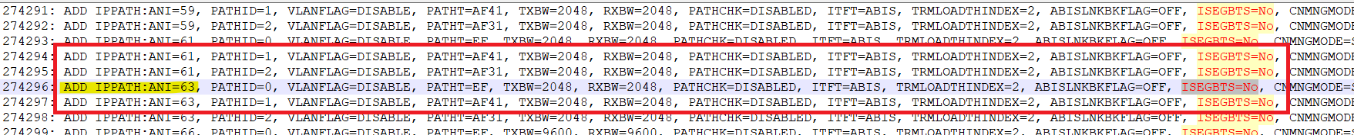

> Search same ANI in respective BSC dump & fetch “BTSID” value from class ADD ADJNODE for same ANI. Check below snippet for reference,
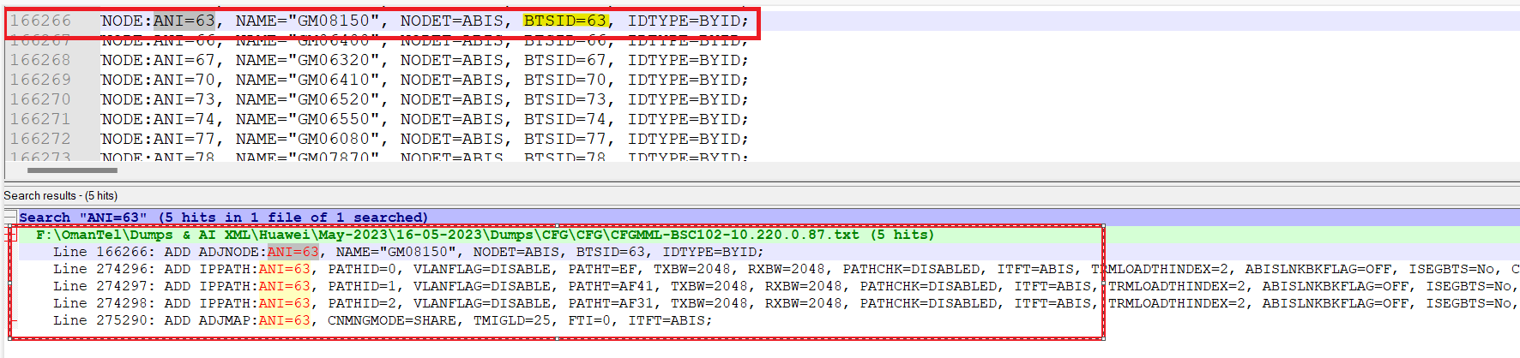

> Then search same “BTSID” value in dump then use “BTSIP” value as “Remote IP” & “BSCIP” value as “Local IP” under class “SET BTSIP” for same “BTSID”.
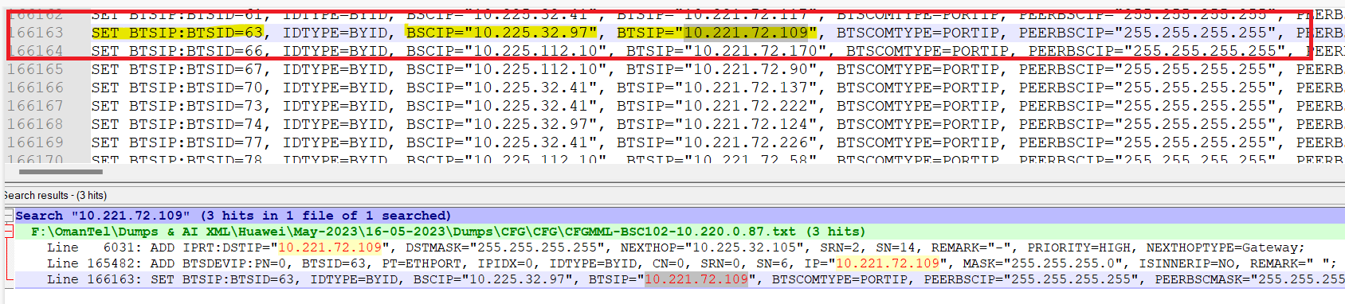

Category | Value | Note
ADJNODE  //Abis// | = the value of “ANI” attribute under each concatenated with ”_Abis” ADD ADJNODE tag | - CONNECTION_TYPE= the value of “NODET” attribute under “ADD ADJNODE” tag. This value should be matched with the enum ran interfaces and to be null if not found  - NODE_ID=  - Take the value of “BTSID” attribute under “ADD ADJNODE” tag.  - Match it with “BTSID” attribute under “ADD BTS” tag  - Take the value of “BTSNAME” attribute  - ID= the value of “ANI” attribute under “ADD ADJNODE” tag  - DESCRIPTION=”Abis”
ASSOCIATION  //Abis// | = the value of “ANI” attribute under each concatenated with”_Abis” ADD ADJNODE tag | - LOCAL_IP= the value of “BSCIP” attribute under each “SET BTSIP” tag  - REMOTE_IP= the value of “BTSIP” attribute under “SET BTSIP” tag (Follow above rules to get “IP” that are mentioned under heading GBTS nodes.  - ID= the value of “ANI” attribute under each “ADD BTSDEVIP” tag  - DESCRIPTION=”Abis”

- FOR TOUCH:

Category | Value | Note
ADJNODE  //Abis// | = the value of “ANI” attribute under each concatenated with”_Abis” ADD ADJNODE tag | - CONNECTION_TYPE= the value of “NODET” attribute under “ADD ADJNODE” tag. This value should be matched with the enum ran interfaces and to be null if not found  - NODE_ID=  - Take the value of “BTSID” attribute under “ADD ADJNODE” tag  - Match it with “BTSID” attribute under “ADD BTS” tag  - Take the value of “BTSNAME” attribute  - ID= the value of “ANI” attribute under “ADD ADJNODE” tag  - DESCRIPTION=”Abis”
ASSOCIATION  //Abis// | = the value of “DPX” attribute under each ADD N7DPC tag | - LOCAL_IP=  - Match the BTSID value under ADD ABISCP tag with the BTSID extracted from ADD ADJNODE tag  - Get the value of SCTPLNKID under ADD ABISCP tag  - Match it with the SCTPLNK value under ADD SCTPLNK tag.  - Take the values of “LOCIP1” under each matched “ADD SCTPLNK” tag  - REMOTE_IP=  - Repeat the previous steps from a c  - Take the values of “PEERIP1” under each matched “ADD SCTPLNK” tag  - ID= the value of “ANI” attribute under each “ADD ADJNODE” tag  - DESCRIPTION=”Abis”

“A” Interface

Category | Value | Note
ADJNODE  //A// | = the value of “DPX” attribute under each ADD N7DPC tag | - CONNECTION_TYPE= the value of “DPCT” attribute under “ADD N7DPC” tag. This value should be matched with the enum ran interfaces and to be null if not found  - DPC= the value of “DPC” attribute under “ADD N7DPC” tag  - ID= the value of “DPX” attribute under “ADD N7DPC” tag  - DESCRIPTION=”A”
ASSOCIATION  //A// | = the value of “DPX” attribute under each ADD N7DPC tag | - LOCAL_IP=  - Take the value of “DPX” attribute under ADD N7DPC tag  - Match it with “DPX” attribute under “ADD M3DE” tag  - Take the value of “DENO” attribute  - Match it with “DENO” attribute under “ADD M3LKS” tag  - Take the value of “SIGLKSX” attribute  - Match it with “SIGLKSX” attribute under all “ADD M3LNK” tags  - Take the values of “SCTPLNKID” from all the matched “ADD M3LNK”  - Match each of them with “SCTPLNKN” under “ADD SCTPLNK” tag  - Take the values of “LOCIP1” under each matched “ADD SCTPLNK” tag  - REMOTE_IP=  - Repeat the previous steps from a h  - Take the values of “PEERIP1” under each matched “ADD SCTPLNK” tag  - ID= ID= the value of “DPX” attribute under “ADD N7DPC” tag  - DESCRIPTION=”A”

“Gb” Interface

Category | Value | Note
ADJNODE  //Gb//  OR  ADJNODE  Every “ADD NSE” with “PT” attribute equals “GB_OVER_IP” represents one ADJNODE | = the value of “NSEI” attribute under ADD NSE tag concatenated with “_Gb”  OR  = the value of “NSEI” under “ADD NSE” | - CONNECTION_TYPE=  - if the value of “PT” attribute under “ADD NSE” tag equals “GB_OVER_IP” Connection type= “Gb”  - This value should be matched with the enum ran interfaces and to be null if not found  - NODE_ID= “IP_DERIVED”  - ID= the value of “NSEI” attribute under “ADD NSE” tag  - DESCRIPTION=”Gb”  OR  - CONNECTION_TYPE=Gb  NODE_ID= IP_DERIVED
ASSOCIATION  //Gb//  OR  ASSOCIATION  // 1st association // | = the value of “NSEI” attribute under ADD NSE tag concatenated with “_Gb”  OR  = the value of “NSEI” under “ADD NSE” | - LOCAL_IP=  - take the value of “NSEI” attribute under “ADD NSE” tag  - match it with “NSEI” under each “ADD NSVLLOCAL” tag  - take the values of “IP” attribute under each matched “ADD NSVLLOCAL” tag  - REMOTE_IP=  - take the value of “NSEI” attribute under “ADD NSE” tag  - match it with “NSEI” under each “ADD NSVLREMOTE” tag  - take the values of “IP” attribute under each matched “ADD NSVLREMOTE” tag  - ID= the value of “NSEI” attribute under “ADD NSE” tag  - DESCRIPTION=”Gb”  OR  - LOCAL_IP=  - Take the value of “NSEI” attribute under “ADD NSE”  - Match it with “NSEI” under “ADD NSVLLOCAL”  - Take the value of “IP”  REMOTE_IP= the value of “SVRIP” under “ADD NSE”

IPRT

Category | Value | Note
IPRT  Each “ADD IPRT” represents one “IPRT” | The value of “NEXTHOP” attribute under “ADD IPRT” | - NETWORK= the value of “DSTIP” attribute  - MASK= the value of ““DSTMASK” attribute  - GATEWAY= the value of “NEXTHOP” attribute

Interfaces

11.1 “Abis” Over TDM

- Abis BTS-BTS over TDM is represented in logical dumps with one or more ADD BTSCONNECT tags where DESTNODE=BTS and BTSID attribute represents the BTS ID.
- Below are the attributes of Abis over TDM interface :

Attributes | Importance | Example
Participant 1 Name | [Optional] | - = BTSNAME attribute under ADD BTS tag where UPBTSID attribute under ADD BTSCONNECT is matching with BTSID attribute under ADD BTS tag
Participant 1 Node Type | [Optional] | - =BTS.
Participant 2 Name | [Optional] | - = BTSNAME attribute under ADD BTS tag where BTSID attribute under ADD BTSCONNECT is matching with BTSID attribute under ADD BTS tag
Participant 2 Node Type | [Optional] | - =BTS.
Transport Type | [Optional] | - = TDM
Interface Name | [Optional] | - Is the concatenation of Participant1 name, _, Participant2 name, _ and Interface Technology.
Interface Type | [Optional] | - = Abis BTS-BTS
Participant 2 C/Sh/S/P | [Optional] | - = INCN, INSRN , INSN and INPN +2 attributes respectively under ADD BTSCONNECT tag.  - The obtained value refers to the BTSID deduced from the same line.  - If multiple ADD BTSCONNECT tags are found then repeat the above for all of them, if the same port is found then take it only one time, if different ports are found then take each port one time only.
Participant 1 C/Sh/S/P | [Optional] | - = FCN, FSRN , FSN and FPN +2 attributes respectively under ADD BTSCONNECT tag.  - The obtained value refers to the UPBTSID deduced from the same line.  - If multiple ADD BTSCONNECT tags are found then repeat the above for all of them, if the same port is found then take it only one time, if different ports are found then take each port one time only.
TX BW | [Optional] | - Each connection from a BTS to the BTS represents one E1  - TX BW = Number of E1s * 2048.
RX BW | [Optional] | - = TX BW

11.2 “Abis” BTS-BTS Over TDM
- Abis BTS-BTS over TDM is represented in logical dumps with one or more ADD BTSCONNECT tags where DESTNODE=BTS and BTSID attribute represents the BTS ID.
- Below are the attributes of Abis over TDM interface :

Attributes | Importance | Example
Participant 1 Name | [Optional] | - = BTSNAME attribute under ADD BTS tag where UPBTSID attribute under ADD BTSCONNECT is matching with BTSID attribute under ADD BTS tag
Participant 1 Node Type | [Optional] | - =BTS.
Participant 2 Name | [Optional] | - = BTSNAME attribute under ADD BTS tag where BTSID attribute under ADD BTSCONNECT is matching with BTSID attribute under ADD BTS tag
Participant 2 Node Type | [Optional] | - =BTS.
Transport Type | [Optional] | - = TDM
Interface Name | [Optional] | - Is the concatenation of Participant1 name, _, Participant2 name, _ and Interface Technology.
Interface Type | [Optional] | - = Abis BTS-BTS
Participant 2 C/Sh/S/P | [Optional] | - = INCN, INSRN , INSN and INPN +2 attributes respectively under ADD BTSCONNECT tag.  - The obtained value refers to the BTSID deduced from the same line.  - If multiple ADD BTSCONNECT tags are found then repeat the above for all of them, if the same port is found then take it only one time, if different ports are found then take each port one time only.
Participant 1 C/Sh/S/P | [Optional] | - = FCN, FSRN , FSN and FPN +2 attributes respectively under ADD BTSCONNECT tag.  - The obtained value refers to the UPBTSID deduced from the same line.  - If multiple ADD BTSCONNECT tags are found then repeat the above for all of them, if the same port is found then take it only one time, if different ports are found then take each port one time only.
TX BW | [Optional] | - Each connection from a BTS to the BTS represents one E1  - TX BW = Number of E1s * 2048.
RX BW | [Optional] | - = TX BW

11.3 “Abis” Over IP (For BTS with BTSTYPE Under ADDBTS <>EGBTS)

- Abis over IP is represented in logical dumps with one ADD ADJNODE tag where NODET=ABIS.
- Abis over IP refers to BTS with ID equals to BTSID attribute under ADD ADJNODE.
- Abis over IP interface has one or several IP paths represented each with one ADD IPPATH tag where ANI value is matching with ANI under ADD ADJNODE tag.
- Below are the attributes of Abis over IP interface:

Attributes | Importance | Parsing
BSC Name | [Optional] | - Logical BSC name = SYSOBJECTID attribute under SET SYS tag.  - Deduce BSC name from Physical dumps.
BTS Name | [Optional] | - = BTSNAME attribute under ADD BTS tag where BTSID attribute under ADD ADJNODE is matching with BTSID attribute under ADD BTS tag
Transport Type | [Mandatory] | - =IP.
Interface Name | [Mandatory] | - = NAME attribute under ADD ADJNODE.
Interface Type | [Mandatory] | - = Abis
BTS C/Sh/S/I/P. | [Optional] | - Find SET BTSIP tag with BTSID matching with BTSID under ADD BTS.  - Find ADD BTSDEVIP with IP attribute matching with BTSIP under SET BTSIP.  - C/Sh/S/P are equal to CN, SRN, SN and PN attributes under ADD BTSDEVIP respectively.  - Index on Slot=0.
BTS IP | [Optional] | - =IP value under ADD BTSDEVIP tag, value refers to the port deduced in BTS C/Sh/S/I/P.
BTS Subnet | [Optional] | - =MASK value under ADD BTSDEVIP tag, value refers to the port deduced in BTS C/Sh/S//IP.
BTS Gateway | [Optional] | - = GWIP under SET BTSIP.  - If GWIP=255.255.255.255 then:  - Find ADD BTSIPRT for same BTSID.  - = NEXTHOP under ADD BTSIPRT.
BTS Vlan | [Optional] | - = VLANID under SET BTSVLAN.  - Value refers to BTSID on the same line.
BSC C/Sh/S/I/P. | [Optional] | - To be deduced from both Logical and Physical Dumps.  - Get BSCIP value under SET BTSIP where BTSID is matching with ID of BTS.  - If BSCIP is matching with IPADDR under any ADD ETHIP:  - Shelf, slot and port are equal to SRN, SN and PN under ADD ETHIP respectively.  - Index on Slot=0.  - Finding ADD IPRT:  - Find ADD IPRT tag with DSTIP under ADD IPRT is matching with BTSIP under SET BTSIP and SRN, SN under ADD IPRT are matching with SRN, SN under ADD ETHIP.  - Else:  - Find ADD IPRT with SRN and SN are matching with ADD ETHIP.  - From DSTIP and DSTMASK under all above ADD IPRT find the range of valid IPs for each ADD IPRT and then get the ADD IPRT with BTSIP under SET BTSIP is included in its range.  - Else:  - Find ADD DEVIP where IPADDR attribute is matching with BSCIP value under SET BTSIP.  - Get SRN and SN attributes under ADD DEVIP  - Match the SRN and SN under ADD DEVIP tag with the SRN and SN under ADD ETHIP.  - From IPADDR and MASK attributes under ADD ETHIP find the range of valid Connected IPs for each "ADD ETHIP".  - Get BTSIP under SET BTSIP.  - Finding ADD IPRT:  - Find ADD IPRT tag with DSTIP under ADD IPRT is matching with BTSIP under SET BTSIP and SRN, SN under ADD IPRT are matching with SRN, SN under ADD DEVIP.  - Else:  - Find ADD IPRT with SRN and SN are matching with ADD DEVIP.  - From DSTIP and DSTMASK under all above ADD IPRT find the range of valid IPs for each ADD IPRT and then get the ADD IPRT with BTSIP under SET BTSIP is included in its range.  - Select among above deduced ADD ETHIP the ones with NEXTHOP under ADD IPRT is included in the range of valid connected IPs.  - Port Index = "PN" attribute under selected "ADD ETHIP".  - Sub-interface ID= IPINDEX under "ADD ETHIP".
BSC IP | [Optional] | - =IPADDR value under ADD ETHIP tag, value refers to the port deduced in BSC C/Sh/S/I/P.
BSC Subnet | [Optional] | - =MASK value under ADD ETHIP tag, value refers to the port deduced in BSC C/Sh/S/I/P.
BSC Gateway | [Optional] | - = NEXTHOP under ADD IPRT.
BSC Vlan | [Optional] | - Find ADD VLANID with IPADDR matching with Gateway of the port.  - =VLANID.
TX BW | [Optional] | - =TXBW attribute under ADD IPPATH tag.  - If multiple ADD IPPATH were found then consider the maximum TXBW value.
RX BW | [Optional] | - =RXBW attribute under ADD IPPATH tag.  - If multiple ADD IPPATH were found then consider the maximum RXBW value.

11.4 “Abis” Over IP (For BTS with BTSTYPE Under ADDBTS <> EGBTS (In Transmission Resource Pool Mode)

- Abis over IP is represented in logical dumps with one ADD ADJNODE where NODET=ABIS and contains IPPOOLINDEX attribute.
- Abis over IP refers to BTS with ID equals to BTSID attribute under ADD ADJNODE.
- Below are the attributes of Abis over IP interface:

Attributes | Importance | Parsing
BSC Name | [Optional] | - Logical BSC name = SYSOBJECTID attribute under SET SYS tag.  - Deduce BSC name from Physical dumps.
BTS Name | [Optional] | - = BTSNAME attribute under ADD BTS tag where BTSID attribute under ADD ADJNODE is matching with BTSID attribute under ADD BTS tag
Transport Type | [Mandatory] | - =IP.
Interface Name | [Mandatory] | - = NAME attribute under ADD ADJNODE.
Interface Type | [Mandatory] | - = Abis
BTS C/Sh/S/I/P. | [Optional] | - Find SET BTSIP tag with BTSID matching with BTSID under ADD BTS.  - Find ADD BTSDEVIP with IP attribute matching with BTSIP under SET BTSIP.  - C/Sh/S/P are equal to CN, SRN, SN and PN attributes under ADD BTSDEVIP respectively.  - Index on Slot=0.
BTS IP | [Optional] | - =IP value under ADD BTSDEVIP tag, value refers to the port deduced in BTS C/Sh/S/I/P.
BTS Subnet | [Optional] | - =MASK value under ADD BTSDEVIP tag, value refers to the port deduced in BTS C/Sh/S//IP.
BTS Gateway | [Optional] | - = GWIP under SET BTSIP.  - If GWIP=255.255.255.255 then:  - Find ADD BTSIPRT for same BTSID.  - = NEXTHOP under ADD BTSIPRT.
BTS Vlan | [Optional] | - = VLANID under SET BTSVLAN.  - Value refers to BTSID on the same line.
BSC IP | [Optional] | - Match IPPOOLINDEX under ADD ADJNODE with IPPOOLINDEX under all ADD IPPOOLIP.  - Match IPADDR under all ADD IPPOOLIP with SRCIPADDR under ADD SRCIPRT with IPTYPE=DEVIP.  - Match SRN, SN and NEXTHOP under ADD SRCIPRT having IPTYPE=DEVIP with SRN, SN and NEXTHOP under ADD SRCIPRT having IPTYPE= ETHTRKIP.  - Find Node Interface having the same IP as SRCIPADDR under ADD SRCIPRT having IPTYPE= ETHTRKIP.  - BSC IP= IP @ of above deduced node interface.
BSC Subnet | [Optional] | - = Mask of above deduced node interface.
BSC Gateway | [Optional] | - = Gateway of above deduced node interface.
BSC Vlan | [Optional] | - = VLAN of above deduced node interface.
BSC C/SH/S/I/P | [Optional] | - Cabinet, Shelf, Slot, Index on Slot, Port and Sub-interface are deduced from above deduced node interface.
TX BW | [Optional] | - =TXBW attribute under ADD ADJNODE.
RX BW | [Optional] | - =RXBW attribute under ADD ADJNODE.

11.5 “Abis” Over IP (For BTS With BTSTYPE Under ADDBTS =EGBTS)

- Abis over IP is represented in logical dumps with one ADD ADJNODE tag where NODET=ABIS.
- Abis over IP refers to BTS with ID equals to BTSID attribute under ADD ADJNODE.
- Abis over IP interface has one or several IP paths represented each with one ADD IPPATH tag where ANI value is matching with ANI under ADD ADJNODE tag.
- Below are the attributes of Abis over IP interface:

Attributes | Importance | Parsing
BSC Name | [Optional] | - Logical BSC name = SYSOBJECTID attribute under SET SYS tag.  - Deduce BSC name from Physical dumps.
BTS Name | [Optional] | - = BTSNAME attribute under ADD BTS tag where BTSID attribute under ADD ADJNODE is matching with BTSID attribute under ADD BTS tag
Transport Type | [Mandatory] | - =IP.
Interface Name | [Mandatory] | - = NAME attribute under ADD ADJNODE.
Interface Type | [Mandatory] | - = Abis
BTS IP | [Optional] | - Find all ADD IPPATH tag where ANI is matching with ANI under ADD ADJNODE.  - = PEERIPADDR value under all above ADD IPPATH.
BTS C/Sh/S/I/P. | [Optional] | - If CFGDATA file with GBTSFUNCTIONNAME under attributes under GBTSFUNCTION under class is matching with BTS name is available then:  - Match PEERIPADDR under ADD IPPATH with IP under attributes under DEVIP under class.  - C/Sh/S/P are equal to CN, SRN, SN and PN attributes under above DEVIP class.  - Index on Slot=0.  - Else:  - Find in physical dump the board with name containing “MPT or “NUTI” or “BBU” (e.g. “WD22WMPT”).  - Cabinet, Shelf and Slot and index on slot are equal to Cabinet, Shelf , Slot and index on slot of above found board.  - Port Index=0.
BTS Subnet | [Optional] | - =MASK under above DEVIP class.  - If not found then consider subnet = 255.255.255.248
BTS Gateway | [Optional] | - Match IPADDR under ADD IPPATH with DSTIP under attributes under IPRT under class in CFGDATA file.  - =NEXTHOP under attributes under above IPRT
BTS Vlan | [Optional] | - Match above deduced NEXTHOP with NEXTHOPIP under attributes under VLANMAP under class in CFGDATA file.  - = VLANID under attributes under above VLANMAP.
BSC C/Sh/S/I/P. | [Optional] | - Get IPADDR value under ADD IPPATH.  - If IPADDR is matching with IPADDR under any ADD ETHIP:  - Shelf, slot and port are equal to SRN, SN and PN under ADD ETHIP respectively.  - Index on Slot=0.  - Finding ADD IPRT:  - Find ADD IPRT tag with DSTIP under ADD IPRT is matching with PEERIPADDR under ADD IPPATH and SRN, SN under ADD IPRT are matching with SRN, SN under ADD ETHIP.  - Else:  - Find ADD IPRT with SRN and SN are matching with ADD ETHIP.  - From DSTIP and DSTMASK under all above ADD IPRT find the range of valid IPs for each ADD IPRT and then get the ADD IPRT with PEERIPADDR under ADD IPPATH is included in its range.  - Else:  - Find ADD DEVIP where IPADDR attribute is matching with IPADDR under ADD IPPATH.  - Get SRN and SN attributes under ADD DEVIP  - Match the SRN and SN under ADD DEVIP tag with the SRN and SN under ADD ETHIP.  - From IPADDR and MASK attributes under ADD ETHIP find the range of valid Connected IPs for each "ADD ETHIP".  - Get PEERIPADDR under ADD IPPATH.  - Finding ADD IPRT:  - Find ADD IPRT tag with DSTIP under ADD IPRT is matching with PEERIPADDR under ADD IPPATH and SRN, SN under ADD IPRT are matching with SRN, SN under ADD DEVIP.  - Else:  - Find ADD IPRT with SRN and SN are matching with ADD DEVIP.  - From DSTIP and DSTMASK under all above ADD IPRT find the range of valid IPs for each ADD IPRT and then get the ADD IPRT with PEERIPADDR under ADD IPPATH is included in its range.  - Select among above deduced ADD ETHIP the ones with NEXTHOP under ADD IPRT is included in the range of valid connected IPs.  - Port Index = "PN" attribute under selected "ADD ETHIP".  - Sub-interface ID= IPINDEX under "ADD ETHIP".
BSC IP | [Optional] | - =IPADDR value under ADD ETHIP tag, value refers to the port deduced in BSC C/Sh/S/I/P.
BSC Subnet | [Optional] | - =MASK value under ADD ETHIP tag, value refers to the port deduced in BSC C/Sh/S/I/P.
BSC Gateway | [Optional] | - = NEXTHOP under ADD IPRT.
BSC Vlan | [Optional] | - Find ADD VLANID with IPADDR matching with Gateway of the port.  - =VLANID.
TX BW | [Optional] | - =TXBW attribute under ADD IPPATH tag.  - If multiple ADD IPPATH were found then consider the maximum TXBW value.
RX BW | [Optional] | - =RXBW attribute under ADD IPPATH tag.  - If multiple ADD IPPATH were found then consider the maximum RXBW value.

11.6 “Abis” Over IP (For BTS With BTSTYPE Under ADDBTS = EGBTS, In Transmission Resource Pool Mode)

- Abis over IP is represented in logical dumps with one ADD ADJNODE tag where NODET=ABIS and contains IPPOOLINDEX attribute.
- Abis over IP refers to BTS with ID equals to BTSID attribute under ADD ADJNODE.
- Each BTS might have a CFG file deduced by matching BTS name with GBTSFUNCTIONNAME under attributes under GBTSFUNCTION under class in CFGDATA files.
- Below are the attributes of Abis over IP interface:

Attributes | Importance | Parsing
BSC Name | [Optional] | - Logical BSC name = SYSOBJECTID attribute under SET SYS tag.  - Deduce BSC name from Physical dumps.
BTS Name | [Optional] | - = BTSNAME attribute under ADD BTS tag where BTSID attribute under ADD ADJNODE is matching with BTSID attribute under ADD BTS tag
Transport Type | [Mandatory] | - =IP.
Interface Name | [Mandatory] | - = NAME attribute under ADD ADJNODE.
Interface Type | [Mandatory] | - = Abis
BTS IP | [Optional] | - Find all ADD ABISCP with BTSID is matching with BTSID under ADD BTS.  - Find all ADD SCTPLNK with SCTPLNKID is matching with SCTPLNKID under ADD ABISCP.  - BTS IP equals all PEERIP1 and PEERIP2 under all ADD SCTPLNK.  - If value is 0.0.0.0 then ignore it.
BTS C/Sh/S/I/P. | [Optional] | - Priority 1:  - Take the name of the BTS  - Match it with GBTSFUNCTIONNAME under attributes under GBTSFUNCTION under class in CFGDATA files  - Search for the IPs of PEERIP1 and PEERIP2 under IP attribute under DEVIP class  - C/Sh/S/I/P= CN, SRN, SN, 0 and PN under the previous DEVIP class  - if the IP was found on a node interface take C/Sh/S/I/P of this node interface.  - Else go to priority 2  - Priority 2:  - Find in physical dump the board with name containing “MPT or “NUTI” or “BBU” (e.g. “WD22WMPT”).  - Cabinet, Shelf and Slot and index on slot are equal to Cabinet, Shelf, Slot and index on slot of above found board.  - Port Index=0.
BTS Subnet | [Optional] | - Priority 1:  - From the matched BTS CFG file  - = MASK attribute under DEVIP class used to deduce BTS C/Sh/S/I/P.  - Priority 2:  - = 255.255.255.248
BTS Gateway | [Optional] | - Priority 1:  - From the matched BTS CFG file  - From DSTIP and DSTMASK under all ADD IPRT find the range of valid IPs for each ADD IPRT  - get the ADD IPRT with LOCIP1 under ADD SCTPLNK, which was to deduce BTS IP, included in its range  - get NEXTHOP attribute under the previous ADD IPRT  - else =Null
BTS Vlan | [Optional] | - =Null
BSC IP | [Optional] | - Match IPPOOLINDEX under ADD ADJNODE with IPPOOLINDEX under all ADD IPPOOLIP.  - Match IPADDR under all ADD IPPOOLIP with SRCIPADDR under ADD SRCIPRT with IPTYPE=DEVIP.  - Take the value of NEXTHOP under the previous ADD SRCIPRT  - Priority 1:  - From IPADDR and MASK attributes under all ADD ETHTRKIP tags  - Deduce the range of IPs included in each ADD ETHTRKIP  - Choose ADD ETHTRKIP that includes the IP of NEXTHOP attribute under ADD SRCIPRT  - Take the value of IPADDR under the deduced ADD ETHTRKIP  - Priority 2:  - Match SRN, SN and NEXTHOP under ADD SRCIPRT having IPTYPE=DEVIP with SRN, SN and NEXTHOP under ADD SRCIPRT having IPTYPE= ETHTRKIP.  - Find Node Interface having the same IP as SRCIPADDR under ADD SRCIPRT having IPTYPE= ETHTRKIP.  - BSC IP= IP @ of above deduced node interface.
BSC Subnet | [Optional] | - Priority1:  - =MASK attribute under the deduced ADD ETHTRKIP  - Priority 2:  - = Mask of above deduced node interface.
BSC Gateway | [Optional] | - Priority 1:  - Match IPPOOLINDEX under ADD ADJNODE with IPPOOLINDEX under all ADD IPPOOLIP.  - Match IPADDR under all ADD IPPOOLIP with SRCIPADDR under ADD SRCIPRT with IPTYPE=DEVIP.  - Take the value of NEXTHOP under the previous ADD SRCIPRT  - Priority 2:  - = Gateway of above deduced node interface.
BSC Vlan | [Optional] | - = VLAN of above deduced node interface.
BSC C/SH/S/I/P | [Optional] | - Cabinet, Shelf, Slot, Index on Slot, Port and Sub-interface are deduced from above deduced node interface.
TX BW | [Optional] | - =TXBW attribute under ADD ADJNODE.
RX BW | [Optional] | - =RXBW attribute under ADD ADJNODE.

11.7 “A-C” Over IP Interface (Huawei MGW)

- ADD N7DPC tag where DPCT=A represents one or multiple A-C interface.
- ADD N7DPC has one or several ADD M3DE where DPX under ADD N7DPC and under ADD M3DE are matching.
- ADD M3DE has one or several ADD M3LKS where DENO under ADD M3DE and under ADD M3LKS are matching.
- ADD M3LKS has one or several ADD M3LNK where SIGLKSX under ADD M3LKS and under ADD M3LNK are matching.
- ADD M3LNK has one or several ADD SCTPLNK where SRN, SN, SCTPLNKN under ADD M3LNK and under ADD SCTPLNK are matching.
- Below are the attributes of an A-C over IP interface:

Attributes | Importance | Parsing
BSC Name | [Mandatory] | - =Node Name
MGW Name | [Optional] | - Find ADD N7DPC in BSC where DPCT=A.  - Get DPC under above deduced ADD N7DPC and convert it to Hexadecimal.  - Find ADD OPC in BSC where SPX under ADD OPC and under ADD N7DPC are matching.  - Get SPC under above deduced ADD OPC.  - Connected MGW should fulfil below 2 conditions:  - MGW should have OSP class where signallingPointCodeDecimal under OSP class in MGW is matching with DPC under ADD N7DPC (DPCT=A) in BSC (e.g. DPC=15757 → signallingPointCodeDecimal>15757</p>).  - MGW should have DSP where signallingPointCodeDecimal under DSP in MGW is matching with SPC under ADD OPC in BSC (e.g. SPC=15771 → signallingPointCodeDecimal>15771</p>).  - MGW Name is the name of above found MGW.
Interface Name | [Mandatory] | - =BSC Name_MGW Name
Interface Type | [Mandatory] | - A-C.
Interface Technology | [Mandatory] | - IP
OPCs | [Optional] | - Find ADD OPC in BSC where SPX under ADD OPC and under ADD N7DPC are matching.  - = SPC under ADD OPC.  - The value is in decimal.
DPCs | [Optional] | - To be deduced from MGW.
BSC C/SH/S/I/P | [Optional] | - To be deduced from both Logical and Physical Dumps.  - Get LOCIP1 value under ADD SCTPLNK.  - Find ADD DEVIP where LOCIP1 attribute is matching with PEERIP1 value under ADD SCTPLNK.  - Get SRN and SN attributes under ADD DEVIP  - Find Board with FrameNo= SRN and SlotNo= SN under Board table in physical dumps.  - Participant1 Cabinet, Shelf, Slot are equal to Cabinet, Shelf and Slot of obtained board.  - Index on Slot=0.  - Port Index Deduction:  - Match the SRN and SN under ADD DEVIP tag with the SRN and SN under ADD ETHIP.  - From IPADDR and MASK attributes under ADD ETHIP find the range of valid Connected IPs for each ADD ETHIP.  - Get PEERIP1 attribute under ADD SCTPLNK.  - From DSTIP and DSTMASK attributes under ADD IPRT find the range of valid Connected IPs for each ADD IPRT.  - Select among above deduced ADD IPRT the ones with PEERIP1 under ADD SCTPLNK is included in the range of valid connected IPs.  - Get NEXTHOP attribute under ADD IPRT tag.  - Select among above deduced ADD ETHIP the ones with NEXTHOP under ADD IPRT is included in the range of valid connected IPs.  - Port Index = PN attribute under selected ADD ETHIP.  - Sub-interface ID= IPINDEX under "ADD ETHIP".  - Multiple ports might be found.
BSC IP Address | [Optional] | - =IPADDR value under ADD ETHIP tag.
BSC Subnet Mask | [Optional] | - =MASK value under ADD ETHIP tag.
MGW Interface Name | [Optional] | - To be deduced from MGW.
MGW IP Address | [Optional] | - To be deduced from MGW.
MGW Subnet Mask | [Optional] | - To be deduced from MGW.
BSC Gateway | [Optional] | - = NEXTHOP attribute under above ADD IPRT tag.  - Value refers to correspondent ADD IFIP.
BSC Vlan |  | - Find ADD VLANID with IPADDR matching with Gateway of the port.  - =VLANID.
MGW Gateway | [Optional] | - To be deduced from MGW.
MGW Vlan | [Optional] | - To be deduced from MGW.

11.8 “A-U” Over IP Interface (Huawei MGW)

- A-U over IP interface is represented in logical dumps with one ADD ADJNODE tag where NODET=A.
- ADD ADJNODE has one or several ADD IPPATH where ANI under ADD ADJNODE and under ADD IPPATH is matching.
- Below are the attributes of an A-U over IP interface:

Attributes | Importance | Parsing
BSC Name | [Mandatory] | - To be deduced from Logical and Physical dumps.  - Logical BSC name = SYSOBJECTID attribute under SET SYS tag.  - Deduce BSC name from Physical dumps.
MGW Name | [Mandatory] | - Get PEERIPADDR attribute under ADD IPPATH in BSC.  - PEERIPADDR is constituted of 4 numbers separated with dots.  - Get the first 3 numbers from the left (e.g. PEERIPADDR=10.192.92.0 → 10.192.92).  - Find MGW with IPADDR attribute under ADD IPADDR starting with same 3 numbers deduced above(e.g. IPADDR=10.192.92.18)  - MGW Name is the name of above found MGW.
Interface Name | [Mandatory] | - =NAME attribute under ADD ADJNODE.
Interface Type | [Mandatory] | - A-U.
Interface Technology | [Mandatory] | - IP
BSC C/SH/S/P | [Optional] | - To be deduced from both Logical and Physical Dumps.  - Get IPADDR value under ADD IPPATH.  - Find ADD DEVIP where IPADDR attribute is matching with IPADDR value under ADD IPPATH.  - Get SRN and SN attributes under ADD DEVIP  - Find Board with FrameNo= SRN and SlotNo= SN under Board table in physical dumps.  - BSC Cabinet, Shelf and Slot are equal to Cabinet, Shelf and Slot of obtained board.  - Port Index Deduction:  - Match the SRN and SN under ADD DEVIP tag with the SRN and SN under ADD ETHIP.  - From IPADDR and MASK attributes under ADD ETHIP find the range of valid Connected IPs for each ADD ETHIP.  - Get PEERIPADDR attribute under ADD IPPATH.  - Find ADD IPRT tag with DSTIP under ADD IPRT is matching with PEERIPADDR under ADD IPPATH and SRN, SN under ADD IPRT are matching with SRN, SN under ADD DEVIP.  - Get NEXTHOP attribute under ADD IPRT tag.  - Select among above deduced ADD ETHIP the ones with NEXTHOP under ADD IPRT is included in the range of valid connected IPs.  - Port Index = PN attribute under selected ADD ETHIP.  - Sub-interface ID= IPINDEX under "ADD ETHIP".  - Multiple ports might be found.
BSC IP Address | [Optional] | - =IPADDR value under ADD ETHIP tag.
BSC Subnet Mask | [Optional] | - =MASK value under ADD ETHIP tag.
BSC Gateway | [Optional] | - Find ADD IPRT tag with DSTIP under ADD IPRT is matching with PEERIPADDR under ADD IPPATH and SRN, SN under ADD IPRT are matching with SRN, SN under ADD DEVIP.  - = NEXTHOP attribute under ADD IPRT tag.
BSC Vlan |  | - Find ADD VLANID with IPADDR matching with Gateway of the port.  - =VLANID.
MGW C/SH/S/I/P | [Optional] | - To be deduced from MGW.
MGW IP Address | [Optional] | - To be deduced from MGW.
MGW Subnet Mask | [Optional] | - To be deduced from MGW.
MGW Gateway | [Optional] | - To be deduced from MGW.
MGW Vlan |  | - To be deduced from MGW.
TX BW | [Optional] | - =TXBW attribute under ADD IPPATH tag.  - If multiple ADD IPPATH were found then consider the maximum TXBW value.
RX BW | [Optional] | - =RXBW attribute under ADD IPPATH tag.  - If multiple ADD IPPATH were found then consider the maximum RXBW value.

11.9 “Gb” Over IP Interface (Huawei SGSN9810)

- Each Gb over IP interface is represented in logical dumps with one ADD NSE where PT=GB_OVER_IP.
- Below are the attributes of a Gb over IP interface:

Attributes | Importance | Example
BSC Name | [Mandatory] | - To be deduced from Logical and Physical dumps.  - Logical BSC name = SYSOBJECTID attribute under SET SYS tag.  - Deduce BSC name from Physical dumps.
Interface Name | [Mandatory] | - = concatenation of BSC name, _, SGSN name, _ and Interface Technology.
Interface Type | [Mandatory] | - Gb.
Interface Technology | [Mandatory] | - IP.
SGSN Name | [Mandatory] | - Priority 1:  - Find ADD NSVLLOCAL and ADD NSVLREMOTE tags in BSC where NSEI attribute under ADD NSVLLOCAL and ADD NSVLREMOTE is matching with NSEI attribute under ADD NSE.  - Find ADD GBIPLOCENDPT and ADD GBIPRMTENDPT tags in SGSN where NSEI attribute under ADD GBIPLOCENDPT and ADD GBIPRMTENDPT is matching with NSEI attribute under ADD NSE.  - Find SGSN fulfilling below conditions:  - NSEI attribute under any ADD NSE in SGSN is matching with NSEI attribute under ADD NSE in BSC.  - RIPV4 attribute under any ADD GBIPRMTENDPT in SGSN is matching with IP attribute under ADD NSVLLOCAL in BSC.  - LIPV4 attribute under any ADD GBIPLOCENDPT in SGSN is matching with IP attribute under ADD NSVLREMOTE in BSC.  - SGSN name is the corresponding name of above deduced SGSN.  - Priority 2:  - From ADD NSE tag  - Take the value of “SVRIP” attribute  - Match it with “IPV4” attribute under ADD BRDIP tag in SGSN dumps  - SGSN name is the corresponding name of above deduced SGSN.
BSC C/SH/S/I/P | [Optional] | - Find ADD NSVLLOCAL tags with NSEI attribute is matching with NSEI attribute under ADD NSE in logical dumps.  - Get SRN and SN attributes under ADD NSVLLOCAL.  - Find Board with FrameNo= SRN and SlotNo= SN under Board table in physical dumps.  - BSC Cabinet, Shelf and Slot are equal to Cabinet, Shelf and Slot of obtained board.  - Port Index Deduction:  - Find all ADD ETHIP tags with SRN and SN are matching with SRN and SN under ADD NSVLLOCAL .  - From IPADDR and MASK attributes under ADD ETHIP find the range of valid Connected IPs for each ADD ETHIP.  - Get IP attribute under ADD NSVLREMOTE.  - If not found. Get the value of “SVRIP” attribute under ADD NSE tag  - Find ADD IPRT tag where IP under ADD NSVLREMOTE or “SVRIP” attribute under ADD NSE tag is included in its range (the range could be deduced from “DSTIP” and “DSTMASK” attributes) and SRN, SN under ADD IPRT are matching with SRN, SN under ADD NSVLLOCAL.  - Get NEXTHOP attribute under ADD IPRT tag.  - Select among above deduced ADD ETHIP the ones with NEXTHOP under ADD IPRT is included in the range of valid connected IPs.  - Port Index = PN attribute under selected ADD ETHIP.  - Sub-interface ID= IPINDEX under "ADD ETHIP".  - Multiple ports might be found.
BSC IP @ | [Optional] | - =IPADDR value under ADD ETHIP tag.
BSC Subnet Mask | [Optional] | - =MASK value under ADD ETHIP tag.
BSC Gateway | [Optional] | - = NEXTHOP attribute under ADD IPRT tag deduced earlier
BSC Vlan | [Optional] | - Find ADD VLANID with IPADDR matching with Gateway of the port.  - =VLANID.
SGSN C/SH/S/I/P | [Optional] | - Priority 1:  - From SGSN dump, find ADD GBIPRMTENDPT tag where “NSEI” attribute under ADD GBIPRMTENDPT is matching with “NSEI” attribute under “ADD NSE”.  - Priority 2:  - From BSC dump, Find ADD NSVLLOCAL tag where “NSEI” attribute under ADD NSVLLOCAL is matching with “NSEI” attribute under “ADD NSE”.  - From IP and MSK attributes under “ADD IFIP” find the range of valid Connected IPs for each "ADD IFIP".  - Get “RIPV4” under “ADD GBIPRMTENDPT” or “IP” under “ADD NSVLOCAL”  - Find “ADD IPRT” tag in SGSN where “RIPV4” under “ADD GBIPRMTENDPT” or “IP” under “ADD NSVLOCAL” is included in its range  - If not found,  - Find ADD GBIPLOCENDPT where NSEI value matches with NSEI under ADD NSE  - Take the value of “LIPV4”  - Match it with “BRDIP” under ADD VRFBRDIPBIND  - Take the values of “SRN”, “SN” and “VRFNAME”  - Match these values with the same attributes names under ADD DFTRT  - Take the value of “GATE”  - Select among above-deduced "ADD IFIP" the ones with “GATE” attribute is included in the range of valid connected IPs.  - Shelf, Slot and port indexes are equal to “SRN”, “SN” and “PN” under "ADD IFIP".  - Index on Slot =1.  - Multiple ports might be found.
SGSN IP @ | [Optional] | - = IP under ADD IFIP.
SGSN Subnet Mask | [Optional] | - = MSK under ADD IFIP.
SGSN Gateway | [Optional] | - = “GATE” attribute under “ADD IPRT”. If not found  - = GATE” attribute under “ADD DFTRT”.
SGSN Vlan | [Optional] | - To be deduced from SGSN.
TX BW | [Optional] | - To be provided later.
RX BW | [Optional] | - To be provided later.

Software Version

- Below additional info is to parse the node software version and backup software version for SRAN nodes.
- Add info need to be parsed from the physical dump of the SRAN nodes.
- Need to be consider for the dump which has all below 3 attributes.
<TABLE attrname="UCELL">
<TABLE attrname="GCELL">
<TABLE attrname="LCELL">

For Example:

<ROW HostVerType="GBTSFunctionHOSTVER" HostVer="BTS3900_5900 V100R012C10SPC280" sDesc="GRAT SOFTWARE VERSION" />

SOFTWARE_VERSION_2G = BTS3900_5900 V100R012C10SPC280

<ROW HostVerType="GBTSFunctionBACKVER" HostVer="BTS3900 V100R011C10SPC210" sDesc="GRAT BACK SOFTWARE VERSION" />

BACKUP_SOFTWARE_VERSION_2G : BTS3900 V100R011C10SPC210

Attribute | Category | Value
SOFTWARE_VERSION_2G | SOFTWARE_VERSION | Take the value of “HostVer=” attribute where HostVerType="GBTSFunctionHOSTVER" under class “<TABLE attrname="HostVer">”  Example given above
BACKUP_SOFTWARE_VERSION_2G | BACKUP_SOFTWARE_VERSION | Take the value of “HostVer=” attribute where HostVerType="GBTSFunctionBACKVER"  under class “<TABLE attrname="HostVer">”  Example given above

