Dear @Khaled Khalil,

Kindly align the resource for the below mentioned issue observed in Zain KW:

Customer has raised issue for the attached nodes SN present in the Unmapped and FR as well.
After did analysis , it has been observed that the asset first Financialised under Active Inventory later it got decommissioned and again inserted via Generic Connector with same SN but sync didn’t work and result in two different records present in both Unmapped and Financial Report with same SN.

Kindly check and do rectify the same
@L2_Team_Leb, Kindly provide logs of 13th and 14th MAY,2025 for Zain KW Prod.

Pl find the below snippet of Asset first financialized under Active Inventory:

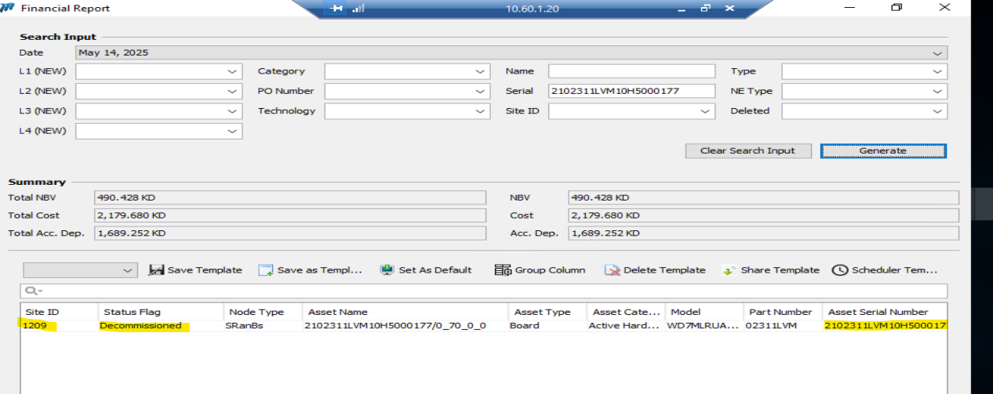

Later Inserted as Generic :

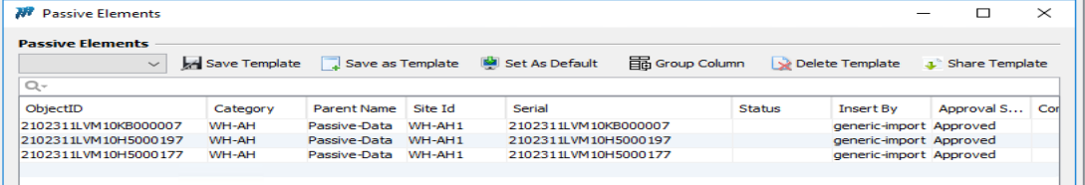

Unmapped report:

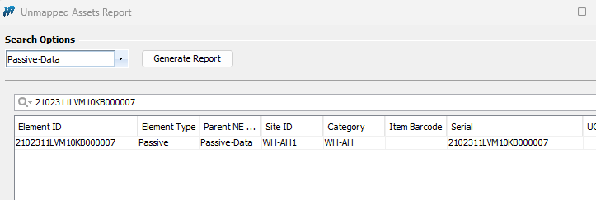

NETWORKS TRANSFORMED

Daljeet Singh Virdi| Senior Telecom Engineer
Mob: +91 9717304711
1102-1103, Tower C, Unitech Cyber Park, Gurgaon
daljeet.virdi@mobinets.com | www.mobinets.com

