

FRS for: Huawei MW

FRS (Functional Requirement Specifications)
Auto-Import

Draft version 0.1
2025-04-28

Change History

Version | Change Description | Author | Date
0.1 | First draft. | Azmat Ali | 06/05/2025

Preamble:

- This document has been created to parse Huawei U2000 MW

Parser:

1 NE details
The details below are all parsed from dump file starting with “NE_Report_XXXX”

Attribute | Importance | Comment
Name | [Mandatory] | - Can be found in column A under attribute “NE Name”  EX: KAI_9023LH_B
ID | [Mandatory] | - Can be found under attribute “NE ID”  - EX = 9-36411
Object ID | [Mandatory] | - Same as ID
Site ID | [Mandatory] | - First priority to consider site matching sheet.  - Second priority to follow the same as below.  - Take the numerical string in “NE Name” attribute & discard the other values before & after special character & spaces.  e.g -Fixe_BAR_8547 then site ID would be “8547”  = Fixe_SBO_8302 8302  = BEJ_9056-FOD-C 9056
Model | [Mandatory] | - Can be found in Column B in attribute “NE Type”
Type | [Mandatory] | =IDU
Manufacturer | [Mandatory] | Huawei
Software Version | [Mandatory] | - Can be taken from column “Software Version”
NE IP Address |  | - To be parsed from attribute “NE IP Address”
Installation Date | [Mandatory] | - Can be taken from column “Created On”

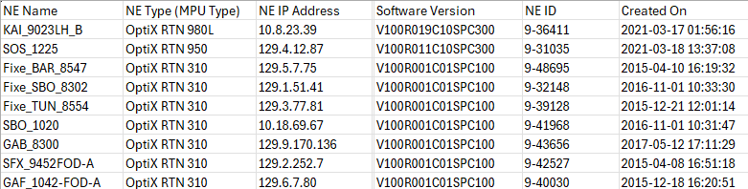

3 Physical configuration
- Parse the physical configuration from the dump name starting with “Board_Report.XXXX”
- There are multiple files with the same name, we have to parse data from all files.

3.1 Boards:
- The below table describes how to parse the boards attributes:

Attribute | Importance | Comments
Node ID | [Mandatory] | - Can be found under attribute “NE ID”  - EX = 9-36411
Cabinet index | [Mandatory] | - = 1
Shelf Index | [Mandatory] | - =1
Index on slot | [Mandatory] | - = Default index on slot = 0
Slot index | [Mandatory] | - Need to be taken under attribute “Slot ID”
Board Type | [Mandatory] | - Take the board type under attribute “Board Name”
Board Model | [Mandatory] | - Need to be taken under attribute “Board Name”
Part Number | [Mandatory] | - Need to be taken under attribute “PN(BOM Code/Item)”
Description | [Mandatory] | - Need to be taken under attribute “Description”
Date Of Manufacture | [Mandatory] | - Need to be taken from column W under attribute “Manufacture On”
Serial Number | [Mandatory] | - Need to be taken from column I under attribute “SN(Bar Code)”
Manufacturer | [Mandatory] | - Huawei
Hardware version |  | - Can be deduced from Card Report file under column Hardware Version
Software version |  | - Can be deduced from Card Report file under column Software Version
Issue Number |  | - Can be deduced from Card Report file under column Rev(Issue Number)

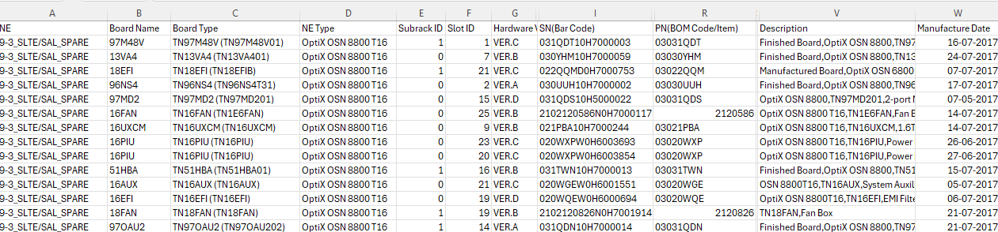

4 Logical Configuration

4.1 Transmission Link Detail

The details below are all parsed from dump file “Microwave Link Report_XX-XX-XXXX_XX-XX-XX”.

Attribute | Importance | Comment
Node 1 | [Mandatory] | - Can be found in the dumps under the label “SOURCE NE ID” .  - e.g: SOURCE NE ID ="217-2781" Node 1 is 217-2781.
Node 2 | [Mandatory] | - Can be found in the dumps under the label “SINK NE ID”  - e.g: SINK NE ID="217-15665" Node 2 is 217-15665.
Node 1 C/Sh/S/I/P | [Mandatory] | - Cabinet Index=1 by default.  - Shelf Index=1 by default.  - Index on slot=0 by default.  - Port Index can be found in the dumps under the label “Source Port” . take the value before the first “(“.  e.g: sink port=" 1(RTNIF-1)" the port number is 1  - Slot Index can be deduced from “Source Board”, take the value before the first “-“  e.g: sink board=" 6-ISV3" the slot number is 6
Node 2 C/Sh/S/I/P | [Mandatory] | - Cabinet Index=1 by default.  - Shelf Index=1 by default.  - Index on slot=0 by default.  - Port Index can be found in the dumps under the label “Sink Port” , take the value before the first “(“.  e.g: sink port=" 1(RTNIF-1)" the port number is 1  - Slot Index can be deduced from “Sink Board”, take the value before the first “-“  e.g: sink board=" 6-ISV3" the slot number is 6
Capacity | [Mandatory] | - Take Minimum value from column Source NE Ethernet Capacity (Mbit/s) & Sink NE Ethernet Capacity (Mbit/s).
E1 Capacity | [Mandatory] | - From the value of column AN “Source NE Radio Work Mode”  - The value format is “E1 Capacity , BandwidthMHz ,Modulation”  - Take the value of E1 Capacity  Ex - 2E1,56MHz,32QAM  Then E1 capacity will be = 2
Type |  | - Take the value under “Level” attribute with Huawei & discard the value after “(“ & add the deduced capacity  Eg : Hybrid(217Mbit/s)  Then type would be – Huawei Hybrid 217Mbps

4.2 MW Link Configurations

- To be parsed from Microwave Link report as follows

Attribute | Importance | Comments
Node 1 ID | [Mandatory] | - = the value of column D “Source NE ID”
Node 2 ID | [Mandatory] | - = the value of column I “Sink NE ID”
Node 1 interface id | [Mandatory] | - Cabinet id= 1  - Shelf id=1  - Slot index= from the value column E “Source Board” attribute, take the value before the first “-“  - Index on slot= 0  - Port index= from the value column F “Source Port” attribute, take the value before the first “(“
Node 2 interface id | [Mandatory] | - Cabinet id= 1  - Shelf id=1  - Slot index= from the value column J “Sink Board” attribute, take the value before the first “-“  - Index on slot= 0  - Port index= from the value column K “Sink Port” attribute, take the value before the first “(“
Modulation | [Optional] | - From the value of column AR “Source NE Radio Work Mode”  - The value format is “Capacity , BandwidthMHz,Modulation”  - Take the value of Modulation
Bandwidth | [Optional] | - From the value of column AR “Source NE Radio Work Mode”  - The value format is “Capacity , BandwidthMHz ,Modulation”  - Take the value of Bandwidth without MHz
Protection mode | [Optional] | - From the value of column N “Source Protect Type”  - If the value equals “None” protection mode = OnePlusZero  - if “1+1(HSB)” protection mode = HSB  - if “1+1(SD)” protection mode = Space Diversity  - Else generate an error “unknown protection mode (protection mode value) in for TR link (link id) in MW configuration report)
Power | [Optional] | - The value of column AT “Source NE Preset Value of Transmit Power”
TX Frequency | [Optional] | - The value of column AP “Source NE Frequency (MHz)”
RX Frequency | [Optional] | - The value of column AQ “Sink NE Frequency (MHz)”
Frequency Band | [Optional] | - Take the values of “Source Frequency (GHz)”  - In case of “0 &/” take the value from “Sink Frequency (GHz)”  If Frequency band not available in dump then follow the below rule:-  - If frequency difference is available as per below table then parse the respect frequency band value mentioned in table.  Example: As available in below snapshot frequency difference b/w TX & RX is 420 the as the table frequency band to be take 15 GHZ
   | Frequency Difference  (TX & RX) | Frequency Band  (GHZ)
   | 154 | 7
   | 266 | 13
   | 420 | 15
   | 1010 | 18
   | 1232 | 23
   | 1008 | 28
   | 1260 | 38
  10000 |  | 80
E1 capacity | [Optional] | - From the value of column AN “Source NE Radio Work Mode”  - The value format is “E1 Capacity , BandwidthMHz ,Modulation”  - Take the value of E1 Capacity  Ex - 2E1,56MHz,32QAM  Then E1 capacity will be = 2
Capacity | [Optional] | - Take Minimum value from column Source NE Ethernet Capacity (Mbit/s) & Sink NE Ethernet Capacity (Mbit/s).
AM Status | [Optional] | - From the value of column CJ “Source NE AM Status”.

4.3 VLAN
- To be parsed from SAI file which is starting from name ResouceMgr_MainTableXXXXXX.
- These files can be multiple.
- Each node interface could have more than one record in the file all the records should be considered

Attribute | Importance | Comments
Node name | [Mandatory] | - = the value of column A “NE Name”
NE id | [Mandatory] | - The ID matched with the node name from XML Network Element.
Node Interface | [Mandatory] | - Cabinet= 1  - Shelf= 1  - Slot index= the first integer (before first -) in the value of column B “Interface Name”  - Index on slot= 0  - Port index= the second integer (after the second -) in the value of column B “Interface Name”
VLANs | [Mandatory] | - From the value of column “C-VLAN”
Port Name | [Optional] | - Take value under () from column B.  - Ex : 7-EM4T-1(Fixe_Client_SOS8361_01) Fixe_Client_SOS8361_01

