Missing Ran Logical Interface issue:

As checked in the Router Builder report and found missing RAN logical interface error for the NE Name “LABS1188”.

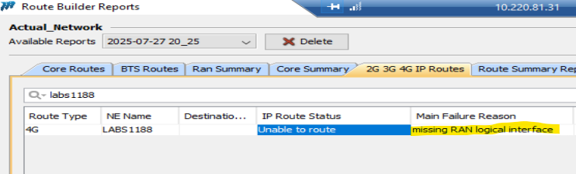

As checked in the additional information and found the Local and Remote IP’s with AdjNode:
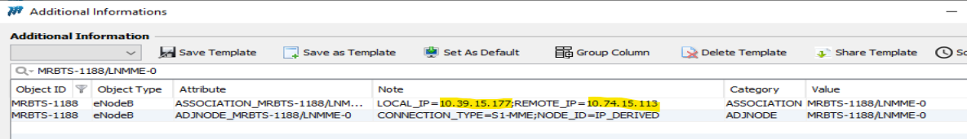

Both the IP’s are available in the IP data with corresponding node details:
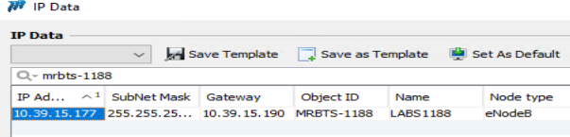

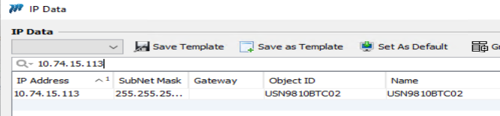
But when checked in the interface report Nodes are not coming.
Kindly check and fix the issue.
