FTTH Service Routing Implementation Using NEP Tool
The scope of this document is to outline the process for creating routing in NEP for FTTH sites by establishing a direct fiber link between the FTTH site and its associated L2 POP site. The link between the RAN site node and the POP will be based on the provided static sheet, which contains the list of FTTH sites along with their corresponding L2 POP details.

Service routing through FTTH media:
• Identification of FTTH sites operating over FTTH media.
• Validation and mapping of connectivity between FTTH media fiber links from the source node to the POP site.
• Alternate routing logic and configuration steps required to enable service flow from the RAN node to the L2 POP over FTTH media.

Solution
To address the requirement for mobility site routing where FTTH media exists between the RAN and an FTTH POP site, alternate routing logic needs to be implemented based on the following static sheet.
Sample static sheet of FTTH sites and their associated FTTH POP sites:
Circle | Source Site | Location Code | FTTH POP
AP | ATP215_AP | ANP/UGR/001 | AP-ANP/QC1-Z1
AP | BAND17_AP | HYD/3ON/901 | AP-HYD/3ON-A1
AP | BAND19_AP | HYD/3OJ/901 | AP-HYD/3OJ-A1
AP | BAND23_AP | HYD/0PC/901 | AP-HYD/0PC-H1
AP | BCH110_AP | HYD/KRR/901 | AP-HYD/KRR-A1
AP | BHL023_AP | HYD/JHC/901 | AP-HYD/JHC-H1

Routing Logic
1. If the site is available in the FTTH site static data, it must be routed as FTTH only, regardless of whether the site also has co-located MW media.
2. Create a fiber link between the Source Site (RAN) and the FTTH POP site.
3. Once the fiber connectivity is established between the Source Site and the FTTH POP site, create a service for the RAN using the existing Interface VLAN available on the RAN node.

Sample Cases and Observations
After analysis, we found that:
- In some cases, the MW IDU or UBR node is present at the source site.
- In most cases listed in the static sheet, only the RAN site is present with no MW IDU nodes.

Case 1
At the source site, the MW IDU or UBR node is present.
Example: Assam Circle – Circle AP, Source Site ID: ATP215, nearby POP site: ATP025.
Assam circle-
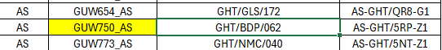
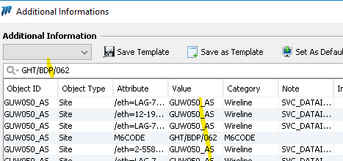
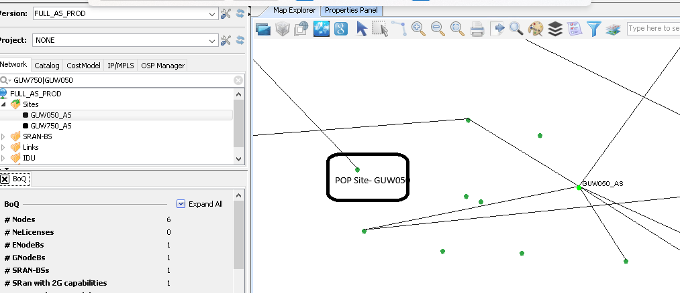

Circle -AP source site id- ATP215 and nearby pop site ATP025

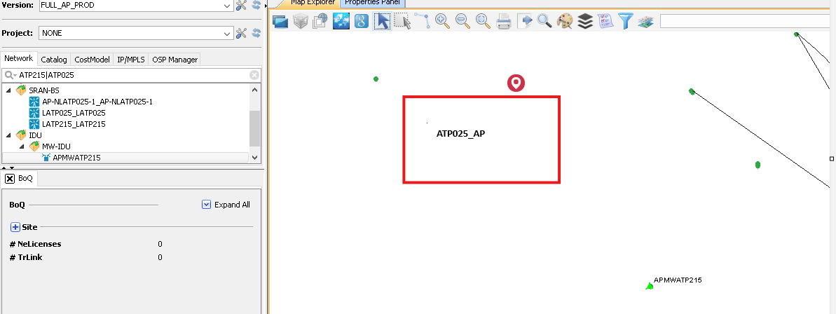

Case 2
There are no MW or UBR nodes at the source sites.
Example: Source Site ID: 10024_DL.

