As checked in the Route Builder report there is a node “LBBK0277” showing Notrouted with Main Failure Reason as “Missing Ran port @Source.

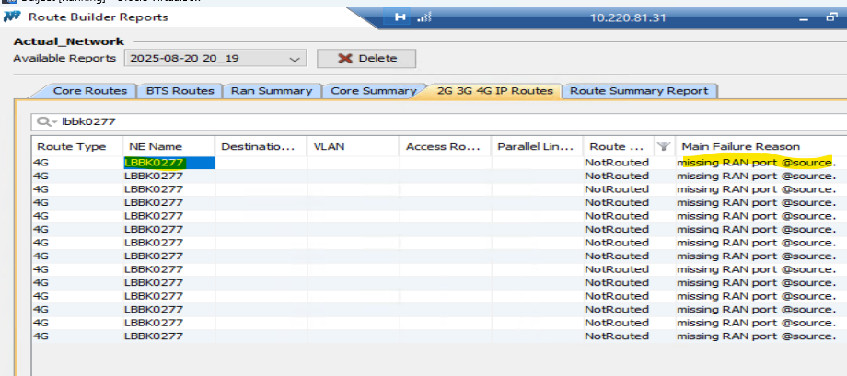

As checked in the IP Data report IP information for the node with Interface Name

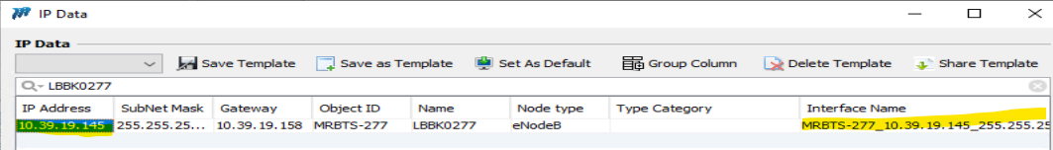
In the Interface report information available with eNodeB Port
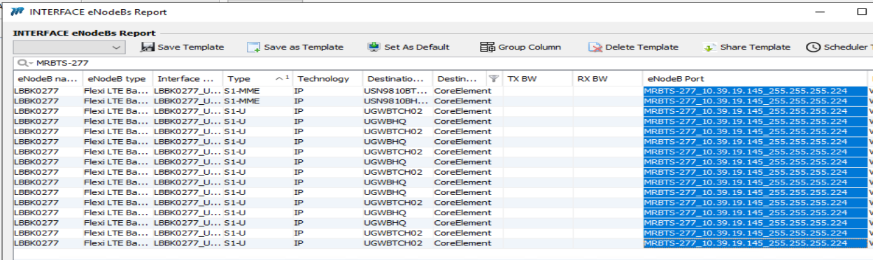

Also , checked in the Loopback , Interface is present.
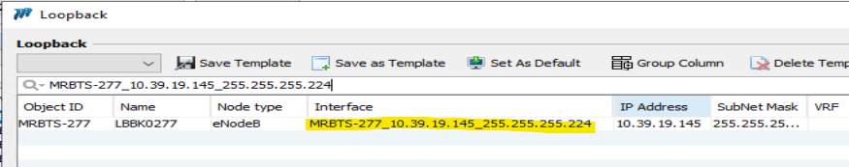

Kindly check why it is still not routed.

