Single Sign-On (SSO) Study and Setup

What is SSO?

Single Sign-On (SSO) is an authentication process that allows a user to access multiple applications with one set of login credentials. Instead of maintaining separate usernames and passwords for each application, the user authenticates once with a central Identity Provider (IdP), and all trusted applications (called Relying Parties or Clients) rely on this IdP for authentication.

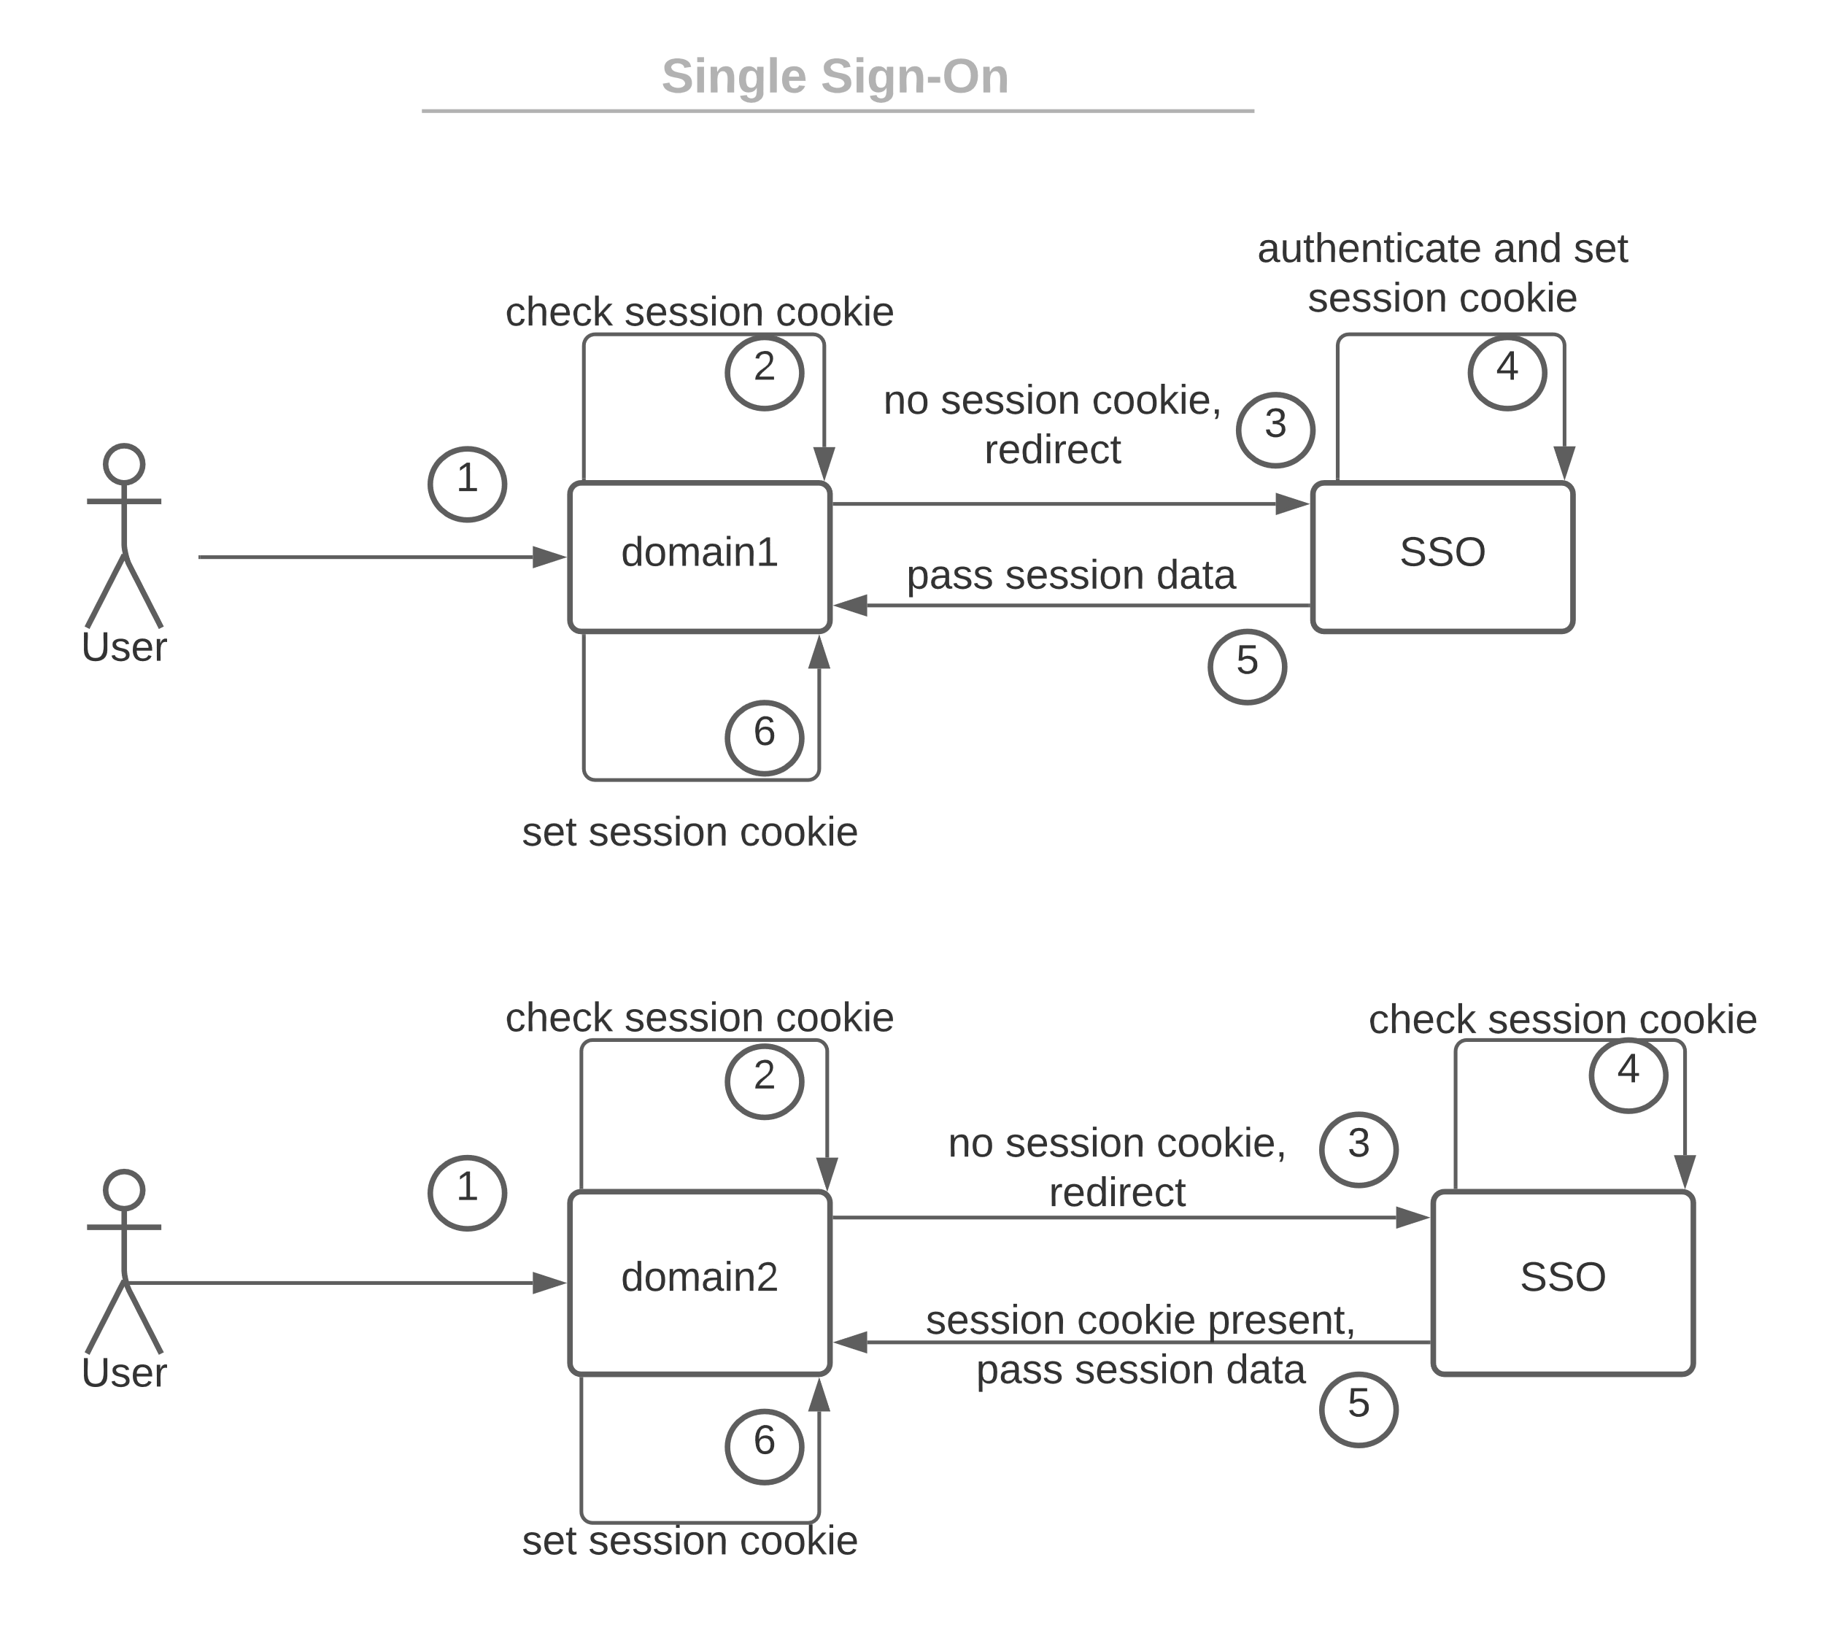

Current Authentication Flow

Currently, each application manages its own authentication independently. Each app uses Spring Security with its own login form and authentication logic.
When a user logs in, the application communicates with UA (Using REST or RMI) and retrieves a LoggedInUserInfo object. Spring Security then creates an Authentication object (UsernamePasswordAuthenticationToken) and stores it in the SecurityContext.
Session management is handled by Spring Security, where a JSESSIONID cookie is issued to the browser and tied to the user's session on the server.
In this model, sessions and cookies are application-specific. Logging into FN does not imply that the user is logged into SRD, because each application has its own session cookie and authentication mechanism.

1. User navigates to FN.
2. FN presents a login form handled by Spring Security.
3. Credentials are validated via UA.
4. UA returns LoggedInUserInfo.
5. Spring Security creates an Authentication object and stores it in SecurityContext.
6. JSESSIONID cookie is issued and tied to the user’s session.
7. Each application repeats this process separately.

Global Overview of SSO Authentication

With SSO, instead of each application authenticating users independently, authentication is delegated to a central SSO server (UA upgraded to Authorization Server).
Applications become OAuth2 / OIDC clients. They redirect unauthenticated users to the SSO server.
The SSO server manages login, sessions, and user identity. Once authenticated, the SSO server issues tokens (ID token, Access token) to the client application. Spring Security continues to manage sessions and route protection within each application as before, but authentication is delegated.

User Story: Seamless Login Across Applications

1. The user opens FN → FN redirects to SSO.
2. User logs in once at SSO → SSO sets its own session cookie.
3. User is redirected back to FN with an authorization code → FN exchanges the code for tokens and creates its own local session.
4. Later, the user opens SRD → SRD also redirects to SSO.
5. Because the browser already has the SSO session cookie, SSO recognizes the user and immediately issues tokens without showing the login page.
6. SRD creates its own local session → user is logged in seamlessly without entering credentials again.

Strategy and Protocol: OIDC with PKCE

The chosen protocol is OpenID Connect (OIDC), built on top of OAuth2. OIDC adds an ID token (JWT) that encodes user identity information. This makes it ideal for authentication.
We use the Authorization Code Flow with PKCE (Proof Key for Code Exchange), which is recommended for web and mobile applications for enhanced security.
Flow Steps:
1. Application redirects the user to /oauth2/authorize with client_id, redirect_uri, scope, state, and PKCE code_challenge.
2. User authenticates at SSO (if not already authenticated).
3. SSO issues an authorization code and redirects back to the app.
4. Application exchanges the authorization code + PKCE code_verifier at /oauth2/token.
5. Application receives ID token (identity), Access token (API access), and optionally a Refresh token.
6. Application creates a session and associates it with the user.
7. User can access protected resources.

Single Logout (SLO)

When a user logs out from one application, the logout request is propagated to the SSO server. The SSO server then invalidates its session and notifies all client applications to clear their local sessions. This ensures the user is logged out from all systems consistently.

Implementation Plan

Steps:
1. Upgrade UA to act as an OAuth2 Authorization Server + OIDC Provider.
2. Configure Applications as OAuth2 clients.
3. Replace local login forms with redirects to the SSO server.
4. Maintain Spring Security session management within each app.
5. Implement Single Logout support.
6. Test end-to-end login and logout flows.
Libraries/Tools:
- On SSO side: Spring Authorization Server.
- On Client side: Spring Security OAuth2 Client.
- Protocols: OAuth2 + OIDC + PKCE.

