API Functionality and Test Report
🔧 API Overview
The deletion process applies to all nodes and report types within the RAN and MW domains, including:
- Node types: eNodeB, gNodeB, BTS SRANBS, IDU, transmission links
- Sub-elements: boards, inventory, addinfo, IPDATA, interfaces, cells, VLANs, etc.
This API is designed to automatically delete outdated nodes associated with RAN, MW, and IDU transmission links. Nodes are considered stale when they no longer receive updates and are removed during each XML import cycle.

API detail-
This API will be added to the Cronjob list and executed accordingly. All other deletion procedures will be discontinued.
http://localhost:8090/NEP_SERVER/services/airtel/deletion/deleteRanNodes?versionName=Test_IPV6&key=y@8j-bZHqp@teHvVB3-@w?K!R5M?YX&duration=1352&nodeSize=500&isByNodeSize=true
⚙️ Working Mechanism
The deletion criteria are configurable and based on the following logic
- Count Condition: The first condition to consider is whether the count limit is set to true or false.
- If Count Condition is set to true, the following cases apply:
Case 1: Data older than X days (X configurable)
  - If the deletion is set to remove data older than X days (where the cutoff date is calculated as Today – X days, inclusive of Today) and the node count threshold is Y, deletion will proceed only if the number of nodes older than the cutoff date is less than Y.
  - Otherwise, no deletion will occur, and a warning will be logged.

Date Calculation logic-

Update duration (in days) > User-specified duration
Currently, the system only considers whole days when calculating the update duration. Any additional hours are ignored.
📌 Example:
Suppose a node was last updated 13 days and 14 hours ago. The system rounds this down to 13 days, disregarding the extra 14 hours.
Now, if the user provides a duration of 13 days, the condition becomes:
13 > 13 → which evaluates to false
As a result, the node is not deleted, even though it's technically older than 13 days.
✅ Recommended input-
To ensure the node is deleted under the current logic, the user should input 12 days instead. This way, the condition becomes:
13 > 12 → which evaluates to true
And the node will be deleted as expected.

Case 2: Delete all data except today’s date (Duration = 0)
  - If the deletion is set to remove all data except today’s date and the node count threshold is Y, deletion will proceed only if the number of nodes older than the cutoff date is less than Y.
  - Otherwise, no deletion will occur, and a warning will be logged.
- If Count Condition is set to false, deletion will occur according to the configured duration (i.e., older than X days) without checking the node count threshold.

🧪 Testing Summary
Environment: JK Circle Production, API for 15 days executed on 10th September 2025.
Result: API performed as expected, successfully deleting outdated nodes.
Evidence: Supporting screenshots from PROD are attached below for reference.
Reports Reviewed:
- Role 5G Report
- gNodeB Report
- Role 4G Report
- eNodeB Report
- BTS and Role 2G Report
- Transmission Link Report
- IDU Report

Role 5G report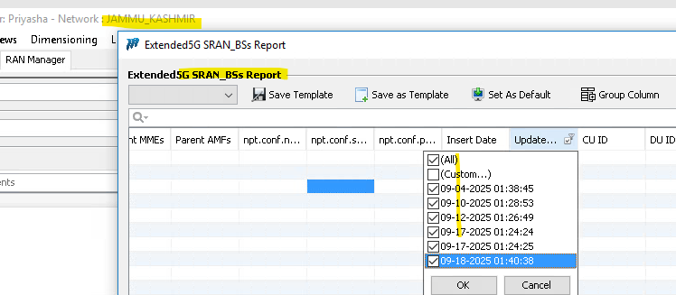

GnodeB Report-
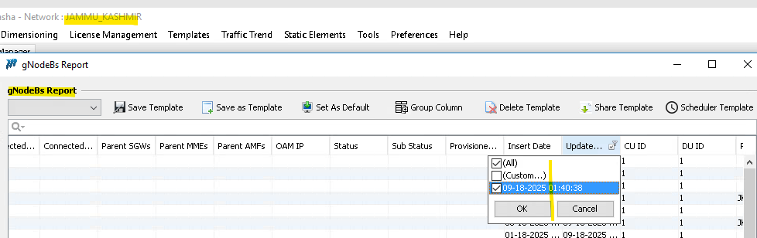

Role4G Report-

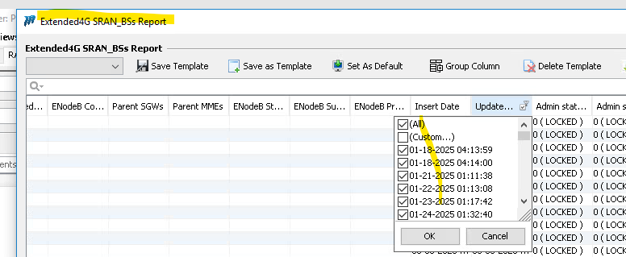

Exception case-
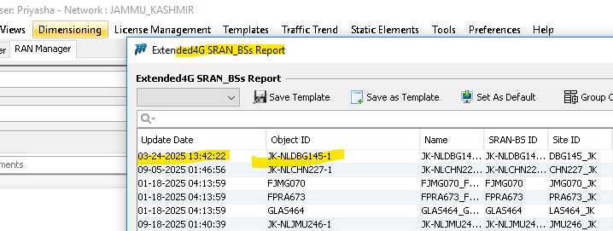
Sample Node- JK-NLDBG145-1, its parent node is getting updated in SRAN BS report snap below
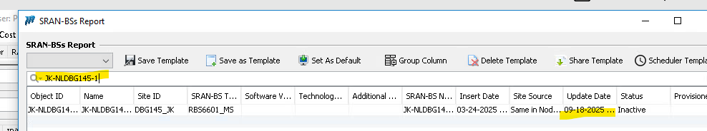

ENODEB REPORT

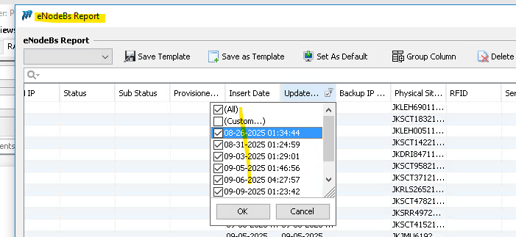

BTS AND ROLE 2G

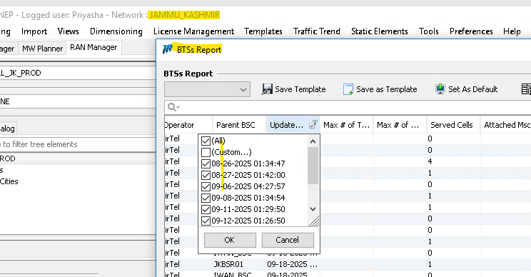
Transmission Link-
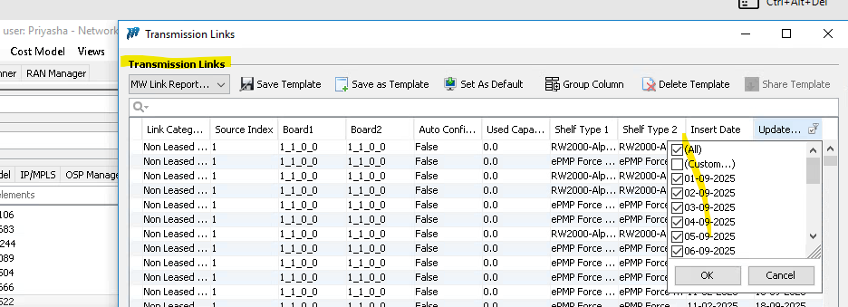
IDU REPORT-
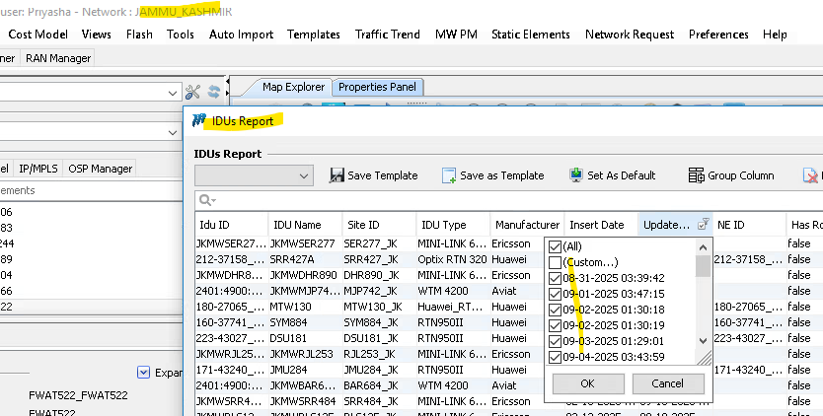

📌 Important Note
1- Tracking Deleted Elements
- Deleted nodes and links can be tracked via logs
- Use keywords like "Deleted" and "to delete" to identify deletions

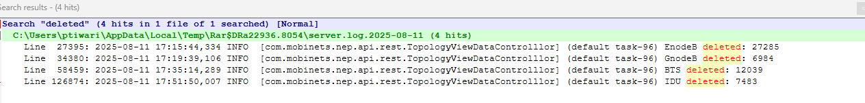

2-Sub-element Deletion Dependency
- If sub-elements (e.g., cell, board, IP data, VLAN) are not deleted, it may be because their parent node is still updating.
- Refer to the exception case and screenshots for illustration
3- Patch is ready for Production ..

