

NSN 5G Parsing

FRS (Functional Requirement Specifications)
Auto-Import
Draft version 0.7
2025-09-16

Change History

Version | Change Description | Author | Date
0.1 | First draft. | Indrasan Yadav | 2025-09-16

PREAMBLE
- This document specifies how to parse the logical inventory attributes for gNodeB and its cells.
- It covers the parameters defined for gNodeB RAN logical attributes.
- The provided dump files are of “.xml” format for each node.
  - File will be name of node id like “MRBTS115228”.

- This is motivated by Ooredoo Tunisia Projects and can be used for other operators having same file structure in case of 5G.

Connector name
NSN_RAN_Ooredoo Tunisia

Connector Information
- The dump file is an “.xml” file composed of set of Managed Objects for each node.
- Each Managed Object starts with “<managedObject “and ends with “</managedObject>”.
- Inside each managed object, there is a Tag name, followed by “attributes” and finally by the different set of parameters with their values.

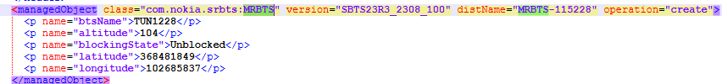

GNODEB logical parameters
The gNodeB logical inventory attributes are classified accordingly in the below categories:
  - Global Parameters
  - Networking Parameters
  - Cell Parameters

- Note: The internal mapping between the Physical and Logical parameters will be based on the Node ID.

Global Parameters
The below global attributes defined at gNodeB level are as follows:

Class=“MRBTS”

Attributes | Importance | Example
Site Name/Site ID | [Mandatory] | - Please follow section 9 in physical FRS.
Node ID | [Mandatory] | - = “distName” attribute under the <managedObject Tag with having the “class” attribute = “NRBTS”.  - E.g.: <managedObject class="com.nokia.srbts.nrbts:NRBTS" version="NRBTSCL24R2_2404_130" distName="MRBTS-515870/NRBTS-115870" operation="create">  gNodeB ID = NRBTS-115870
Name | [Mandatory] | “Name” OR <p name="btsName"> attribute in the same class=”MRBTS.
gNodeB Name | [Mandatory] | The value of an attribute: <p name="gNbCuName"> under class=”NRBTS”.  Example: <p name="gNbCuName">TUNN870</p>  Note: If class”NRBTS” is not found please consider the attribute “name” from class=”MRBTS”.
Type | [Mandatory] | - Model of that gNodeB  - If Model not found Type will be “NSN gNodeB”
OAM IP | [Optional] | - Mplane IP parsing rule under section 5 and take IP address
OAM Subnet Mask | [Optional] | - Mplane IP parsing rule under section 5 and take subnetmask for that IP address

Networking Parameters
The below networking attributes defined at gNodeB level are as follows:

Attributes | Importance | Example
MCC | [Mandatory] | - The value of an attribute <p name="mcc"> under the “class”=“NRBTS”  E.g.: name= <p name="mcc">605</p>  - The “name” attribute mentioned under same class=”NRBTS” refers the node name.
MNC | [Mandatory] | - The value of an attribute <p name="mnc"> under the “class”=“NRBTS”  E.g.: name= <p name="mnc">3</p>  - The “name” attribute mentioned under same class=”NNRBTS” refers the node name.
TAC list | [Optional] | - =NEP tool calculated, TAC list of children cells.
Served Cells | [Optional] | - NEP tool calculated.
DU ID | [Optional] | - “gNbDuId” attribute under class=”NRDU”
CU ID | [Optional] | - "gNbCuUpId" attribute under class=”NRCUUP”
Status
Parent AMFs | [Optional] | the value of " “amfName” _”amfIPAddress" in class=“ SERVEDAMF”, If amfName or amfIPAddress is not available put blank value for the same.

Cell Logical Parameters

Attributes | Importance | Comment
Node ID | Mandatory | - In class=”NRBTS” under attribute below:  distName="MRBTS-515870/NRBTS-115870/NRCELL-11"  - Node ID = MRBTS-515870
Parent Site ID | Mandatory | - (NEP tool calculated) OR Site id of parent node.
Cell ID | Mandatory | - It is the value of an attribute <p name="physCellId"> under class=”NRCELL”.  - Exp: <p name="physCellId">561</p>
Cell Name | Mandatory | - The value of attribute <p name="cellName"> under class=”NRBTS”  - Exp: <p name="cellName">TUNN870F11</p>  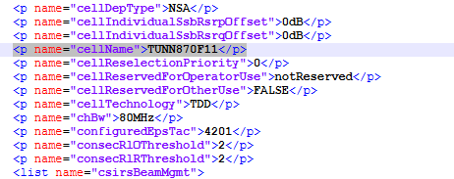
Display Name/Cell Object Id | Mandatory | - Concatenate of the value <p name="physCellId"> attribute <p name="nrCellIdentity"> under class=”NRCELL” with a special character “_”.  - <p name="physCellId">561</p>  - <p name="nrCellIdentity">1898414091</p>  - E.g.: 561_1898414091
External Code | Mandatory | - Is the concatenation of “gnodeBID”, “_” and “Cell Object ID”.  - E.g. NRBTS-115870_561_1898414091
Cell Technology | Mandatory | - NR
MCC | [Mandatory] | - The same as described under section-4.2.
MNC | [Mandatory] | - The same as described under section-4.2.
Neighbor Cells 2G | Optional | - NULL

- Specific attributes for 5G cells
Attributes | Example | Comments
Cell Duplexing Mode | Mandatory | - under class=“NRCELL”  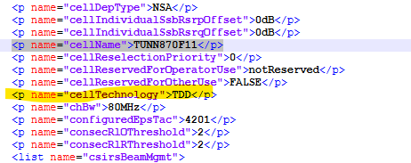  If “cellTechnology”>FDD< Duplexing Mode= FDD  If “cellTechnology”>0< Duplexing Mode= FDD  If “cellTechnology”>TDD< Duplexing Mode= TDD  If “cellTechnology”>1< Duplexing Mode= TDD
PCID | Mandatory | - Under Class=”NRCELL” name=" physCellId”  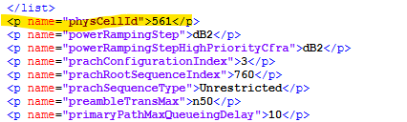  - "E.g.: <PhysCellId>561</PhyCellId>
TAC lD | Mandatory | - Under: Class=”NRCELL” An attribute  - <p name="configuredEpsTac">4201</p>
Downlink Bandwidths | Mandatory | - For FDD:  Match the distname of class=”NRCELL” with class=”NRCELL_FDD”  - It is found Under : Class=”NRCELL_FDD” name=" chBwDl "  E.g.: name=" chBwDl ">20MHz</p>  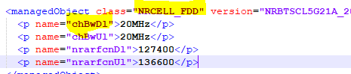  - For TDD:  Match the distname of class=”NRCELL” with class=”NRCELL_TDD”  - it will be found under class=”NRCELL_TDD” ” name=" chBwDl "  E.g.: name=" chBwDl ">200</p>  - Divide the value of dlChBw/ChBw by 10 to obtain  Downlink Bandwidth E.g.: name="ChBw">200</p>  Then bandwidth will be 20  If “NRCELL_TDD” not found for the distname get the value of  Attribute “chBw” that will be downlink Bandwidth  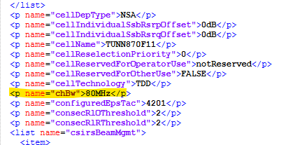  - Divide the value of dlChBw/ChBw by 10 to obtain  Downlink Bandwidth E.g.: name="ChBw">80MHz</p>  Then Downlink Bandwidth will be 8.
Uplink Bandwidths | Mandatory | - For FDD:  Match the distname of class=”NRCELL” with class=”NRCELL_FDD”  - It is found Under : Class=”NRCELL_FDD” name=" chBwUl "  E.g.: name=" chBwUl ">20MHz</p>  - For TDD:  Match the distname of class=”NRCELL” with class=”NRCELL_TDD”  - it will be found under class=”NRCELL_TDD” ” name=" chBwUl "  E.g.: name=" chBwUl ">200</p>  - Divide the value of chBwUl /ChBw by 10 to obtain  Uplink Bandwidth E.g.: name="ChBw">200</p>  Then Uplink bandwidth will be 20  If “NRCELL_TDD” not found for the distname get the value of  Attribute “chBw” that will be downlink Bandwidth  - Divide the value of chBwUl /ChBw by 10 to obtain  Uplink Bandwidth E.g.: name="ChBw">80MHz</p>  Then Uplink bandwidth will be 8.
Downlink Narfcn | Mandatory | - For FDD:  Match the distname of class=”NRCELL” with class=”NRCELL_FDD”  - It is found Under : Class=”NRCELL_FDD” name=" nrarfcnDl"  E.g.: name="nrarfcnDl">127400</p>  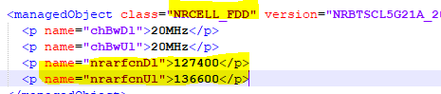  - For TDD:  Match the distname of class=”NRCELL” with class=”NRCELL_TDD”  - it will be found under class=”NRCELL_TDD” ” name=" nrarfcnDl "  E.g.: name="nrarfcnDl">127400</p>  So, downlink NARFCN will be “127400”  If “NRCELL_TDD” not found for the distname get the value of  Attribute “nrarfcn” that will be downlink Bandwidth  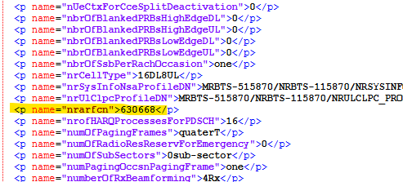  So, downlink NARFCN will be “630668”
Uplink Narfcn | Mandatory | - For FDD:  Match the distname of class=”NRCELL” with class=”NRCELL_FDD”  - It is found Under : Class=”NRCELL_FDD” name=" nrarfcnDl"  E.g.: name="nrarfcnUl">127400</p>  So Uplink NARFCN will be 136600  - For TDD:  Match the distname of class=”NRCELL” with class=”NRCELL_TDD”  - it will be found under class=”NRCELL_TDD” ” name=" nrarfcnDl "  E.g.: name="nrarfcnUl">127400</p>  So Uplink NARFCN will be “127400”  If “NRCELL_TDD” not found for the distname get the value of  Attribute “nrarfcn” that will be downlink Bandwidth  So, Uplink NARFCN will be “630668”
MIMO configuration | Mandatory | - For FDD: Following the value of “dlMimoMode”, the “MIMO configuration” will be deduced.  - “dlMimoMode” is found under Class=”NRCELL” name="dlMimoMode"  - E.g.: name="dlMimoMode">40</p>  OR  E.g.: name="dlMimoMode">4x4 or 4x2 Closed Loop Spatial Multiplexing</p>  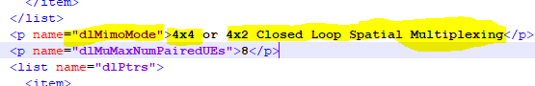  - For TDD: Following the value of <p name="dlMimoMode">, the “MIMO configuration” will be deduced under class=“NRCELL”.  - E.g.: <p name="dlMimoMode">8x4 Closed Loop Spatial Multiplexing</p>  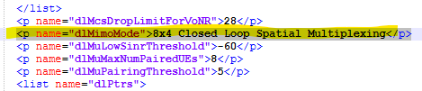  If this value is in numeric form, then follow the following:  Below mapping to be used to get mimo configuration from dlMimoMode  - 0 : SingleTX;  10 : TXDiv;  11 : 4-way TXDiv;  30 : Dynamic Open Loop MIMO;  40 : Closed Loop Mimo;  41 : Closed Loop MIMO (4x2);  43 : Closed Loop MIMO (4x4)  50: MASSIVEMIMO_SINGLE_BEAM_64x64  60: MASSIVEMIMO_DUAL_BEAM_64x64  70: Closed Loop Spatial Multiplexing_8x4
Cell Status | Mandatory | - Under each Cell of a gnodeB (Class= “NRCELL”)  - Take the value from attribute <p name="administrativeState">Locked</p>  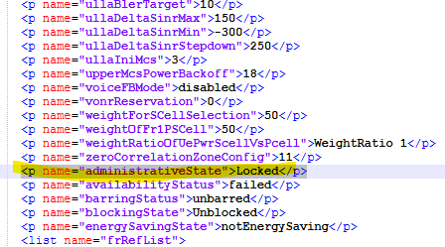  - If value is equal to Unlocked, then the Cell will be in ACTIVE state.  - If value is equal to Locked, then the Cell will be in HALT state.  - If value is coming in Numeric below mentioned mapping is there:
  Value | Name
  0 | Locked
  1 | Shutting Down
  2 | Unlocked
Manufacturer | Optional | - Nokia
maximumTransmissionPower | Mandatory | Get the value of attribute “pMax” under class=”NRCELL” and divide it by 10.  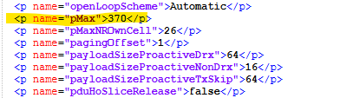  So maximumTransmissionPower will be: 37
NR GSCN | Mandatory | Get the value of attribute <p name="gscnOrSsPbchArfcn">7798</p> under class=”NRCELL”  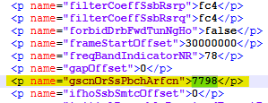  So, NR GSCN will be 7798
Cell Type | Mandatory | Get the value of attribute “nrCellType” under class=”NRCELL”  And map the value as per given below table:  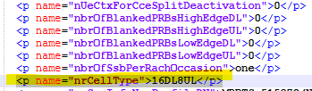  If it is in numeric format the following are:  So, Cell Type will be 4DL2UL
  Value | Name
  20 | 2DL0UL
  21 | 2DL1UL
  22 | 2DL2UL
  24 | 2DL4UL
  42 | 4DL2UL
  44 | 4DL4UL
  82 | 8DL2UL
  84 | 8DL4UL
  88 | 8DL8UL
  164 | 16DL4UL
  168 | 16DL8UL
  1616 | 16DL16UL
RSI | Mandatory | Get the value of attribute “prachRootSequenceIndex” under class=”NRCELL”  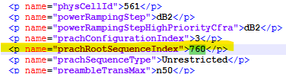  So, the RSI will be “760”
Azimuth | Optional | Get the value of attribute “antBearing” from class=”RAEU_R” after cell to AMT mapping given in section 4.4.  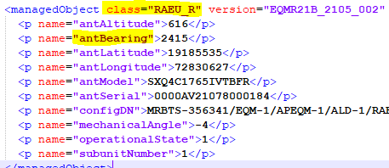  So, Azimuth will be 2415
M Tilt | Optional | Get the value of attribute “mechanicalAngle” from class=”RAEU_R” after cell to AMT mapping given in section 4.4.  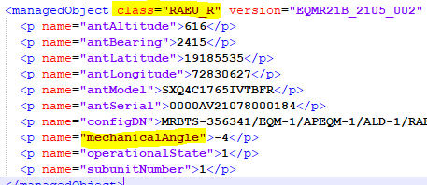  So, M Tilt will be “-4”
Antenna Height(m) | Optional | Get the value of attribute “antAltitude” from class=”RAEU_R” after cell to AMT mapping given in section 4.4.  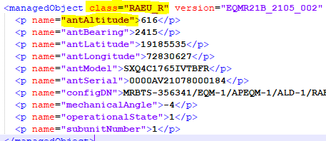  Devide “antAltitude” value by 10  So Antenna Height(m) will be “61.6”
AMT Operational State | Optional | Get the value of attribute “operationalState” from class=”RAEU_R” after cell to AMT mapping given in section 4.4.  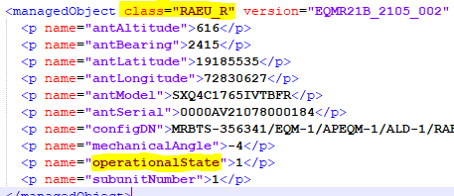  So AMT Operational State will be “1”
AMT Model No | Optional | Get the value of attribute “antModel” from class=”RAEU_R” after cell to AMT mapping given in section 4.4.  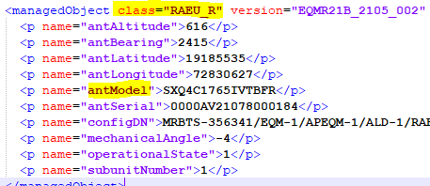  So AMT Model No will be “SXQ4C1765IVTBFR”
AMT Serial No | Optional | Get the value of attribute “antSerial” from class=”RAEU_R” after cell to AMT mapping given in section 4.4.  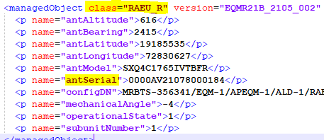  AMT Serial No will be “0000AV21078000184”
AMT Make | Optional
RET E Tilt | Mandatory | Get the value of attribute “tiltOffset” under class=”NRCELL”  And map the value as per given below table:  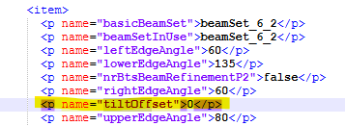  So, RET E Tilt will be 6
  Value | Tilt Value
  -4 | 2
  -3 | 3
  -2 | 4
  -1 | 5
  0 | 6
  1 | 7
  2 | 8
  3 | 9
  4 | 10
  5 | 11
  6 | 12
  7 | 13
  8 | 14
RET Operational state | Optional | Get the value from RET Operational state Section 4.5
Antenna Model | Optional
Beamset | Mandatory | - under class=“NRCELL” get the value of “beamSetInUse” as Beamset  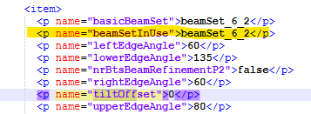
Cell radius | Optional
SSB Power | Mandatory | - under class=“NRCELL” get the value of “ssPbchBlockPower” as SSB Power  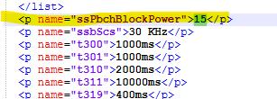
SSB power Boost | Mandatory | - under class=“NRCELL” get the value of “ssPbchBlockPower” as SSB Power Boost
Sub frame configuration | Mandatory | - under class=“NRCELL” get the value of “frameStructureType” as Sub frame configuration  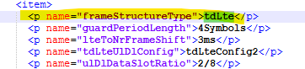
Special sub frame configuration | Mandatory | under class=“NRCELL” get the value of “ulDlDataSlotRatio” as Special sub frame configuration  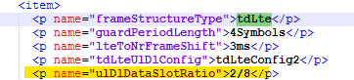
RU Model | Optional | - Check attribute value “name="rModDNList">” under class=” NRCELL”  So value got from the rule is “MRBTS-365006/EQM-1/APEQM-1/RMOD-1”  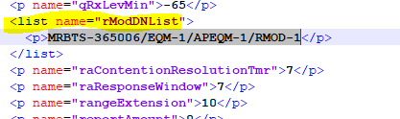  - Match the value got from Step-1 with "configDN" attribute under class=”RMOD_R” and if matched get the value of attribute “productName” from class=”RMOD_R” as RU Model.  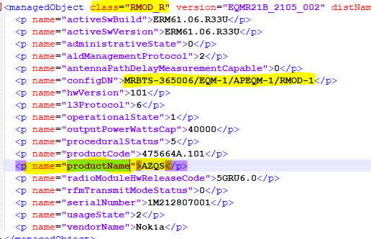  So, RU Model will be: “AZQS”
RU serial number | Optional | - Check attribute value “name="rModDNList">” under class=” NRCELL”  So value got from the rule is “MRBTS-365006/EQM-1/APEQM-1/RMOD-1”  - Match the value got from Step-1 with "configDN" attribute under class=”RMOD_R” and if matched get the value of attribute “serialNumber” from class=”RMOD_R” as RU Model.  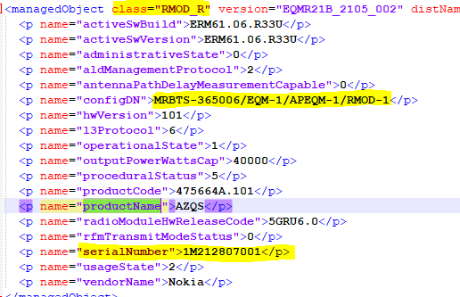  So, RU serial number will be: “1M212807001”
GPS Longitude | Optional | Get the value of attribute  <p name="gnssAntennaLongitude">102936311</p>  from class=”GNSSE_R”.  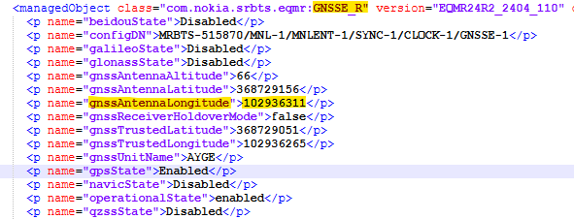  Rule of conversion  - Unit in dump = 1/10,000 arc-seconds.  - 1 degree = 3,600 arc-seconds.  - So, to convert to decimal degrees (°):  Decimal Degrees=Value/ (10,000×3600)  Exp:  gnssAntennaLatitude = 368729156  Latitude= (368729156)/ (10000×3600)  = (368729156)/ (36000000)​  = 10.2424776°  Latitude ≈ 10.24248°
GPS Latitude | Optional | Get the value of attribute  <p name="gnssAntennaLongitude">102936311</p>  from class=”GNSSE_R”.  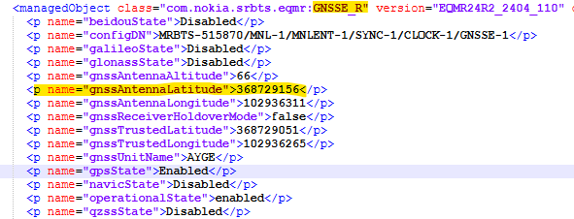  Rule of conversion  - Unit in dump = 1/10,000 arc-seconds.  - 1 degree = 3,600 arc-seconds.  - So, to convert to decimal degrees (°):  Decimal Degrees=Value/ (10,000×3600)  Exp:  gnssAntennaLongitude = 102936311  Longitude= (102936311)/ (10000*3600)  = (102936311)/ (36000000)  = 2.85934197°  Longitude ≈ 2.85934°

Cell to AMT mapping: (Ignore for now)

- Check attribute value “name="rModDNList">” under class=” NRCELL”

So attribute value is “MRBTS-356341/EQM-1/APEQM-1/RMOD-1” from the rule

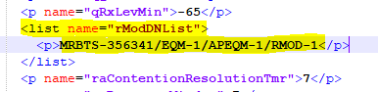

- Match attribute value got from Step-1 with attribute name="firstEndpointDN" under class="LOGLINK" i.e. “MRBTS-356341/EQM-1/APEQM-1/RMOD-1/RSL-1” we can ignore RSL-1 while matching

- Get the value of name="secondEndpointDN" from same class after matching found from above. So secondEndpointDN value will be MRBTS-356341/EQM-1/APEQM-1/ALD-1

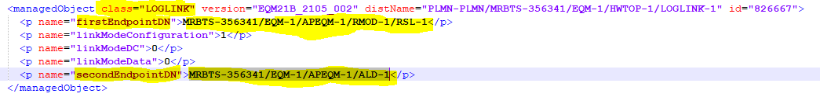

- Match the attribute value got from Step-3 i.e. MRBTS-356341/EQM-1/APEQM-1/ALD-1 with attribute "configDN" under class=” RAEU_R”

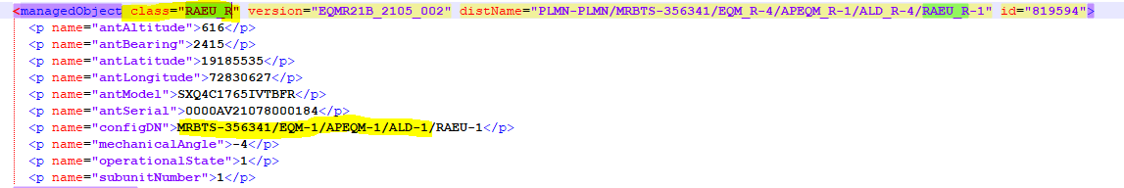

- Get the required attributes from this class=”RAEU_R” with respect to cell after mapping

Cell to RET Mapping: (Ignore for now)

RET parameter will parse as below.
- From class=”NRBTS” take MRBTS for that node.

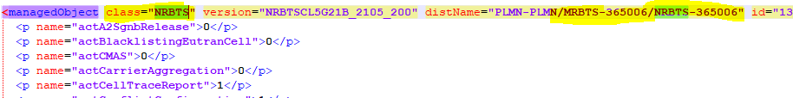

- check class=”NRCELLL” for that NRBTS

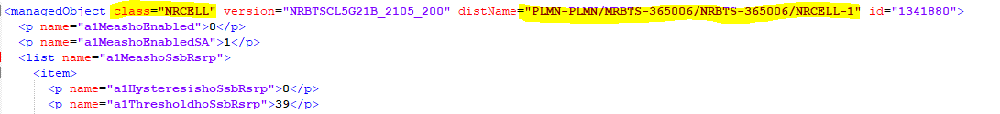

- From the above step we got “NRCELL-1” so we match “LCELNR-1” in distName under class= “CHANNEL”

Example:

distName="PLMN-PLMN/MRBTS-365006/MNL-1/MNLENT-1/CELLMAPPING-1/LCELNR-1

under class”CHANNEL” take attribute name=”antlDN”

example:

<p name="antlDN">MRBTS-365006/EQM-1/APEQM-1/RMOD-1/ANTL-1</p>

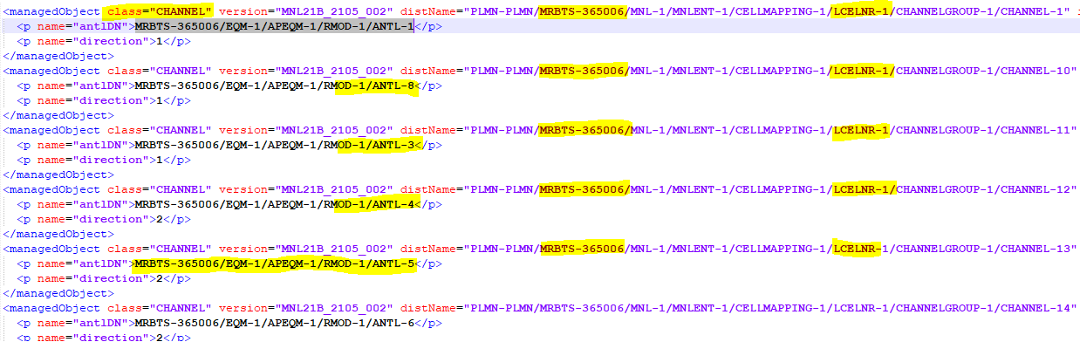

If antlDN did not found take attribute “ressourceDN”.

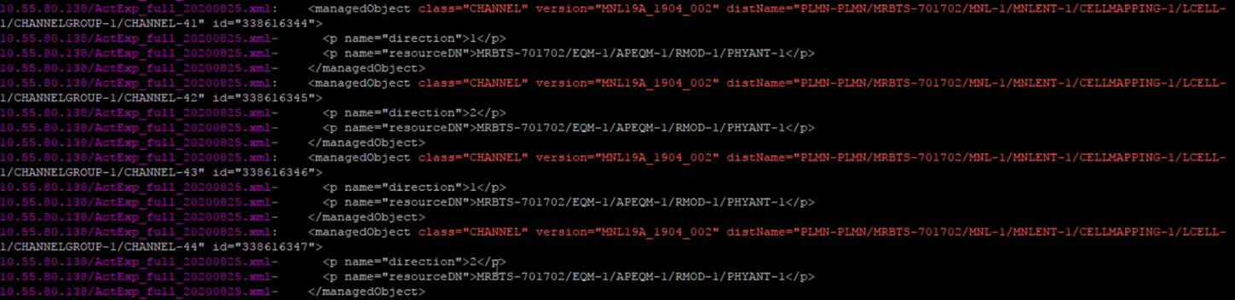

- Match ” antlDN” value got from Step-3 with “configDN” attribute under class=”ANTL_R” , if matched get distName of class=”ANTL_R” starts from MRBTS

i.e. MRBTS-365006/EQM_R-4/APEQM_R-1/RMOD_R-1/ANTL_R-1

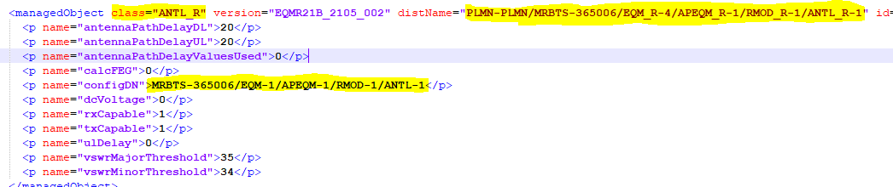

- Match distName value got from Step-4 with “antlDNList” values under class “RETU_R” for same MRBTS,

SS:-

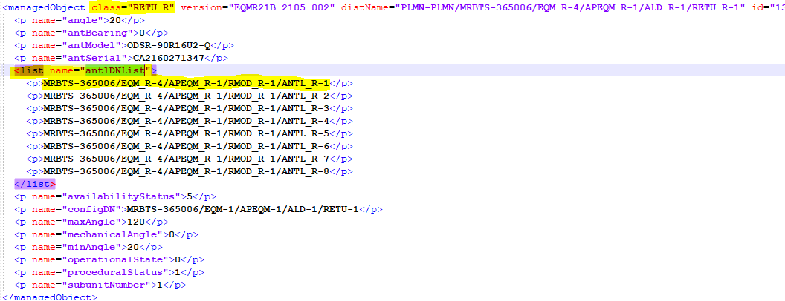

- If Matched get the values of attributes from class=”RETU__R”
This is how cell will map to RETU_R class.

- Below attributes will taken from class=”RETU_R as per step 7.

Object Type | Category | Attribute | Value
NR CELL | RET | RET E Tilt
NR CELL | RET | Max E Tilt
NR CELL | RET | Min E Tilt
NR CELL | RET | RET Operational state
NR CELL | RET | Ret Subunit iD
NR CELL | RET | RET Antenna Model
NR CELL | RET | RET Antenna Serial Number
NR CELL | RET | RET Antenna Group

- Below is attribute and dumps mapping: -

Attribute | Parameters detail
RET E Tilt | angle
Max E Tilt | maxAngle
Min E Tilt | minAngle
RET Operational state | operationalState
Ret Subunit iD | subunitNumber
RET Antenna Model | antModel
RET Antenna Serial Number | antSerial
RET Antenna Group | antlDNList

IP Parsing gNodeB and description

x2Uplane/x2Cplane and s1Uplane IP parsing:

Interface | Full Form (Description) | Plane | Used For | Protocol
X2-U | X2 User Plane | User (data) | Data forwarding eNB↔eNB / eNB↔gNB | GTP-U/UDP
X2-C | X2 Control Plane | Control (signaling) | Handover prep, dual connectivity, coordination | SCTP/IP
S1-U | S1 User Plane | User (data) | Data transport eNB ↔ EPC SGW | GTP-U/UDP

Note: X2-U & S1-U are same so we can consider any one of them.

- To be parsed from class=“NRBTS”, where the disttname will as below:
<managedObject class="com.nokia.srbts.nrbts:NRBTS" version="NRBTSCL24R2_2404_130" distName="MRBTS-515870/NRBTS-115870" operation="create">
where NRBTS-115870 represent the gNodeB ID

Value of <p name="ipV4AddressDN1"> under attribute <list name="x2Uplane">, <list name="s1Uplane"> and <list name="x2Cplane"> under class="NRBTS" and mapping can be done with class="IPADDRESSV4_R"

Step-1: get the value of "ipV4AddressDN1" under s1Uplane, x2Uplane and x2Cplane respectively.

i.e.:

MRBTS-515870/TNLSVC-1/TNL-1/IPNO-1/IPIF-5/IPADDRESSV4-1 under s1Uplane

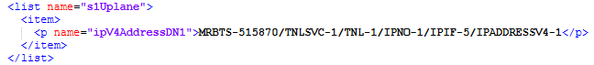

MRBTS-515870/TNLSVC-1/TNL-1/IPNO-1/IPIF-5/IPADDRESSV4-1 under x2Uplane

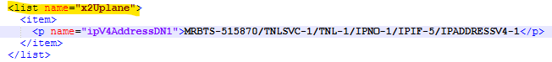

MRBTS-515870/TNLSVC-1/TNL-1/IPNO-1/IPIF-4/IPADDRESSV4-3 under x2Cplane

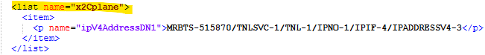

Step-2: search the value of "ipV4AddressDN1" which is got from step-1 in the distname of class="IPADDRESSV4_R" and get the IP address from attribute “localIpAddrAllocated” under class="IPADDRESSV4_R"

For: MRBTS-515870/TNLSVC-1/TNL-1/IPNO-1/IPIF-5/IPADDRESSV4-1 under s1Uplane &
MRBTS-515870/TNLSVC-1/TNL-1/IPNO-1/IPIF-5/IPADDRESSV4-1 under x2Uplane

For: MRBTS-515870/TNLSVC-1/TNL-1/IPNO-1/IPIF-4/IPADDRESSV4-3 under x2Cplane

Step 3: For VLAN, take the value of "ipV4AddressDN1" got in step-1 till IPIF value i.e. MRBTS-515870/TNLSVC-1/TNL-1/IPNO-1/IPIF-5 and same will be search in distname of class=”IPIF” and get the value of attribute <p name="interfaceDN">.

i.e. <p name="interfaceDN">MRBTS-515870/TNLSVC-1/TNL-1/ETHSVC-1/ETHIF-1/VLANIF-4</p>

Step-4: Search the value of attribute <p name="interfaceDN"> got in step-3 in distname of class=”VLANIF” and get the value of vlanId i.e. 33.

So, the VLAN will be 33 for this IP.

Step-5: for subnet search the value of "ipV4AddressDN1" got in step-1and match with distname of class="IPADDRESSV4”

i.e. MRBTS-515870/TNLSVC-1/TNL-1/IPNO-1/IPIF-5/IPADDRESSV4-1

match the value of localIpAddr value with IP address got in step-2, if both are same get the value of subnet mask from attribute “localIpPrefixLength” from class=” IPADDRESSV4”

Physical port

Attributes | Importance | Parsing
Interface Name | [Mandatory] | - =Physical port
Node ID | [Mandatory] | - = from the distName
Physical Port C/Sh/S/I/P | [Mandatory] | - To be provided later.
IP address | [Optional] | - = attribute "localIpAddr"
Subnet Mask | [Optional] | - = attribute " localIpPrefixLength "
VLAN | [Optional] | - = attribute " vlanId"
Gateway | [Optional] | - From class=“ IPRT_R”  - Deduce the range of IP from attribute <p name="gateway"> and attribute <p name="destinationIpPrefixLength">.  - Match the above IP address with the deduce range of IP  - When matched take Gateway = attribute "gateway"  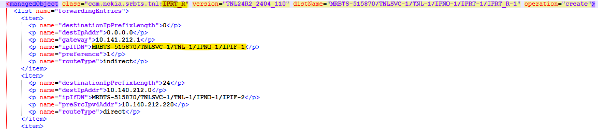
Description | [Optional] | - The value of attribute below in class=”VLANIF” against given VLAN.  - <p name="userLabel">OM</p>

IP Parsing SRAN

Physical port “SBTS” (Ignore for now as No SBTS class)

- To be parsed from class=“IPIF”, where the distName="PLMN-PLMN/SBTS-xxx/TNL-y/IPNO-z/IPIF-x where xxx represent the node ID and each x represent an interface

Attributes | Importance | Parsing
Interface Name | [Mandatory] | - =Physical port
Node ID | [Mandatory] | - = from the distName
Physical Port C/Sh/S/I/P | [Mandatory] | - To be provided later.
IP address | [Optional] | - = attribute "localIpAddr"
Subnet Mask | [Optional] | - = attribute "localIpPrefixLength"
VLAN | [Optional] | - = attribute "vlanId" under class=“VLANIF”  - Matching is described in below snapshot
Gateway | [Optional] | - From class=“RTPOL”  - Match deduced IP address above with attribute "srcIpAddress"  - Take the attribute "routingTablePtr" for the deduced "srcIpAddress"  - From class=“IPRT” Put the value of "routingTablePtr" in distName="PLMN-PLMN/SBTS-5672/TNL-1/IPNO-1/Value_OF_routingTablePtr”  - Gateway= attribute "gateway"

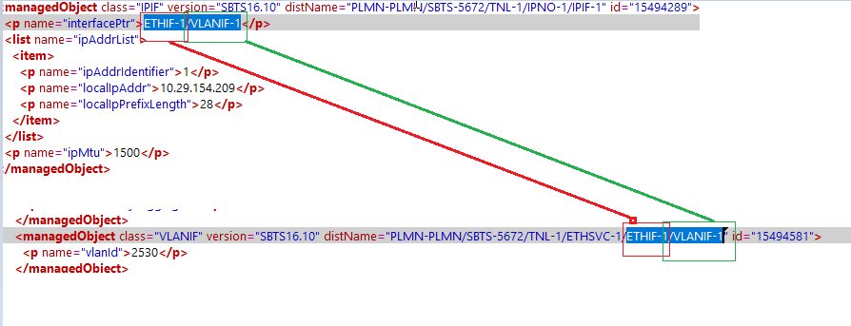

Physical Port “MRBTS” version “SBTS

Attributes | Importance | Parsing
Interface Name | [Mandatory] | - =Physical port
Node ID | [Mandatory] | - = from the distName
Physical Port C/Sh/S/I/P | [Mandatory] | - To be provided later.
IP address | [Optional] | - = attribute "localIpAddr"
Subnet Mask | [Optional] | - = attribute " localIpPrefixLength "
VLAN | [Optional] | - = attribute " vlanId"
Gateway | [Optional] | - From class=“ IPRT_R”  - Deduce the range of IP from attribute <p name="gateway"> and attribute <p name="destinationIpPrefixLength">.  - Match the above IP address with the deduce range of IP  - When matched take Gateway = attribute "gateway"
Description | [Optional] | - The value of attribute below in class=”VLANIF” against given VLAN.  - <p name="userLabel">OM</p>

IP description Logic: (Describe in starting under section-5)

CPLANE and UPLANE:

- Get IP Address from class=” IPADDRESSV4” and class=”IPADDRESSV6”

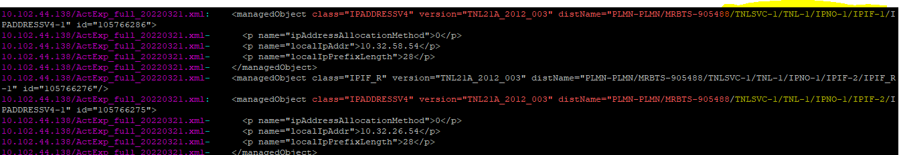

- Match the section from above class start by MRBTS till IPIF in the distname example “MRBTS-905488/TNLSVC-1/TNL-1/IPNO-1/IPIF-2” with value under attribute “cPlaneipV4AddressDN1, ipV4AddressDN1 and ipV6AddressDN1” under the class “class="TRSNW"” where the distname start with “PLMN-PLMN/MRBTS-ID

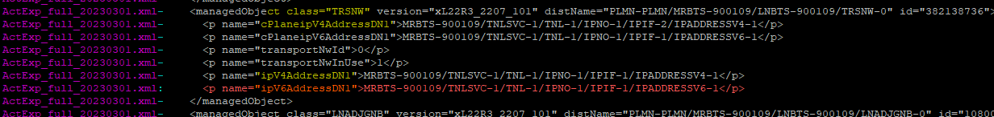

So Description of IP address matched distname with given below attributes will be:

Attribute | IP Description
cPlaneipV4AddressDN1 | CPLANE
ipV4AddressDN1 | UPLANE
ipV6AddressDN1 | ENB-ENDC

MPLANE:

- Match the section from IPADDRESSV4 class start by MRBTS till IPIF in the distname example “MRBTS-905488/TNLSVC-1/TNL-1/IPNO-1/IPIF-3” with value under attribute “mPlaneIpv4AddressDN” under the class “class=" MPLANENW"” where the distname start with “PLMN-PLMN/MRBTS-ID

So Description of IP address matched distname with given below attributes will be:

Attribute | IP Description
mPlaneIpv4AddressDN | MPLANE

ABIS and BTS-MPLANE:

IP which are not able to get description from above 2 points, search the IP from class=”BCF” under attribute btsCuPlaneIpAddress and btsMPlaneIpAddress.

If IP available under btsCuPlaneIpAddress class IP description will be “ABIS”
If IP available under btsMPlaneIpAddress class IP description will be “BTS-MPLANE”

x2Uplane and s1Uplane IP parsing:

Description of IP will be as follows:

IP got from s1Uplane: NR-UPLANE
IP got from x2Uplane: NR- ENDC

- To be parsed from class=“NRBTS”, where the distName=" PLMN-PLMN/MRBTS-1585637/NRBTS-XXX where xxx represent the gNodeB ID

Value of name=" ipV6AddressDN1 under attribute name="x2Uplane">, name="s1Uplane"> under class="NRBTS" and mapping can be done with class="IPADDRESSV6_R"

Step-1: get the value of ipV6AddressDN1 under x2Uplane and s1Uplane

i.e.:

MRBTS-365006/TNLSVC-1/TNL-1/IPNO-1/IPIF-1/IPADDRESSV6-1

IPV6:

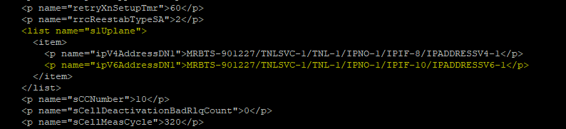

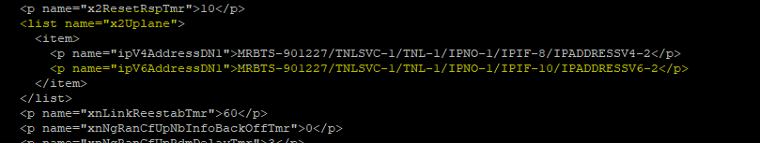

Step-2: search the value of ipV6AddressDN1 got from step 1 in the distname of class="IPADDRESSV6_R" and get the IP address from attribute “localIpAddrAllocated” under class="IPADDRESSV6_R"

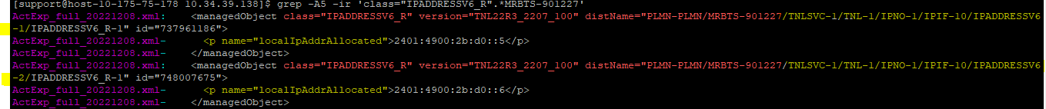

Step 3: for vlan search the value of =" ipV6AddressDN1" got in step no 1 till IPIF value i.e. “MRBTS-901227/TNLSVC-1/TNL-1/IPNO-1/IPIF-10” in distname of class=”IPIF” and get the value of attribute “interfaceDN"

i.e. MRBTS-901227/TNLSVC-1/TNL-1/ETHSVC-1/ETHIF-1/VLANIF-10

Step-4: search the value of attribute “interfaceDN" got in step 3 in distname of class=”VLANIF” and get the value of vlanId i.e. 3050.

So vlan will be 3050 for the IP

Step-5: for subnet search the value of “ipV4AddressDN1” got in STEP 1and match with distname of class="IPADDRESSV6”

i.e. MRBTS-365006/TNLSVC-1/TNL-1/IPNO-1/IPIF-1/IPADDRESSV6-1

match the value of localIpAddr value with IP address got in step no 2, if both are same get the value of subnetmask from attribute “localIpPrefixLength” from class=” IPADDRESSV6” or class=” IPADDRESSV4”

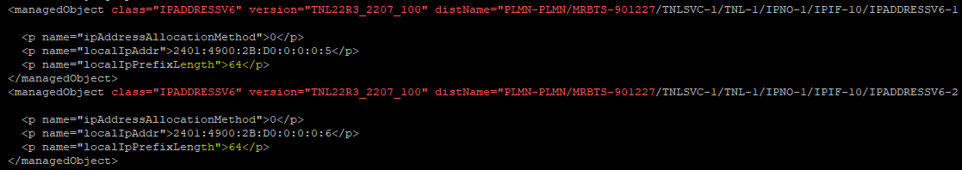

Additional info for gNodeB (Ignore for now as no SA-gNodeB)

6.2 NR-S1-U

- This section related to MRBTS dump which contain class=”NRBTS”
- From class=“NRBTS”, from the distName="MRBTS-515870/NRBTS-115870" where after “NRBTS-” parse the gNodeB ID.
- Value of name=“ipV4AddressDN1”under attribute name="s1Uplane"> under class="NRBTS" and mapping can be done with class="IPADDRESSV4_R"

Step-1: Get the value of “ipV4AddressDN1” under <list name="s1Uplane">

i.e. MRBTS-515870/TNLSVC-1/TNL-1/IPNO-1/IPIF-5/IPADDRESSV4-1

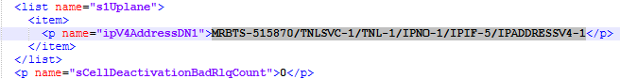

Step-2: Search the value of “ipV4AddressDN1” got from step-1 in the distname of class="IPADDRESSV4_R" and get the IP address from attribute “localIpAddrAllocated” under class="IPADDRESSV4_R"

- In the same class take the Local_IP from the attribute " localIpAddrAllocated "
- From class="GTPU", where the distName="PLMN-PLMN/MRBTS-365006/NRBTS-XXX/SERVEDAMF-Y" where xxx is the gNodeB ID, each Y represent an additional info
- From the same class, each attribute "sgwIpAddress" represent one remote IP, increase the attribute of the additional info by 1 for each remote IP

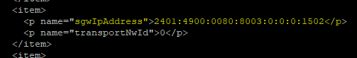

Category | Value | Note
ADJNODE | MRBTS-ID/GTPU-Y | - CONNECTION_TYPE=NR-S1-U  - NODE_ID= IP_DERIVED
ASSOCIATION  // 1st association // | MRBTS-ID/GTPU-Y | - LOCAL_IP= the value of " localIpAddrAllocated " in class="IPADDRESSV6_R" or  REMOTE_IP= the value of "sgwIpAddress" in class=“ GTPU”

6.3 Lat/Long parsing rule gnodeB

Under <managedObject class="GNSSE_R" take value of <p name="gnssAntennaLatitude"> for latitude and <p name="gnssAntennaLongitude"> for Longitude and divide it with 10 million (10^7).
Take the corresponding value of parent node for MRBTS.

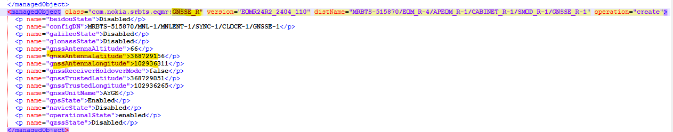

Category | Attribute | Value
gnodeb | latitude | Value of latitude
gnodeb | longitude | Value of longitude

5G Cell to RRU Mapping

- From class=”NRBTS” take MRBTS for that node.

- check class=”NRCELL” for that MRBTS

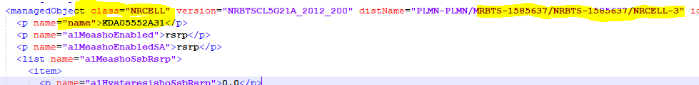

- From the above step we got “NRCELL-3” so we match “LCELNR-3” in distName under class= “CHANNEL”

Example:

distName="PLMN-PLMN/ MRBTS-1585637/MNL-1/MNLENT-1/CELLMAPPING-1/LCELNR-3

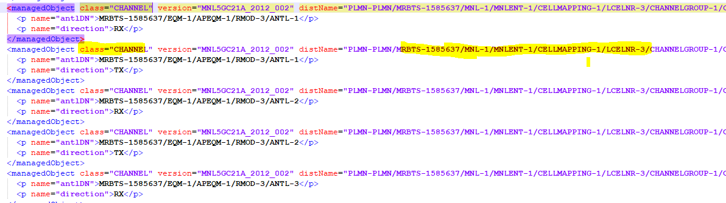

under class”CHANNEL” take attribute name=”antlDN”

example:
<p name="antlDN">MRBTS-1585637/EQM-1/APEQM-1/RMOD-3/ANTL-1</p>

If antlDN did not found, take attribute “ressourceDN”.

- under class”CHANNEL” take attribute name=”antlDN”/resourceDN till RMOD type, and match it with attribute name=”configDN” under class= ”RMOD_R”

so, we match attribute like given below screenshots:

name=”antlDN

<p name="antlDN">MRBTS-1585637/EQM-1/APEQM-1/RMOD-3

name=”configDN”

i.e. <p name="configDN"> MRBTS-1585637/EQM-1/APEQM-1/RMOD-3</p>

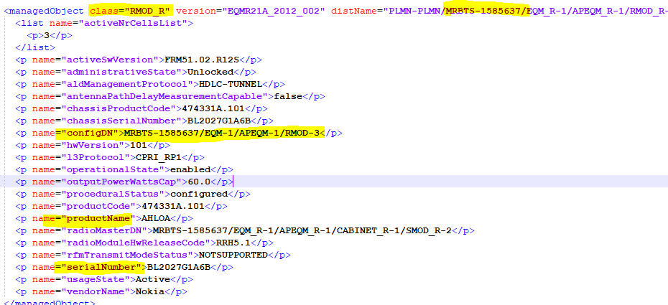

For cell to RRU mapping from class="RMOD_R”, parse the value of name="productName" in RU Model and name="serialNumber" in Serial Number of additionalinfo.

Object ID | Object Type | Attribute | Value | Category
CELLID | NRCell | Serial Number | Value of SerialNumber: Value of SerialNumber | RADIO
CELLID | NRCell | RU Model | Value of productName: Value of productName | RADIO

Physical Site ID

- Get the value of “siteTemplateName” attribute under class=”NRBTS” and map with the node.

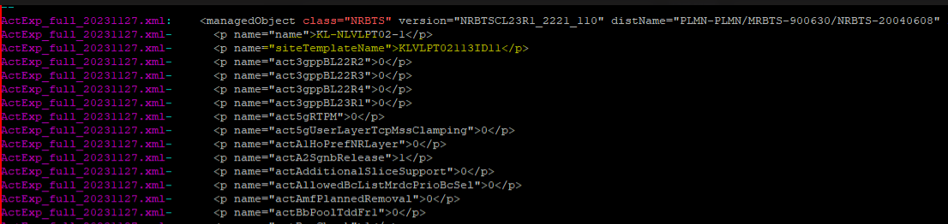

- So Physical Site ID will be: KLVLPT02113ID11

elementId | elementType | attribute | Value | category | note
MRBTS-123 | gNodeB/SRAN | Physical Site Id | Value of attribute “siteTemplateName” | Physical Site

Additional info for sranbs

7.2 NR-S1-U

- This section related to MRBTS dump which contain class=”NRBTS”
- From class=“NRBTS”, from the distName="MRBTS-515870/NRBTS-115870" where after “NRBTS-” parse the gNodeB ID.
- Value of name=“ipV4AddressDN1”under attribute name="s1Uplane"> under class="NRBTS" and mapping can be done with class="IPADDRESSV4_R"

Step-1: Get the value of “ipV4AddressDN1” under <list name="s1Uplane">

i.e. MRBTS-515870/TNLSVC-1/TNL-1/IPNO-1/IPIF-5/IPADDRESSV4-1

Step-2: Search the value of “ipV4AddressDN1” got from step-1 in the distname of class="IPADDRESSV4_R" and get the IP address from attribute “localIpAddrAllocated” under class="IPADDRESSV4_R"

- In the same class take the Local_IP from the attribute " localIpAddrAllocated "
- From class="GTPU", where the distName="PLMN-PLMN/MRBTS-365006/NRBTS-XXX/SERVEDAMF-Y" where xxx is the gNodeB ID, each Y represent an additional info
- From the same class, each attribute "sgwIpAddress" represent one remote IP, increase the attribute of the additional info by 1 for each remote IP

Category | Value | Note
ADJNODE | SRAN-ID/GTPU-Y | - CONNECTION_TYPE=NR-S1-U  - NODE_ID= IP_DERIVED
ASSOCIATION  // 1st association // | eNodeB-ID/GTPU-Y | - LOCAL_IP= the value of " localIpAddrAllocated " in class="IPADDRESSV6_R" or  REMOTE_IP= the value of "sgwIpAddress" in class=“ GTPU”

