Solution Design for NEP Service Routing Enhancement



Revision Log

Version | Date | Author | Summary of Change
1.0 | 2025-08-22 | Mobinets Product Team | Initial engineering response

Table of Contents
1 Executive Overview 3
2 Network Topology Gap Remediation (Pre-Processing Workflow) 4
3 Access Layer Adaptation Logic 5
3.1 FTTH-based Sites 5
3.2 Non-Routed RAN 6
4 Core Routing Continuity 7
5 Data Integration and Quality Assurance 7
6 How the Solution Meets Each Requirement 8

Executive Overview
This document presents the technical approach for improving NEP service routing in Airtel's network.
The solution introduces a topology gap-remediation workflow, adapts the access routing logic for FTTH and MW segments, and preserves existing routing mechanisms for wireline and IP cloud domains.
The new implementation is designed to:
- Automate detection of incomplete or incorrect routes.
- Create missing network elements (dummy NEs) and links where required.
- Validate and correct POP site definitions and associations.
- Ensure service continuity from RAN site to Core.
- Complete end-to-end path discovery from RAN → MW → POP → Wireline → IP Cloud → Core.

This approach will standardize and simplify routing corrections, ensuring that all service flows are consistently connected to the core. It specifically resolves the following five cases where issues are commonly observed:
- RAN–MW Topology Not Stitched
- MW–MW Topology Missing
- POP Site Missing or Mismatch Issue
- Service VLAN Missing on Routing Path
- Core Details Missing

Network Topology Gap Remediation (Pre-Processing Workflow)
Before any routing calculations, the network model will be enhanced via a dedicated pre-processing stage:
- Three static sheets will be ingested:
  - one for FTTH POP sites
  - one for FTTH connectivity
  - and one for RAN/MW/core relationships
- Missing elements (FTTH POPs, MW nodes, Fiber & MW links, Radio Controllers/Core Elements) will be automatically created in NEP, ensuring that all required entities and associations are present.
- Dummy network elements definition will be created in NEP Catalog and linked as needed to complete the physical/logical topology.
Prerequisites for Pre-Processing
- Static sheets: Up-to-date FTTH and MW/core mapping files in XLSX format
- All POP sites, MW sites, wireline, and IP cloud data available and categorized in NEP
- NE catalog definitions for dummy types
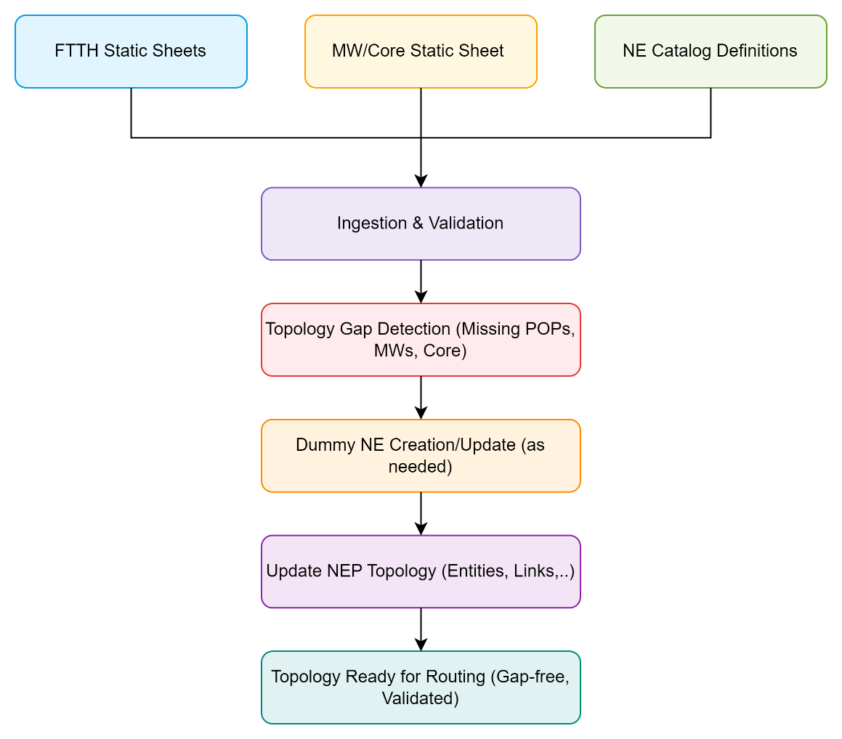

Access Layer Adaptation Logic
With a complete topology, the routing engine will adapt its workflow for the access layer (the segment between source and POP):

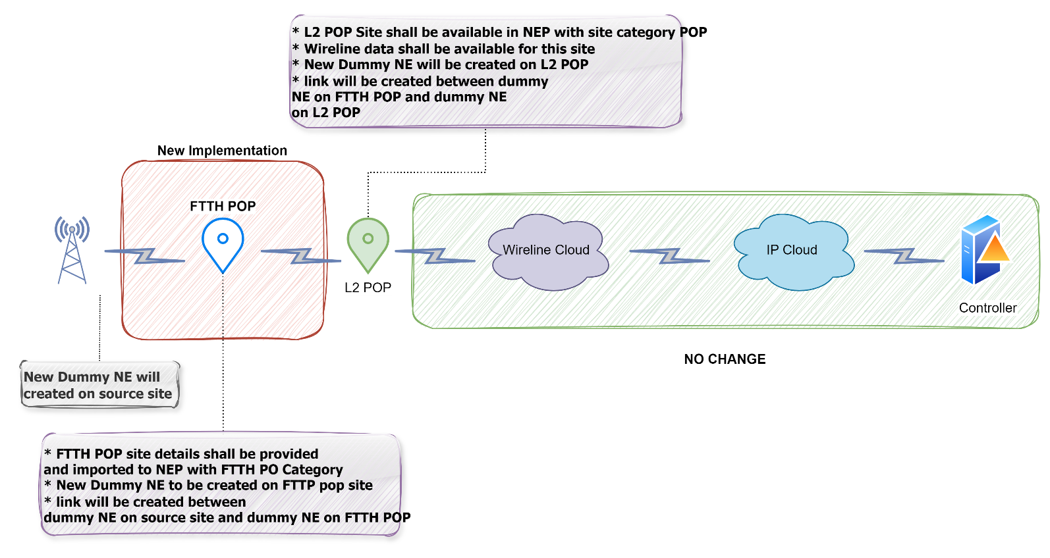
FTTH-based Sites
- Source Site:
  - A new Dummy NE will be created at the Source Site.
  - This dummy NE represents the logical device at the source (ex: cell site router, ONU, or base station node).
  - This will be used to establish a link with the next hop site (FTTH POP).
- FTTH POP Site:
  - FTTH POP Site details to be provided and imported into NEP under a new category FTTH POP.
  - At this FTTH POP, another new Dummy NE will be created.
  - A link will be created between Dummy NE on the Source Site, and Dummy NE on the FTTH POP Site.
  - This link simulates the fiber connection between source and FTTH aggregation.
- L2 POP Site:
  - L2 POP Site should be already available in NEP (under category POP).
  - A new Dummy NE will be created at the L2 POP Site.
  - A link will be created between Dummy NE at FTTH POP and Dummy NE at L2 POP
  - This simulates the dummy transport link from FTTH aggregation to L2 aggregation

- Wireline Cloud (same as current implementation, no change):
  - Once traffic reaches the L2 POP, it is carried further into the Wireline Cloud.
  - Wireline data must be available in NEP for this site.
- IP Cloud (same as current implementation, no change):
  - From the Wireline Cloud, traffic is routed into the IP Cloud (IP/MPLS core).
- Controller (same as current implementation, no change):
  - Finally, traffic is terminated at the Controller
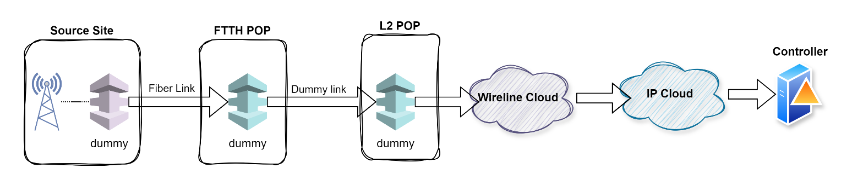

Non-Routed RAN
To address non-routed RAN sites, the solution incorporates a decision logic based on PCM path analysis and service type, utilizing static sheet data for authoritative topology updates:
- MW Link Evaluation:
  - If a MW link exists between two consecutive sites in the PCM path, no remediation action is needed, and the route builder continues as normal.
  - If no MW link is present, the system will:
    - Create dummy IDUs for each involved site.
    - Establish a dummy MW link between these dummy IDUs, ensuring logical connectivity in the NEP topology.
  - In scenarios where both a dummy and a real IDU exist on the same site (as indicated by static sheet requirements), create a dummy MW link to represent internal logical connectivity.
- POP Site Categorization:
  - All POP sites provided in the static sheet are updated or created in NEP with the category “POP.”
  - The static sheet is considered the authoritative source; its data supersedes other sources for POP markings.
- RAN Logical Interface & Parent Element Restoration:
  - For RAN nodes lacking a logical interface or parent element:
    - 2G (Abis): Create a dummy BSC (Base Station Controller) with the same name as the RAN node and assign the logical interface.
    - 3G (Iub): Create a dummy RNC (Radio Network Controller) with the same name and assign the logical interface.
    - 4G (S1-MME/S1-U): Create a dummy core element with the same name and assign the logical interface.
  - This ensures that every RAN node, regardless of physical or logical gaps, is properly linked for service routing.
- Dummy NE Cataloging:
  - All dummy network elements (IDU, MW link, BSC, RNC, core element, etc.) created through this process will be defined in the NEP element catalog to maintain consistency and allow for accurate reporting and management.

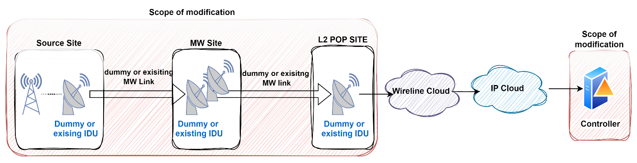
This targeted remediation ensures that previously isolated or incomplete RAN sites are rendered fully routable, with all necessary logical and physical associations in place, leveraging static sheet data as the master for network corrections.

Core Routing Continuity
No changes will be made to the routing algorithms governing wireline and IP cloud segments. These components will continue to operate on the improved topology, ensuring seamless service flow from access through core.

Data Integration and Quality Assurance
- The solution will be integrated into NEP’s existing workflow, leveraging bulk data import and automated validation routines.
- All dummy and real network entities will be checked for consistency and completeness before activating routing updates.
- Reporting modules will reflect the new entities and paths, supporting route tracing and service validation.

How the Solution Meets Each Requirement
Requirement | Solution Mapping
Automated FTTH Service Routing | The pre-processing workflow uses the FTTH static sheet to identify all FTTH POPs and connections, populates NEP with missing FTTH POPs and dummy NEs, and links them as needed. The routing logic adapts only the access segment, using static data to ensure correct POP selection for FTTH access.
Dummy MW Site Correction | A dedicated static sheet will provide exact site-to-IDU matching for the auto-discover module. During pre-processing, this data will be loaded to replace dummy MW nodes/sites with accurate site IDs and connections. The auto-discovery module will use this mapping to ensure all MW elements are mapped to the correct site.
Non-Routed RAN Site Restoration | The pre-processing step ensures all MW, POP, and core data is present using both static sheets. The routing engine is able to deduce and route previously isolated RAN sites by leveraging the now-complete topology. Dummy or real MW links are created as needed, and logical interfaces are updated in the catalog for RAN access.
Reporting Accuracy | All new and updated entities are reflected in NEP’s reporting modules, including path tracing and service validation. This ensures visibility of routing improvements.
Minimal Change to Wireline/IP Logic | Except for the adapted deduction of access paths (FTTH/MW), no change is made to wireline or IP cloud routing logic. The solution preserves existing routing algorithms for these segments, maintaining operational stability while improving access routing.

- This approach ensures that routing gaps are remediated prior to route computation, with minimal disruption to existing backend logic.
- The process is extensible for future topology enhancements or new access media types.

End of the Document

