Core Node Categorization in NEP
It is required to create new reports in NEP as per Core Node Categories. The new Reports will be added to NEP actual version as well as Planning version of Production server.
Path for new Reports
Transport NetworkReportingNetwork Elements
New Reports are as follows with rules

CS Core Report
This report will include all the CoreElement nodes from CoreElements Report where the Type Category is “CS Core”.
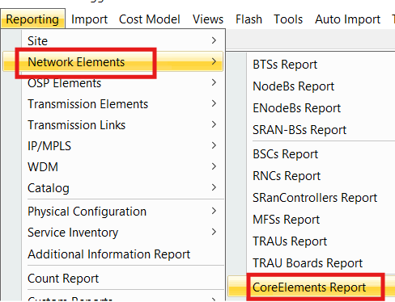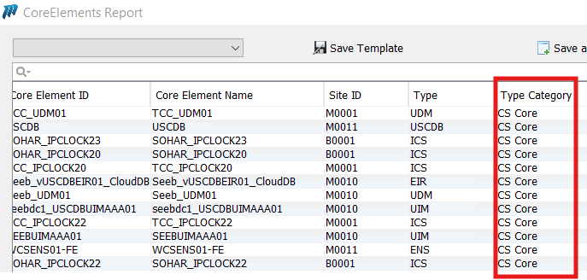
The Nodes from MGW, MSS and HSS reports also will be added to CS Core Report
Below are the attributes need to be added to new “CS Core Report”
Node ID | NE Type
Node Name | Node Type
Site ID | Vendor

Attribute Parsing Rule
Attribute Name in CS Core Report | CoreElements Report | MSSs Report | MGWs Report | HSSs Report
Node ID | Core Element ID | Object ID | Object ID | Object ID
Node Name | Core Element Name | MSS Name | MGW Name | HSS Name
Site ID | Site ID | Site ID | Site ID | Site ID
NE Type | Type | MSS Type | MGW Type | HSS Type
Node Type | If the NE is parsed from CoreElements Report then Node Type CoreElement  If the NE is parsed from MSSs Report then Node Type MSS  If the NE is parsed from MGWs Report then Node Type MGW  If the NE is parsed from HSSs Report then Node Type HSS
Vendor | Vendor | Vendor | Vendor | Vendor

PS Core Report

This report will include the CoreElement Nodes from CoreElements Report where the Type Category is “PS Core”.
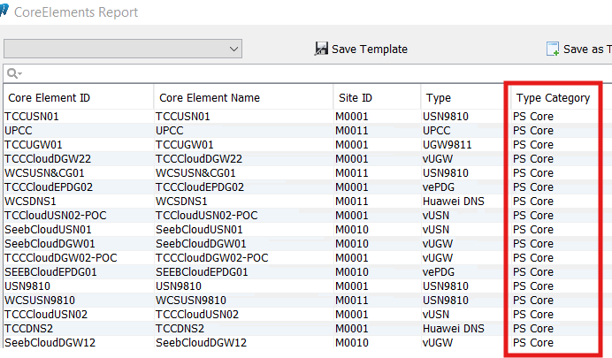
Below are the attributes need to be added to new “PS Core Report” Report.
Node ID | NE Type
Node Name | Node Type
Site ID | Vendor

Attribute Parsing Rule
Attribute Name in PS Core Report | CoreElements Report
Node ID | Core Element ID
Node Name | Core Element Name
Site ID | Site ID
NE Type | Type
Node Type | CoreElement
Vendor | Vendor

IMS Core Report
This report will include the CoreElement Nodes from CoreElements Report where the Type Category is “IMS Core”.
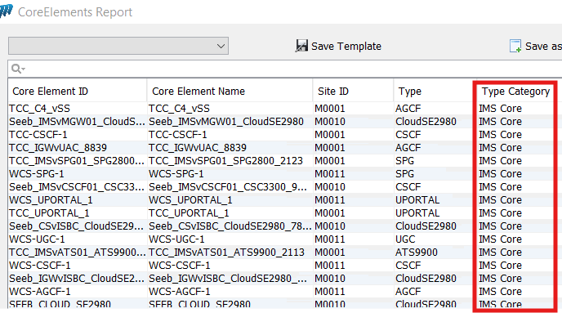
Below are the attributes need to be added to new “IMS Core Report” Report.
Node ID | NE Type
Node Name | Node Type
Site ID | Vendor

Attribute Parsing Rule
Attribute Name in PS Core Report | CoreElements Report
Node ID | Core Element ID
Node Name | Core Element Name
Site ID | Site ID
NE Type | Type
Node Type | CoreElement
Vendor | Vendor

NGN Core Report
This report will include the CoreElement Nodes from “CoreElements Report” where the Type Category is “NGN Core”.
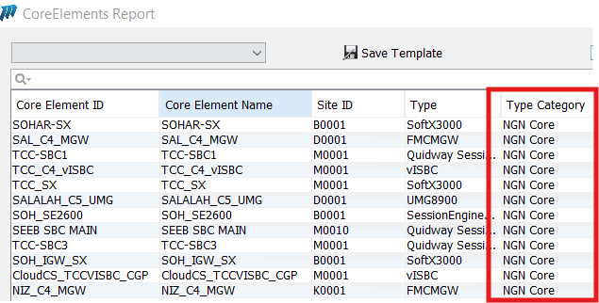

Below are the attributes need to be added to new “NGN Core Report” Report.
Node ID | NE Type
Node Name | Node Type
Site ID | Vendor

Attribute Parsing Rule
Attribute Name in PS Core Report | CoreElements Report
Node ID | Core Element ID
Node Name | Core Element Name
Site ID | Site ID
NE Type | Type
Node Type | CoreElement
Vendor | Vendor

Note: Any change in Existing Reports will reflect same in the new Reports

