Dear @Khaled Khalil,

Kindly align the resource for the below mentioned issue observed in Zain IQ Prod platform,

Kindly support to check the below Item not available in Unmapped Report. Barcode(20116016)
@Manjit Kumar , Kindly provide today logs of Zain IQ Prod.

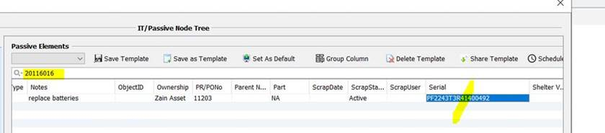

Unmapped Report.
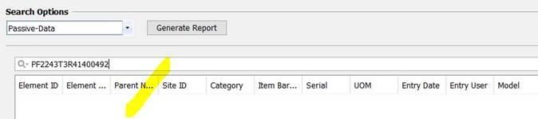

Not in FR

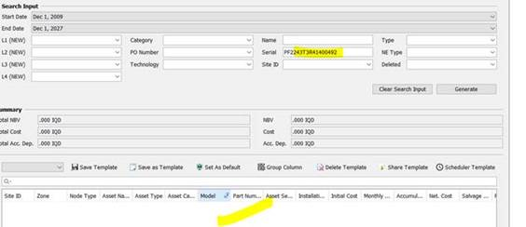

Also note we checked the WriteOff Report but still not available.

I have checked the Customize Confirguration and its Serial number present :

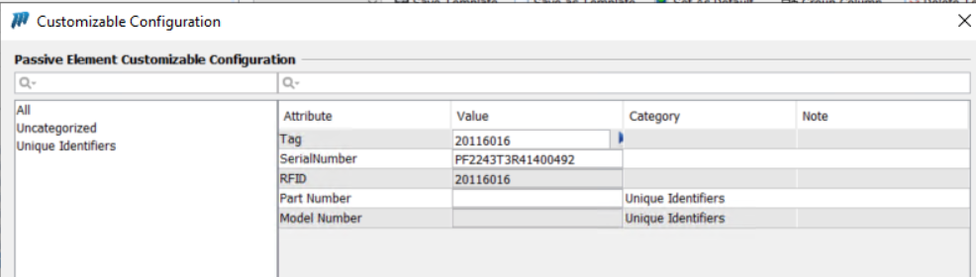

And When I try to put financials on it showing below error:

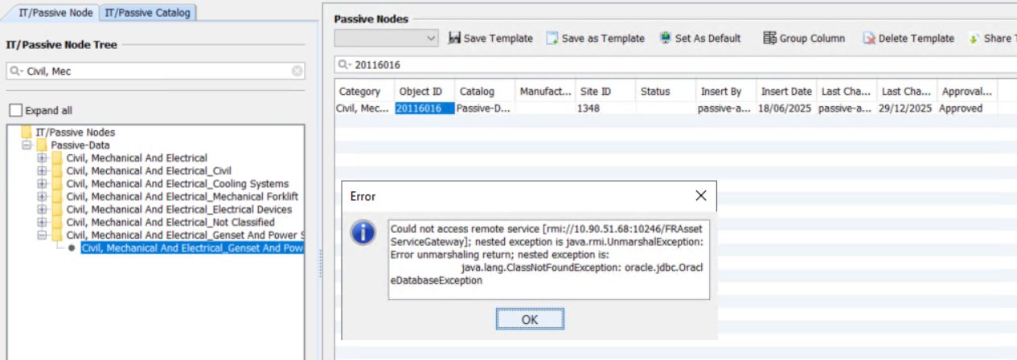


NETWORKS TRANSFORMED

Daljeet Singh Virdi| Senior Telecom Engineer
Mob: +91 9717304711
1102-1103, Tower C, Unitech Cyber Park, Gurgaon
daljeet.virdi@mobinets.com | www.mobinets.com

