

NSN 2G Logical Parsing

FRS (Functional Requirement Specifications)
Auto-Import
Indrasan Yadav
04-06-2025

Change History

Version | Change Description | Author | Date
0.1 | First draft. | Indrasan Yadav | 16-05-2025
0.2 | Updated the rule to parse GSM frequency band (via static sheet) under section 5 highlighted with green color. | Indrasan Yadav | 20-01-2026

Table of Contents

PREAMBLE
- This document specifies how to parse the logical inventory attributes for the BSC, BTS, and Cell logical inventory.
- It covers the parameters defined for 2G RAN Logical attributes
- The provided dump files are of “.xml”, named as “BSC-xxxxxx_ACTUAL_EXPORT_RESULT” where the “x” are digits.
  - E.g.: BSC-385502_ACTUAL_EXPORT_RESULT
- OR one dumps for all nodes, dump name is ActExp_full_DATE
- Only files with “<managedObject class="BSC”” are to be taken into consideration for this connector.
- Each “.xml” file represents the whole configuration network for each BSC, it served BTSs, and its cells.
- All the “.xml” files are expected to exist in one location folder; folder location and name will be provided later.
- This is motivated by Azer-connect Project and can be used for other operators having the same file structure.
- Another source type of dump files could be provided later for Antenna attributes.
- NOTE: The internal mapping between the physical and logical connectors will be based on the Node ID.

Connector Information
- Each “.xml” file is composed of different class types (i.e. BSC, BTS, BCF, TRX...)

Below is a description of the main class types
- Each class=”BSC” represents a BSC node.
- Each class=”BCF” represents a new BTS node.
- Each class="BTS" represents the served cells for the parent BTS.
- Each class=“ADCE” or class=”ADJW” or class=”ADJL” represents the neighbouring 2G, 3G and 4G cells respectively for a specific cell mentioned under class=”BTS”.
Each class=”TRX” represents the specific TRX’s information of the parent cell.

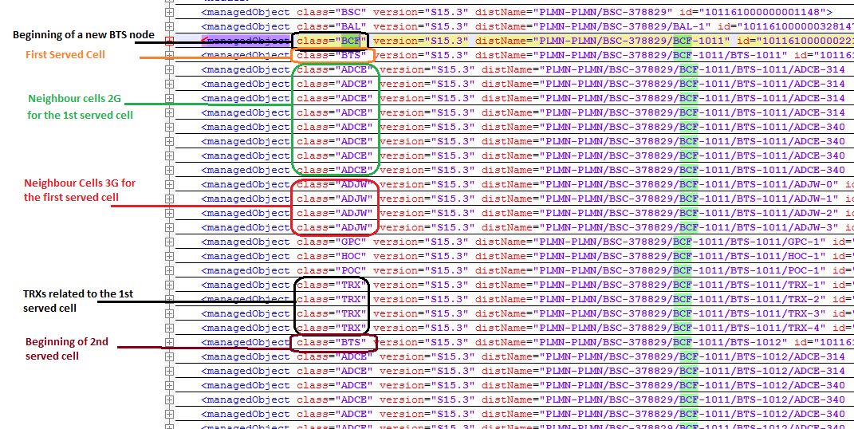

Connector name
NSN_RAN_Ooredoo_Tunisia

BSC logical parameters
The BSC logical inventory attributes are classified accordingly in categories as follows:
  - Global Parameters
  - Networking Parameters

Global Parameters
- The global attributes mentioned below and defined at BSC level are to be extracted as follows:

Attribute | Importance | Example
Site Name | [Mandatory] | - Describe later
Node ID | [Mandatory] | - = “distName” attribute on the same line as: <managedObject in class="BSC"  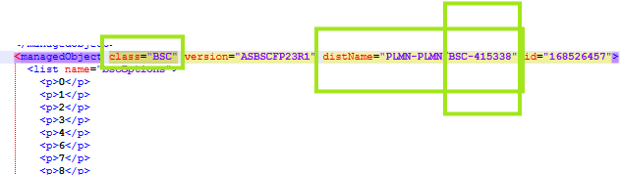  - E.g.: distName="PLMN-PLMN/BSC-415338"  Node ID = BSC-415338
Node Name | [Mandatory] | - = “name” attribute under <managedObject class=”BSC”  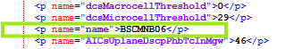  - E.g.: name="name">BSCMNB06</p>  Node Name = BSCMNB06
Type | [Mandatory] | - BSC OR  - Deduced from physical connector.  - Else couldn’t find it is extracted from the first <managedObject “class” type mentioned in the beginning of the file, as follows:  If class=”BSC”, therefore Type = BSC.  Else, if the first “class” type is different from “BSC”, the file should be ignored.
OAM IP | [Optional] | - =null
OAM Subnet Mask | [Optional] | - =null

Networking Parameters
- The networking attributes mentioned below and defined at BSC level are to be extracted as follows:

Attributes | Importance | Example
MCC | [Mandatory] | - Extracted from “locationAreaIdMCC” attribute under <managedObject class="BTS”.  - It is sufficient to parse only one value from the “locationAreaIdMCC” attribute across the entire file.  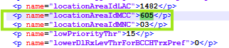  - E.g.: name=” locationAreaIdMCC”>655</p>
MNC | [Mandatory] | - Extracted from “locationAreaIdMNC” attribute under <managedObject class="BTS”.  - It is sufficient to parse only one value from the “locationAreaIdMNC” attribute across the entire file.  - E.g.: name=“locationAreaIdMNC”>03</p>
Parent MSC | [Optional] | - check within file name “Parent_MSC_SGSN.xlsx” within sheet MSC if the RNC Name is matched with column A, then set the Parent MSC attribute equal to value in Column B.  - Else, not found, default value =Null  - Note: “Parent_MSC_SGSN.xlsx” file will be provided later
Parent SGSN | [Optional] | - Check within file name “Parent_MSC_SGSN.xlsx” in sheet SGSB if the RNC Name is matched with column A, then set the Parent SGSN attribute equal to value in Column B.  - Else, not found, default value =Null  Note: “Parent_MSC_SGSN.xlsx” file will be provided later.
Attached BTSs | [Mandatory] | - (NEP tool calculated)
TRAU Boards | [Optional] | - Refer to TRAU Logical attributes section.  - All TRAU boards parsed from a BSC dump file to be assigned to the same BSC.
PCU card location | [Optional] | - NEP tool calculated
PCU Card Type | [Optional] | - To be deduced from both Physical and Logical dumps as per below:  - From Logical Dumps, extract the value of the attribute “bcsuID” stated under <managedObject class="PCU”.  - If “bcsuID” was found multiple times, then take only first value.  - Find in matching physical dump the Unit List supporting Functional Role=”BCSU” and “functionalUnitId” equal to the value of BSCU extracted from logical dump.  - Only boards with board type starting with “PCU” to be considered, e.g. “PCU2_E”.  - PCU Board Type= Board Type of above boards.  - Please refer to below photo.
PCU Card ID | [Optional] | - Is the concatenation of below attributes separated with “_”:  - “Cartridge ID”.  - “Cartridge shelf Index”  - “Board Slot Index”  - E.g. “NE-FlexiBSC-373889_1_4_1_2”
PCU Card Name | [Optional] | - =PCU Card Type
PCU Card Parent SGSN | [Optional] | - =Null

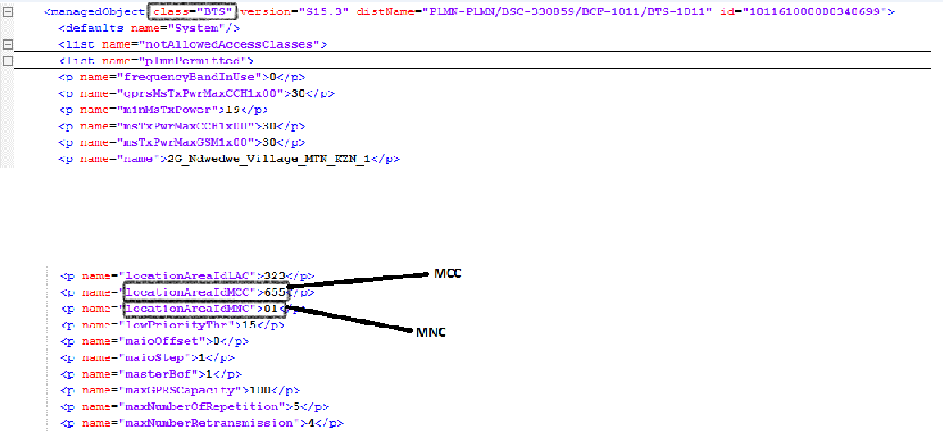

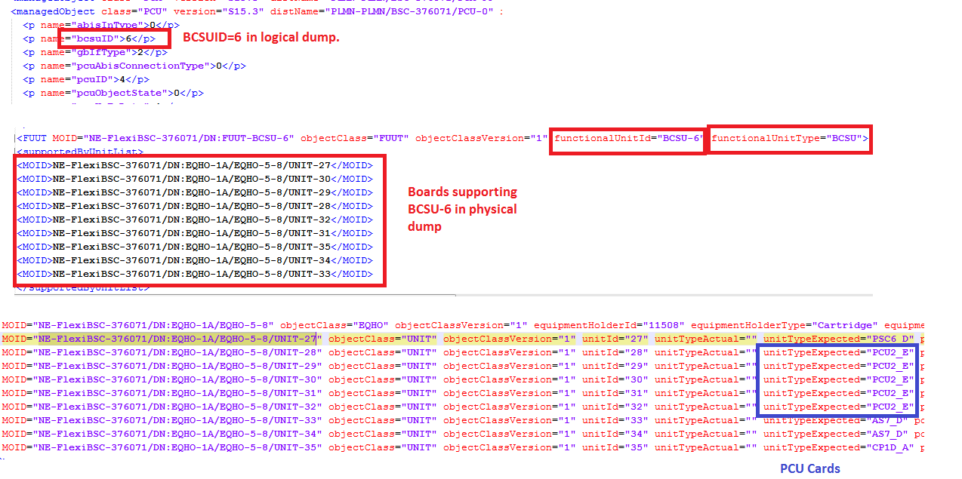

IP Parsing
- This section to be parsed from a separated dump
- Each section will start with date and time than the BSC ID and name
- Under ZQRI section
- Example: --------
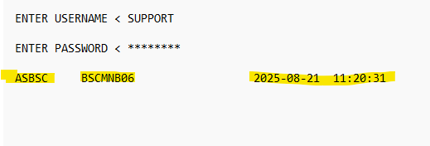
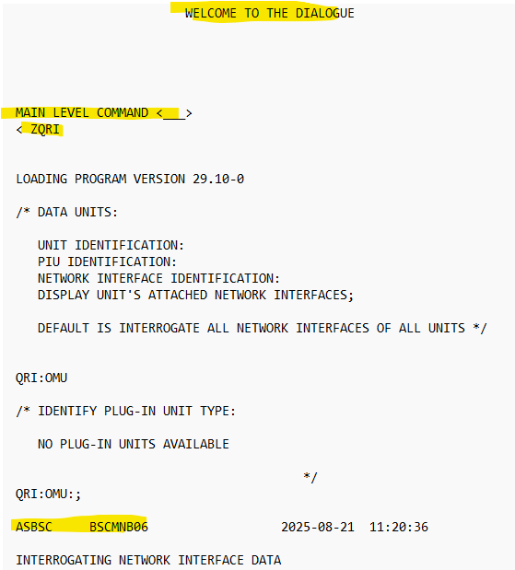

Each section lists Network Interfaces of the OMU with their status and IP information:
- UNIT: The hardware/software unit being queried (here, OMU).
- INTERFACE (EL0, EL1, EL4, EL5, EMB0, EMB1): These are logical Ethernet interfaces of the OMU.
- ADMIN STATE: Indicates whether the interface is UP (active) or DOWN.
- MTU (Maximum Transmission Unit): Packet size supported, typically 1500 bytes.
- ATTR (Attribute): Interface role, like:
  - PI – Primary Interface
  - P – Physical Interface
- IP ADDRESS: The configured IP with subnet (e.g., 10.20.98.4/24).
- Usage Label (right side, not part of table but shown below each IP): Defines purpose of IP interface:
  - NTP → Used for time synchronization.
  - Monitoring → Used for monitoring traffic / O&M access.
  - OAM (Operations, Administration, Maintenance) → Used for management access to BSC.

- Example:
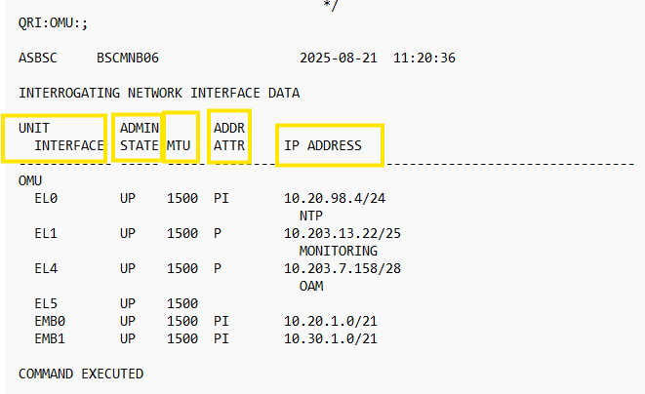
Meaning:
- EL0 → Interface used for NTP sync (clock).
- EL1 → Interface for Monitoring network.
- EL4 → Interface for OAM traffic (remote management).
- EL5 → Interface is UP but no IP configured.
- EMB0/EMB1 → Backbone transport interfaces with broader subnets (likely for Abis traffic between BSC and BTS).

Attributes | Importance | Example
Interface name | [Mandatory] | - = NodeID_IP_Mask  - Example: BSCMNB06_10.203.7.158_Mask (28)  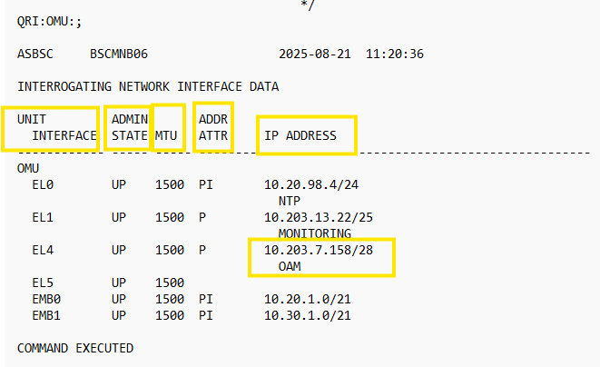
IP Address | [Mandatory] | - To be parsed from header IP  - For OAM  - In the same line 10.203.7.158 with EL4
Mask | [Mandatory] | - After the IP Address and separated by /
VLAN | [Mandatory] | - 506 (Shared by Ooredoo over an email)
Gateway | [Mandatory] | - For BSCMNB06 (10.203.13.1) And  And, for BSCMGH03 (10.107.38.1) Shared by Ooredoo in a separate file over an same email of VLAN
Description | [Optional] | - It is available in dump not part of table but shown below each IP. Defines purpose of IP interface.

BTS 2G logical Attributes
The BTS 2G logical inventory attributes are classified accordingly in categories as follows:
- Global Parameters
- Networking Parameters

Global Parameters for BTS
- The global attributes mentioned below and defined at BTS level are to be extracted as follows:

Attribute | Importance | Example
Node ID | [Mandatory] | - = “distName” attribute on the same line as <managedObject class=”BCF”  - E.g.: distName="PLMN-PLMN/BSC-248098/BCF-1011"  Node ID = PLMN-PLMN/BSC-248098/BCF-1011
Node Name | [Mandatory] | - = “name” attribute under <managedObject class=”BCF”  - E.g.: name="name">2G_Northwood_KZN</p>  Node Name = 2G_Northwood_KZN
Site Name | [Mandatory] | - Describe later
Type | [Mandatory] | - deduced from node configuration
PS Technology | [Optional] | - The PS Technology can have the following values: GPRS, EDGE, None, or both GPRS and EDGE.  - This can be deduced from the served cells mentioned in the below section (Cell Logical Configuration):  - If one of the served cells has both GPRS and EDGE enabled, then the parent node would have GPRS and EDGE as PS Technology.  - Else if all the served cells have only EDGE enabled and GPRS not enabled, then the PS technology will be set to “EDGE”.  - Else if all the served cells have only GPRS enabled and EDGE not enabled, then the PS technology will be set to “GRPS”.  - Else if none of them is enabled then the PS Technology will be then set to “NONE”.
OAM IP | [Optional] | - =Null
OAM Subnet Mask | [Optional] | - =Null

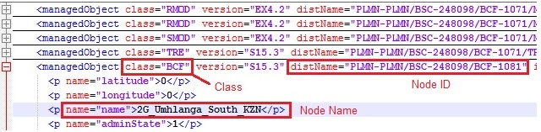

Status | [Mandatory] | - deduced from “AZCN_2G_SITE_STATUS_20” file from Sites folder, where the status of the SITE ID is equal to “ON_AIR” or HUB_ON_AIR”  - If the Status is empty keep the value blank  - Exclude the nodes with status “DEFINED”

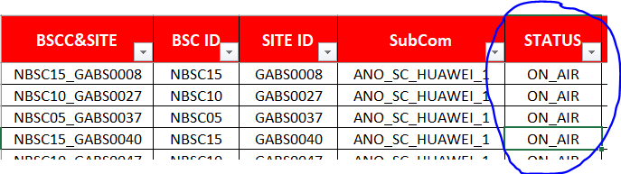

Global Parameters for SRAN
- The global attributes mentioned below and defined at SRAN Level for 2G role are to be extracted as follows:

Attribute | Importance | Example
Node ID | [Mandatory] | - = same as physical
Node Name | [Mandatory] | = same as physical
Site Name | [Mandatory] | - = same as physical
Type | [Mandatory] | - = same as physical
PS Technology | [Optional] | - PS Technology can have the following values: GPRS, EDGE, None, or both GPRS and EDGE.  - This can be deduced from the served cells mentioned in the below section (Cell Logical Configuration):  - If one of the served cells has both GPRS and EDGE enabled, then the parent node would have GPRS and EDGE as PS Technology.  - Else if all the served cells have only EDGE enabled and GPRS not enabled, then the PS technology will be set to “EDGE”.  - Else if all the served cells have only GPRS enabled and EDGE not enabled, then the PS technology will be set to “GRPS”.  - Else if none of them is enabled then the PS Technology will be then set to “NONE”.
OAM IP | [Optional] | - =Null
OAM Subnet Mask | [Optional] | - =Null

Networking Parameters for BTS
- The networking attributes mentioned below and defined at BTS level are to be extracted as follows:

Attributes | Importance | Example
MCC | [Mandatory] | - (NEP tool calculated)
MNC | [Mandatory] | - (NEP tool calculated)
LAC | [Optional] | - (NEP tool calculated)
RAC | [Optional] | - (NEP tool calculated)
Parent BSC | [Mandatory] | - = “name” attribute under <managedObject class=“BSC”  - E.g. : name=“name”>2G_UH11_DTJ_KZN</p>  OR  - From the managedObject class="BCF", in the same line after distName= BSC ID will be after BSC-  - Example:  - <managedObject class="BCF" version="S16_3" distName="PLMN-PLMN/BSC-206967/BCF-195" id="7286135">  - BSC ID= 206967
Attached MSC | [Optional] | - Deduced from parent BSC
Attached SGSN | [Optional] | - Deduced from parent BSC
Served cells | [Optional] | - (NEP tool calculated)

Networking Parameters for SRAN
- The networking attributes mentioned below and defined at SRAN for 2G role are to be extracted as follows:

Attributes | Importance | Example
MCC | [Mandatory] | - (NEP tool calculated)
MNC | [Mandatory] | - (NEP tool calculated)
LAC | [Optional] | - (NEP tool calculated)
RAC | [Optional] | - (NEP tool calculated)
Parent BSC | [Mandatory] | - Under class="GNBCF"  - =the Value of Attribute bscId  - Map the value of bscid to the bsc name like in BSC section
Attached MSC | [Optional] | - Deduced from parent BSC
Attached SGSN | [Optional] | - Deduced from parent BSC
Served cells | [Optional] | - (NEP tool calculated)

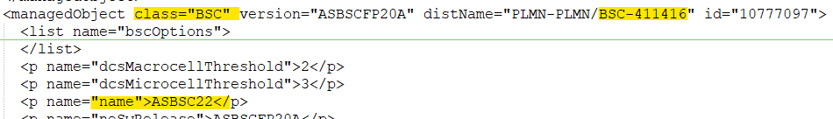

Logical IP Parsing for BTS

- If the BTS is standalone, then parse directly the IPs
- If the BTS is a 2G Role under SRAN, then Parse the IP if it does not exist under the SRAN

Attributes | Importance | Example
Interface name | [Mandatory] | - = Node-Name_mPlan
IP Address | [Mandatory] | - Under class=“BCF”  - = attribute “btsMPlaneIpAddress”  - If above attribute is missing, then check attribute mPlaneLocalIpAddress in class “PABTRS”
Mask | [Mandatory] | - Under class=“BCF”  - =attribute “btsIpv4SubnetMasklengthMplane” or "btsSubnetMasklengthMplane"  - If above attribute is missing, then check attribute mPlaneSubnetMask in class “PABTRS”
GW | [Mandatory] | - Under class=“PABTRS”  - =attribute “mPlaneGatewayIpAddress”
VLAN | [Mandatory] | - Under class=“PABTRS”  - =attribute “mPlaneVlanId”

Attributes | Importance | Example
Interface name | [Mandatory] | - = Node-Name_cPlan
IP Address | [Mandatory] | - Under class=“BCF”  - = attribute “btsCuPlaneIpAddress”
Mask | [Mandatory] | - Under class=“BCF”  - =attribute “btsIpv4SubnetMasklengthCUplane”  Or  =attribute “btsSubnetMasklengthCUplane"  Or  “btsCuPlaneIpAddress”
GW | [Mandatory] | - Under class=“PABTRS”  - =attribute “cuPlaneGatewayIpAddress”
VLAN | [Optional] | - Under class=“PABTRS”  - =attribute “cPlaneVlanId”

Logical IP Parsing for SRAN

- If the BTS is a 2G Role under SRAN, then Parse the below information

Attributes | Importance | Example
Interface name | [Mandatory] | - = Node-Name_mPlan
IP Address | [Mandatory] | - Under class=“GNBCF”  - Take the value of “mPlaneLocalIpAddressDN”  - Search the value in the same MRBTS for class="IPADDRESSV4"  - The value of localIpAddr will be the IP address of SRAN with 2G role  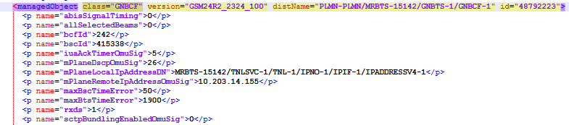
Mask | [Mandatory] | - Under same class=“ IPADDRESSV4”  - =Take attribute “localIpPrefixLength”. Map it with the table below for subnet mask
  localIpPrefixLength | Subnet Mask
  22 | 255.255.252.0
  23 | 255.255.254.0
  24 | 255.255.255.0
  25 | 255.255.255.128
  26 | 255.255.255.192
  27 | 255.255.255.224
  28 | 255.255.255.240
  29 | 255.255.255.248
  30 | 255.255.255.252
GW | [Mandatory] | - Search the dist name of class=“ mPlaneLocalIpAddressDN” in class="IPRT" without “/IPADDRESSV4-X” & “IPIF “ will be replaced by “IPRT”  - The value of attribute “gateway “will be considered as GW for SRAN  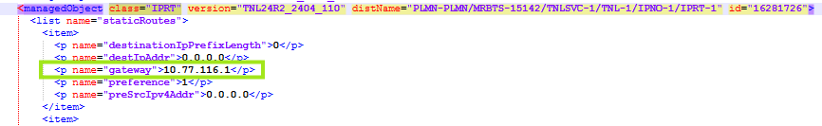
VLAN | [Mandatory] | - Under class=“VLANIF” for the same MRBTS, check for the attribute “userLabel”  - If the “userLabel” value is “GSM” check the attribute VlanId under this attribute.  - =The value of “VlanId” is the VLAN for 2G role node of SRAN  Or  If userLabel is not found, follow the process below.  - From class=” IPADDRESSV4” take the value of distname  - Replace “IPNO-1/IPIF” with “ETHSVC-1/ETHIF-1/VLANIF”  - Ignore the section “/IPADDRESSV4-X” in class=” IPADDRESSV4”  - Match the value with distname of class="VLANIF" from the above deduced section  - The value of vlanId under this class is the VLAN ID.

Cell LoGICAL PARAMETERS

Attribute | Importance | Example
Cell Name | [Optional] | - Deduced from name="name" attribute under each <managedObject class="BTS":  - E.g.:  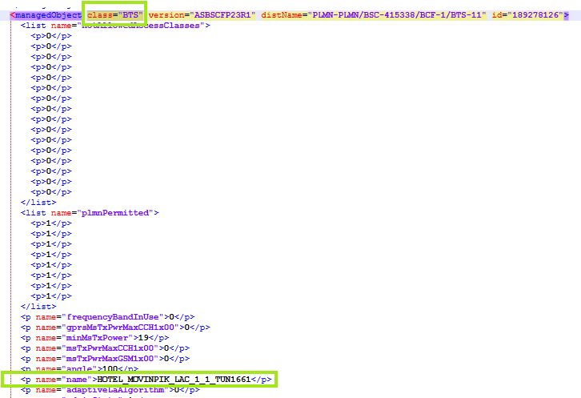
Cell Object ID | [Mandatory] | - The “Cell Object ID” is equal to the concatenation of: “LAC”, “_” and “Cell_ID”  - Cell_ID is deduced from name="cellId" attribute under each <managedObject class="BTS":  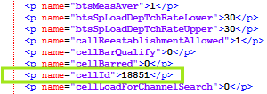  - E.g.: name="cellId">18851</p>  - “LAC” is deduced through the attribute name “locationAreaIdLAC” within the same class.  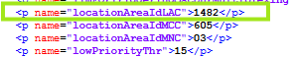  - E.g.: <p name="locationAreaIdLAC">1482</p>  - Cell_ID = 1482_18851  - In case detected same “Cell_ID” value under the same node, thus only the 2nd detected duplicate cell ID will be a concatenation of “LAC”,”_”,”Cell_ID”,”-”,X”.  - To get the value of “X”, get the value of “frequencyBandInUse” under <managedObject class=“BTS” for the 2nd detected duplicate cell ID and match it within the below table in column A.  - The value in Column B will be then the value of  “X”  - E.g. Cell ID 1st=1482_18851  - Cell ID 2 (duplicate) =1482_18851-1800  Note: This processes it to be executed only for the 2nd detected Cell_ID.
  Column A | Column B
  0 | 900
  1 | 1800
  2 | 1900
  5 | 800
Cell ID |  | - Cell_ID is deduced from name="cellId" attribute under each <managedObject class="BTS":  - E.g.: name="cellId">18851</p>
Node ID | [Mandatory] | - Deduced from "distName" attribute on the same line as <managedObject class="BCF"attribute.  - E.g.: distName="PLMN-PLMN/BSC-415338/BCF-1
Parent Site ID | [Mandatory] | - Deduced from parent Node at saving
Cell Technology | [Mandatory] | - (NEP tool calculated)  - Else = GSM
MCC | [Mandatory] | - (NEP tool calculated)
MNC | [Mandatory] | - (NEP tool calculated)
Operators | [Optional] | - (NEP tool calculated)
Neighbor Cells 2G | [Optional] | - Each <managedObject class="ADCE" mentioned under each <managedObject class="BTS" refers to a “Neighbor Cell 2G” for the mentioned Cell Name already parsed under <managedObject class=“BTS”.  - Thus, the “Neighbor Cells 2G” attribute is obtained by extracting the name="adjacentCellIdCI" attribute and the name= "adjacentCellIdLac" mentioned under each <managedObject class=“ADCE”.  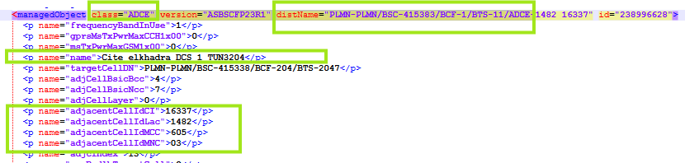  - E.g.: name="adjacentCellIdCI">16337</p>  - E.g: name="adjacentCellIdLac">1482</p>  - Neighbor Cell 2G Object ID is equal to the concatenation of: “LAC”, “_” and “Cell_ID”  - In the example mentioned above  - Object ID= 1482_16337
Neighbor Cells 3G | [Optional] | - Each <managedObject class="ADJW" mentioned under each <managedObject class="BTS" refers to a “Neighbor Cell 3G” for the mentioned Cell Name already parsed under <managedObject class="BTS".  - Thus, the “Neighbor Cells 3G” attribute is obtained by extracting the name="AdjwCId” attribute and the attribute name=“lac” mentioned under each <managedObject class=“ADJW”.  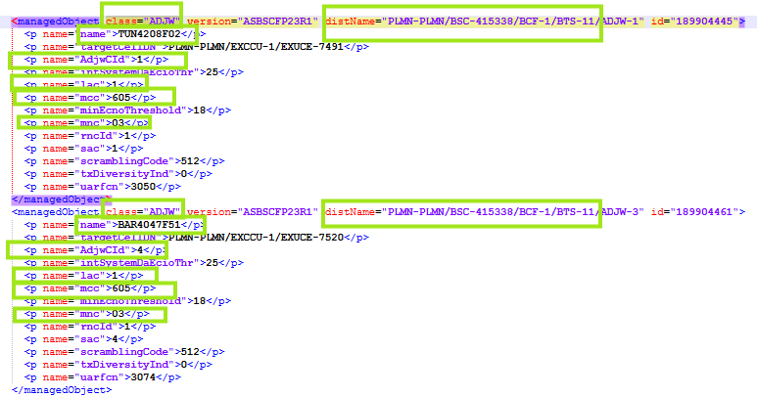  - E.g.: name="AdjwCId">1</p>  - E.g: name=“Lac”>1</p>  - Neighbor’s Cell Object ID= 1_1  And,  - E.g.: name="AdjwCId">4</p>  - E.g: name=“Lac”>1</p>  - Neighbor’s Cell Object ID= 1_4
Neighbor Cells 4G | [Optional] | - (to be provided later)
Last Audit Date | [Optional] | - =Null
Additional Information | [Optional] | - =Null
Below are the specific attributes that need to be parsed in case the cell technology is GSM

- Specific attributes for 2G cells

Attributes | Importance | Example
Parent BSC ID | [Optional] | - NEP tool calculated.
BCCH ARFCNs | [Optional] | - NEP tool calculated.  - Else through the following rule:  - Lookup under <managedObject class=“ADCE” for the same "Cell Name" mentioned under name="name".  - Once matched, the "BCCH ARFCN" will be obtained by extracting name="bcchFrequency" attribute under the same <managedObject class=“ADCE” where the “Cell Name” was matched.  - The same “Cell Name” with the same “bcchFrequency “could be duplicated under different objects having <managedObject class=“ADCE”. Thus, ignore the repeated values.
#TRX installed | [Optional] | - (NEP tool calculated)
BSIC | [Optional] | - NEP Tool calculated
NCC | [Optional] | - = name="bsIdentityCodeNCC” attribute found under each line containing <managedObject class=“BTS”.  - The obtained value refers to the cell ID value of name="cellId” attribute under the same class=“BTS”.
BCC | [Optional] | - = name="bsIdentityCodeBCC” attribute found under each line containing <managedObject class=“BTS”.  - The obtained value refers to the cell ID value of name="cellId” attribute under the same class=“BTS”.
HSN | [Optional] | - = name="hoppingSequenceNumber1” attribute found under each line containing <managedObject class=“BTS”.  - The obtained value refers to the cell ID value of name="cellId” attribute under the same class=“BTS”.
MAIO List | [Optional] | - NEP tool calculated.
LAC | [Optional] | - = name="locationAreaIdLAC" attribute found under each line containing <managedObject class=“BTS”  - E.g. : name="locationAreaIdLAC">307</p> LAC = 307  - The obtained value refers to the cell ID value of name="cellId" attribute under the same class=“BTS”
RAC | [Optional] | - = name="rac" attribute found under each line containing <managedObject class=“BTS”  - E.g. : name="rac">107</p>  RAC = 107  - The obtained value refers to the cell ID value of name="cellId” attribute under the same <managedObject class=“BTS”
GPRS enabled | [Optional] | - A cell has “GPRS enabled” if name="gprsEnabled" attribute under <managedObject class=“BTS” is equal to “1”.  - E.g.: name="gprsEnabled">1</p>  - if name="gprsEnabled" attribute under <managedObject class=“BTS” is equal to “0”, the Default value = NO  - The obtained value refers to the cell ID value of name="cellId" attribute under the same <managedObject class=“BTS”
EDGE enabled | [Optional] | - A cell has “EDGE enabled” if name="egprsEnabled" attribute under <managedObject class=“BTS” is equal to “1”.  - E.g.: name="egprsEnabled">1</p>  - if name="gprsEnabled" attribute under <managedObject class=“BTS” is equal to “0”, the Default value = NO  - The obtained value refers to the cell ID value of name="cellId" attribute under the same <managedObject class=“BTS”
Frequency bands | [Optional] | - Deduced by extracting the value of name="frequencyBandInUse" attribute stated under each <managedObject class=“BTS”, where the parsed value will refer to Cell Name mentioned as the value of the name=“name” attribute under the same class type (<managedObject class= “BTS”).  - Check if the value of name="frequencyBandInUse" attribute is equal to 0 or 1.  - Map this value within static sheet “GSM_Frequency_Band” to parse the frequency band.
AMR support | [Optional] | - Check the value of “amrConfFrCodecModeSet” attribute if it is equal to 0, then AMR Support is equal to “NO”.  - Else if any different value other than “0”, hence the AMR Support=YES.
PCU Card | [Optional] | - To be deduced from both Physical and logical dumps as per below:  - Check in logical dumps “daPool_ID” value under <managedObject class="TRX" for any of the TRXs under <managedObject class=“BTS” (e.g. name="daPool_ID">1001).  - PCU Card found below refers to the Cell represented with above <managedObject class="BTS".  - Find <managedObject class="DAP" with “distName” value="PLMN-PLMN/BSC-BSC ID/DAP-daPool_ID"(e.g. "PLMN-PLMN/BSC-388214/DAP-1001").  - Get name="bcsuID" and name="pcuID" values under above <managedObject class="DAP”.  - Find in matching physical dump the Unit List supporting Functional Role=”BCSU” and “functionalUnitId” equal to the value of name="bcsuID" extracted from logical dump.  - PCU card is the PCU board in physical dumps under above deduced BSCU cartridge with unitTypeExpected="PCU2_E" and position is deduced based on “pcuID" from logical dumps as per below rule:  - “pcuID"=4→ PCU2_E with lowest position in the BSCU cartridge.  - “pcuID"=6→ PCU2_E with second lowest position in the BSCU cartride.  - “pcuID"=8→ PCU2_E with third lowest position in the BSCU cartride.  - “pcuID"=10→ PCU2_E with fourth lowest position in the BSCU cartride.  - “pcuID"=12→ PCU2_E with fifth lowest position in the BSCU cartride.  - Please refer to below snapshot.

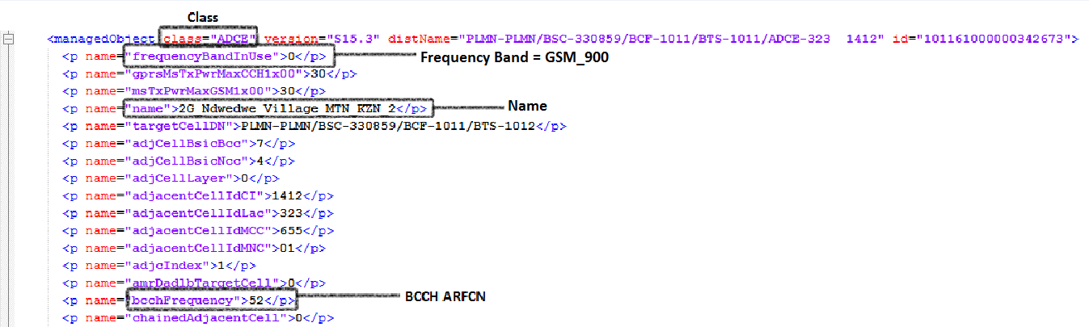

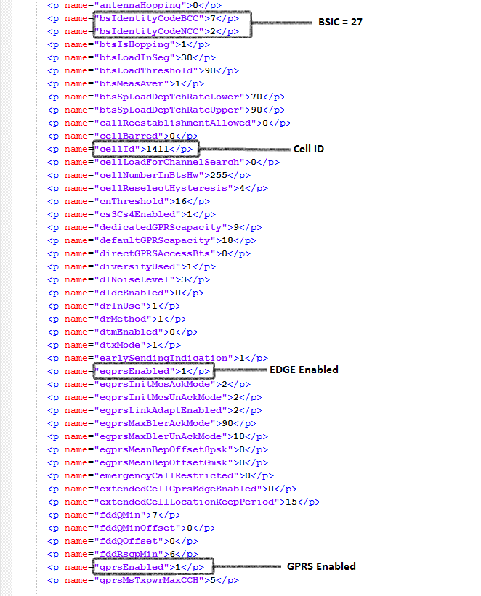

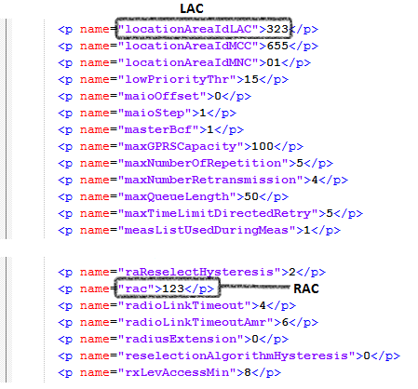

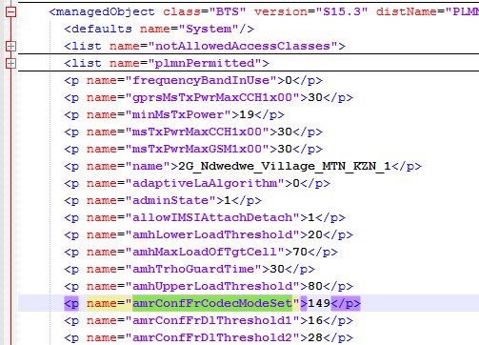

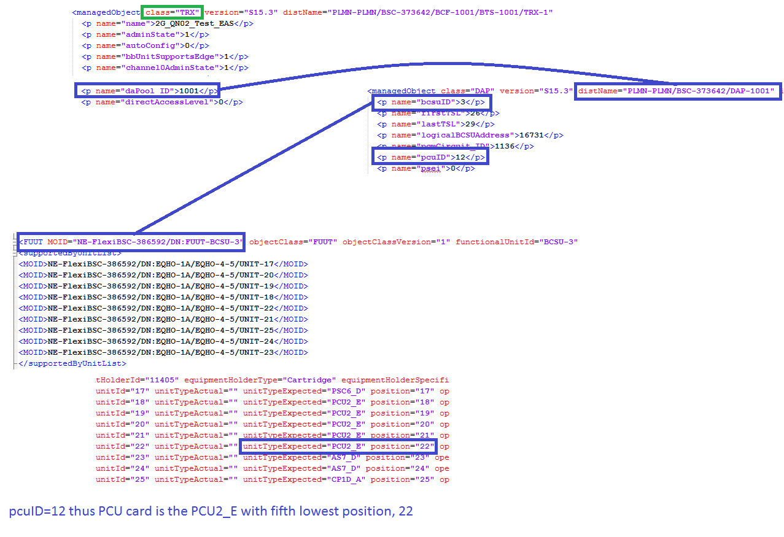

- Specific attributes for 2G TRXs in the instance level
Attributes | Importance | Example
TRX ID Object ID | Mandatory | - The “TRX ID” is equal to the concatenation of : “Cell ID”, “_” and “TRXID”  - For each Cell, there exist multiple TRXs.  All classes mentioned as <managedObject class=“TRX” stated under <managedObject class=“BTS” refer to the Cell Name mentioned under class <managedObject =“BTS” as mentioned previously.  - The TRXID is deduced by extracting the value of the attribute “distName” stated on the same line as <managedObject class=“TRX” and taking the number following the keyword “TRX-” :  - E.g.: distName="PLMN-PLMN/BSC-248098/BCF-1011/BTS-1011/TRX-14"  TRXID = 14
TRX ID |  | - The TRXID is deduced by extracting the value of the attribute “distName” stated on the same line as <managedObject class=“TRX” and taking the number following the keyword “TRX-” :  - E.g.: distName="PLMN-PLMN/BSC-248098/BCF-1011/BTS-1011/TRX-14"  - TRXID = 14
ARFCN list | Mandatory | - Deduced by extracting the value of the name=“initialFrequency“ attribute for each <managedObject class="TRX"  - E.g.: name="initialFrequency">33</p>  - This value refers to the “TRX ID” as deduced by extracting the value of the attribute “distName” stated on the same line as <managedObject class=“TRX” and taking the number following the keyword “TRX-” .  - Note : under each line containing (<managedObject class=“BCF”) we have many (<managedObject class=“TRX”)
Type | Optional | - Deduced by checking for each TRX ID the values of the attributes name="bbUnitSupportsEdge" and name="gprsEnabledTrx" mentioned under each <managedObject class=“TRX”, as follows:  - If the value of both “bbUnitSupportsEdge” and “gprsEnabledTrx" is equal to “1”  Type = “GPRS and EDGE”  - Else if “bbUnitSupportsEdge” is equal to “1” and “gprsEnabledTrx” is equal to “0”  Type = “EDGE”  - Else if “bbUnitSupportsEdge” is equal to “0” and “gprsEnabledTrx” is equal to “1”  Type = “GPRS”.  - Else if both are equal to “0”  Type = None.  - This value refer to the "TRX ID" which is deduced by extracting the value of the attribute “distName” stated on the same line as <managedObject class=“TRX” and taking the number following the keyword “TRX-” .
MAIO | Optional | - = name="channel0Maio" value under <managedObject class="TRX".  - Value refer to TRX represented with <managedObject class="TRX".
Half rate supported | Optional | - Deduced by checking for each TRX ID the value of the attribute name=“halfRateSupport” mentioned under each class=”TRX”, as follows:  - if value=“1” Half rate supported =“Yes”  - if value=“0” Half rate supported= “No”  - E.g.: name="halfRateSupport">1</p>  - This value refer to the "TRX ID" which is deduced by extracting the value of the attribute “distName” stated on the same line as <managedObject class=“TRX” and taking the number following the keyword “TRX-”
Channel type | Optional | - Deduced by checking the values of all the attributes having the shape name="channelxType" where x represents a digit under each class=”TRX” ( <managedObject class=“TRX” )  - According to the matching value, mentioned below, the “Channel type” can be deduced:  - “0 or “2” or “15” Channel type = TCHFR.  - “1” Channel type = TCHHR.  - “3” or “8” Channel type = SDCCH  - “4” or ”5” or “6” or “7”or “10” Channel type = BCCH  - “14” Channel type = Fixed-GPRS  - Any undefined number which is not defined in the above list is to be ignored  - E.g.: - name="channel0Type">4</p>  Channel type = BCCH  - name="channel1Type">8</p>  Channel type = SDCCH  This value refer to the "TRX ID" which is deduced by extracting the value of the attribute “distName” stated on the same line as <managedObject class=“TRX” and taking the number following the keyword “TRX-”
Number of PDCH | Optional | - (NEP tool calculated)
Number of BCCH/SDCCH control channels | Optional | - (NEP tool calculated)
status | Optional | - Under the above class TRX, take the attribute “adminState”  - If value equal to 1 then it is active  - If the value equal to

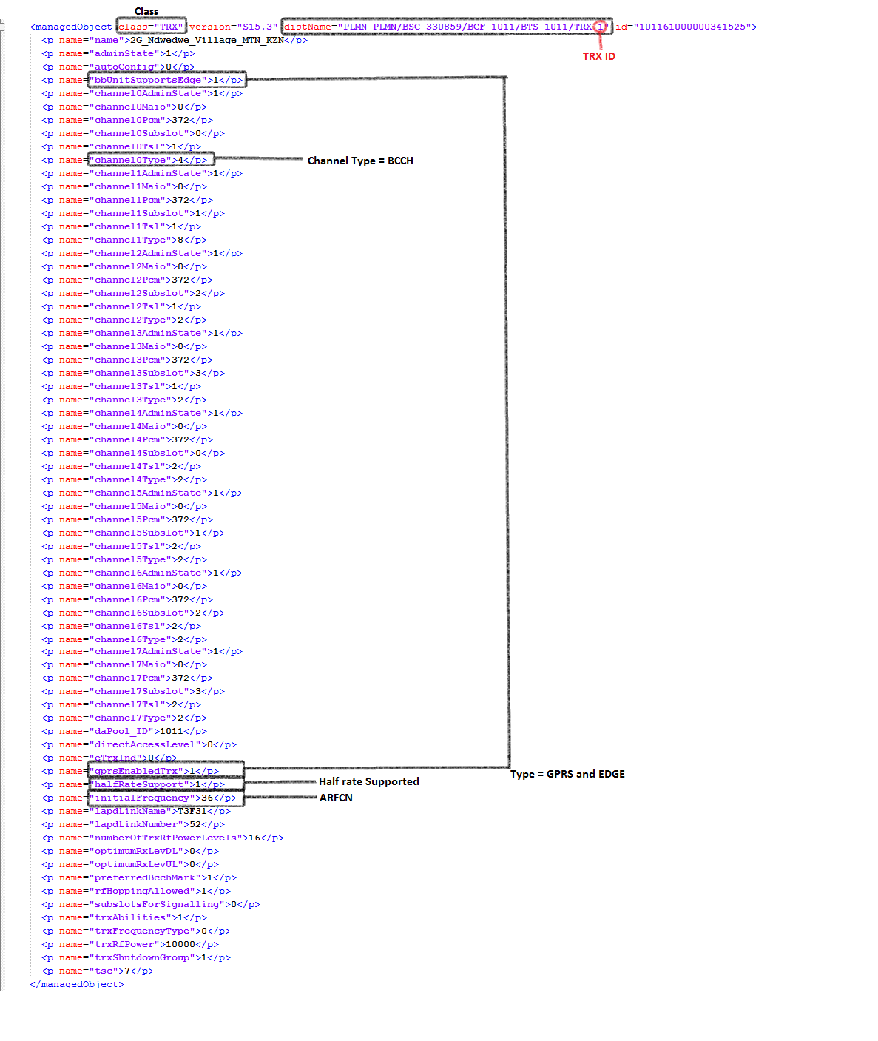

TRAU Logical attributes

Attributes | Importance | Example
TRAU Board Type | [Mandatory] | - To be deduced from both Physical and Logical dumps as per below:  - From Logical Dumps, extract the value of the attribute “distName” stated on the same line as <managedObject class=“TCSM” and take the value after last “/”, e.g. “TCSM-192”, multiple managed objects might be found for each BSC.  - Find in matching physical dump the Unit List supporting Functional Role=”TCSM” and “functionalUnitId” equal to the value extracted from logical dump, multiple boards might be found.  - Only boards with board type starting with “TR” to be considered, e.g. “TR3T”.  - TRAU Board Type= Board Type of above boards.  - Please refer to attached photo.
TRAU Board ID | [Mandatory] | - Is the concatenation of below attributes separated with “_”:  - “Cartridge ID”.  - “Cartridge shelf Index”  - “Board Slot Index”  - E.g. “NE-FlexiBSC-373889_3_2_6_1”

Attributes | Importance | Example
TRAU ID | [Mandatory] | - Find “Cartridge shelf” comprising the TRAU Boards extracted above in physical dumps.  - TRAU ID Is the concatenation of below attributes separated with “_”:  - “Cartridge ID”.  - “Cartridge shelf Index”  - E.g. “NE-FlexiBSC-373889_3_2_6”
TRAU Name | [Optional] | - To be deduced from Physical dumps.  - =”Cartridge Shelf Model”.  - Please refer to Physical connector.
TRAU Type | [Mandatory] | - If BSC type is “FlexiBSC” then TRAU type is ”TCSM3i”

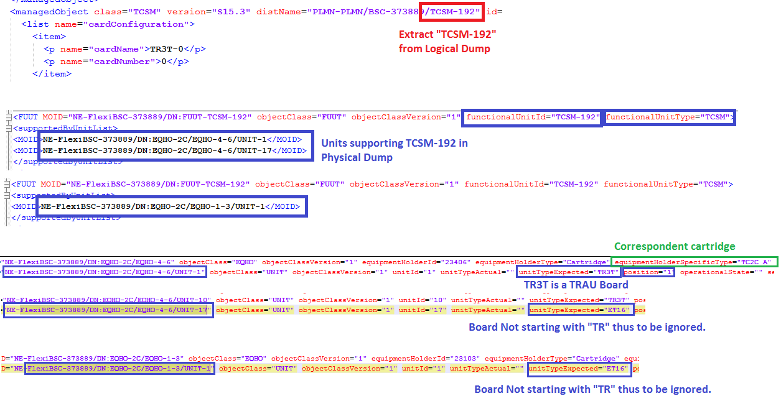

Additional attribute

- Below listed additional info to be added on BSC
- Attribute to be incremented from 1 for each Category
- The values in note field should be separated with “;”
- Each class “NSVL” represent one ADJNODE, from distName we deduce the BSC-ID example: <managedObject class="NSVL" version="S16_3" distName="PLMN-PLMN/BSC-ID/NSVL-XX
- Under the above class, we deduce the Remote_IP, where Remote_IP= ipAddressValue
- The Local_IP to be deduced from the separate dumps sheet named ZQRI
- Where each section start with: --------- DATE and Time PLMN-PLMN/BSC-ID BSC-Name ---------
- We get the Local_IP under section:
  - BCSU-X -PCU2E-Y where X and Y are integer
    - 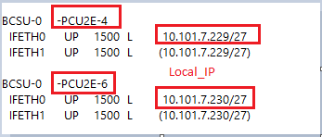
  - BCSU-X -PCU2D-X where X and Y are integer
    - 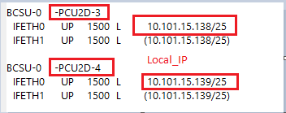
  - PCUM-X where X is an integer
    - For this section we get only the IP address where Vlan exist
    - 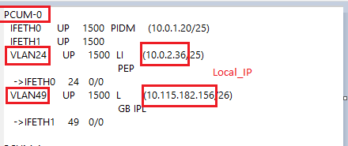

Category | Value | Note
ADJNODE  Every class="NSVL" represents one connected ADJNODE | = distName of class=" NSVL"/1 and to be increment for each ADJNODE and Association  e.g. distName="PLMN-PLMN/BSC-316953/NSVL-19113/1 | - CONNECTION_TYPE=GB  - NODE_ID= IP_DERIVED
ASSOCIATION | = distName of class=" NSVL"/1 and to be increment for each ADJNODE and Association  e.g. distName="PLMN-PLMN/BSC-316953/NSVL-19113/1 | - LOCAL_IP:  From the ZQRI as described above  - REMOTE_IP= the value of “ipAddressValue” under class=" NSVL"

Abis over TDM:
- Each class=”BCF” represents one Abis over TDM interface
- For each “BCF” class
  - go to the “TRX” classes that contain in “distName” the same value of “distName” of “BCF” class. Multiple matches will be found. All matches to be considered
  - for each matched “TRX” class
    - take the value of “channel0Pcm”
  - duplicated values are to be removed
  - These values are to be used in ASSOCIATION records
  - The number of ASSOCIATION records for each ADJNODE will be based on the found values. E.g. If two unique values were found two ASSOCIATION should be created for this ADJNODE

Category | Attribute | Value | Note
ASSOCIATION  //The number of records for each ASSOCIATION  depends on the unique values found under “channel0Pcm”// | = the value of “distName” attribute of “BCF” class concatenated with “_ASSOCIATION_”  And with an integer increased for each ASSOCIATION under the same BCF  e.g. PLMN-PLMN/BSC-367255/BCF-241_ASSOCIATION_2 | = the value of “distName” attribute of “BCF” class  concatenated with “_”  And with an integer increased for each ASSOCIATION under the same BCF | - LOCAL_PORT= has the format of port key C/S/S/I/P  - Index on slot=0  - Port index=  - take the unique value of “channel0Pcm”  - match it with a range in the static file “NSN_2G_TDM_Matching”. Where every range starts with the value in column A and ends with the value of column B  - take the value of column D of the matched record as port index  - counting ETS2 boards:  - give each board found in physical under the same BSC of the BCF with type “ETS2” a number  - start from 0 and increment by one for each board  - C/S/S=  - take the unique value of all “channel0Pcm”  - match it with a range in the static file “NSN_2G_TDM_Matching”. Where every range starts with the value in column A and ends with the value of column B  - take the value of column C of the matched record. This value will be the value of group number  - Sort the groups numbers for all ports for each BSC in ascending order  - For each group number assign one ETS2. And assign the boards respectively.  - If the BSC model is “flexiBSC” don’t use ETS2 with even numbers  - E.g. groups numbers are: 0, 1, 5 assign the groups as follows:  - Group 0: ETS number 0  - Group 1: ETS number 2  - Group 5: ETS number 4  - take C/S/S of an ETS2 board with the same number from previous step  - LOCAL_TRIBUTARY= the unique value of “channel0Pcm”
ADJNODE  //Every class=”BCF” represents one or more connected ADJNODE//  Create one ADJNODE For each ASSOCIATION record | = the value of “distName” attribute of “BCF” class  concatenated with “_”  And with an integer increased for each  ASSOCIATION under the same BCF | = the value of “distName” attribute of “BCF” class  concatenated with “_”  And with an integer increased for each ASSOCIATION under the same BCF | - CONNECTION_TYPE=Abis  - INTERFACE_TECHNOLOGY=TDM  - NODE_ID=OBJECT_ID  - NODE_OBJECT_ID= the value of “distName” attribute of “BCF” class

Abis over IP

- Abis over IP to be added to Additional Info under BSC
- The parent BSC on which the additional info should be added, could be got from the “distName” attribute

Category | Attribute | Value | Note
ADJNODE  Every " PABTRS" class represents one ADJNODE | = the value of “distName” attribute of “PABTRS” class concatenated with “_ADJNODE” | = the value of “distName” attribute of “PABTRS” class | - CONNECTION_TYPE=Abis  - INTERFACE_TECHNOLOGY=IP  - NODE_ID=IP_DERIVED  - NODE_OBJECT_ID= the value of “distName” attribute of “BCF” class  - CONNECTION_NAME= The value of “distName” attribute of “PABTRS” class
ASSOCIATION  1st Association | = the value of “distName” attribute of “PABTRS” class concatenated with “_Association” | = the value of “distName” attribute of “PABTRS” class | - LOCAL_IP= the value of attribute "mPlaneRemoteIpAddress" under class “PABTRS”  - REMOTE_IP= the value of attribute "mPlaneLocalIpAddress" under class “PABTRS”  Note: No Space exists between LOCAL_IP and REMOTE_IP

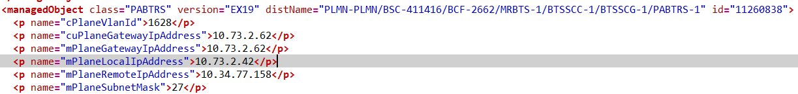

BSC OPC
- This additional info is to be added under BSCs
- Every “BSC” class represents one OPC
- The parent BSC could be derived from distName attribute of “BSC” class

Category | Attribute | Value | Note
OPC | “OPC_value”  e.g. OPC_ 3882 | = the value of “signallingPointCodeNA1” attribute of “BSC” class | - OPC= the value of “signallingPointCodeNA1” attribute of “BSC” class  e.g. OPC=3882

Abis over IP for SRAN
- This section related to MRBTS will be added under BSC

- Remote IP will be parsed from attribute IP address of section 5.6

- From class="GNBCF", from the distName "PLMN-PLMN/MRBTS-xxxx/GNBTS-Y/GNBCF-Z" where xxxx is the SRAN ID & Y and Z are an integer
- From the same class, each attribute "mPlaneRemoteIpAddressOmuSig" represent one Local IP.

Category | Value | Note
ADJNODE | SRAN-ID/ /GNBTS-Y/GNBCF-Z | - CONNECTION_TYPE=Abis  - INTERFACE_TECHNOLOGY=IP  - NODE_ID=IP_DERIVED  - NODE_OBJECT_ID= the value of “distName” attribute of “MRBTS” class  - CONNECTION_NAME= The value of “distName” attribute of “GNBCF” class
ASSOCIATION  // 1st association // | SRAN-ID/ /GNBTS-Y/GNBCF-Z | - LOCAL_IP= the value of "mPlaneRemoteIpAddressOmuSig" in class=“GNBCF”  - REMOTE_IP= the value of "localIpAddr" in class=“IPADDRESSV4”

