

NSN 3G Logical Parsing

FRS (Functional Requirement Specifications)
Auto-Import

Change History

Version | Change Description | Author | Date
0.1 | First Draft | Indrasan Yadav | 09-06-2025
0.2 | Updated the rule to parse UMTS frequency band (via static sheet) under section 7 highlighted with green color. | Indrasan Yadav | 20-01-2026

PREAMBLE
- This document specifies how to parse the logical inventory attributes for the RNC, NodeB, and Cell logical inventory.
- It covers the parameters defined for 3G RAN Logical attributes
- The provided dump files are of “.xml”, having the name as “ACTUAL_EXPORT_CM-RNC-xxx” where “x” is a digit, OR “ActExp_full_DATE”
  - E.g.: ACTUAL_EXPORT_CM-RNC-603.xml , ActExp_full_20171121.xml
  - Note: The file Names are subject to change
- Only files with “<managedObject class="RNC"” are to be taken into consideration for this connector.
- Each “.xml” file represents the whole configuration network for each RNC.
- All the “.xml” files are expected to exist in one location folder; folder location and name are to be defined later.
- This is motivated by Ooredoo Myanmar project and can be used for other operators having the same file structure.
- Another source type of dump files could be provided later for Antenna attributes.
- NOTE: The internal mapping between the physical and logical connectors will be based on the Node ID.

Connector Information
- The “.xml” file is composed of different class types (i.e.: RNC, WBTS, WCEL…)

- Each line begins with “<managedObject” and is followed by a specific class attribute
- E.g.:

<managedObject class="RNC" version="mcRN4.1" distName="PLMN-PLMN/RNC-603" id="274907">

<managedObject class="WCEL" version="mcRN4.1" distName="PLMN-PLMN/RNC-603/WBTS-1189/WCEL-1" id="275746">

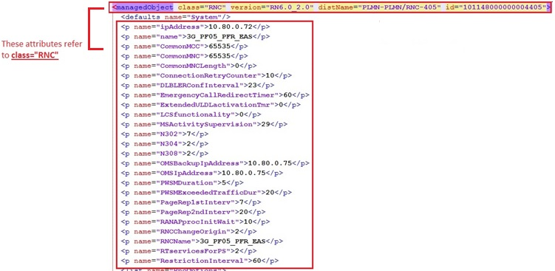

- Each class=“RNC” attribute represents a RNC node.
- Each class=“WBTS” attribute represents a new NodeB.
- Each class=“WCEL” attribute represents the served cells for the parent NodeB.
- Each class=“ADJI” and class=“ADJS” attribute represents neighbouring 3G cells for a specific cell mentioned under class=“WCEL”.

- Each class=“RNC” has many class=“WBTS” attributes under it.

- Each class= “WBTS” has many class=“WCEL” attributes under it.

- Each class= “WCEL” has many class=“ADJI” or class=“ADJS” under it.
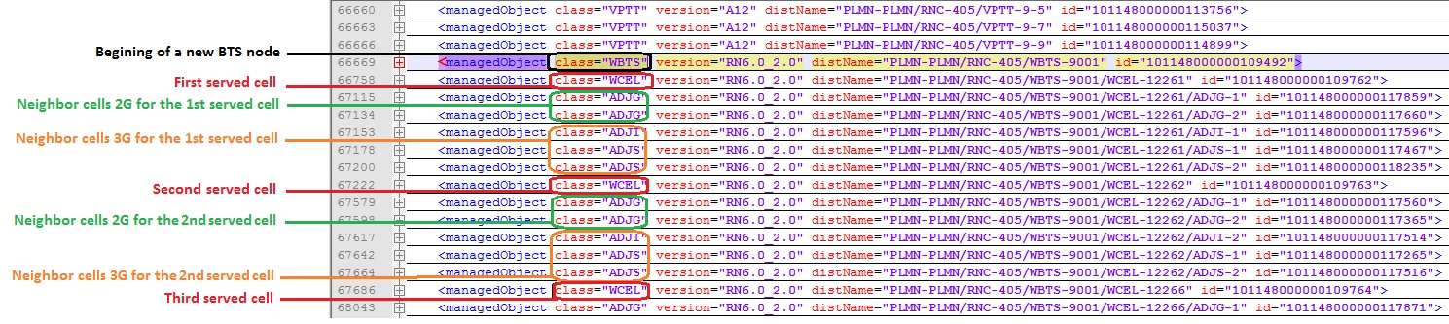

Connector name
NSN_RAN_Ooredoo_Tunisia

RNC logical parameters
The RNC logical inventory attributes are classified as per the categories below:
  - Global Parameters
  - Networking Parameters
- Note: The internal mapping between the Physical and Logical parameters will be based on the Node ID.

Global Parameters
The below global attributes defined at RNC level are as follows:

Attributes | Importance | Example
Node ID | [Mandatory] | - = distName attribute within each line containing class="RNC"  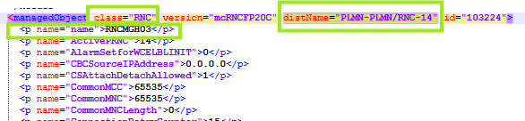  - E.g.: distName="PLMN-PLMN/RNC-14"  Node ID = RNC-14
Node Name | [Mandatory] | - = name="name" attribute under each line containing class=”RNC” attribute  - E.g.: name="name">RNCMGH03</p>
Site Name | [Mandatory] | - Deduced from node configuration (physical connector).
Type | [Mandatory] | - Deduced from node configuration (physical connector).
OAM IP | [Optional] | Deduced through “OMSIpAddress” under Class=”RNC”  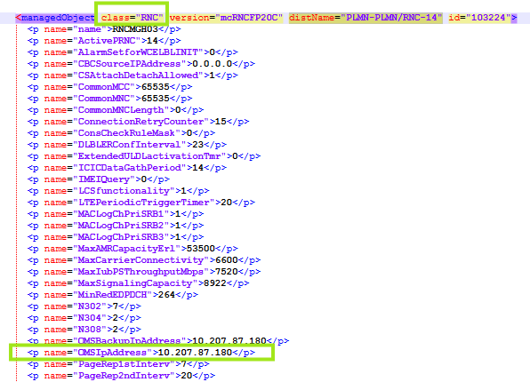  E.g.: OMSIpAddress">10.207.87.180</p>
OAM Subnet Mask | [Optional] | The default subnet mask could be as follows:  o If the 1st field is less than or equal 127  § The default subnet mask = 255.0.0.0  o If the 1st field is greater than or equal 128 and less than or equal 191  § The default subnet mask = 255.255.0.0  o If the 1st field of the IP address is greater than or equal to 192  § The default subnet mask = 255.255.255.0

Networking Parameters
The following networking attributes defined at RNC level are as follows:

Attributes | Importance | Example
MCC | [Mandatory] | - = name="WCELMCC" value under each class="WCEL"attribute.  - It is sufficient to parse only one value from the “WCELMCC” attribute across the entire file.  - E.g.: name=” WCELMCC”>605</p>  MCC = 605
MNC | [Mandatory] | - = name="WCELMNC" value under each class=”WCEL” attribute.  - It is sufficient to parse only one value from the “WCELMNC” attribute across the entire file.  E.g.: name=” WCELMNC”>03</p>  MNC = 03
Parent MSC | [Optional] | - Null
Parent SGSN | [Optional] | - Deduced through name="CNId" attribute under each class="IUPS".  - E.g.: name="CNId">302</p>  - Search for the SGSN that has the above CNID from the NEP tool.
Attached NodeBs | [Optional] | - (NEP tool calculated)
Neighbour RNCs | [Optional] | - Deduced from name="NRncId" value under each line containing class="IUR”.  Concatenate “PLMN-PLMN/RNC-“ with the value of “NRncId” hence the RNC name could be deduced at saving  E.g.: name="NRncId">604</p> after concatenation ==>  "PLMN-PLMN/RNC-604" => RNC Name = RNCYA0103

Logical IP Parsing
- Each class="ADDR" in RNC logical dumps which has “OWNER-QN” or “OWNER-QC” in “disName” attribute represents one logical interface
- E.g.
<managedObject class="ADDR" version="mcRNCFP20C" distName="PLMN-PLMN/RNC-14/IP-1/OWNER-QNIUB-2/ADDR-10.107.187.145-lo13" id="1971362">
Or
class="ADDR" version="ASRNCFP20B" distName="PLMN-PLMN/RNC-1011/TRANSPORT-1/OWNER-QCIUB-0/ADDR-10.64.84.223-uplane4" (this example is from previous FRS-Airtel because it is NA in sample dump)

- Do not parse the IP if the attribute “iface” value under class “ADDR” contain cfeigw OR sctp

Attributes | Importance | Example
Interface Name |  | - From “distName” attribute, the value after “ADDR-“  - E.g. <managedObject class="ADDR" version="mcRNCFP20C" distName="PLMN-PLMN/RNC-14/IP-1/OWNER-QNOMU/ADDR-10.107.187.252-lo" id="1971447">  - 10.107.187.252-lo
IP Address | [Mandatory] | - =”address” attribute under class=”ADDR”  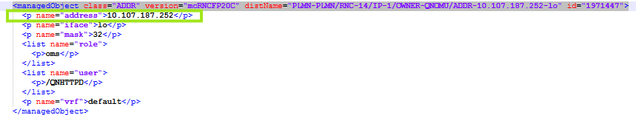
Mask | [Mandatory] | - =”mask” attribute under class=”ADDR”  - E.g. 32 mask = 255.255.255.255  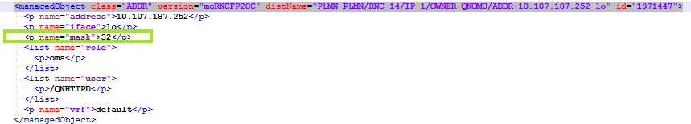
VLAN | [Optional] | - Under the same class=”ADDR”  - VLAN name= <name=”VRF”>  - Match the VLAN name deduced above with VLAN name deduced from class =”VLAN”  - Under the class=”VLAN”  - VLAN ID= < name="vid">
Description | [Optional] | - =after “role” attribute  - E.g.  <list name="role">  <p>oms</p> description= oms  Example:  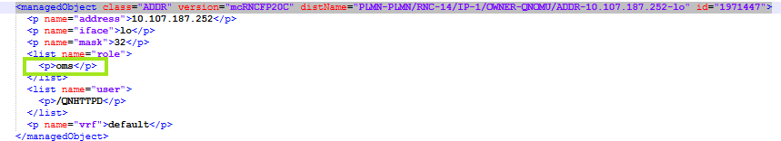

LO0
- Each class “IEIF” in RNC logical dumps which “distName” value matching the following regular expression (PLMN-PLMN/RNC-\d+/IPNO-ICSU.+) represents one or more loopback interfaces
- Each “IEIF” class could contain more than one “item”. Each one represents a loopback interface

Attributes | Importance | Example
Interface Name |  | - RNC name_ IPaddress  - E.g. RNC01_10.64.67.3
IP Address | [Mandatory] | - =”addrValueIPV4” attribute under ”item”
Mask | [Mandatory] | - =”netmask” attribute under ”item”
VLAN | [Optional] | - null
Description | [Optional] | - null

Physical IP Parsing

Deduced from class="ADDR"
- Each class="ADDR" in RNC logical dumps which has “OWNER-EIPU” in “disName” attribute represents one node interface
- E.g.
class="ADDR" version="mcRN4.1" distName="PLMN-PLMN/RNC-605/IP-1/OWNER-EIPU-6/ADDR-10.16.49.173-iub_r2"
- The interfaces on the same port should be configured as sub-interfaces

Attributes | Importance | Example
Physical Port C/SH/S/I/P | [Optional] | - Cabinet=1  - Shelf=1  - Index on slot= 0  - Slot index= 0  - port  - From class=”ADDR” take the value of “distName” attribute  - E.g. distName="PLMN-PLMN/RNC-611/IP-1/OWNER-EIPU-7/ADDR-10.18.0.57-iucs_cp_r1”  - Search for a class=”VLAN” where the value of “distName” = “distName” of “ADDR” after replacing the section marked in green with “VLAN”  - E.g. distName="PLMN-PLMN/RNC-611/IP-1/OWNER-EIPU-7/VLAN-iucs_cp_r1"  - From this class=”VLAN” take the value of “realIface” attribute  - if the value= xaui0 ignore the board  - if the value= xaui1 ignore the board  - if the value= eth0 port index= 7  - if the value= eth1 port index= 8  - else Take the number after “ethsfp” and before “_” e.g. name="realIface">ethsfp17_r1</p> port index= 17  - If the value=Eth_r1 port index=9  - If the value=Eth_r2 port index=10
IP Address | [Mandatory] | - =”address” attribute under class=”ADDR”
Mask | [Mandatory] | - =”mask” attribute under class=”ADDR”  - E.g. 24 mask = 255.255.255.0
VLAN | [Optional] | - =form the class=”VLAN” above  - VLAN ID= < name="vid">
Description | [Optional] | - =”iface” attribute under class=”ADDR”
Gateway | [Optional] | - Deduce the range of ip above from the subnet mask  - Get the gateway ip address from class=“ADR4GW” in the distName after ADR4GW that is include in the above range  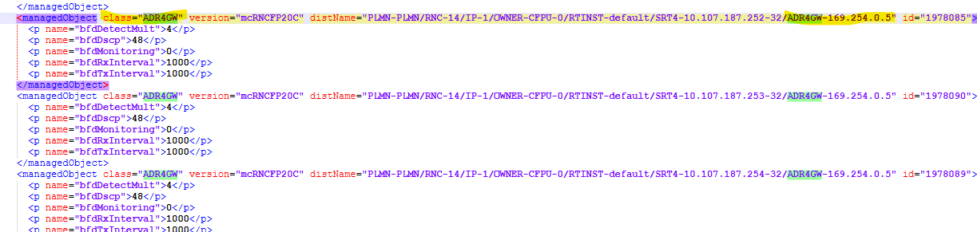

Deduced from class="IEIF"
- Each <item> under <list under class="IEIF" in RNC logical dumps with distname has the following format distName="PLMN-PLMN/RNC-X/IPNO-NPGEP-Y/IEIF-VLZ" represents a physical interface with an IP address where X and Z are integers and Y is an even number, e.g. distName="PLMN-PLMN/RNC-2/IPNO-NPGEP-8/IEIF-VL270"
- The interfaces on the same port should be configured as sub-interfaces

Attributes | Importance | Example
VLAN | [Optional] | - Find the class="IVIF" with distName has the following format distName="PLMN-PLMN/RNC-X/IPNO-NPGEP-Y/IVIF-VLZ  - E.g. distName="PLMN-PLMN/RNC-2/IPNO-NPGEP-8/IVIF-VL270"  - VLAN= vid under
Physical Port C/SH/S/I/P | [Mandatory] | - Find in the physical dumps of the RNC the class="FUUNIT" with distName ends with NPGEP-Y.  - Get the <p> value under <list under above class="FUUNIT.  - <p> format is PLMN-PLMN/RNC-W/HW-1/CABINET-X/SUBRACK-Y/UNIT-Z  - Cabinet index =X, Shelf index=Y, slot index =Z, Index on slot=0.  - Port to be deduced from parentInterface under above class="IVIF", if value is IFGE0 then port index=0, else if value is IFGE1 then port index=1
IP Address | [Mandatory] | - =”addrValueIPV4” attribute under <item> under <list under class="IEIF".  - E.g. 172.25.2.1
Mask | [Mandatory] | - =” netmask” attribute under <item> under <list under class="IEIF"  - E.g.: 255.255.255.248
Gateway | [Optional] | - Deduce the range of IPs from the above IP @ and Mask.  - Find the <managedObject class="ADR4GW" with distName has the format distName="PLMN-PLMN/RNC-X/IPNO-NPGEP-Y/SRT4-xxxx/ADR4GW-yyyyy where yyyyy is an IP @ in the above deduced range.  - Gateway = yyyyy.  - E.g. distName="PLMN-PLMN/RNC-2/IPNO-NPGEP-8/SRT4-10.0.46.67-32/ADR4GW-172.25.2.6 Gateway=172.25.2.6

Eth-Trunk

- Each class=“LAGGR” represent an Eth-Trunk interface
- The RNC ID to be deduce from the distName
- The Board index of the physical interface association to be deduced from the distName

Attribute | Priority | Description
Interface | Mandatory | - Class=“LAGGR”  - From distName="PLMN-PLMN/RNC-xxx/IP-x/OWNER-EIPU-x/LAGGR-laggrY  - Interface index= xY  - Example: <managedObject class="LAGGR" version="mcRNC16" distName="PLMN-PLMN/RNC-13/IP-1/OWNER-EIPU-1/LAGGR-laggr1"  - interface index= 11
Description | Optional | - From distName="PLMN-PLMN/RNC-xxx/IP-x/OWNER-EIPU-x/LAGGR-laggrY  - Description= OWNER-EIPU-x/LAGGR-laggrY
Physical interface association | Optional | - Class=“LAGGR”  - Take by default:  - Cabinet index=1  - Shelf index=1  - Index on slot=0  - From From distName="PLMN-PLMN/RNC-xxx/IP-x/OWNER-EIPU-x/LAGGR-laggrY  - Slot index = integer X after EIPU  - Port index =  - Under attribute "slave"  - Example:  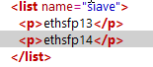  - The integer after ethsfp, in the previous example ports index are  - 13 and 14
Sub-interface | Optional | - From class=“ADDR” where in the distName include  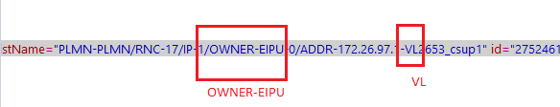  - Sub-interface index= integer after VL in the attribute “iface”  - Example  - 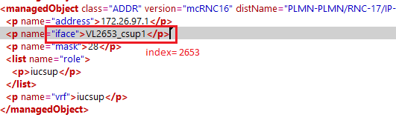
IP Address | Optional | - from the same class=“ADDR” above  - =attribute “ADDR”
Mask | Optional | - From the same class=“ADDR” above  - =attribute “mask”
gateway | Optional | - Deduce the range of ip above from the subnet mask  - Get the gateway ip address from class=“ADR4GW” in the distName after ADR4GW that is include in the above range  - 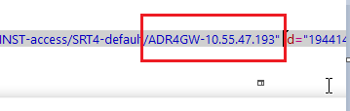
vrf | Optional | - From the same class=“ADDR” above  - =attribute “vrf”

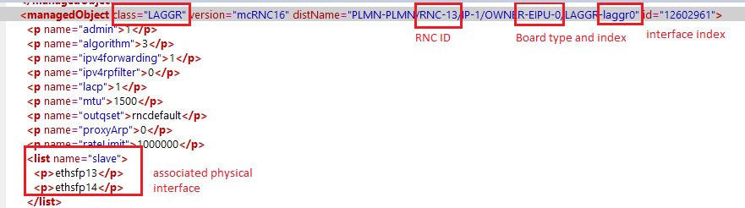

NodeB 3G logical Attributes

Global Parameters
- The global attributes at NodeB level are to be extracted as follow :

Attribute | Importance | Example
NodeB ID | [Mandatory] | - =from ”distName” attribute under each <managedObject class="WBTS"  - E.g.: distName= "PLMN-PLMN/RNC-603/WBTS-1190"  NodeB ID = 603_1190
NodeB Name | [Mandatory] | - Deduced through name="name" attribute under each <managedObject class="WBTS"  E.g.: name=”name”>AYW5053_U2100_G</p>
Site Name | [Mandatory] | - Match the deduced “NE Name” with values under “Column A” from “Site_Matching” file and deduce site Name from column B. If no site is found go to the next step  - From NE Name take the first 4 integers and 3 characters before them.  - Search for a site with this ID.  - E.g AYW5053_U2100_G search for a site with ID = AYW5053
Type | [Mandatory] | - =deduced from node configuration
OAM IP | [Optional] | - Deduced through “BTSIPAddress” attribute under each <managedObject class="WBTS"  - E.g.: name="BTSIPAddress">172.22.112.154</p>
OAM Subnet Mask | [Optional] | - The default subnet mask could be as follows:  o If the 1st field is less than or equal 127  § The default subnet mask = 255.0.0.0  o If the 1st field is greater than or equal 128 and less than or equal 191  § The default subnet mask = 255.255.0.0  o If the 1st field of the IP address is greater than or equal to 192  § The default subnet mask = 255.255.255.0
64-QAM Support | [Optional] | - A NodeB has 64-QAM Support enabled if at least one of its served cells has the value of attribute 64-QAM enabled is equal to YES  - Else default value = NO => 64-QAM Support = NO  - The obtained value refers to the NodeB Name value of name="name" attribute under each class=”WBTS” attribute
HSDPA Support | [Optional] | - A NodeB has HSDPA Support enabled if at least one of its served cells has the value of attribute HSDPA enabled equal to YES  - Else default value = NO => HSDPA Support = NO  - The obtained value refers to the NodeB Name value of name="name" attribute under each class=”WBTS” attribute
HSUPA Support | [Optional] | - A NodeB has (HSUPA Support = YES) if at least one of its served cells has the value of the attribute HSUPA enabled = YES  - Else default value = NO => HSUPA Support = NO  - The obtained value refers to the NodeB Name value of name="name" attribute under each class=”WBTS”
MIMO Support | [Optional] | - A NodeB has Mimo Support enabled if at least one of its served cells has the value of the attribute MIMO enabled = YES  - Else default value =NO => Mimo Support = NO  - The obtained value refers to the NodeB Name value of name="name" attribute under each class=”WBTS”
Node Status | [Optional] | - DCNLinkStatus Under the class “WBTS”  - Active if value equal to 1  - Inactive if value equal to 0
3G Node Status | [Optional] | - This to be added as addinfo section for 3G Role under sran  - DCNLinkStatus Under the class “WBTS”  - Active if value equal to 1  - Inactive if value equal to 0  - Below is the table for Addinfo
  Category | Value | Note
  3G Status | Active Or Inactive as describe above | Active Or Inactive as describe above

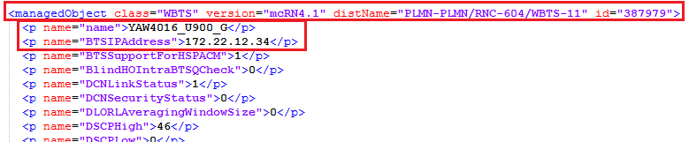

Status | [Mandatory] | - deduced from “AZCN_3G_STATUS_20” file from Sites folder, where the status of the SITE ID is equal to “ON_AIR”  - If the Status is empty keep the value blank  - Exclude the nodes with status “DEFINED”

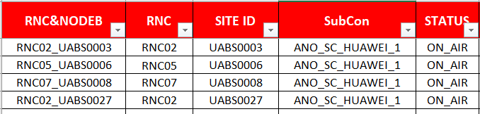

Networking Parameters
- The following table summarizes the Networking attributes at NodeB level:

Attributes | Importance | Example
MNC | [Mandatory] | - (NEP tool calculated) from the Cell attribute.
MCC | [Mandatory] | - (NEP tool calculated) from the Cell attribute.
LAC | [Optional] | - (Nep Tool calculated) from the Cell attribute.  - If different LAC values are reported for same NodeB ID, list the different detected values separated by «, ».  - E.g. 10032,
SAC | [Optional] | - (NEP Tool Calculated)  - If different SAC values are reported for same NodeB ID, list the different detected values separated by «, ».  - E.g. 30955, 30956
RAC | [Optional] | - = (NEP Tool Calculated)  - If different RAC values are reported for same NodeB ID, list the different detected values separated by « , »  - E.g. 5, 6…
Parent RNC | [Mandatory] | - =(name=”name”) value under (class=”RNC”) attribute  - E.g. : name=”name”>RNCYA0102</p>  - Parent RNC = RNCYA0102
Attached MSC | [Optional] | - Deduced from parent RNC
Attached SGSN | [Optional] | - Deduced from parent RNC
Served cells | [Optional] | - (NEP tool calculated)

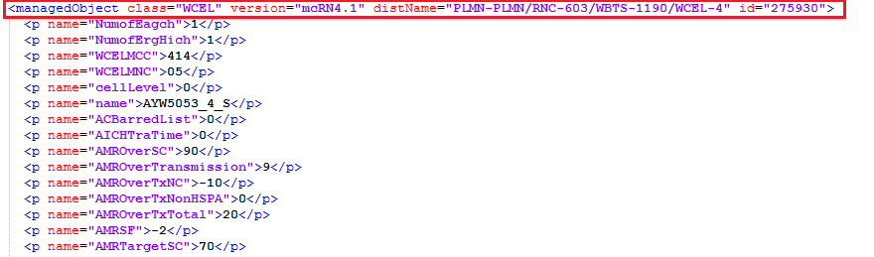

IP Parsing

IVIF

- Each IVIF class represents one node logical interface
- E.g. : <managedObject class="IVIF" version="WBTSFP20C" distName="PLMN-PLMN/RNC-14/WBTS-14110/FTM-1/IPNO-1/IEIF-1/IVIF-1" id="3053420">
- This logical interface is for the NodeB ID: 14_14110.

Attributes | Importance | Example
IP Address | [Mandatory] | - = from “localIpAddr” attribute under above specified class  - E.g.: <p name="localIpAddr">10.113.77.14</p>  IP address: 10.113.77.14  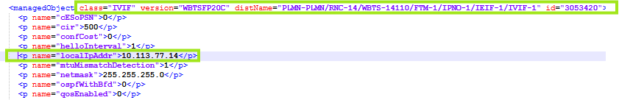
Mask | [Mandatory] | - = from “netmask” attribute under above specified class  - E.g.: <p name="netmask">255.255.255.0</p>  Mask: 255.255.255.0
Gateway | [Mandatory] | - Using IP and Mask deduce the range of IPs  - Search in “IPRT” classes for this NodeB ID in “gateway” attribute for an IP which is in the same previous subnet  - Take this as a gateway  - E.g: <managedObject class="IPRT" version="WBTSFP20C" distName="PLMN-PLMN/RNC-14/WBTS-14110/FTM-1/IPNO-1/IPRT-2" id="3053275">  <list name="staticRoutes">  <item>  <p name="bfdId">0</p>  <p name="destIpAddr">10.107.187.146</p>  <p name="gateway">10.113.77.1</p>  <p name="netmask">255.255.255.255</p>  <p name="preference">1</p>  </item>  <item>  <p name="bfdId">0</p>  <p name="destIpAddr">0.0.0.0</p>  <p name="gateway">10.173.77.1</p>  <p name="netmask">0.0.0.0</p>  <p name="preference">1</p>  </item>  <item>  <p name="bfdId">0</p>  <p name="destIpAddr">10.107.87.250</p>  <p name="gateway">10.163.77.1</p>  <p name="netmask">255.255.255.255</p>  <p name="preference">1</p>  </item>  Gateway: 10.113.77.1  - If no gateway is found get the “IPRT” class with the “destIpAddr” equals “0.0.0.0”. take the “gateway” attribute as gateway.
VLAN | [Optional] | - From “vlanId” attribute under class=”IVIF”.  - E.g.: <p name="vlanId">2101</p>  VLAN: 925  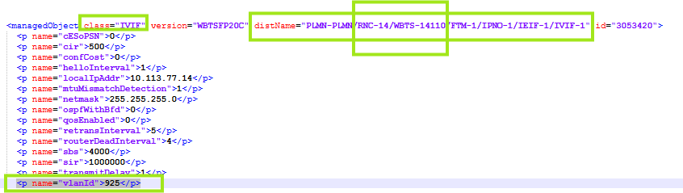

IEIF

- Each IEIF class with the following attributes represents one node logical interface
  - the value of “localIpAddr” attribute under “ipAddr” under IEIF is not null nor “0.0.0.0”
- E.g. : <managedObject class="IEIF" version="WBTS17" distName="PLMN-PLMN/RNC-4/WBTS-294/FTM-1/IPNO-1/IEIF-1" id="2118995">
- This logical interface is for the NodeB ID: PLMN-PLMN/RNC-4/WBTS-294

Attributes | Importance | Example
IP Address | [Mandatory] | - = from “localIpAddr” attribute under above specified class  - E.g.: <p name="localIpAddr">10.20.64.12</p>  IP address: 10.79.1.147
Mask | [Mandatory] | - = from “netmask” attribute under above specified class  - E.g.: <p name="netmask">255.255.255.224</p>  Mask: 255.255.255.224
Gateway | [Mandatory] | - Using IP and Mask deduce the range of IPs  - Search in “IPRT” classes for this NodeB ID in “gateway” attribute for an IP which is in the same previous subnet  - Take this as a gateway  - E.g: <managedObject class="IPRT" version="WN9.1" distName="PLMN-PLMN/RNC-602/WBTS-24/FTM-1/IPNO-1/IPRT-2" id="2118910">  <list name="staticRoutes">  <item>  <p name="bfdId">0</p>  <p name="destIpAddr">172.20.9.1</p>  <p name="gateway">172.18.219.30</p>  <p name="netmask">255.255.255.255</p>  <p name="preference">1</p>  </item>  <item>  <p name="bfdId">0</p>  <p name="destIpAddr">10.16.52.176</p>  <p name="gateway">10.20.64.30</p>  <p name="netmask">255.255.255.240</p>  <p name="preference">1</p>  </item>  Gateway: 10.20.64.30  - If no gateway is found get the “IPRT” class with the “destIpAddr” equals “0.0.0.0”. take the “gateway” attribute as gateway.
VLAN | [Optional] | - If “vlanEnabled” attribute does not “0”  - From “vlanId” attribute  - E.g.: <p name="vlanId">2101</p> VLAN: 2101  - Else: null

SRAN 3G logical Attributes

Global Parameters
- The global attributes at NodeB level are to be extracted as follows:

Attribute | Importance | Example
SRAN ID | [Mandatory] | - =same as in Physical parsing
SRAN Name | [Mandatory] | - =same as in Physical parsing
Site Name | [Mandatory] | - =same as in Physical parsing
Type | [Mandatory] | - =deduced from node configuration
OAM IP | [Optional] | - From class=”WNBTS” take the value of “ipV4AddressDN”  - Match this value with dist name for class="IPADDRESSV4"  - Take the value of attribute "localIpAddr" as OAM IP under this class
OAM Subnet Mask | [Optional] | - =Value of “localIpPrefixLength” under class="IPADDRESSV4"

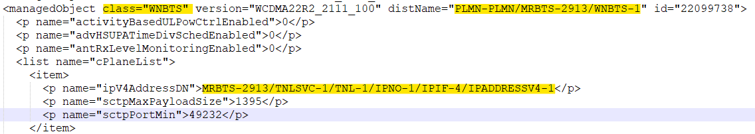

Networking Parameters
- The following table summarizes the Networking attributes at NodeB level:

Attributes | Importance | Example
MNC | [Mandatory] | - (NEP tool calculated) from the Cell attribute.
MCC | [Mandatory] | - (NEP tool calculated) from the Cell attribute.
LAC | [Optional] | - (Nep Tool calculated) from the Cell attribute.  - If different LAC values are reported for same SRanBs ID, list the different detected values separated by «, ».  - E.g. 10032,
SAC | [Optional] | - (NEP Tool Calculated)  - If different SAC values are reported for same SRanBs ID, list the different detected values separated by «, ».  - E.g. 30955, 30956
RAC | [Optional] | - = (NEP Tool Calculated)  - If different RAC values are reported for same SRanBs ID, list the different detected values separated by « , »  - E.g. 5, 6…
Parent RNC | [Mandatory] | - Match the deduced IP Address from attribute currentSctpIpAddress under class=”WNBTS” with the IP address of RNC parsed in section 4.3
Attached MSC | [Optional] | - Deduced from parent RNC
Attached SGSN | [Optional] | - Deduced from parent RNC
Served cells | [Optional] | - (NEP tool calculated)

IP Parsing

- Below are IP parsing attributes.
Attributes | Importance | Example
IP Address | [Mandatory] | - From class=”WNBTS” take the value of “ipV4AddressDN”  - Match this value with dist name for class="IPADDRESSV4"  Take the value of "localIpAddr" as OAM IP
Mask | [Mandatory] | =Value of “localIpPrefixLength” under class="IPADDRESSV4"
Gateway | [Mandatory] | - From class=”WNBTS” take the value of “ipV4AddressDN”  - Match this value with dist name for class="IPRT"/class=”IPRT_R”  Where “IPIF” will be replaced by “IPRT”  - Then value of gateway under this class is the gateway IP.
VLAN ID | [Mandatory] | - Under class=" VLANIF" if the attribute “userLabel” contains “WCDMA”  - The value of vlanId under this class is the VLAN ID.  If userLabel is not found, follow the process below.  - From class=” IPADDRESSV4” take the value of distname  - Replace “IPNO-1/IPIF” with “ETHSVC-1/ETHIF-1/VLANIF”  - Ignore the section “/IPADDRESSV4-X” class=” IPADDRESSV4”  - Match the value with distname of class="VLANIF" from the above deduced section  - The value of vlanId under this class is the VLAN ID.

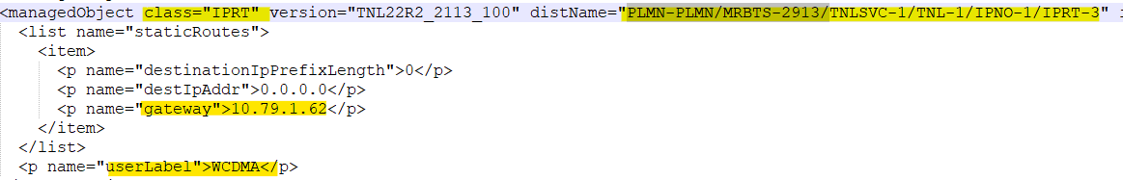

Cell Logical Parameters
- The following table summarizes the Networking attributes at Cell level:

Attributes | Importance | Example
Cell Name | [Optional] | - To be get from (name=”name”) attribute under each line containing (class=”WCEL”) attribute  - E.g.: name="name">AYW5053_4_S</p>  Cell Name = AYW5053_4_S
Cell ID | [Mandatory] | - The Cell ID equals “CId” attribute.
Cell Object ID | [Mandatory] | - The “Cell Object ID” is equal to the concatenation of: “LAC”, “_” and “CellID”  - Cell Id deduced above, and LAC deduce below
Node ID | [Mandatory] | - = to be deduced from “distName” attribute available with each line containing (class=”WBTS”) attribute.  E.g.: distName= "PLMN-PLMN/RNC-603/WBTS-1190” Node ID = 603_1190
Parent Site ID | [Mandatory] | - = Deduced from parent Node
Cell Technology | [Mandatory] | - (Nep tool calculated)  - Else, if not found, Cell Technology = UMTS
Cell frequency band |  | - Based on the value of an attribute <p name="UARFCN"> under class class="WCEL" which will be the “UARFCN Downlink” attribute of the first carrier of this cell.  - If the UARFCN value falls within the ranges listed in static sheet “UMTS_Frequency_Band”, the corresponding band will be parsed accordingly.
MCC | [Mandatory] | - To be get from (name=”WCELMCC”) attribute under each line containing (class=”WCEL”) attribute  - E.g.: <p name="WCELMCC">414</p>  MCC = 414
MNC | [Mandatory] | - To be get from (name=”WCELMNC”) attribute under each line containing (class=”WCEL”) attribute  - E.g.: <p name="WCELMNC">05</p>  - MNC = 05
Neighbor Cells 2G | [Optional] | - Source Cell ID:  - To be parsed from the class="ADJG" after distantName, where its include WBTS  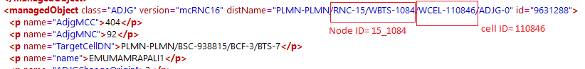  - Neighbor Cell Object ID:  - Under the class=“ADJG” mention above  - From attribute “AdjgCI” and attribute "AdjgLAC"  - Neighbor Cell Object ID= LAC_CellID  - Example:  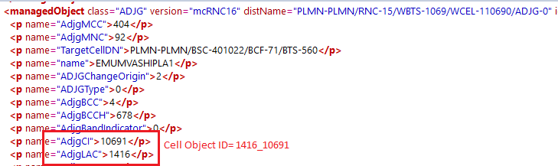
Neighbor Cells 3G | [Optional] | The neighbors cell 3G is a concatenation of “LAC” ,”_” and “CELL_ID” under each line containing (class=”ADJI”) or (class=”ADJS”) attribute where for each (class=”WBTS”) attribute there is a set of 3G neighbor cells as follows:  - Under each line containing (class=”ADJI”), “CELL_ID” is equal to the value of (name="AdjiCI") attribute, whereas the “LAC” value is equal to the value of (name="AdjiLAC") attribute.  - Under each line containing (class=”ADJS”), “CELL_ID” is equal to the value of (name="AdjsCI") attribute, whereas the “LAC” value is equal to the value of (name="AdjsLAC") attribute.
Neighbor Cells 4G | [Optional] | - = Null (to be defined later)
Last Audit Date | [Optional] | - = Null
Additional Information | [Optional] | - = Null

Below are the specific attributes to be parsed in case the cell technology is UMTS

- Specific attributes for 3G cells

Attributes | Importance | Example
Parent RNC ID | [Optional] | - =To be deduced from parent node
Primary Scrambling code | [Optional] | - = name="PriScrCode" attribute under each class=”WCEL” attribute  - E.g.: name="PriScrCode">40</p>  - Primary Scrambling code = 40  - The obtained value refers to the cell ID value of name="CId" attribute  under each class=”WCEL”
DTX enabled | [Optional] | - =Null (to be defined later)
LAC | [Optional] | - = (name="LAC") value under each line containing class=”WCEL”  - E.g. : name="LAC">10032</p>  - LAC = 10032  - The obtained value refers to the cell ID value of name="CId" attribute  Under each class=”WCEL”
RAC | [Optional] | - = name="RAC" attribute under each line containing class=”WCEL”  - E.g. : name="RAC">5</p>  - RAC = 5  - The obtained value refers to the cell ID value of name="CId" attribute under each class=”WCEL”
SAC | [Optional] | - = name="SAC" attribute under each line containing class=”WCEL”  - E.g.: name="SAC">30955</p>  - SAC = 30955  - The obtained value refers to the cell ID value of name=”CId” attribute under each class=”WCEL”
HSDPA enabled | [Optional] | - A Cell has HSDPA Enabled if name="HSDPAenabled" attribute under each class=”WCEL” is equal to 1 => HSDPA enabled = YES  - Else if different than “1”, Default value =NO  - The obtained value refers to the cell ID value of name="CId" attribute  Under each class=”WCEL”
HSUPA enabled | [Optional] | - A Cell has HSUPA Enabled if name="HSUPAenabled" attribute under each class=”WCEL” is equal to 1 => HSUPA enabled = YES  - Else if different than “1”, Default value =NO  - The obtained value refers to the cell ID value of name="CId" attribute  Under each class=”WCEL”
URA | [Optional] | - = name="URAId" value under each class=”WCEL”  - The obtained value refers to the cell ID value of name="CId" attribute  under each class=”WCEL”
64-QAM enabled | [Optional] | - A Cell has 64-QAM enabled if name="HSDPA64QAMallowed" attribute under each class=”WCEL” is equal to 1 => 64-QAM enabled = YES  - Else if different than “1”, Default value =NO  - The obtained value refers to the cell ID value of name="CId" attribute  Under each class=”WCEL”
MIMO enabled | [Optional] | - A Cell has MIMO Enabled if name="MIMOEnabled" attribute under each class=”WCEL” is equal to 1 => MIMO enabled = YES  - Else if value is different than “1”, Default value =NO  - The obtained value refers to the cell ID value of name="CId" attribute  under each class="WCEL"
MIMO configuration | [Optional] | - Deduced from name="mimoType" attribute under each class="LCELW" following the below rule:  - If name="mimoType"= 1 => MIMO configuration = 2x2  - The obtained value refers to the NodeB ID value mentioned in the first part of “distName” and to Cell Number value mentioned in the last integers of “distName” on the same line of class="LCELW"  - The Cell Number will be the integer values followed by the keyword “LCELW-“  - E.g. : distName="PLMN-PLMN/RNC-603/WBTS-1190/MRBTS-1/BTSSCW-1/LCELW-4"  ==> NodeB ID = PLMN-PLMN/RNC-603/WBTS-1190  ==> Cell Number =4  Cell ID will be then deduced from the above value.
Cell status | [Mandatory] | - Under each Cell of a NodeB (class=”WCEL”)  - Need to find the value of attribute <p name="AdminCellState"0</p>  - If the value is 0, then Cell is in HALT state  - And if the value is 1, then Cell is in ACTIVE state.

SS - for <p name="AdminCellState"1</p> CELL status will be ACTIVE
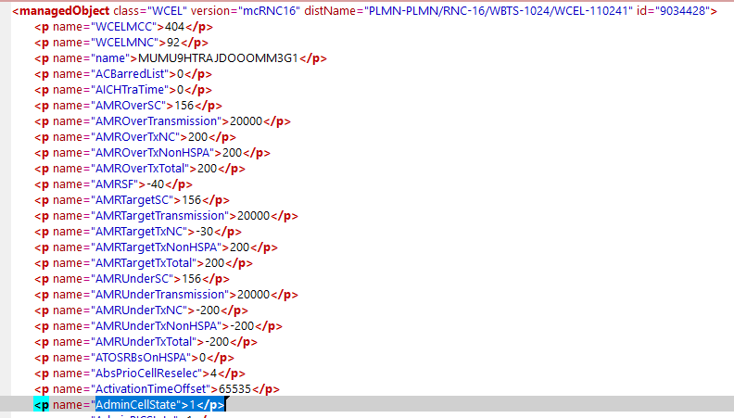
SS for <p name="AdminCellState"0</p> CELL status will be HALT

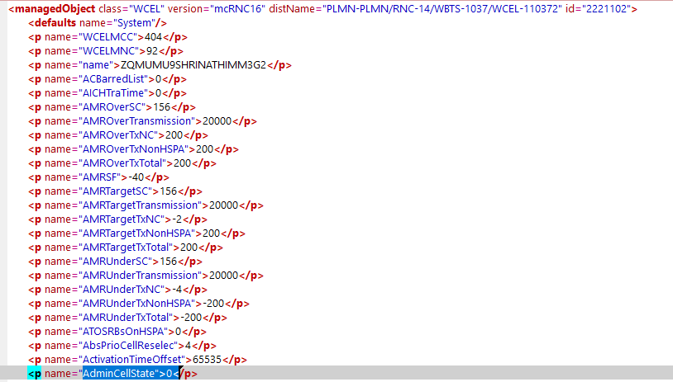

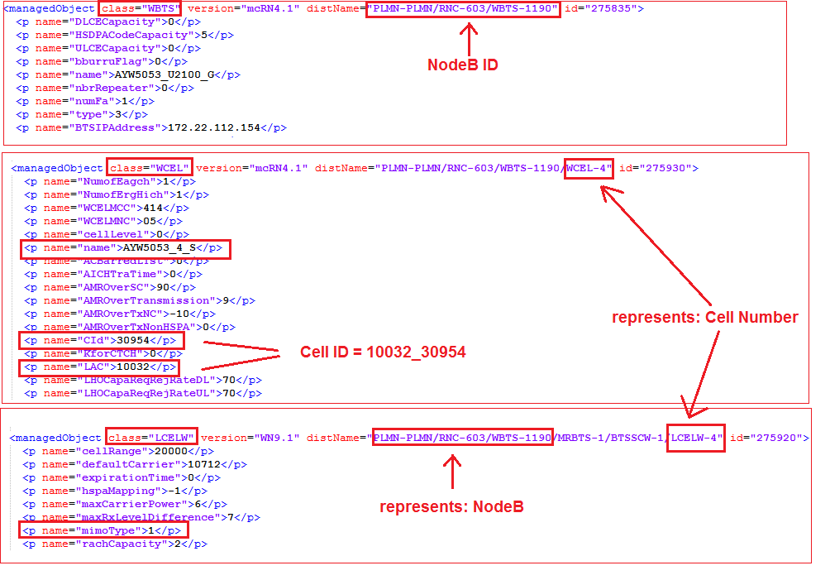

Carrier Logical Parameters

- Specific attributes for 3G carriers
Attributes | Importance | Example
Carrier ID | Mandatory | - The “Carrier ID” is equal to the concatenation of:  “Cell ID”, “_” and “UARFCN Downlink”
UARFCN Downlink | Mandatory | - = name=”UARFCN” attribute under each class=”WCEL”  - The obtained value refers to the cell ID value of name=“CId” attribute under each class=”WCEL”
UARFCN Uplink | Optional | - = It is deduced per each cell  - = To be deduced from "UARFCN Downlink" aforementioned value  - First search for this "UARFCN Downlink" value among the given ranges, if the value is located at a specific range deduce the corresponding "Duplex spacing" :  - Once the duplex spacing is found, calculate the Fd, Fu and finally "UARFCN Uplink"  - Fd=("UARFCN Downlink")*0.2 ;  - Fu=Fd - "Duplex spacing";  - UARFCN Uplink = Fu * 5;  - The obtained value refers to the cell ID value of name=“CId” attribute under each class=”WCEL”  - E.g.: name="UARFCN">10562</p> Value Range is 10562 -> 10838, therefore the Duplex spacing is equal to 190, hence:  - Fd=(10562)*0.2=2112.4  - Fu=2112.4 – 190 = 1922.4  - UARFCN Uplink = Fu * 5 = 1922.4 * 5 = 9612
  UARFCN Downlink ranges | Duplex spacing
  10562 -> 10838 | 190
  9662 -> 9938 | 80
  1162 -> 1513 | 95
  1537 -> 1738 | 400
  4357 -> 4458 | 45
  4387 -> 4413 | 45
  2237 -> 2563 | 120
  2937 -> 3088 | 45
  9237 -> 9387 | 95
  3112 -> 3388 | 400
  3712 -> 3787 | 48
  3842 -> 3903 | 30
  4017 -> 4043 | -31
  4117 -> 4143 | -30
  712 -> 763 | 45
  4512 -> 4638 | -41
  862 -> 912 | 48
  4662 -> 5038 | 100
  5112 -> 5413 | 80
Code type | Optional | - HSDPA codes: Number of HSDPA codes is deduced by “HSPDSCHCodeSet” attribute referring to the cell ID value of name=“CId” attribute under each class=”WCEL” as per below:  - Get: name=” HSPDSCHCodeSet” attribute under each class=”WCEL”  - Convert “HSPDSCHCodeSet” from Decimal to a Binary number of 16 digits ordered from bit0 to bit15 (e.g. “HSPDSCHCodeSet”= 65504→binary=111111111100000), please refer to below snapshot.  - Find the first bit having value “1” starting bit0 (e.g. binary=111111111100000→ bit5 is the first bit having value “1”.  - Number of HSDPA codes is equal to the index of first bit with value “1” (e.g. first bit with value “1” is bit 5→ number of HSDPA codes =5).  - Find the last bit having value “1” starting bit0 (e.g. binary=111111111100000→ bit15 is the last bit having value “1”.  - Shared Codes=index of last bit with value “1” – number of HSDPA codes (e.g. last bit with value “1” is bit15, HSDPA codes =5, Shared codes=15-5=10).  - Reserved Codes: Number of reserved codes is deduced by “MaxNbrOfHSSCCHCodes” and “HSUPAEnabled” attributes referring to the cell ID value of name=“CId” attribute under each class=”WCEL” as per below:  - Get: name=”HSUPAEnabled” and name=” MaxNbrOfHSSCCHCodes” attributes under each class=”WCEL”.  - If “HSUPAEnabled” is equal to 1 then number of Reserved codes=Roundup ((MaxNbrOfHSSCCHCodes+11)/16).e.g.( MaxNbrOfHSSCCHCodes =3→ Reserved codes=roundup ((3+11)/16) =1).  - Else, number of Reserved codes=Roundup ((MaxNbrOfHSSCCHCodes+8)/16).e.g. MaxNbrOfHSSCCHCodes =3→ Reserved codes=roundup ((3+8)/16) =1.  - UMTS Codes = 16-HSDPA codes-Shared codes-Reserved codes).  - E.g. HSDPA codes=5  - Shared codes=10  - Reserved codes=1.  - UMTS codes=16-5-10-1=0.  - Assign codes: codes are assigned to the carrier under the concerned cell as per below priorities:  - Priority 1: Reserved Codes.  - Priority 2: UMTS codes.  - Priority 3: Shared codes.  - Priority 4: HSDPA codes.  - Example:  - HSDPA codes=5  - Shared codes=10  - Reserved codes=1.  - UMTS codes=0.  - Assignment would be as per below:  - Code Type 1=Reserved.  - Code Type 2=Shared.  - Code Type 3=Shared.  - Code Type 4=Shared.  - Code Type 5=Shared.  - Code Type 6=Shared.  - Code Type 7=Shared.  - Code Type 8=Shared.  - Code Type 9=Shared.  - Code Type 10=Shared.  - Code Type 11=Shared.  - Code Type 12=HSDPA.  - Code Type 13=HSDPA.  - Code Type 14=HSDPA.  - Code Type 15=HSDPA.  - Code Type 16=HSDPA.
Supports HSDPA? | [Optional] | - =”True” if any of the Carrier codes is HSDPA or Shared.  - Else, =”False”.

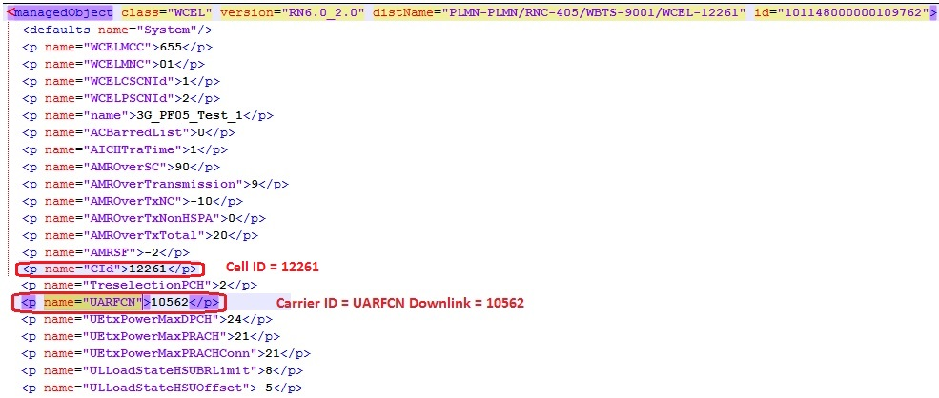

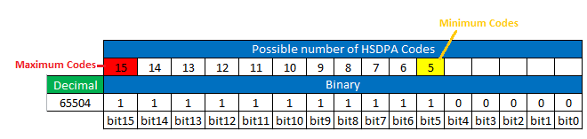

Customizable attributes

- Below listed additional info to be added on RNC
- Attribute to be incremented from 1 for each Category
- The values in note field should be separated with “;”

RNC IuCS Customizable attributes

- This section related to RNC version=“RNCY” where Y is an intgere

Category | Value | Note
ADJNODE  Every class="IUCSIP" represents one connected ADJNODE | = distName of class="IUCSIP"  e.g. PLMN-PLMN/RNC-9/IUCS-1/IUCSIP-1 | - CONNECTION_TYPE=IuCS  - NODE_ID= IP_DERIVED
ASSOCIATION  Every class="IUCSIP" represents one ASSOCIATION  record | = distName of class="IUCSIP" | - LOCAL_IP:  - Find class="IPRO" under the same RNC with ipBasedRouteId under class="IPRO" is matching with IPBasedRouteIdCS under class="IUCSIP”.  - LOCAL_IP = addrValueIPV4 under class="IPRO"  - REMOTE_IP= the value of “DestIPAddressCS” under class="IUCSIP"

- This section related to RNC version=“mcRNCY” where Y is an integer
Category | Value | Note
ADJNODE  Every class="IUCSIP" represents one connected ADJNODE | = distName of class="IUCSIP"  e.g. PLMN-PLMN/RNC-13/IUCS-1/IUCSIP-1 | - CONNECTION_TYPE=IuCS  - NODE_ID= IP_DERIVED
ASSOCIATION  Every class="IUCSIP" represents one ASSOCIATION  record | = distName of class="IUCSIP" | - LOCAL_IP:  - Find class="IPRO" under the same RNC with ipBasedRouteId under class="IPRO" is matching with IPBasedRouteIdCS under class="IUCSIP”.  - LOCAL_IP= attribute “address” under class=“ADDR” where the attribute vrf under class=“ADDR” equal vrf attribute class=“IPRO”  - REMOTE_IP= the value of “DestIPAddressCS” under class="IUCSIP"

RNC IuPS Customizable attributes

Category | Value | Note
ADJNODE  Every class="IUPSIP" represents one connected ADJNODE | = distName of class="IUPSIP"  e.g. PLMN-PLMN/RNC-13/IUPS-1/IUPSIP-10 | - CONNECTION_TYPE=IuPS  - NODE_ID= IP_DERIVED
ASSOCIATION  Every class="IUPSIP" represents one ASSOCIATION  record | = distName of class="IUPSIP" | - LOCAL_IP:  - Find class="IPRO" under the same RNC with ipBasedRouteId under class="IPRO" is matching with IPBasedRouteIdPS under class="IUPSIP”.  - LOCAL_IP = addrValueIPV4 under class="IPRO"  - REMOTE_IP= the value of “DestIPAddressPS” under class="IUPSIP"
- This section related to RNC version=“mcRNCY” where Y is an integer
Category | Value | Note
ADJNODE  Every class="IUPSIP" represents one connected ADJNODE | = distName of class=" IUPSIP"  e.g. PLMN-PLMN/RNC-13/IUCS-1/IUPSIP-1 | - CONNECTION_TYPE= IuPS  - NODE_ID= IP_DERIVED
ASSOCIATION  Every class="IUPSIP" represents one ASSOCIATION  record | = distName of class="IUPSIP" | - LOCAL_IP:  - Find class="IPRO" under the same RNC with ipBasedRouteId under class="IPRO" is matching with IPBasedRouteIdPS under class="IUPSIP”.  - LOCAL_IP= attribute “address” under class=“ADDR” where the attribute vrf under class=“ADDR” equal vrf attribute class=“IPRO”  - REMOTE_IP= the value of “DestIPAddressCS” under class="IUCSIP"

RNC Iur Customizable attributes

- To be parsed from the dump “NRNC.log”
- The dump consists of the configuration of all the network’s RNCs
- The dump consists of multiple commands. Each command starts with “ZOYI::A;” and ends with.
- Each command contains multiple sections. each section starts with “ASSOC.”
- Each section represents one ADJNODE and one ASSOCIATION
- RNC id is to be deduced as follows:
  - After deducing “LOCAL_IP”
  - Search for an RNC with loopback or node interface with the same IP
  - Take the id of this RNC

Category | Attribute | Value | Note
ADJNODE  each section under the commands that starts with “ASSOC.” represents one ADJNODE | “IUR” and an incremented integer for each record  e.g. IUR_1 | The value of “LOCAL_IP”, “_”, and the value of “REMOTE_IP”  e.g. 10.34.58.21_10.76.15.17 | - CONNECTION_TYPE=Iur  - NODE_ID=IP_DERIVED
ASSOCIATION  each section under the commands that starts with “ASSOC.” represents one ASSOCIATION | “IUR” and an incremented integer for each record  e.g. IUR_2 | The value of “LOCAL_IP”, “_”, and the value of “REMOTE_IP”  e.g. 10.34.58.21_10.76.15.17 | - LOCAL_IP=  - From the line that starts with: “SOURCE ADDRESS 1”  - Take the value after “:”  - E.g. SOURCE ADDRESS 1 . . . . . : 10.34.58.21 10.34.58.21  - REMOTE_IP=  - From the line that starts with: “PRIMARY DEST. ADDRESS”  - Take the value between “:” and “/”  - E.g. PRIMARY DEST. ADDRESS . . : 10.76.15.17/29 10.76.15.17

Cell Additional Info

1.Take the id “<p name="antlId"> from class="LCELW" version="WBTS17" distName="PLMN-PLMN/RNC-X/WBTS-Y/MRBTS-1/BTSSCW-1/LCELW-ZZZ" (where X,Y,Z are integer).
2. Match the class ‘WCEL’ with LCELW to deduce the cell id.
3. Map ANTL-id from “class="ANTL" version="WBTS17" distName="PLMN-PLMN/RNC-X/WBTS-YYYY/MRBTS-1/ANTL-Z "
3. Take the value from attribute
<p name="vswrMajorAlarm">xx</p> and <p name="vswrMinorAlarm">yy</p> (where x and y is integer)

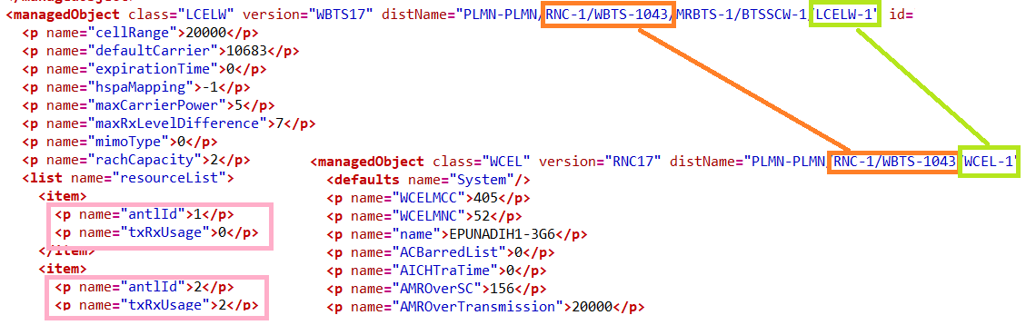

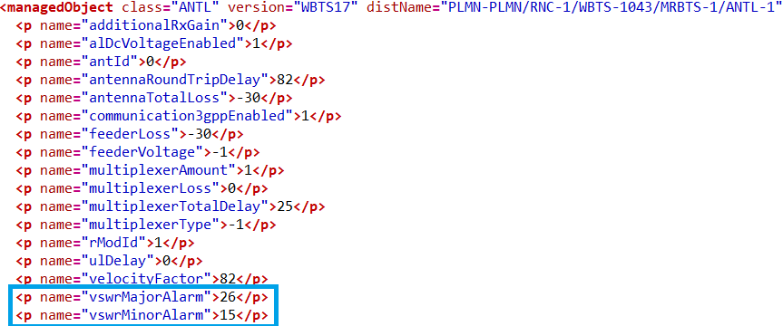

Category | Attribute | Value | Note
RADIO | vswrMajorAlarm | antlId=* | Divide the value by 10. If value is 26 then it is 2.6
RADIO | vswrMinorAlarm | antlId=* | Divide the value by 10. If value is 15 then it is 1.5

Additional Info

Iub
- Iub additional info is to be added under RNC
- The parent RNC on which the additional info should be added, could be got from the “distName” attribute

Category | Attribute | Value | Note
ADJNODE  Every “IPNB” class represents one ADJNODE  If class “IPNB” not found then every class “IPNO” represents one ADJNODE | = the value of “distName” attribute of “IPNB” class concatenated with “_ADJNODE”  Or  = the value of “distName” attribute of “IPNO” class concatenated with “_ADJNODE” | = the value of “distName” attribute of “IPNB” class  Or  = the value of “distName” attribute of “IPNO” class | - CONNECTION_TYPE=Iub  - NODE_ID= IP_DERIVED;  - CONNECTION_NAME= The value of “distName” attribute of “IPNB” class  Or  CONNECTION_NAME= The value of “distName” attribute of “IPNO” class
ASSOCIATION  // 1st association // | = the value of “distName” attribute of “IPNB” class concatenated with “_ASSOCIATION”  Or  = the value of “distName” attribute of “IPRO” class concatenated with “_ASSOCIATION” | = the value of “distName” attribute of “IPNB” class  Or  = the value of “distName” attribute of “IPRO” class | - LOCAL_IP= the value of “SourceNBAPIPAddress” under “IPNB” class  - If the SourceNBAPIPAddress was not found or it was null or 0.0.0.0 take the value of “IPBasedRouteId”  - Match it with “IPBasedRouteId” under “IPRO” class under the same RNC  - Take the value of “addrValueIPV4” or “address”  - REMOTE_IP= the value of “NodeBIPAddress” under “IPNB” class  - Don’t consider the association if WBTSid is null or “0”  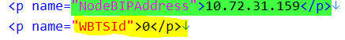  - If NodeBIPAddress” under “IPNB” class not found for the corresponding RNC follow the below process to find Remote_IP  - Match value of IPBasedRouteId” under class ”IPRO” to the value of "btsId" under class “IPNO”  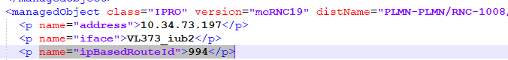  - Take the value of "cPlaneIpAddress" under class="IPNO" as “Remote_IP”  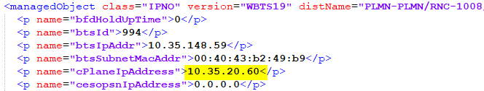  - Remove duplicate values if any found.

OPC
- To be parsed from class=”IUR”
- For each RNC, duplicates should be removed
- Each class=”IUR” could represent one OPC
- RNC ID= Take the value of “NRncId” attribute under “IUR” class

Iub for SRAN
- Iub additional info are to be added under RNC
- Under class=”WNBTS”, attribute "currentSctpIpAddress" is considered as Local_IP.
- REMOTE_IP will be parsed as section 6.3.

Category | Attribute | Value | Note
ADJNODE  Every “WNBTS” class represents one ADJNODE | = the value of “distName” attribute of “WNBTS” class concatenated with “_ADJNODE” | = the value of “distName” attribute of “WNBTS” class | - CONNECTION_TYPE=Iub  - NODE_ID= IP_DERIVED;  - CONNECTION_NAME= The value of “distName” attribute of “WNBTS” class
ASSOCIATION  // 1st association // | = the value of “distName” attribute of “WNBTS” class concatenated with “_ASSOCIATION” | = the value of “distName” attribute of “WNBTS” class | - LOCAL_IP= the value of “currentSctpIpAddress” under class “WNBTS” class  - REMOTE_IP= the value of “localIpAddr” under class “IPADDRESSV4”

