703 Cabinet Testing

Active Part:
Check the sync process for the following:
We have two different nodes:

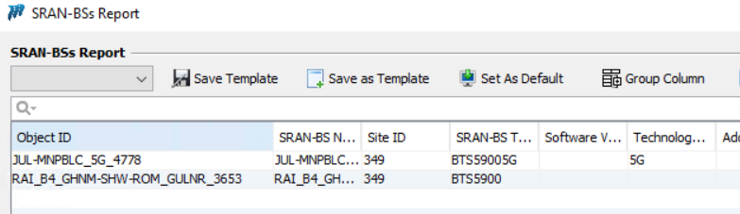

Cabinet :

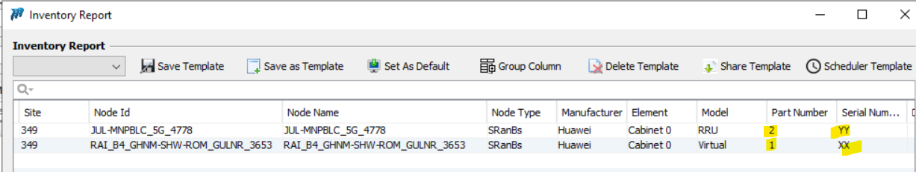

Run the sync process to check all the info updated in Unmapped report :
We are doing this testing on Version : Test

Updated fine on Um:

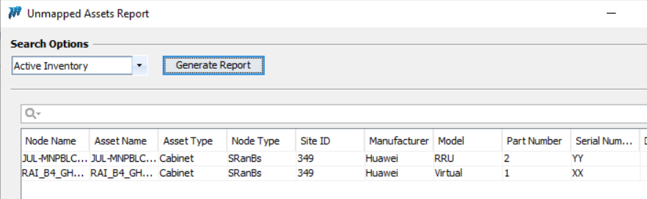

We put financials on it:
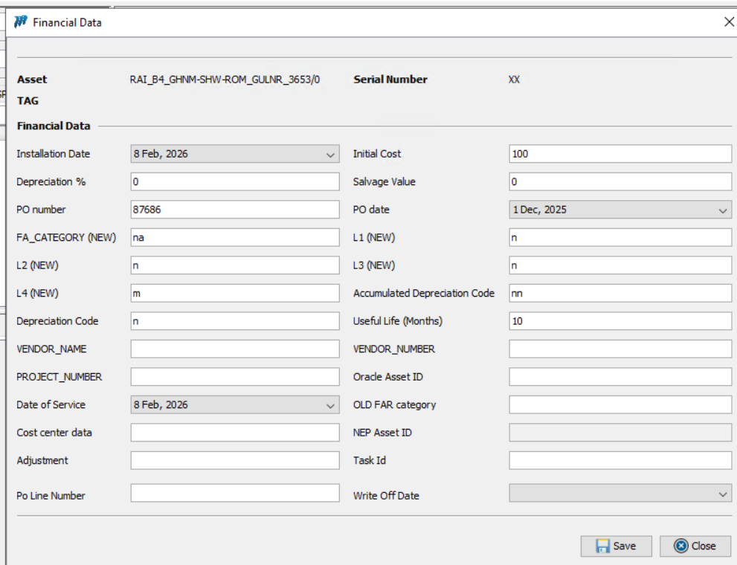

Request is not coming at Financials WF:

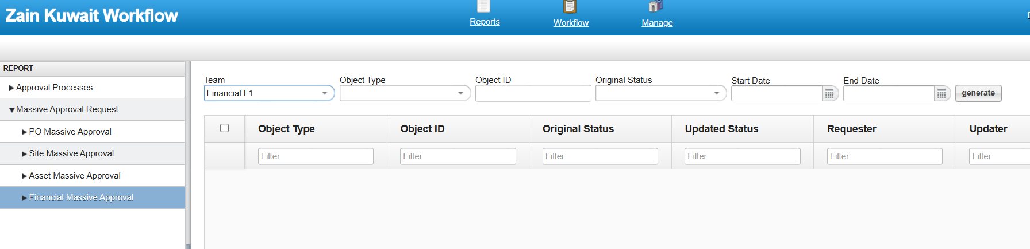

When we try to switch the PN and SN between the two assets, it shows error:

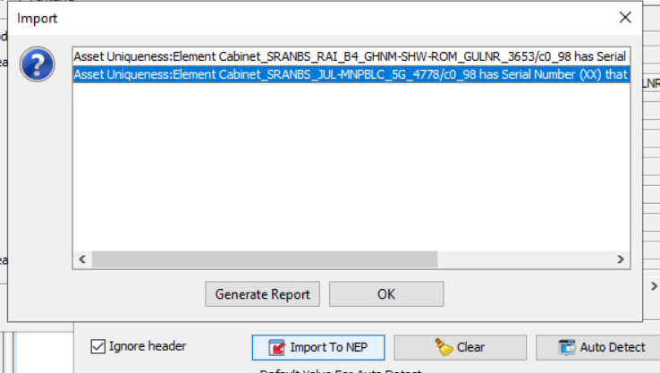

And the SN is blank for both the nodes. Even after importing the same switched csv again Sn didn’t came, ideally it shouldn’t get blank.
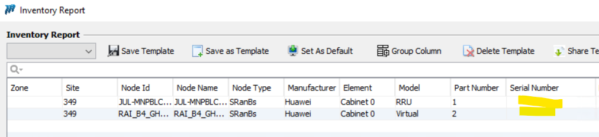

The Blank SN issue can be observed if the Board or SN switched to another asset.

Now when use different SN like “RR” and “ZZ” , it got updated fine :

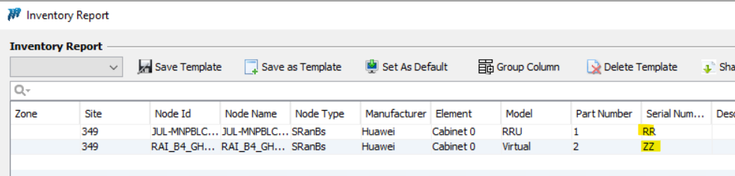

We run the sync process again to check the status updated in UM:

Updated fine in UM:

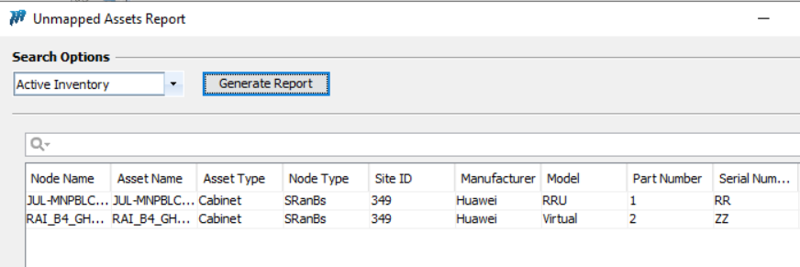

Now trying csv import method for FR:
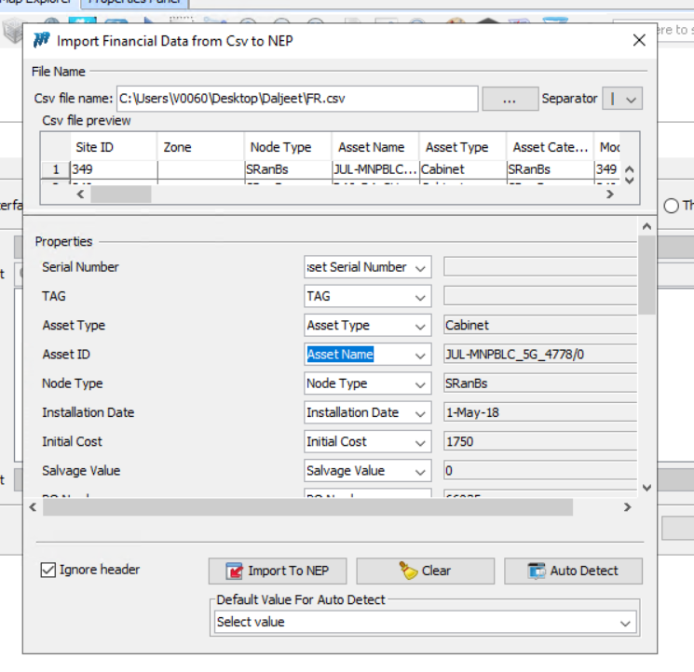
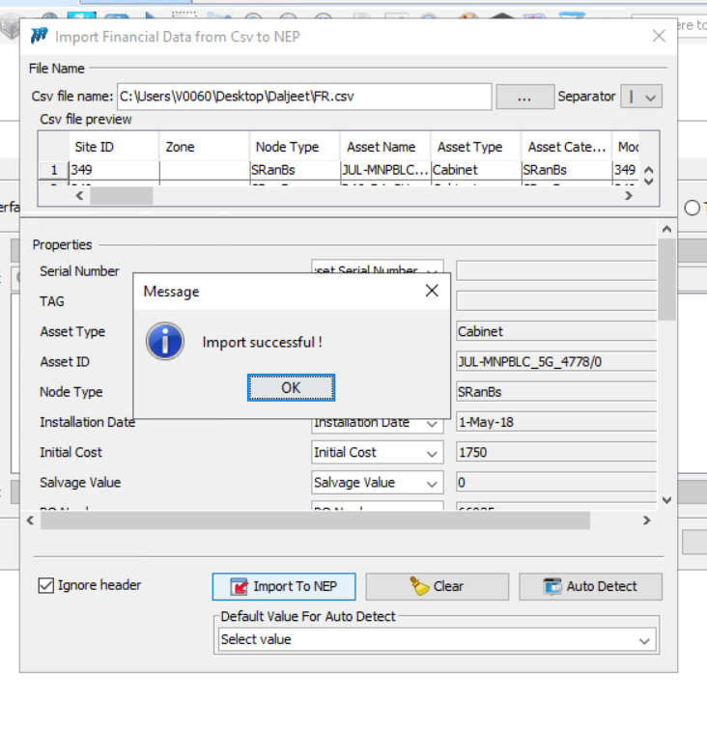

It works fine and request came in WF:

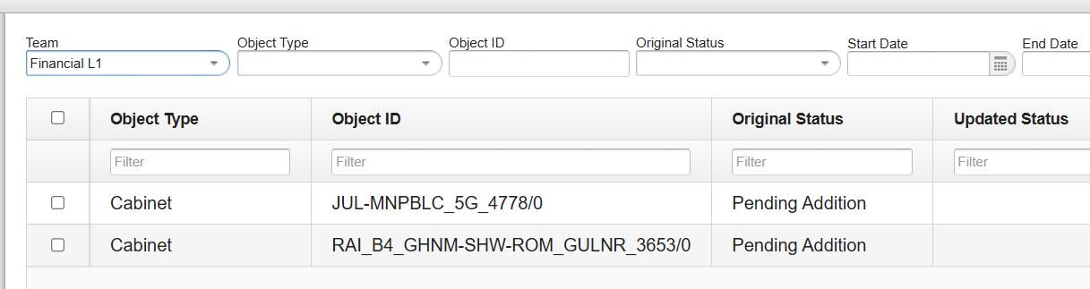

Asset updated fine in FR:
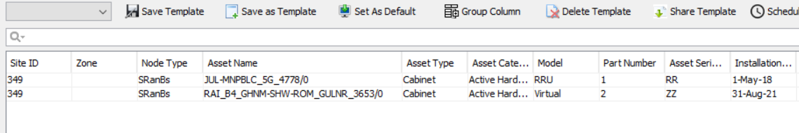

Now we will change the PN and SN at Inventory and run the sync process:
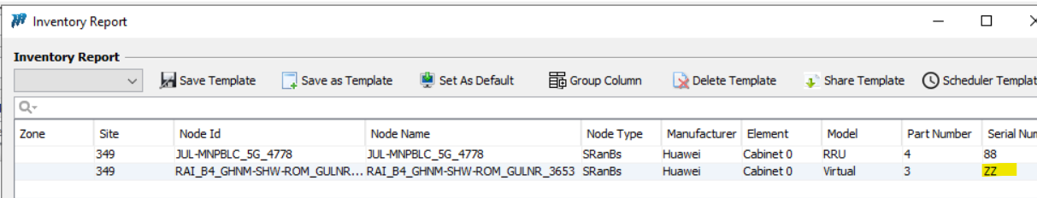
Run the sync again:
New Entry created in UM for the new SN:
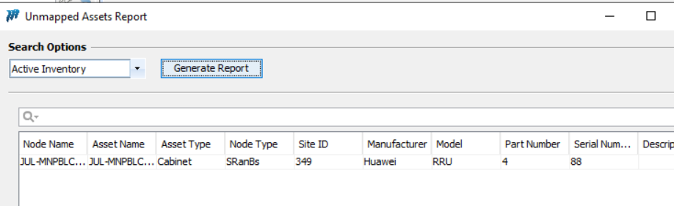

And The “RR” shown decommissioned in FR.

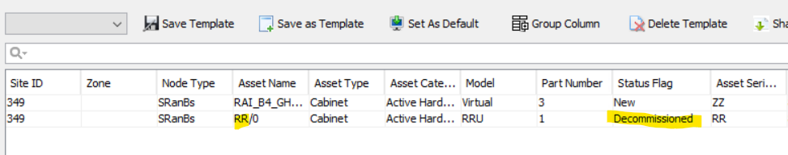

Shelf:
We have two different nodes:

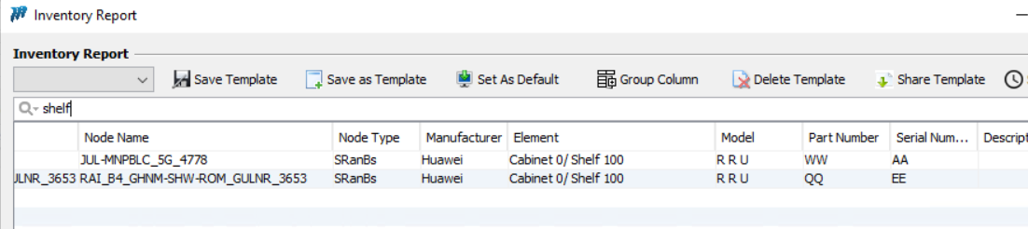

Run the sync process to check all the info updated in Unmapped report :
We are doing this testing on Version : Test

Updated fine on Um:
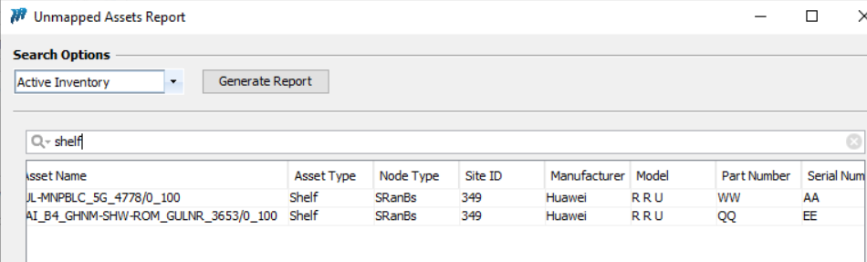
Lets put financials on it:
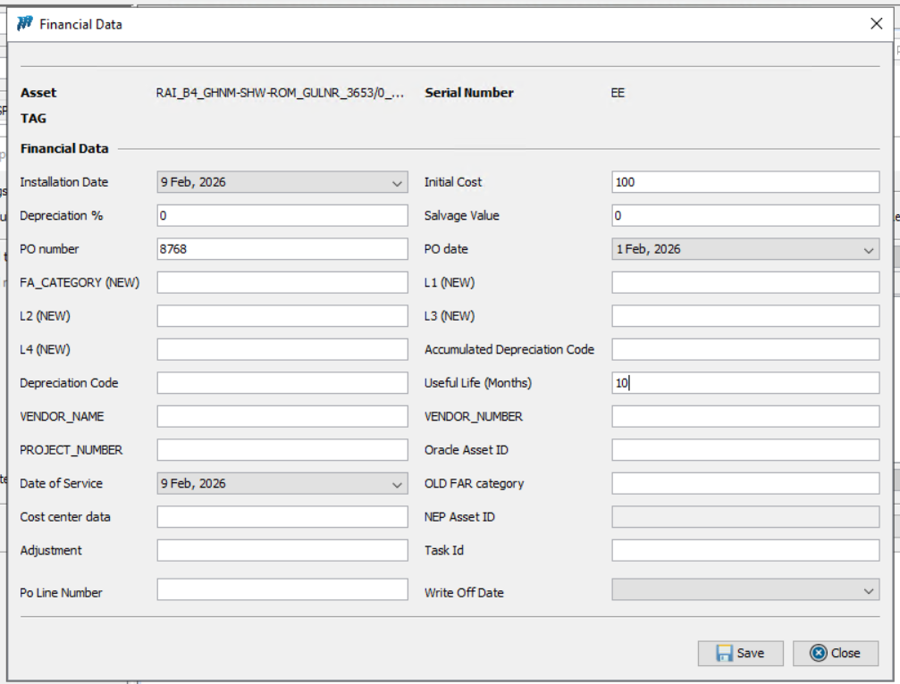
Request came in WF:
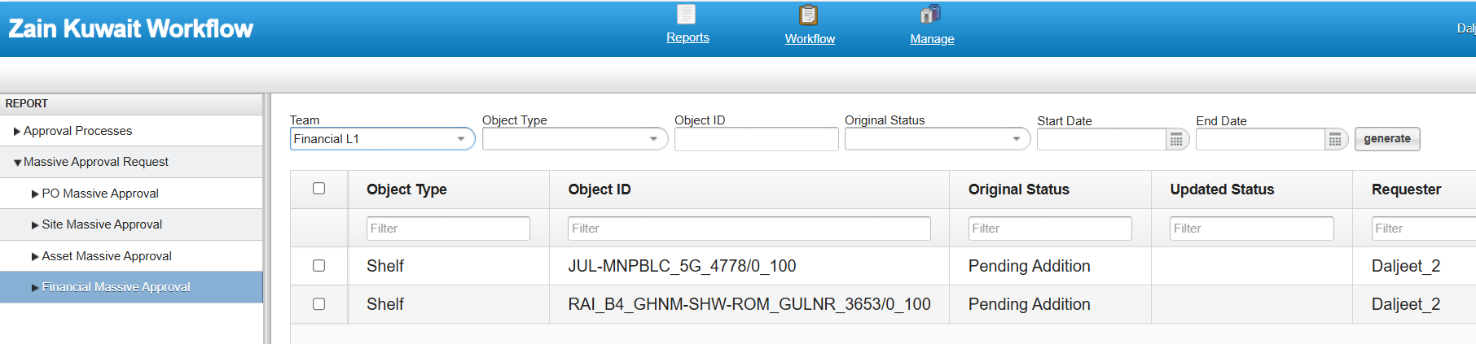

After approving it came in FR:
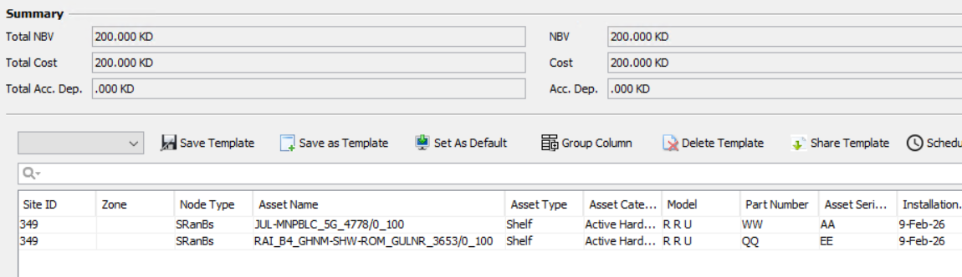

Run the sync process to check all the info updated in Unmapped report :
Updated fine in UM:
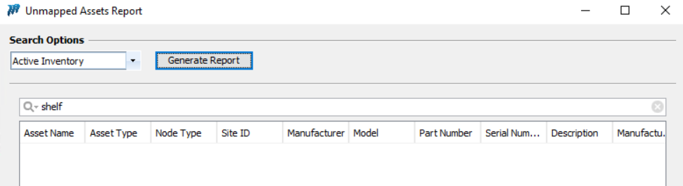

Now when we change the SN , I changed the SN from AA to “GG” and EE to “AA”.
The “GG” got updated but “AA” becomes blank:

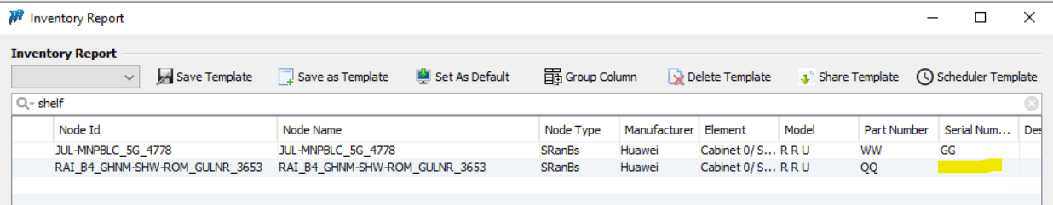
This is the issue will raise blank SN.
Run the sync process to check the status in UM and FR:

UM :
New entry has been created with “GG” sn:
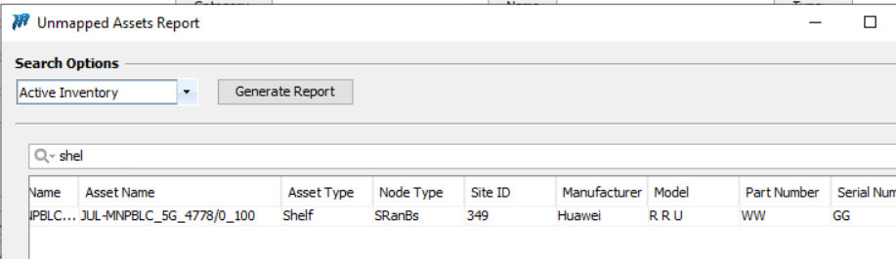

FR:
The “AA” sn shown decommissioned. However “EE” shown status flag as New and it is coming blank in Inventory report.

