703 Shelf & Board Testing

Active Part:

Shelf:
We have two different nodes:

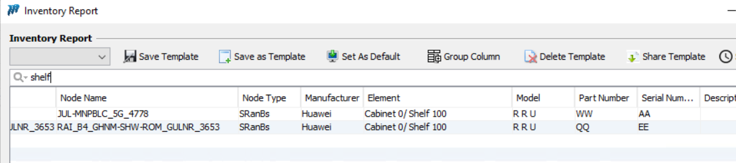

Run the sync process to check all the info updated in Unmapped report :
We are doing this testing on Version : Test

Updated fine on Um:
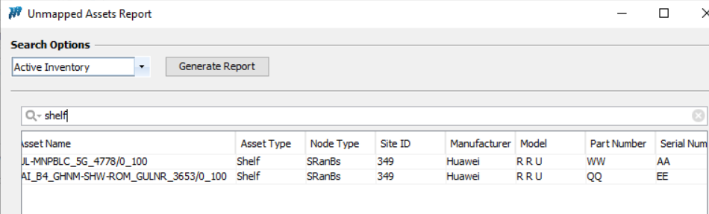
Lets put financials on it:
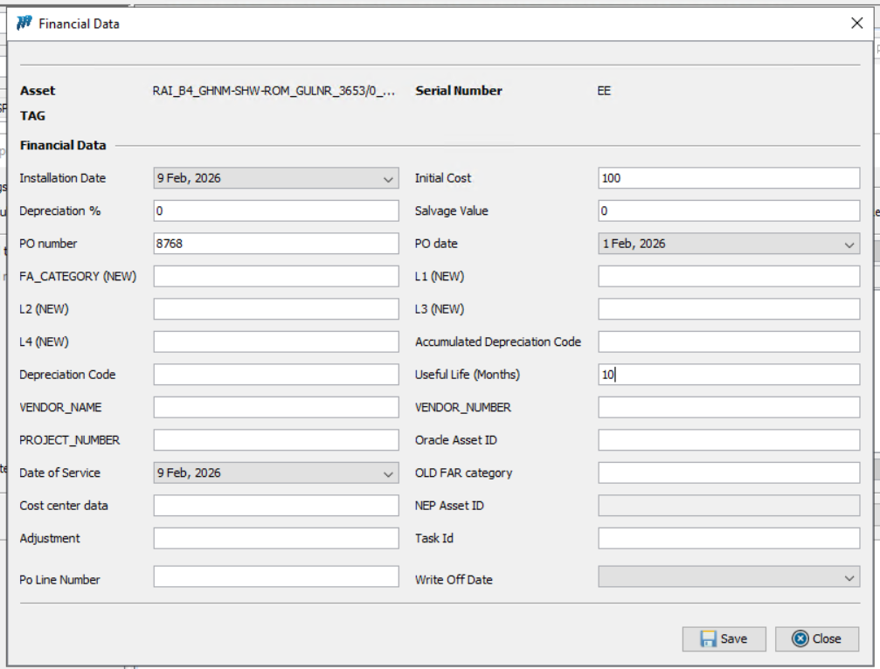
Request came in WF:
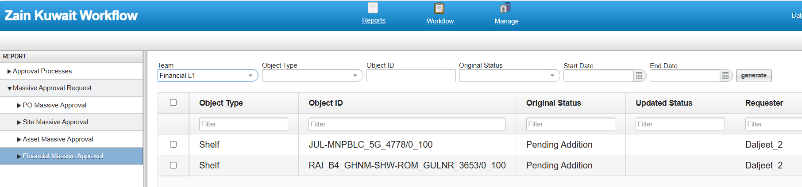

After approving it came in FR:
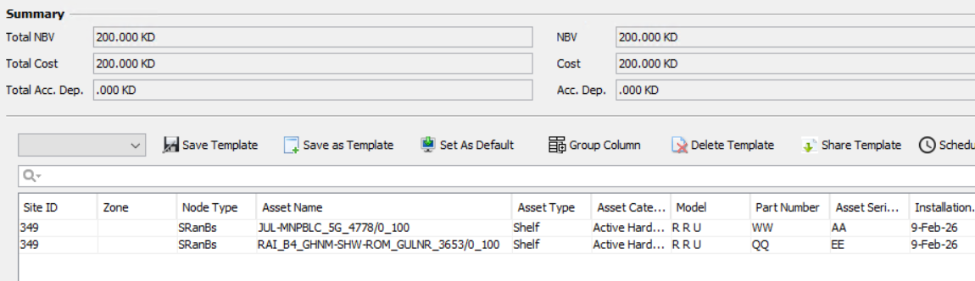

Run the sync process to check all the info updated in Unmapped report :
Updated fine in UM:
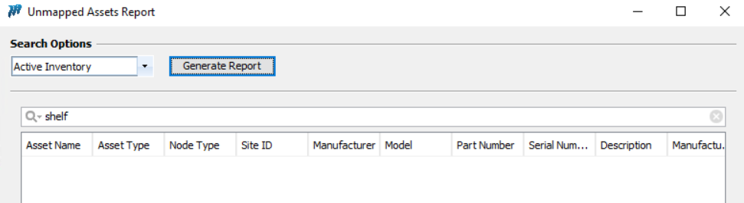

Now when we change the SN , I changed the SN from AA to “GG” and EE to “AA”.
The “GG” got updated but “AA” becomes blank:

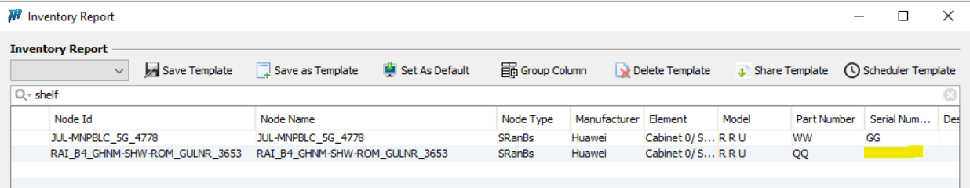
This is the issue will raise blank SN.
Run the sync process to check the status in UM and FR:

UM :
New entry has been created with “GG” sn:
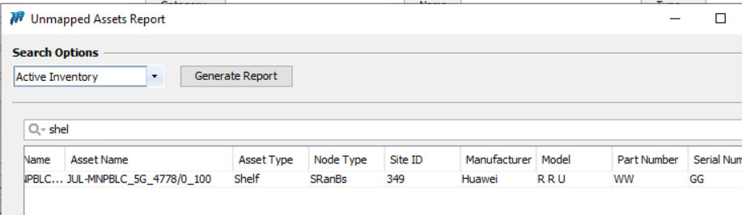

FR:
The “AA” sn shown decommissioned. However “EE” shown status flag as New and it is coming blank in Inventory report.

Board:
We have two different nodes:
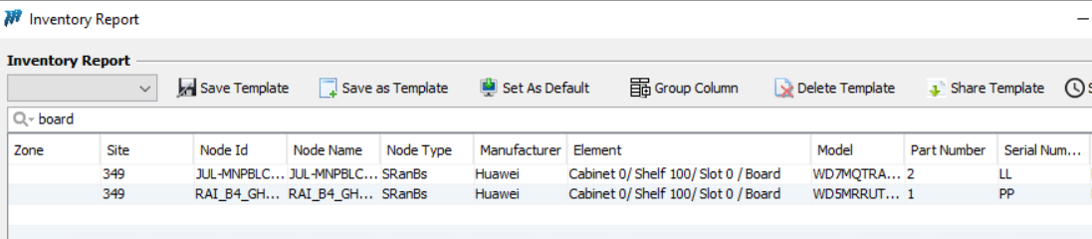

Run the sync process to check all the info updated in Unmapped report :
We are doing this testing on Version : Test

Updated fine on Um:
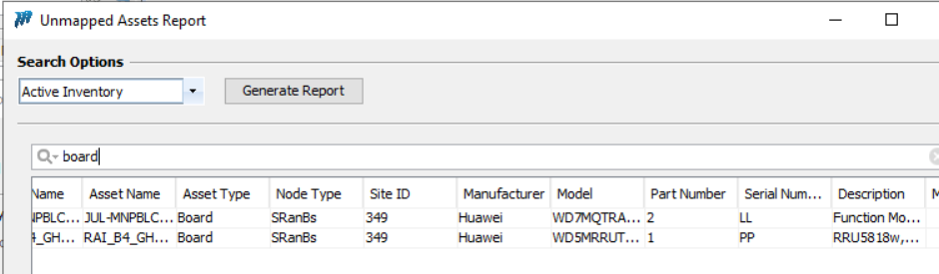

Lets put financials on it:
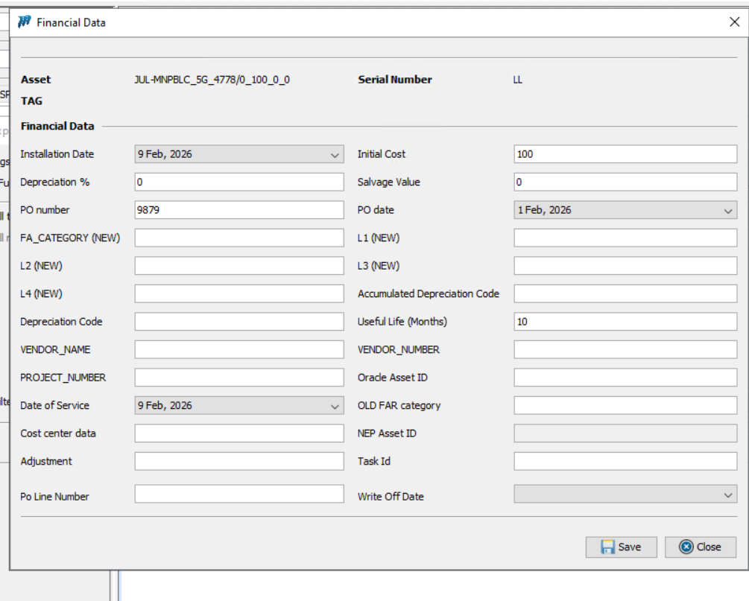

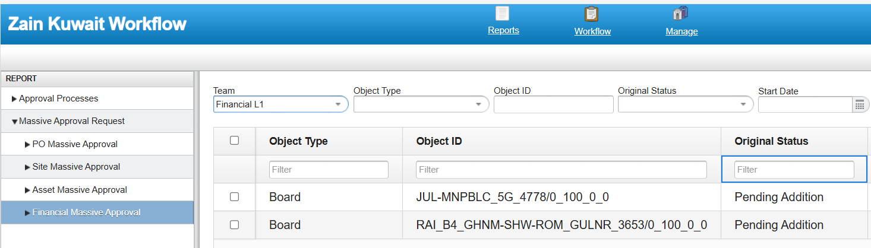

Updated fine at FR:
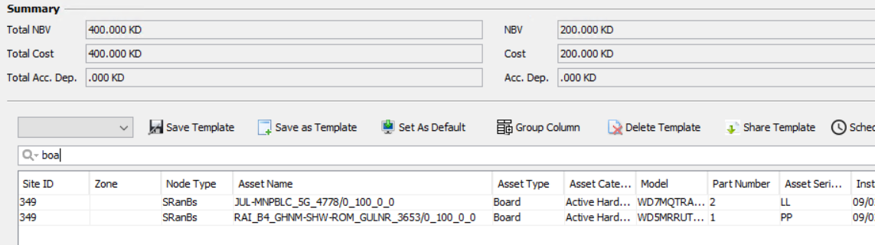

Run the sync process to check all the info updated in Unmapped report :
Updated fine in UM:
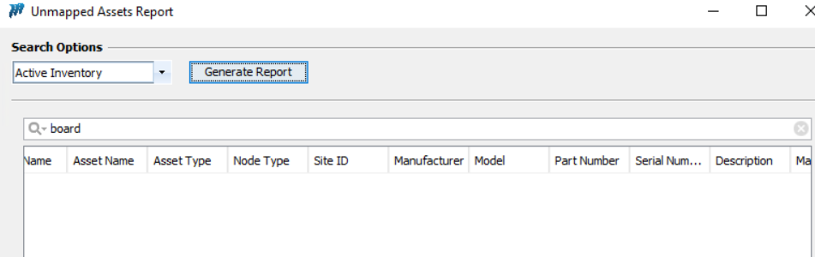

Now we have changed the sn “LL” to “KK” and “PP” to “LL”.

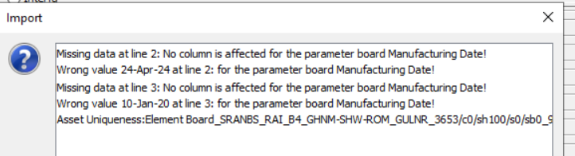

Only the KK has been updated and LL has been blank :
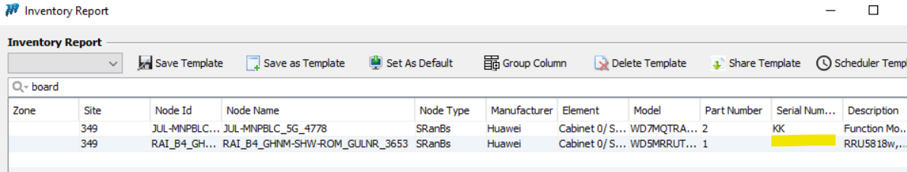

Run the sync to check the UM and FR:
UM : New entry has been created.
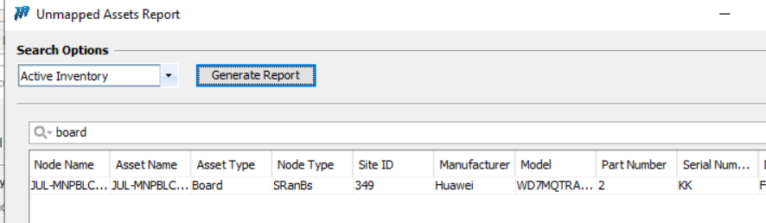
FR: LL showing decommissioned but PP is still showing New however it is coming as blank at Inventory.
