Sync Testing Patch .703

Recitifier:

102436954338
Having an asset with “102436954338” :
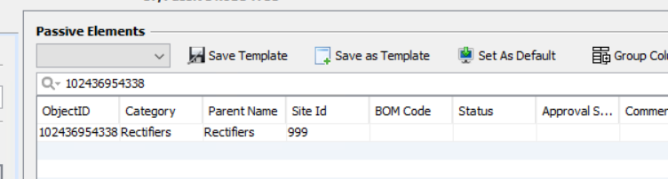
Same observed at Unmapped report:

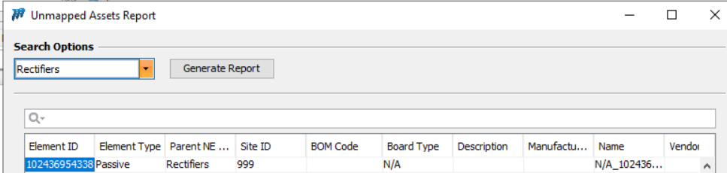
Also present at FR:
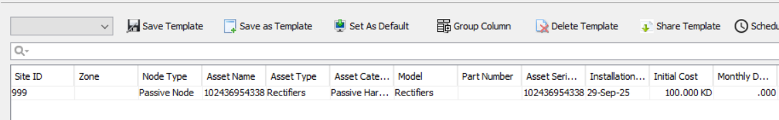

Now we made changes at Inventory level by changings its Object ID:
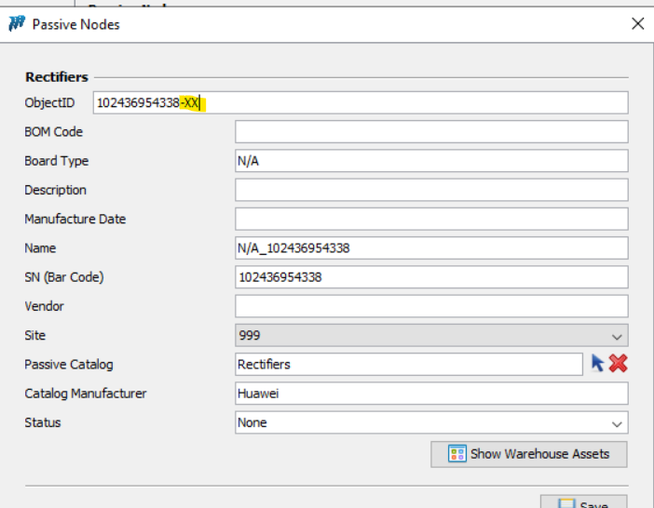

Run the Sync process:

It has been found the Asset Name updated at FR as well:

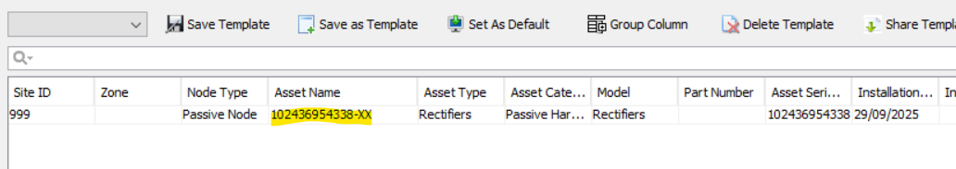

Passive:

Having an asset “10000009”:
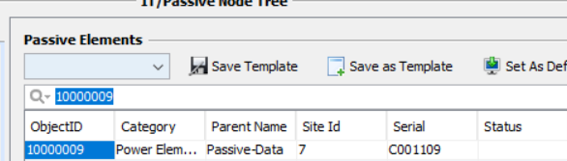

Present at UM:

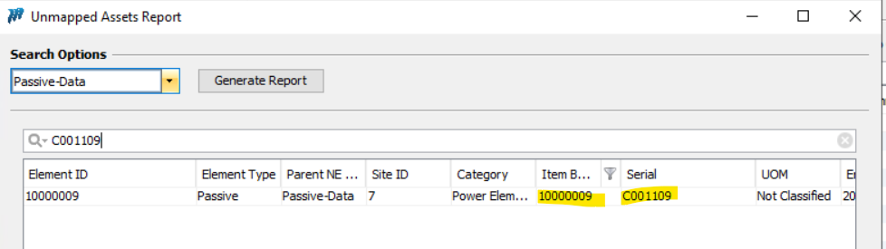

Present at FR:

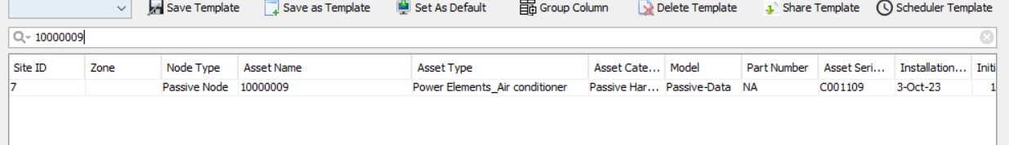

We made changes at Inventory level:

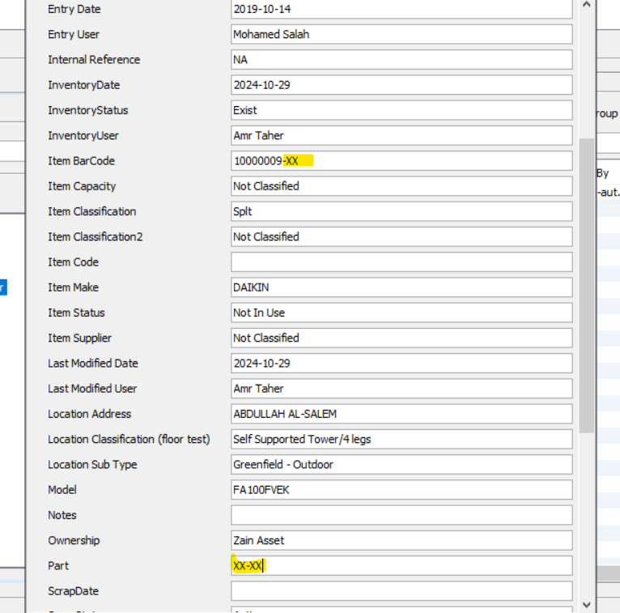

Run the sync:

It has been observed that the changes reflect at FR as well.

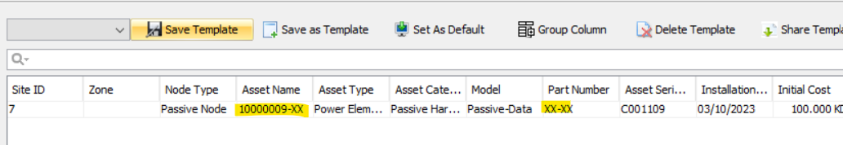

IT:
Having an asset with “10_222_7_205MY33317T6P”:

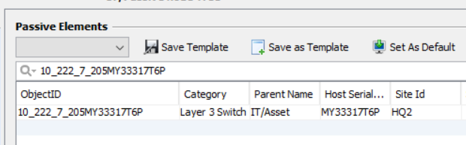
Present at UM:
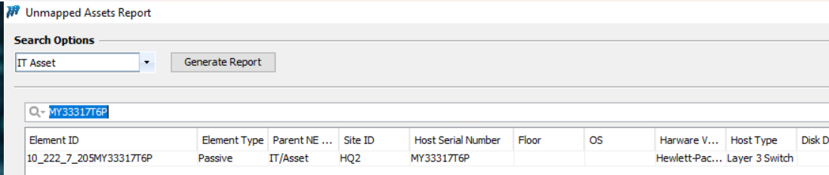
Present at FR:
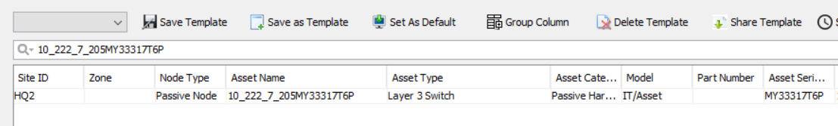

Now we made changes at Inventory level:

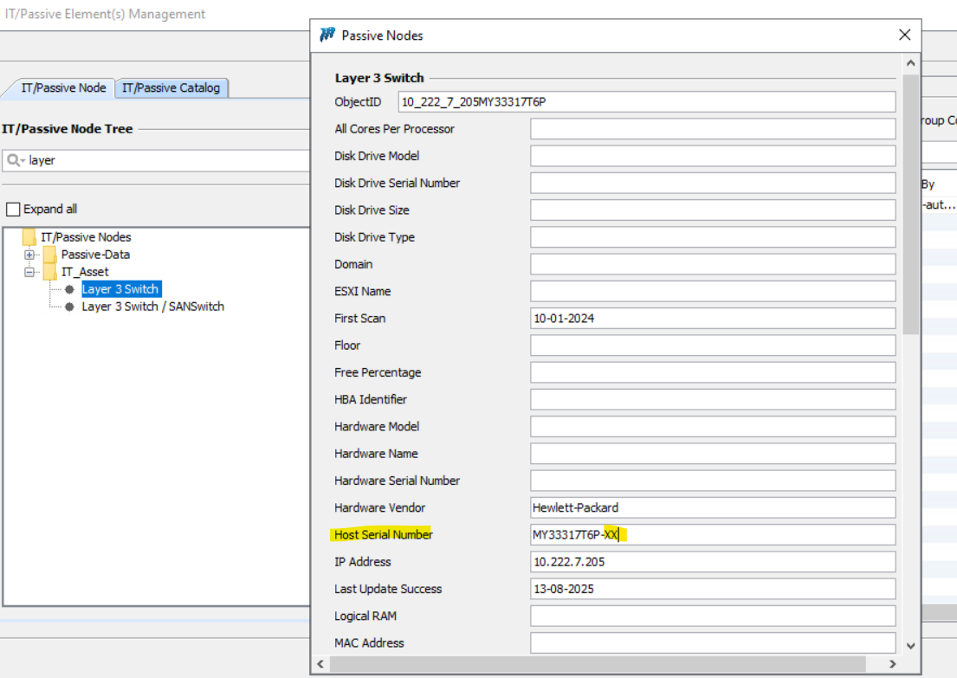
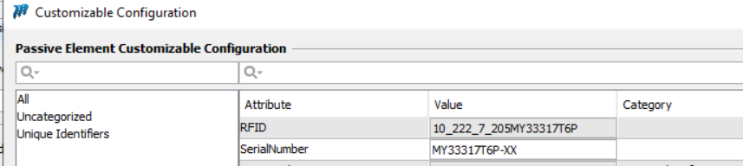
Run the sync:

It has been observed that the Changes didn’t reflect at FR it SN remain same and there is no new entry created at UM as well:

Check Sync between Inv and UM:
Having an asset at UM:

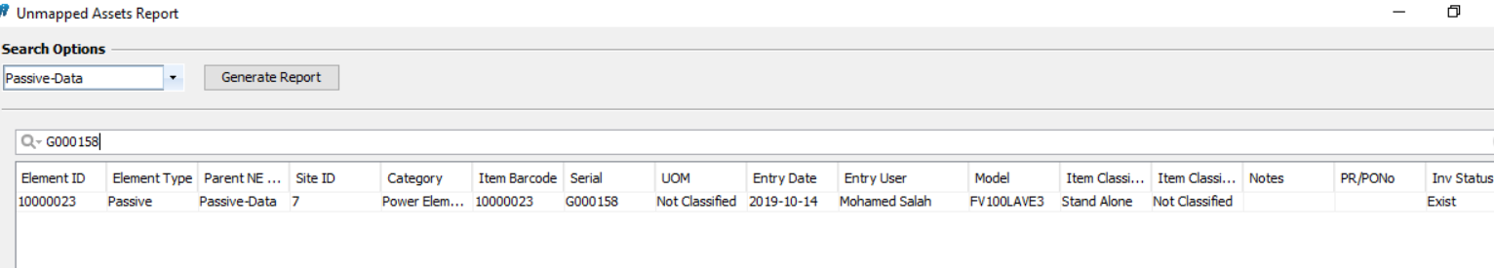

Then made changes at Inventory level related to Part and Serial number:

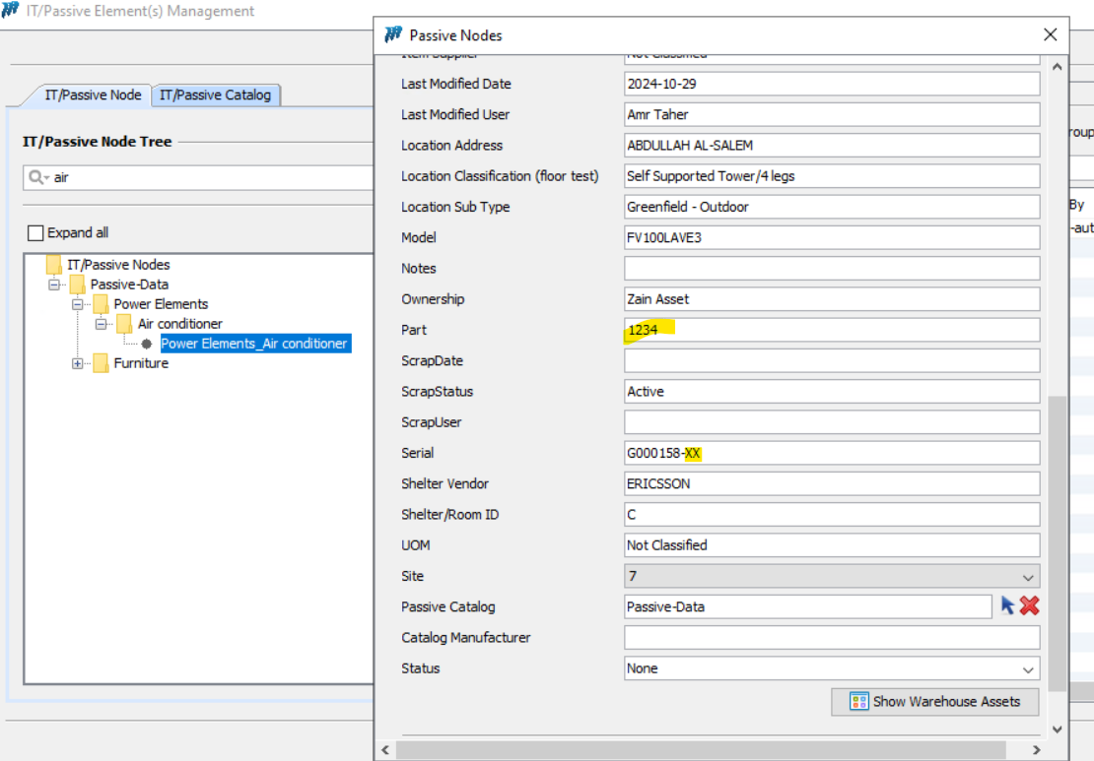

Run the sync:

Changes reflected at UM inventory:
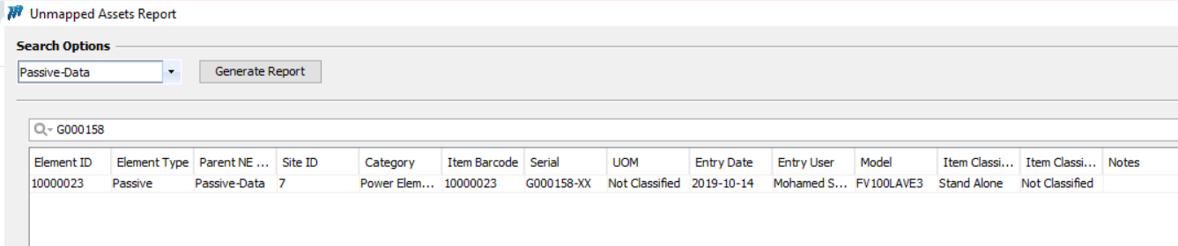

But when we financialize the same its Serial number coming incorrect:
