Testing Patch .703

Case 1: We need to be ensured that the Old Fr sync api is working fine :

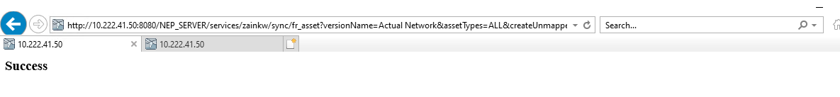

Case 2: Reproduce the same issue:
Approving the L3 WF request during sync running
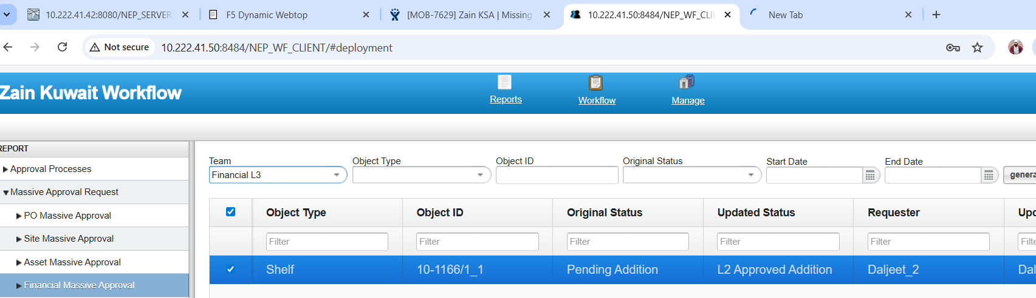

Sync running on the same time

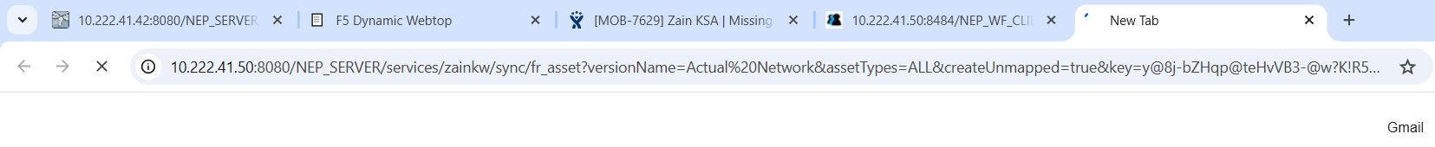

After approving the same Data imported to NEP FR:
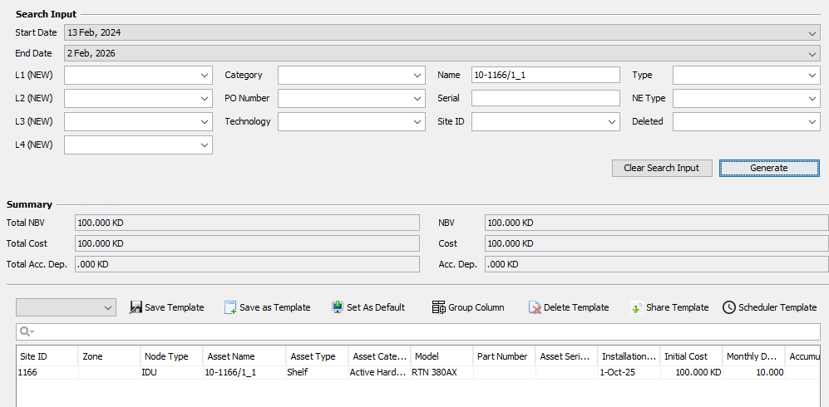

Did another case during the same sync run and approve it from L1, L2 and L3.
And data came in NEP FR fine:





