Document: Financial Report (FR) Enhancement — Introduction of “Insertion User” Attribute

1. Purpose
The purpose of this enhancement is to introduce a new column/attribute in the Financial Report (FR) to capture the details of the user responsible for inserting records into the system. This will improve tracking, accountability, auditability of data changes, and alignment with workflow approvals.
2. Background
Currently, the Financial Report does not maintain information about the user who inserted specific records. As a result, tracking the origin of data entries and identifying responsible users for modifications is challenging.
To address this limitation, a new attribute will be added to record the insertion user details and associate it with the workflow approval process.
3. Requirement Description
A new static column named:
“Insertion User”
will be introduced in the Financial Report (FR).
This column will:
- Automatically capture the username (or user ID) of the individual who inserts the record.
- Maintain a permanent record of the user responsible for the data entry.
- Enable tracking of changes made by different users.
- Be linked with the workflow approval process to ensure traceability between the record creator and approval stages.
- Support audit and reconciliation activities.
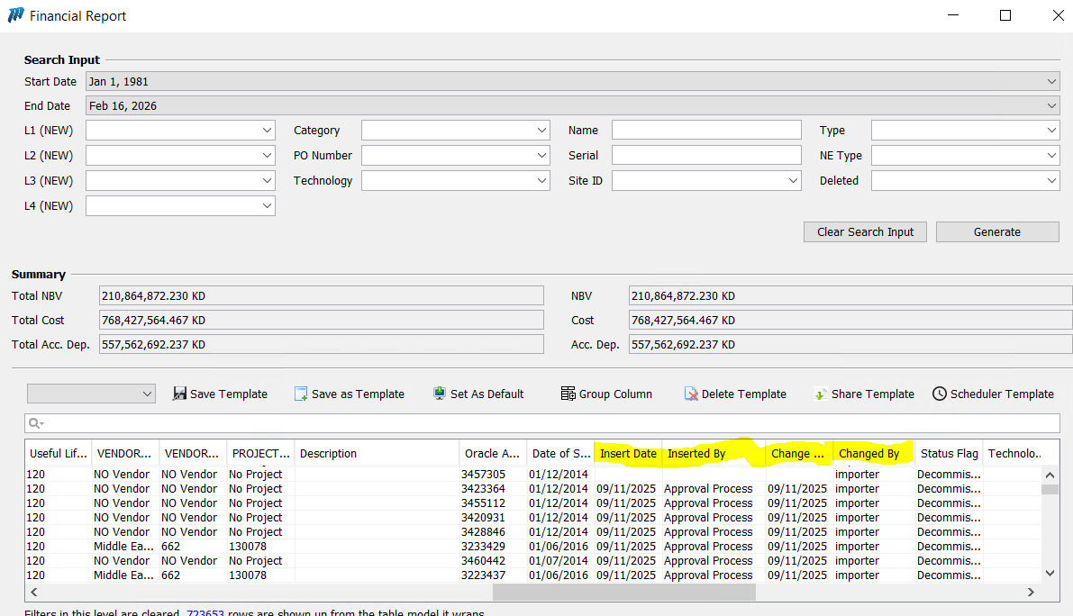

4. Functional Details
- The field will be auto-populated by the system at the time of record creation.
- Manual editing of this field will not be permitted.
- The value in the “Insertion User” column must remain permanent and must never change once recorded.
- The value will always reflect the original logged-in user who performed the insertion.
- The captured user information will be referenced during workflow approvals to identify the originator of the request.
- Existing records may remain blank or populated based on feasibility (to be confirmed by development team).
5. Workflow Integration
- The “Insertion User” will serve as the reference for workflow initiation.
- Approvers will be able to view the originating user during approval stages.
- This linkage will enhance transparency and accountability in the approval process.
- It will support tracking from record creation through approval completion.

6. Benefits
- Improved traceability of data entries
- Enhanced accountability
- Clear linkage between record creation and approvals
- Prevention of manipulation of origin data
- Easier identification of user actions
- Support for audit requirements
- Better monitoring of data modifications
7. Impact Assessment
- Minimal impact on existing functionality
- No changes to current workflows structure, only added visibility
- Report structure will include one additional column
8. Dependencies
- User authentication system must provide valid user identification.
- Workflow module integration for displaying the insertion user.
- Development team confirmation on handling historical data.

9. Conclusion
The introduction of the immutable “Insertion User” attribute, integrated with workflow approvals, will significantly enhance the tracking capability of the Financial Report. It will provide better visibility into user actions, strengthen accountability, prevent alteration of origin information, and improve overall governance and audit readiness.

