Proposed Document Structure – “Site Status (On Air / Off Air)”
- Objective
  - Introduce a new Site attribute: Site Status
  - Purpose: Identify whether a site is On Air or Off Air based on inventory availability
- Background / Problem Statement
  - Current limitation (no clear indicator of live vs inactive sites)
  - Impact on reporting / operations / planning
- New Attribute Definition
  - Attribute Name: Site Status
  - Possible Values:
    - On Air
    - Off Air
- Logic / Determination Criteria
- Automated Site Status Determination
- For sites where active inventory records are available, the Site Status will be automatically derived.
- The system will evaluate the presence of active inventory items associated with the site.
- On Air: Site has at least one active inventory record.
- Off Air: Site has no active inventory records.
- This automated evaluation will be triggered during inventory updates and scheduled synchronization processes.
- Manual Site Status Update
- For sites where inventory data is not available or not applicable, the Site Status will be updated manually.
Examples of such sites include, but are not limited to:
- Buildings
- Warehouses
- Non-network or passive locations

- Manual updates will allow users to correctly reflect the operational status of these sites without dependency on inventory records.
- Role of Site Category
The Site Category column will be used to identify and classify the type of site for reference purposes in the detailed sites report.
Examples of Site Categories include:
- Buildings
- Warehouses
- Offices
- Administrative locations
- Storage facilities
- Non-network or passive locations
Site Category will not drive any automated status changes.
- Inventory Dependency
  - Inventory object(s) considered
  - Status fields used from inventory
- UI / Report Impact
  - Where the Site Status will be visible
  - Filters / columns / site reports impacted

- Data Refresh & Sync
  - When Site Status is calculated (real-time ( manual import ) / scheduled (auto importer)
  - Trigger points (inventory add/remove/update)
  - Workflow approval for modifications/changes
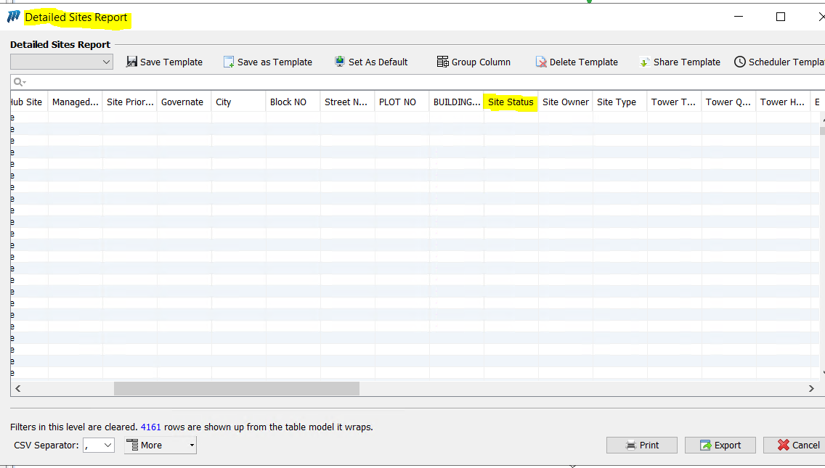
- Edge Cases & Assumptions
  - Partial inventory
  - Temporarily inactive items
  - Newly created sites
  - Automated Site Status determination will take precedence for sites with active inventory.
  - Site Category data is correctly maintained for reference purposes.
  - Manual Site Status updates will be applicable only when automation criteria cannot be met due to lack of inventory data.

