

Huawei RAN Connector

FRS (Functional Requirement Specifications)
Auto-Import connector

Connector Name:
Huawei_RAN_Ooredoo_Tunisia
Change History

Version | Change Description | Author | Date
0.1 | First draft | Indrasan Yadav | 05-05-2025
0.2 | Added a rule to parse site id in section 1.3 for all node type | Indrasan Yadav | 19-08-2025
0.3 | Added a rule where duplicate name in antenna under section 1.2 | Indrasan Yadav | 23-09-2025
0.4 | Added a rule to parse supported technologies for SRAN under section 1 highlighted with color green | Indrasan Yadav | 19-12-2025
0.5 | Added a rule to parse site id for micro site under section 1.3.7 (Applicable for all node type but currently in SRAN only now) marked with green color | Indrasan Yadav | 24-12-2025
0.6 | Update the sheet “Node_Matching” which to be consider by AI DEV to parse node type based on “NEType” under section 1 highlighted with green color. | Indrasan Yadav | 20-01-2026
0.7 | Update the rule to parse equipment model in section 1.1 highlighted with yellow. | Indrasan Yadav | 27-02-2026
0.8 | Update the rule to remove “FModule” as board from nodeboard.and update the node model rule. | Indrasan Yadav | 27-02-2026
0.9 | Added a rule to remove boards where BoardType=”” is empty in dump under section 1.1.3 highlighted with green. | Indrasan Yadav | 24-03-2026
1.0 | Added a rule to parse cabinet index for RackType=”BBC” under section 1.1.1 highlighted wit green. | Indrasan Yadav | 24-03-2026

Table of Contents
Introduction 3
1 RAN Nodes 5
1.1 RAN Physical configuration 8
1.1.1 Cabinet 8
1.1.2 Shelf 9
1.1.3 Boards 11
1.2 Antenna…………………………………………………………………………………………………………………………13

Introduction

- This FRS is intended for Huawei RAN Nodes extraction.
- It describes how to parse the nodes details and physical configuration.
- The dump files provided are of xml file per node.
- The folder location is to be précised later.
- The files format is as follow:

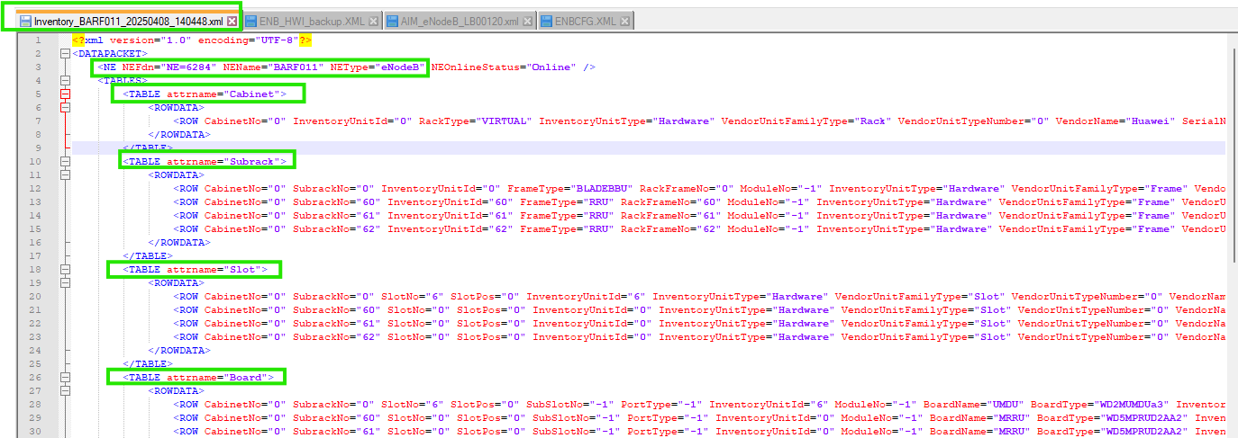

RAN Nodes
We will consider the static sheet to define node type based on the value of attribute “NEType” in dump.

Static file name: “Node_Matching”.

- The following attributes are defined at node level:

Attribute | Importance | Comment
NE External Code | [Mandatory] | - NE ID
NE ID | [Mandatory] | - =NE name.
NE Name | [Mandatory] | NE Name will be extracted from attribute “NEName=”” in individual dump.  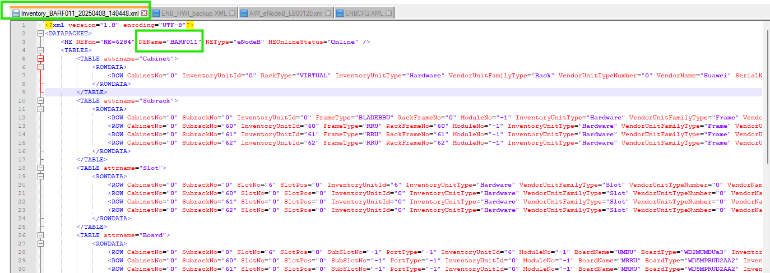
Site id | [Mandatory] | - Explain in section 1.3
Site Name | [Mandatory] | - = Site id
Type | [Mandatory] | To be deduced from node matching file
Model | [Mandatory] | - To be deduced from sheet “nemodelMatching” under static sheet “HW_MatchingFile”  Note: Please note that for associated role nodes, the model’s name will be formed by concatenating the parent node model with the suffix as follows:  - “_GSM” for role2g  - “_UMTS” for role3g  - “_LTE” for role4g
Manufacturer | [Mandatory] | - = Huawei
IP + subnet mask | [Optional] | - =NULL
Technology Supported | [Optional] | - First, the Technology supported will be deduced as follow through matching the “NEType” within the below table:  Rule: In the physical dump of SRAN, under the class <TABLE attrname="HostVer">, the following attribute values should be checked to determine the corresponding technology:  - <ROW HostVerType="GBTSFunctionHOSTVER" with sDesc="GRAT SOFTWARE VERSION" → 2G  OR  <ROW HostVerType="GBTSApplicationVER" 2G  - <ROW HostVerType="NodeBFunctionHOSTVER" with sDesc="URAT SOFTWARE VERSION" → 3G  OR  <ROW HostVerType="NodeBApplicationVER" 3G  - <ROW HostVerType="eNodeBFunctionHOSTVER" with sDesc="LRAT SOFTWARE VERSION" → 4G  OR  <ROW HostVerType="eNodeBApplicationVER"4G  - <ROW HostVerType="gNodeBFunctionHOSTVER" with sDesc="NRAT SOFTWARE VERSION" → 5G  OR  <ROW HostVerType="gNodeBApplicationVER"5G  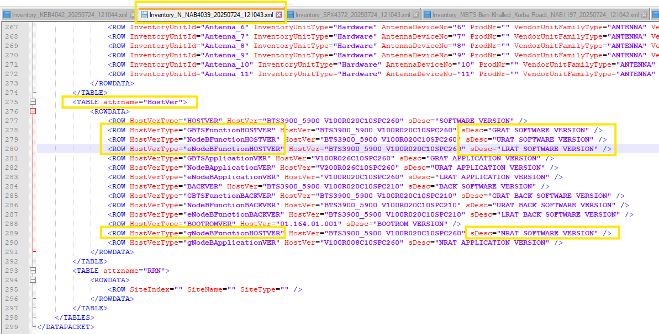
  NEType | Technology Supported
  GSMBTS | 2G
  BSC6900GSM | 2G
  BSC6900UMTS | 3G
  BSC6900GU | 2G/3G
  BSC6910GSM | 2G
  BSC6910UMTS | 3G
  BSC6910GU | 2G/3G
  NodeB | 3G
  MBTS(GL) | 2G/4G
  MBTS(GU) | 2G/3G
  MBTS(UL) | 3G/4G
  MBTS(GUL) | 2G/3G/4G
  eNodeB | 4G
  BTS | 2G
  MBTSGU | 2G/3G
  BSC6000BTS | 2G
  BTS3900/BTS5900/BTS59005G | 2G/3G/4G
Parent BSC | [Mandatory] | - The node (BTS) with SiteName= which is available in that BSC dump under attribute <TABLE attrname="BTS"> then that BSC will be parent BSC for all available node (BTS).  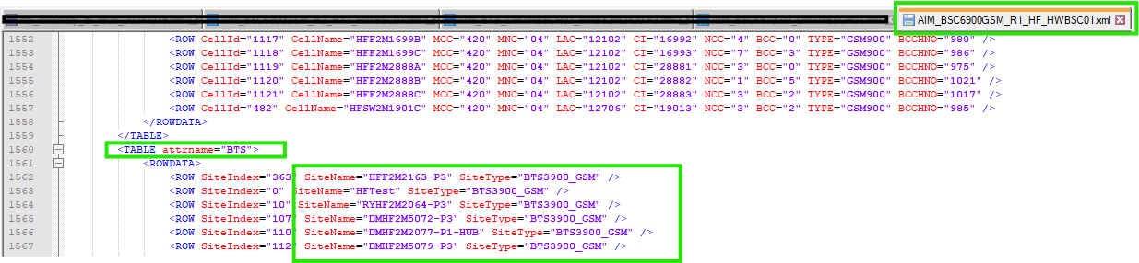  Note: same rule will be applied also for if parent will be SRAN Controller.
Parent RNC | [Mandatory] | - The node (NodeB) with NodeBName= which is available in that RNC dump under attribute <TABLE attrname="UCELL"> then that RNC will be parent RNC for all available node (NodeB).  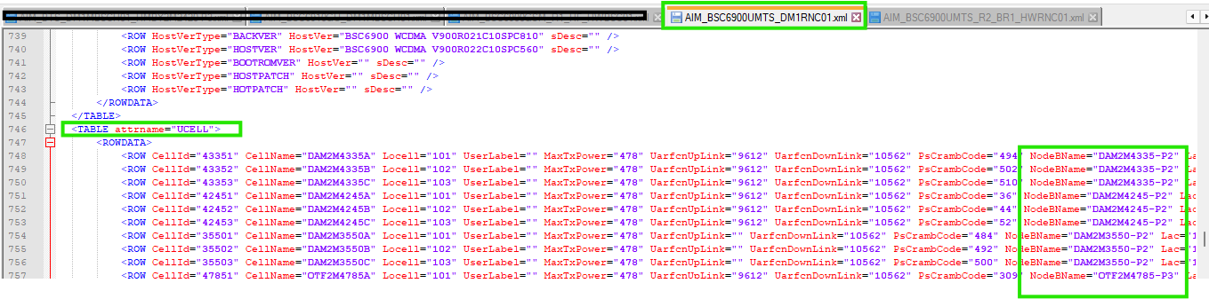  Note: same rule will be applied also for if parent will be SRAN Controller.
Software version | [Optional] | - =Null
Additional Information | [Optional] | - =Null

1.1 RAN Physical configuration

1.1.1 Cabinet

- Each XML file of each node contains information about cabinets. From this file we will be taking the data for the cabinet.

- each type has one attribute <TABLE attrname="Cabinet"> for the cabinet’s info.

- The cabinet attributes are extracted as follow:

Attribute | Importance | Comments
NE External code | [Mandatory] | - Same as NE ID  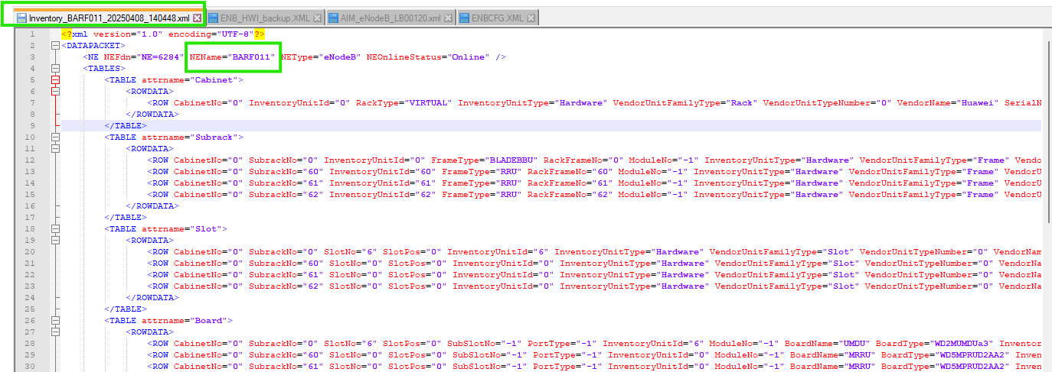
Cabinet index | [Mandatory] | - The value of “CabinetNo” under attribute <TABLE attrname="Cabinet">  - Eg: CabinetNo="0" Cabinet index=0  - If “CabinetNo” is empty, then ignore the line.  - Sometimes we can get more than one cabinet. Parse all of them.  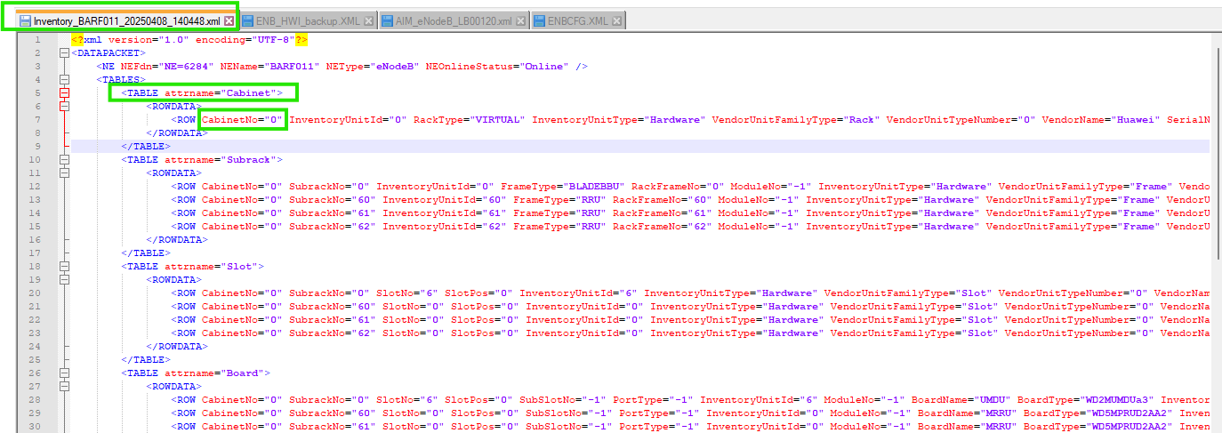  Note:  - If any node which contains blank physical (cabinet, shelf, board) information, then in that case only node will be parse & physical data (cabinet, shelf & boards & antenna) will not be parse.  - In case of RackType=”BBC” If CabinetNo.=”9” & CabinetNo.=”10” then cabinet index will be “3” & “4” respectively.  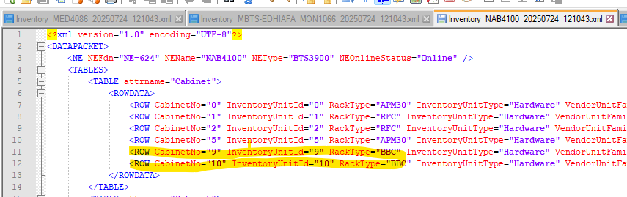
Cabinet id | [Mandatory] | - = NE External code _cabinet index  - E.g.: BARF011_0 (For above example)
Model | [Mandatory] | - The value of “RackType” attribute  - Eg: RackType="VIRTUAL" VIRTUAL  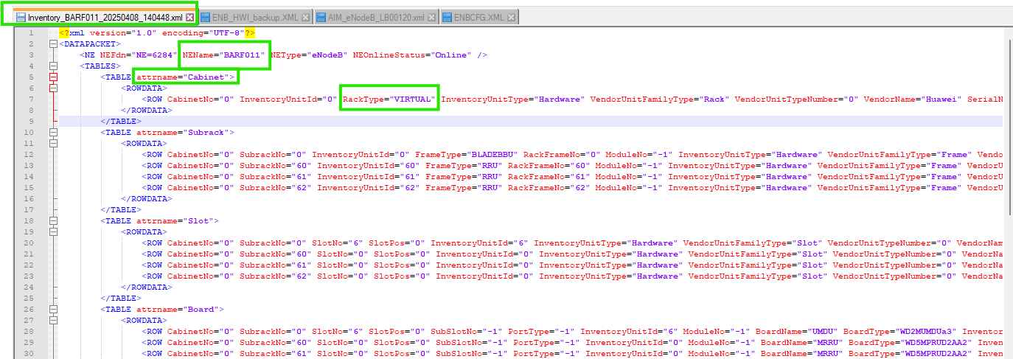
Part Number | [optional] | - =Value of “BOMCode” attribute  - Eg: BOMCode="01071087”
Date Of Manufacturer | [optional] | - =Value of “DateOfManufacture” attribute  - Eg: DateOfManufacture="2011-03-10" DateOfManufacture=2011-03-10
Description | [optional] | - =Value of “ManufacturerData” attribute  - If empty = null
Serial Number | [optional] | - =Value of “SerialNumber” attribute  - E.g.: SerialNumber="21010710876TB3000615
Manufacturer | [Mandatory] | - =Huawei
Power Consumption | [optional] | - =null
Additional Information | [optional] | - =null
Dimensions and Weight | [optional] | - =null

1.1.2 Shelf
- Each row under attribute <TABLE attrname="Subrack"> shows shelf information.
- The below table describes how to parse the shelf attributes:

Attribute | Importance | Comments
Cabinet Id | [Mandatory] | - = NE External code _cabinet index  - E.g.: BARF011_0
Shelf Id | [Mandatory] | - Concatenation between NEName, “_” and CabinetNo=, “_” and SubrackNo in related row under attribute <TABLE attrname="Subrack">
Shelf index | [Mandatory] | - The value of “SubrackNo=” under attribute <TABLE attrname="Subrack">  - E.g.: SubrackNo="0" Shelf index=0  - If “SubrackNo” is empty, then ignore the line.  - Sometimes we can get more than one subrack. Parse all of them.  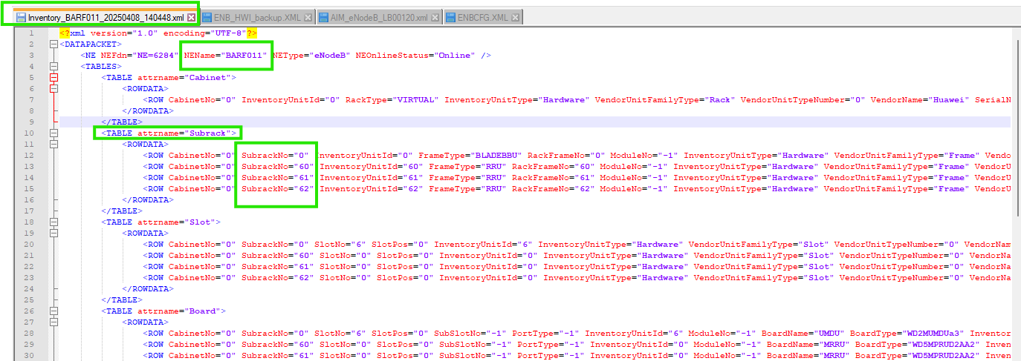
RU Index | [Mandatory] | - To be followed static sheet “series3900_RuMatching” under static sheet “HW_MatchingFile”s.
Part Number | [Optional] | - =Value of “BOMCode” attribute  - Eg: BOMCode="01071087”
Model | [Mandatory] | - =”FrameType” attribute, e.g.: MPS or EPS.  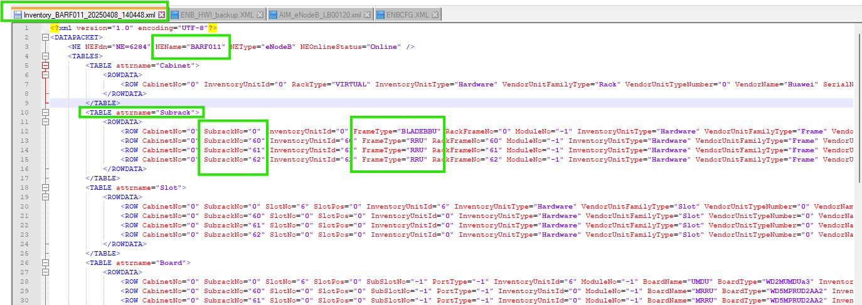
Date Of Manufacture | [Optional] | - =Value of “DateOfManufacture” attribute  Eg: DateOfManufacture="2011-03-10" DateOfManufacture=2011-03-10
Issue Number | [Optional] | - Take the Value of “IssueNumber=” under same attribute <TABLE attrname="Subrack"> for related shelf.  - =Value of “IssueNumber” attribute  Eg: IssueNumber="00”
Description | [Optional] | - =Value of “ManufacturerData” attribute  If empty = null
Serial Number | [Optional] | - =Value of “SerialNumber” attribute  E.g.: SerialNumber="21010710876TB3000615
Power Consumption | [Optional] | - Null
Additional Information | [Optional] | - Null
Dimensions and Weight | [Optional] | - Null

1.1.3 Boards
- Each row under attribute <TABLE attrname="Board"> shows boards information.
- The below table describes how to parse the boards attributes:

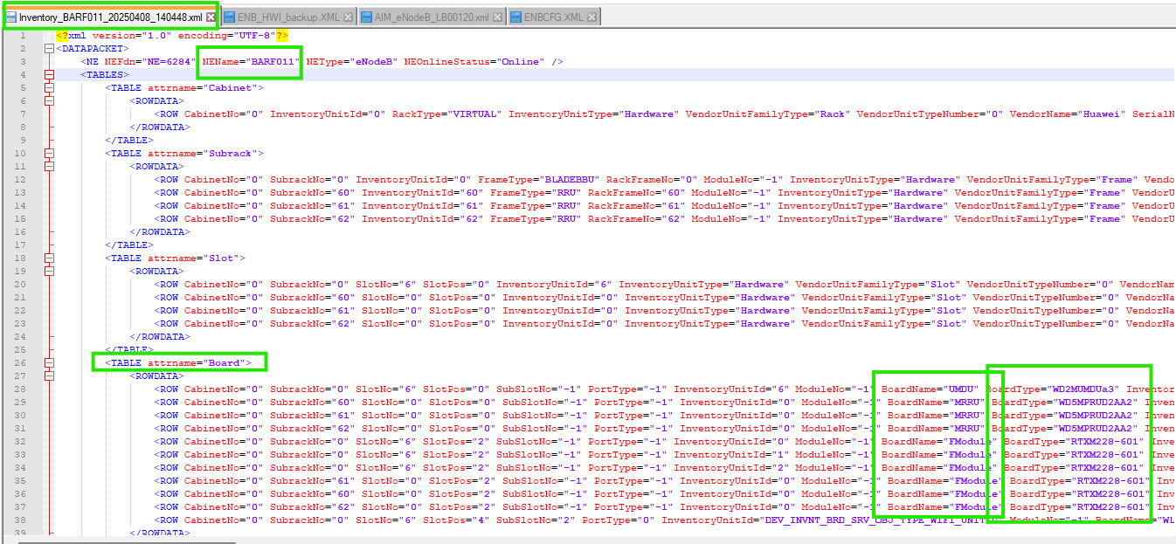

Note: If in dump BoardType=”” mean blank then it will be ignored from board parsing.

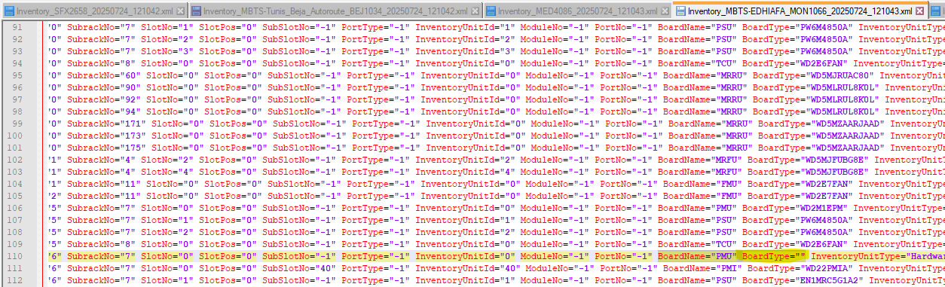

Attribute | Importance | Comments
Shelf Id | [Mandatory] | - Concatenation between NEName, “_”, CabinetNo,” _” and SubrackNo
Shelf Index | [Mandatory] | - The value of “SubrackNo=” under attribute <TABLE attrname="Subrack">  - E.g.: SubrackNo="0" Shelf index=0  - If “SubrackNo” is empty, then ignore the line.  - Sometimes we can get more than one cabinet. Parse all of them.
Index on slot | [Mandatory] | =0 By default
Board Id | [Mandatory] | - Concatenation between NEName, “_”, “CabinetNo”, “_”, SubrackNo,” _”, “SlotNo” and Index on slot.  - E.g.: BARF011_0_0_6_0
Slot Index | [Mandatory] | - =Value of “SlotNo” attribute in each Row.  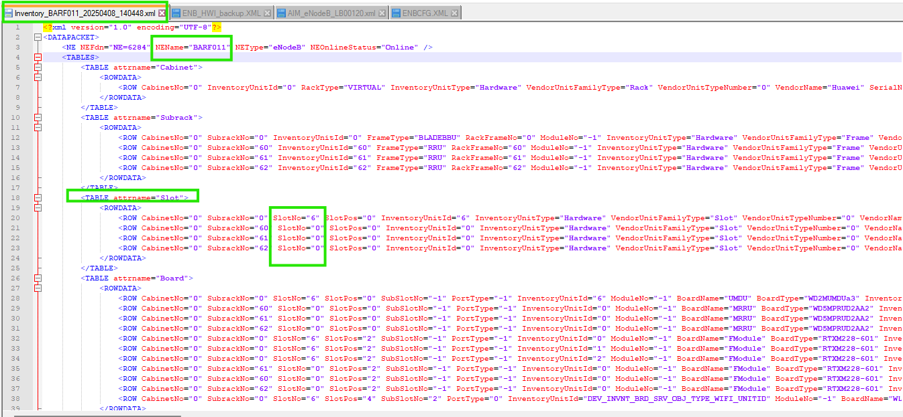
Board Type | [Mandatory] | Take the value of “BoardName=” under attribute “<TABLE attrname="Board">”  Note:  If any BoardName="FModule" then it will be ignored from board parsing. (It will be parse as an interface in “nodeinterface” like ports for board.  Sample Case:  The snippet below illustrates an example:  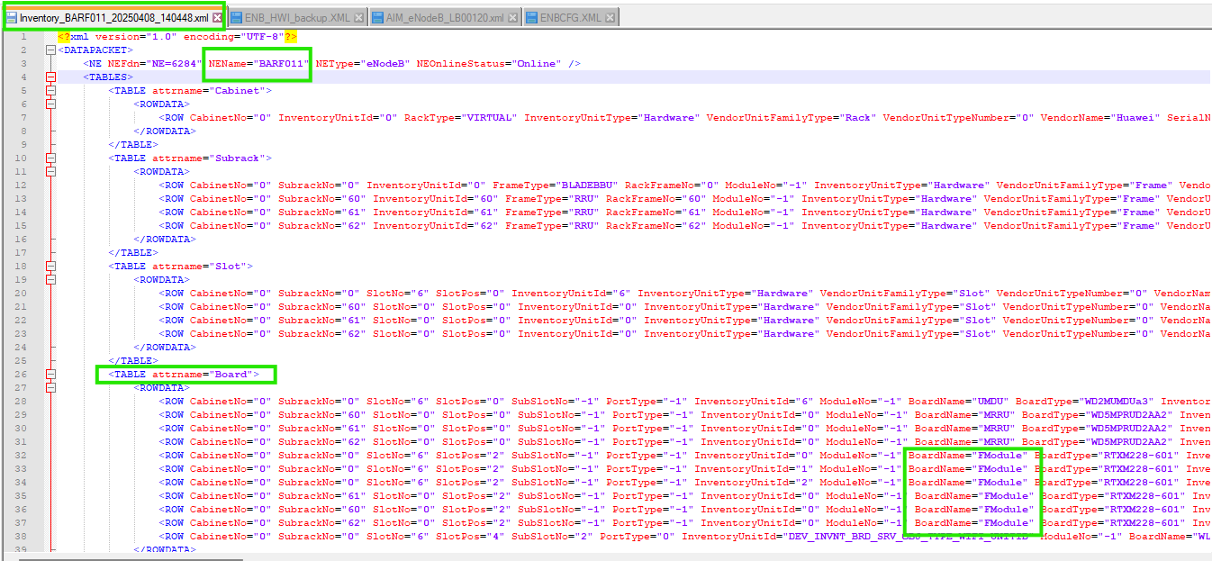
Part Number | [Optional] | - =Value of “BOMCode” attribute  E.g.: BOMCode="03051122" Part Number= 03051122
Description | [Optional] | - =Value of “ManufacturerData” attribute  E.g.: ManufacturerData="PARC WP11OIUa 1-port channelized Optical Interface Unit REV:a" then description will be = "PARC WP11OIUa 1-port channelized Optical Interface Unit REV:a"
Date Of Manufacture | [Optional] | - =Value of “DateOfManufacture” attribute  Eg: DateOfManufacture="2011-05-07" DateOfManufacture=2011-05-07
Serial number | [Optional] | - =Value of “SerialNumber” attribute  E.g.: SerialNumber="210305112210B5000522" SerialNumber=210305112210B5000522
Issue Number | [Optional] | - =Value of “IssueNumber” attribute  Eg: IssueNumber="00" Issue Number=00
Power Consumption | [Optional] | - =null
Additional Information | [Optional] | - =null
Dimensions and Weight | [Optional] | - =null

1.2 Antenna Parsing

Antenna details will be parse under table of “radioantenna” in XML.

Antenna Parsing rule described below:

Attribute | Importance | Comments
Antenna Id/Object ID | [Mandatory] | - =Concatenate of “NEName=” and the value of “InventoryUnitId” (“InventoryUnitId” will be available under attribute <TABLE attrname="Antenna">
Name | [Mandatory] | - =Attribute “UnitPosition” take the value before the “,” indicator.  - Example: UnitPosition="AntennaDeviceName=RET_UMTS-A,AntennaDeviceNo=1" Name = RIY2657-P1-HUB_SRAN-FON_1,RET_UMTS-A.  Note:  1- In cases where duplicate names are found, each subsequent duplicate must be made unique after the first data is parsed.  2- To achieve this, a special character \1 should be appended to the duplicate name, with the number incremented by +1 for each occurrence.  Example:  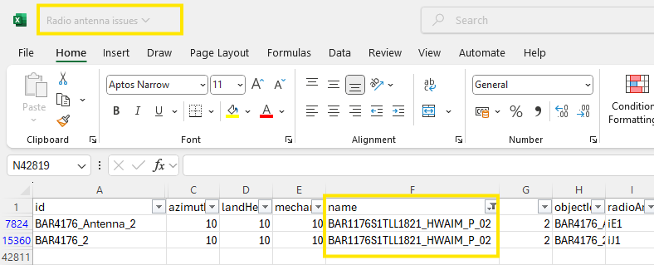  As per given rule 2nd one should be BAR1176S1TLL1821_HWAIM_P_02\1.
RadioantennaType | [Mandatory] | - =attribute “AntennaDeviceType=”  - Example: AntennaDeviceType="RCU136" type =”RCU136”
VersionID | [Optional] | - Value of HardwareVersion, e.g if HardwareVersion="RF11CLPT_VER.D" then VersionId is RF11CLPT_VER.D
Band | [Optional] | - =attribute “ManufacturerData”
Sector | [Optional]

Additional information: Serial number will be parse under addinfo in XML under attribute “Value”.

Attribute | Importance | Comments
SerialNumber_<serialnumber> | [Optional] | - =Value of “SerialNumberEx” attribute  - Eg:SerialNumber="030LPM4MB5618639" SerialNumber=030LPM4MB5618639
SerialNumber_<serialnumber> |  | - Value of “SerialNumber” attribute  Eg:SerialNumber="030LPM4MB5618639" SerialNumber=030LPM4MB5618639

Note:

Current Implementation:
The system currently parses SerialNumberEx as the primary source for the antenna serial number.
Issue:
SerialNumberEx is often found to be empty in the data dump, which causes it to come blank for some Antenna nodes in the NEP report.
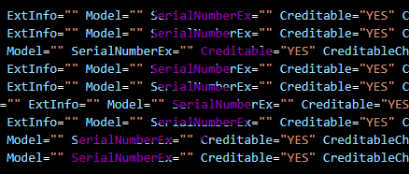

1. Objective
Ericsson antennas are connected to Huawei RAN. To correctly identify and import serial numbers (SN) without duplications in this unique scenario, the active assets include:
- Ericsson antennas connected to Huawei RAN.
- Serial Numbers are in either SerialNumberEx or AntennaSerialNumber attribute whereby SerialNumberEx is for Huawei and AntennaSerialNumber is for Ericsson antenna
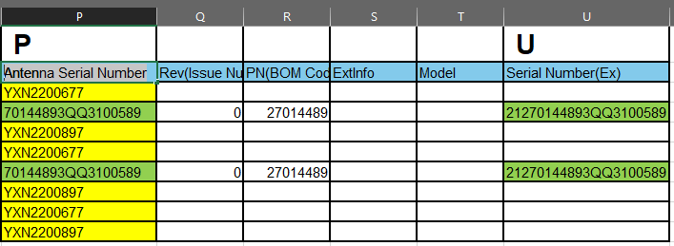
3. Data Import Logic
To correctly import the active assets without duplications, we propose the following logic:
- Step 1: Check Column U (SerialNumberEx)) for SN
  - If Column U has a value, use it as the SN for Huawei antennas and proceed with the import. If it is empty Check AntennaSerialNumber
  - The value from Column U is imported only if it is unique
- Step 2: Check AntennaSerialNumber for Ericsson Antennas
  - If it is empty, use the SN from SerialNumberEx and proceed with the import, ensuring no duplicates

1.3 Site Id Parsing Rule

The Site ID will be parsed from the node name according to the rules defined for each node type.
Priority Order:

- Priority 1: Site Matching Sheet (to be provided separately).
- Priority 2: Naming Convention Rules (as described below, based on node type).

1.3.1 BTS
Site ID Parsing from BTS Node Name

The Site ID will be derived from the BTS node name based on the following rules:

Case 1: If the node name contains the special character “_” (underscore), the Site ID will be the value appearing after the last underscore.

Case 2: If the node name does not contain an underscore, the Site ID will be the same as the node name.

Case 3: If any other case occurs, the site will be ignored and parsed as the default site.

Examples:
Example 1:

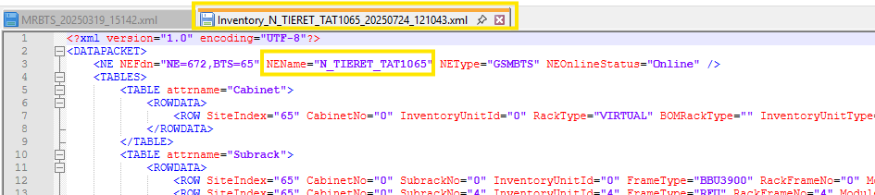

Node Name: N_TIERET_TAT1065
Rule Applied: Case 1
Site ID = TAT1065

Example 2:
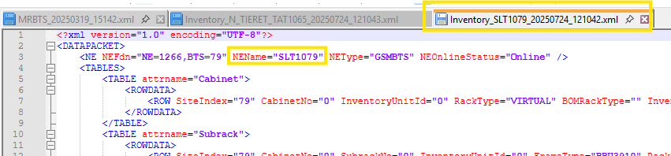

Node Name: SLT1079
Rule Applied: Case 2
Site ID = SLT1079

1.3.2 NodeB
Site ID Parsing from NodeB Node Name

The Site ID will be derived from the NodeB node name based on the following rules:

- Case 1: Replace the 4th numeric digit with 1 except 2 (after the first three alphabets). The remaining characters stay unchanged.
- Case 2: If 4th numeric digit is 2 (after the first three alphabets) and after 2 next 3 numeric digit is >600 then to be subtract 600 from last 3 digit and find value will be site id.
- Case 3: If above Case 1 & Case 2 is not applicable, the Site ID will be parsed as the default site.

Example:

Example 1: For Case 1

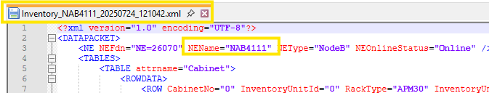

Node Name: NAB4111
Rule Applied: Case 1 (4 → 1)
Site ID = NAB1111

1.3.3 eNodeB
Site ID Parsing from eNodeB Node Name

The Site ID will be derived from the eNodeB node name based on the following rules:

- Case 1: Replace the 4th alphabetic character (commonly F) with 1.
- Case 2: If Case 1 is not applicable, the Site ID will be parsed as the default site.

Example:

Example 1:

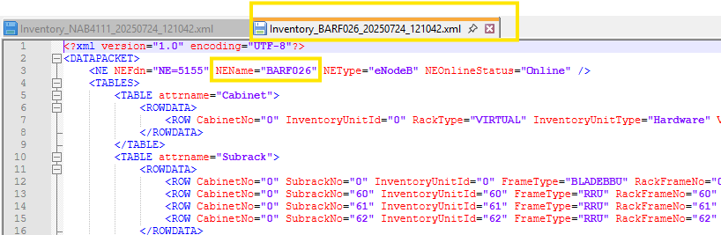

- Node Name: BARF026
- Rule Applied: Case 1 (F → 1)
- Site ID = BAR1026

1.3.4 SRAN
Note: For Role2G, Role3G, and Role4, the Site ID will remain the same as the parent SRAN Node ID.

Site ID Parsing from SRAN Node Name

The Site ID will be derived from the SRAN node name based on the following rules:

- Case 1: If the node name contains “_” (underscore) or “-” (hyphen), take the value after the last special character and replace the 4th digit with 1.
- Case 2: If the node name does not contain any special characters, replace the 4th digit with 1 directly.
- Case 3: In all cases, if the value extracted after the special character has the 4th digit as 2 and the next three digits are less than 600, the extracted value itself should be considered as the Site ID.
- Case 4: If any other case occurs, the site will be ignored and parsed as the default site.

Examples:
Example 1:

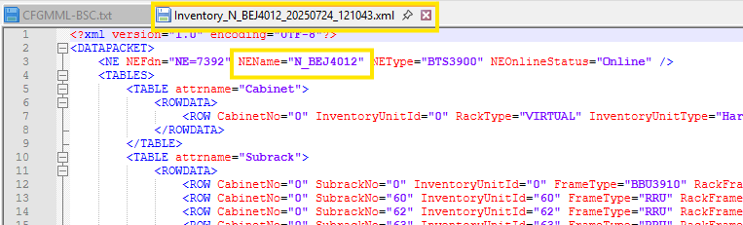

Node Name: N_BEJ4012
Rule Applied: Case 1 (4 → 1)
Site ID = BEJ1012

Example 2:

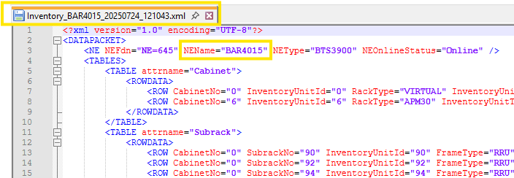

Node Name: BAR4015
Rule Applied: Case 2 (4 → 1)
Site ID = BAR1015

Example 3:

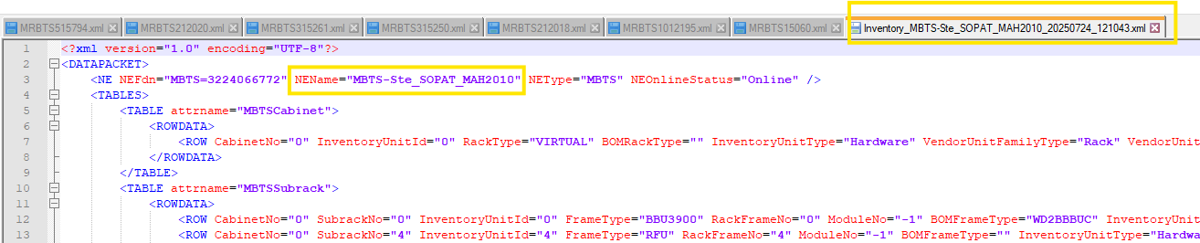

Node Name: MBTS-Ste_SOPAT_MAH2010
Rule Applied: Case 3 (Extracted value after special character is MAH2010 where 4th digit is 2 & next three digits are less than 600)
Site ID = MAH2010

1.3.5 BSC

Site Id will be same as node name of BSC.

1.3.6 RNC

Site Id will be same as node name of RNC.

1.3.7 Site ID for micro site

1.3.7.1 Case 1: 4th digit is 2 & next three digits are ‘=’ or ‘>’ 600.

If extracted value from Node name, the 4th character is 2 & after 2 next three digit is = or > 600 then subtract 600 from last three digit. (It will be applicable for all node type but currently this condition is finding in SRAN only)

Example: For Case 1

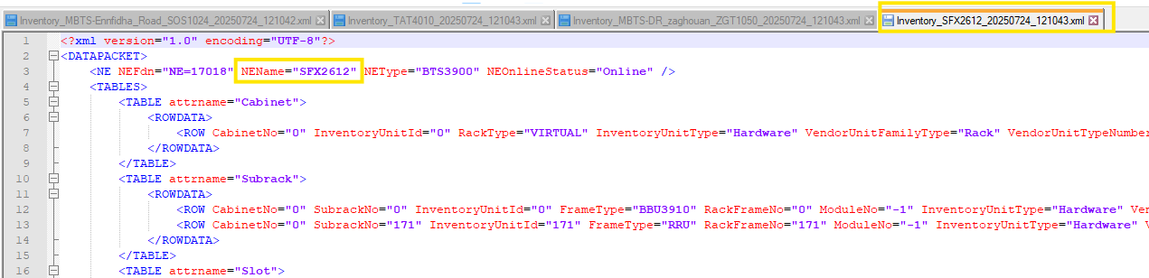

Node Name: SFX2612
Rule Applied: Case 3 (4th is → 2 and next three digit is > 600 then subtract 600 from last three digit)
Site ID = SFX2012

1.3.7.2 Case 2: 4th digit is 2 and next three digit are ‘=’ or ‘>’ 500

If extracted value from Node name before & after special character ‘_’ or ‘– ‘, the 4th character is 2 & after 2 next three digit is = or > 500 then subtract 50 from last three digit. (It will be applicable for only NodeB type)

