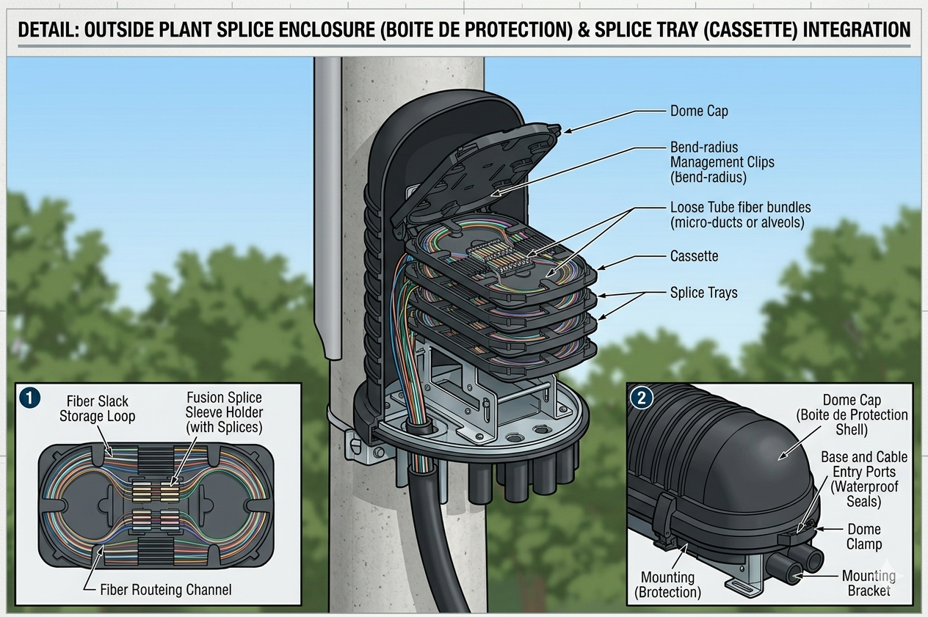

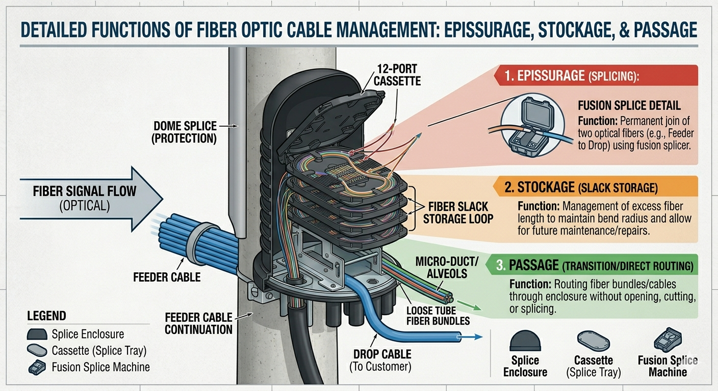

Enclosure:
- A new network element can be added to the site.
- The Enclosure has the following attributes:
  - Site
  - Name
  - Object ID: unique
  - Status: standard NEP status
  - Additional information: same as other elements
  - Model Type: Enum - Dome, Inline, or Wall-mount.
  - Material: String (e.g. High-density polyethylene (HDPE), Metal, etc.)
  - IP Rating: String (e.g. Resistance to water/dust (e.g., IP68 for underground).)
  - Max Tray Capacity: Integer (Total number of trays the enclosure can hold.)
  - Entry Ports: Integer (Number of holes for cables to enter (Alvéoles/Ducts).)
  - Mounting Type: Enum - Aerial (Pole), Manhole (Vault), or Pedestal.
- Import CSV and XML: Panel, report

Splice Module: Update the existing model
- The splice module can be linked to the enclosure
- The following attributes to be added:
  - Status: standard NEP status (make sure it’s available)
  - Additional information: same as other elements (make sure is available)
  - Parent Enclosure: Links the tray to its specific physical box.
  - Sequence Number: Integer - The position of the tray in the stack (Tray 1, Tray 2, etc.).
  - Capacity: Integer - Number of splice "slots" available (usually 12, 24, or 48).
  - Splice Type: Enum Fusion (heat) or Mechanical.
  - Fiber Type: Enum - Single-mode (SM) or Multi-mode (MM).
  - Occupied Slots: Integer - Current number of splices already performed.
  - Color Code: String - Often the tray itself is color-coded to match a specific buffer tube.
- Consider the new parameters in import, report and panel
- Enclosure → Contains → Splice Trays → Contain → Splices (the actual joins).

Ability to add additional information & status
Add the ability to add additional information & status to:
- ODF Cabinet
- ODF Magazine
- ODF Port
- MDF Cabinet
- MDF Magazine
- MDF Port

Patch Cord (new entity):
- A new network element can be added to the site.
- The Patch Cord has the following attributes:
  - Site
  - Name
  - Object ID: unique
  - Status: standard NEP status
  - Additional information: same as other elements
  - Connector_Type_A: Enum: LC, SC, ST, FC, etc.
  - Connector_Type_B: Enum: LC, SC, ST, FC, etc.
  - Fiber_Type: EnumOS2 (Singlemode), OM3/OM4 (Multimode)
  - Length: Float Length in meters (e.g., 1m, 2m, 3m, 5m).
  - Color: String - Standard coding (e.g., Yellow for SM, Aqua for OM3).
  - Polarity: Enum: A-to-A or A-to-B (for duplex cords).
- Consider the new parameters in import, report and panel
- The patch cord will be used in OSP connections (same as ODF port, MDF port, Strand, Node Interface, etc.)

OSP Pathway Inner duct
Check current data mode to agree on the implementation
