Test case for site status ( On air / Off Air )

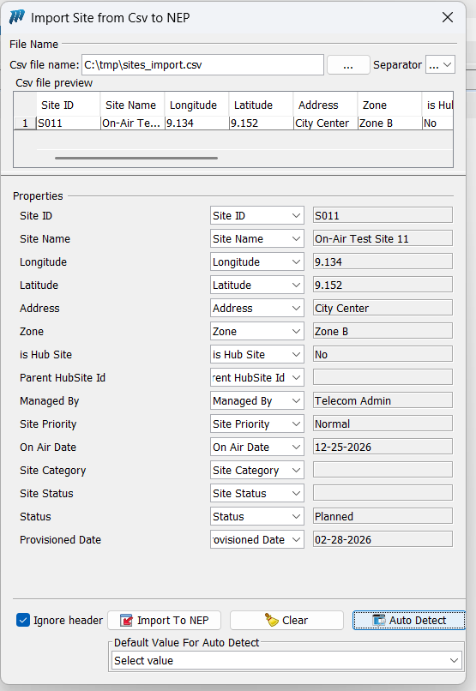
Addded Site S011:

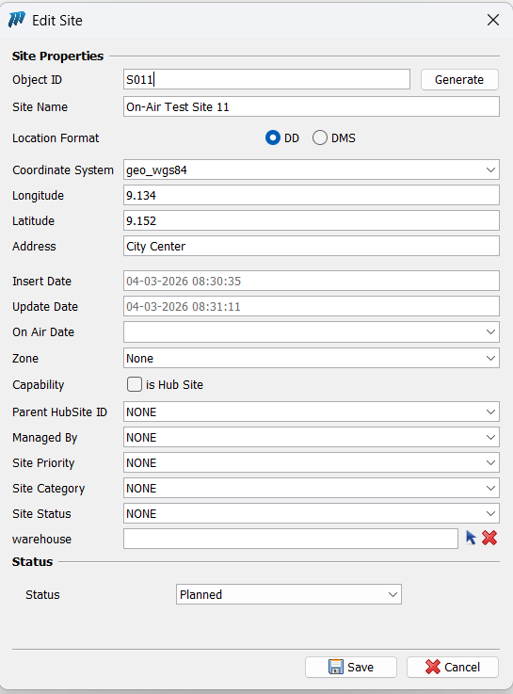
Site S011 exist site tree ( we didnt assign site status for now , so site status is none )

Now when we check the site report , the site status should be calculated , and since we don’t have any active on the site : Site Status = OFF_AIR
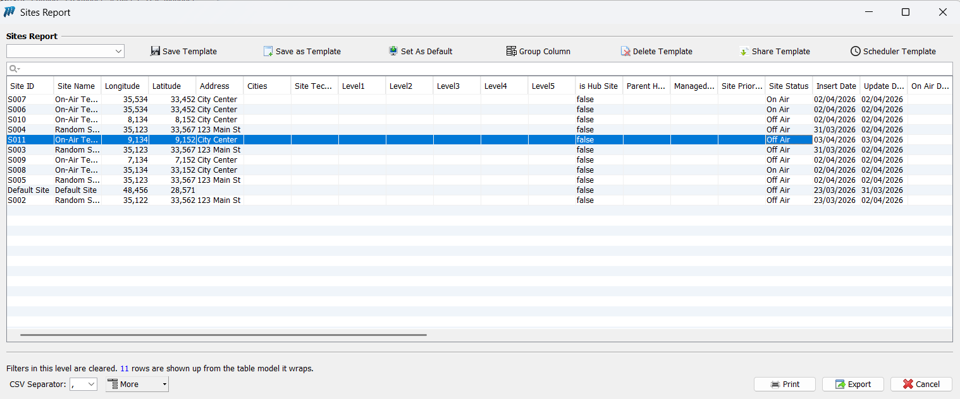

Now we add an active ( BTS ) to the site S011 :
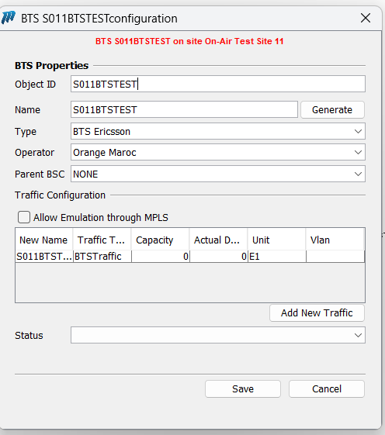
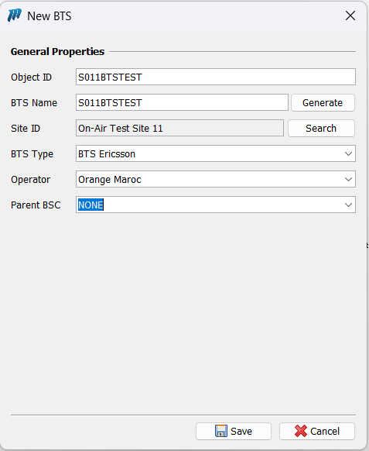

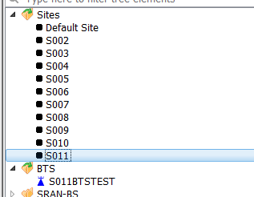
- BTS Added successfully

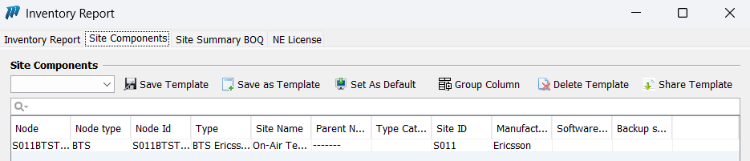

Now when we check Site report : Site_Status = ON_AIR ( since we added the BTS )
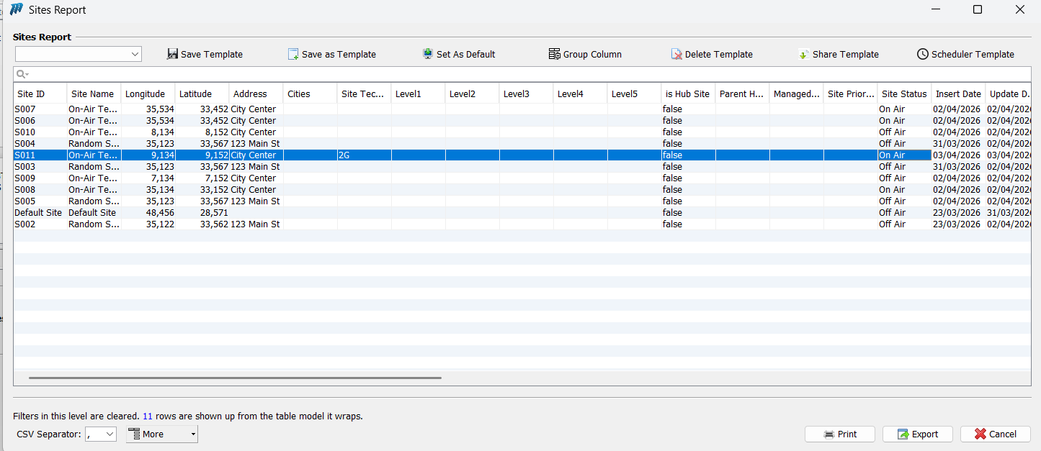

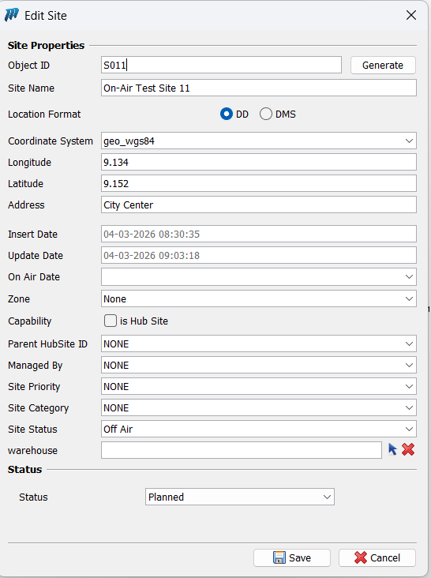
If we change the site_status manually now and we set it to OFF_AIR

- Site Report shows Site_Status = OFF_AIR even tho we have an ACTIVE BTS because we did set manually the Site_Status to OFF_AIR

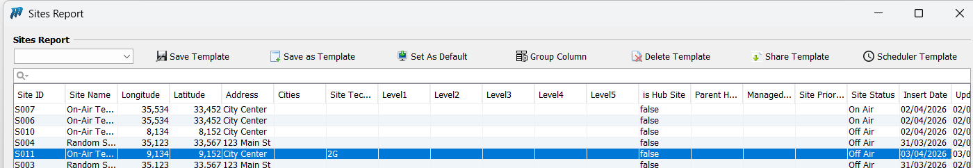
Now if we set SITE_STATUS back to None

Now we set SITE_STATUS to NONE again
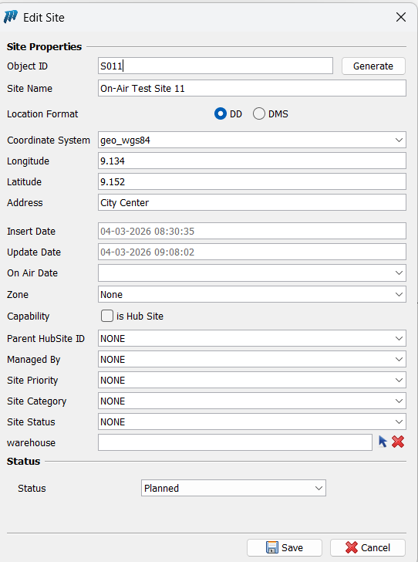

Site report will show Site_Status = ON_AIR again

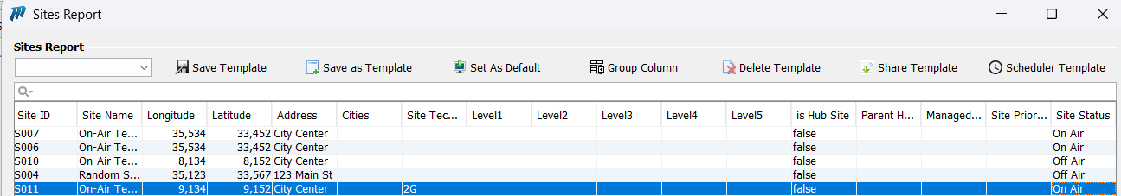

now we delete the BTS from the SITE011, and we approve the deletion in the WF
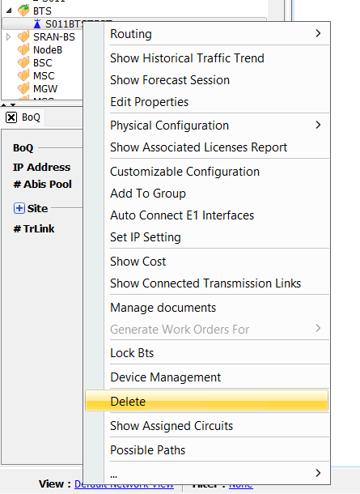

Site report will show Site_Status = OFF_AIR ( because we deleted the BTS and we have no active anymore )
