

FRS for: Huawei Nodes Parsing Zain IRAQ

FRS (Functional Requirement Specifications)
Auto-Import

Draft version 0.1
2021-12-15

Change History

Version | Change Description | Author | Date
0.1 | First draft. | Deepak | 05-09-2022

Preamble:

- This document has been created to parse Huawei Transmission nodes in Zain IRAQ.

Parser:

NE details
The details below are all parsed from dump file starting with “NE_Report_XXXXX”

Attribute | Importance | Comment
Name | [Mandatory] | - Can be found in the dump file under column “NE Name”  e.g.: NE Name= “2836-Sukhneh_PD-NE-1”  Then NE name will be =2836-Sukhneh_PD-NE-1
ID | [Mandatory] | - Can be found in dump file under column= “NE ID”  - Format of the ID is numbers - numbers  e.g.: NE ID = “11-45137”
Site ID | [Mandatory] | - First Refer to Site Matching file.  - If node not found in Site Matching file, then take value from column “NE Name” using below rule.  e.g.: If NE Name= “2836-Sukhneh_PD-NE-1” then take Site id = “2836” (Take numeric value before - or _)  if NE Name= “9007_KRK MGW_NE_11” then take Site ID = 9007  - Format of the ID is numbers - numbers
Model | [Mandatory] | - First take the value of column NE Type (MPU Type), and then apply Nodetype_matching rule.  Please refer to below image.
Type | [Mandatory] | - To be taken from the Nodetype_matching file
Software Version | [Mandatory] | - Can be taken from column “Software Version”
NE IP Address |  | - To be parsed from attribute “NE IP Address”
Installation Date | [Mandatory] | - Can be taken from column “Created On”.  Format should be DD-MM-YYYY.

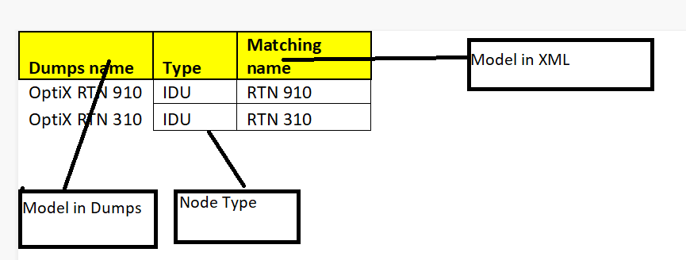

Physical Details
The details below are all parsed from dump file starting with “Card_Report_XXXXX” & Frame Report_xxxxx
There are multiple files with the same name, we have to parse data from all files.

Attribute | Importance | Comment
Node ID | [Mandatory] | - Can be found in Card Report file in Column = “NE ID”  e.g: NE ID =11-22083  Node ID is 11-22083
Cabinet | [Mandatory] | - To add one cabinet by default to each node  - Cabinet Type=Node Model  - Cabinet Index=1 by default
Shelf index | [Mandatory] | - To be Parsed from the files starting with Frame.  - Shelf Type= To be taken from the column Subrack Type  - Shelf Index=if Subrack id is 0 or -- then take shelf index =1, Ru index =1  - If Subrack id is 1 then take shelf index =2, Ru index =10  and so on…  Part number = To be taken from column PN(BOM Code)  Serial number= To be taken from column SN(Bar Code)  Description= To be taken from column Description  Manufactured date=To be taken from column Manufactured On
Board(C/Sh/S/I) | [Mandatory] | - Cabinet Index=1  To be parsed from file starting with Card.  - Shelf Index=if Subrack id is 0 or -- then take shelf index =1  - If Subrack id is 1 then take shelf index =2  - If Subrack id is 2 then take shelf index =3 and so on  - Index on Slot=0  - Slot index is the number under column Slot ID  - The board type is provided in the Card report file as column name= Board Name
Board Serial Number | [Mandatory] | - Can be deduced from Card Report file under “SN(Bar Code)”  e.g.:  Board Name= SXCSB  SN(Bar Code) = 030KBQ1099000193  Serial number is 030KBQ1099000193
Product description code |  | - Can be deduced from Card Report file under column PN (BOM Code)  e.g.:  Board Name= SXCSB  PN(BOM Code)=03030KBQ  Description code is 03030KBQ
Manufacturing Date |  | - Can be deduced from Card Report file under column Manufactured On
Manufacturer Name |  | - Huawei
Description |  | - Can be deduced from Card Report file under column Description
Hardware version |  | - Can be deduced from Card Report file under column Hardware Version
Software version |  | - Can be deduced from Card Report file under column Software Version
Issue Number |  | - Can be deduced from Card Report file under column Rev(Issue Number)

For Board name /Slot index snapshot:

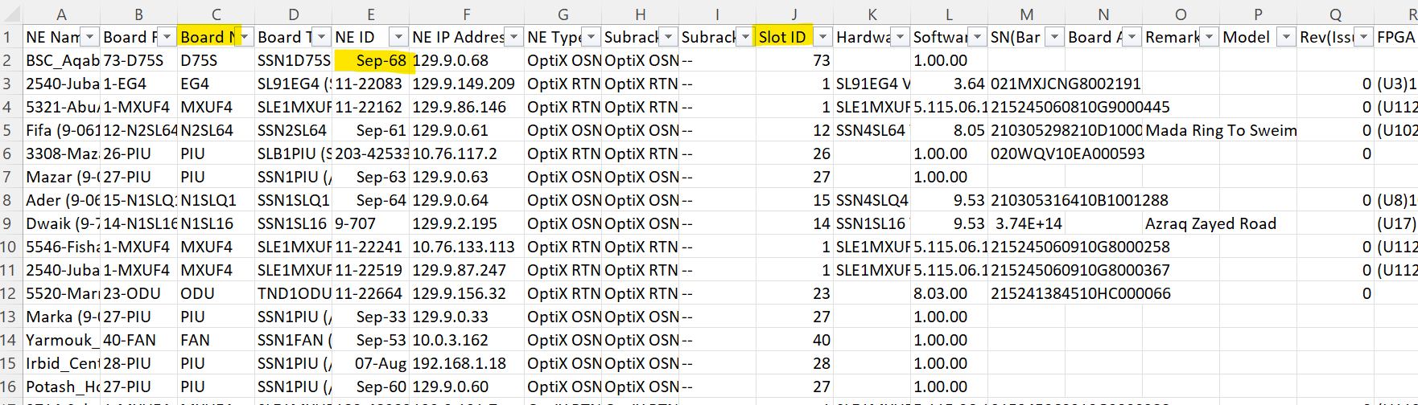

Additional Info.
The details below are all parsed from dump file starting with “NE_Report_XXXXX”

Attribute | Importance | Comment
ID | [Mandatory] | - Can be found in dump file under column= “NE ID”  - Format of the ID is numbers - numbers  e.g.: NE ID = “9-152”
Type | [Mandatory] | - To be taken from the Nodetype_matching file
Software Version | [Mandatory] | - Can be taken from column “Software Version”
Installation Date | [Mandatory] | - Can be taken from column “Created On”.  Format should be DD-MM-YYYY.

Licenses
To be Parsed from file named with Detailed_Report_of_Network-Wide_Licenses_xxxxx. There are multiple files with the same name, we have to parse data from all files.

These are details that need to be extracted and mapped in NEP
- First line is having Node Name which should be parsed and mapped to every license item.

NEP Attribute | Dump File Attribute | Mandatory | Remarks
Node Name | NE Name | Y | The node should be parsed based on the inventory based on the mapping of the NODE Name in the XML
Node Type | N/A | N | To be taken from the netype in the network element in the xml
License Id | License Type_Board Name | Y | Concatenate Value of column named License Type using _ (Underscore) with column Board Name.  If Value under column Board Name is – or Blank Then do not concatenate ,just take value under column License Type.
License Detail |  | Y | Same as License ID
Allocated | Authorized capacity | Y | Take Integar Value under column Authorized Capacity
licenseDetailValue | Authorized capacity | Y | Take Value under column Authorized Capacity
Config | N/A | N | NA
Unit | License Type | N | If Value under ( ) from License Type
Expiry Date | N/A | N | NA

