Node/Inventory Auto Deletion from NEP
It is found that the Nodes/Network Elements are getting updated or replaced by new nodes. So, it is necessary to delete the old/outdated Network Elements from NEP also.
Current Scenario
The nodes coming from dumps are getting updated on daily basis through Auto import process. Once the Node/NE is deleted from network, it is getting deleted from Network or not reporting in Dumps. So, the NE gets outdated in NEP.
The Outdated nodes can be found by selecting the “update date” column in the required NE Report. The last updated date would be the day when last XML is imported to NEP.
Required Scenario
It is required to delete the nodes which are having outdated date, or the nodes are not having the update date. The update date would be the last XML import date.
A Configurable period of 14 days will be considered for deletion from NEP.
Below are few reports where it is well described for the outdated dates.
Ex.
From BTSs report
The updated date is as 02-06-2024. Other than this all other are outdated.
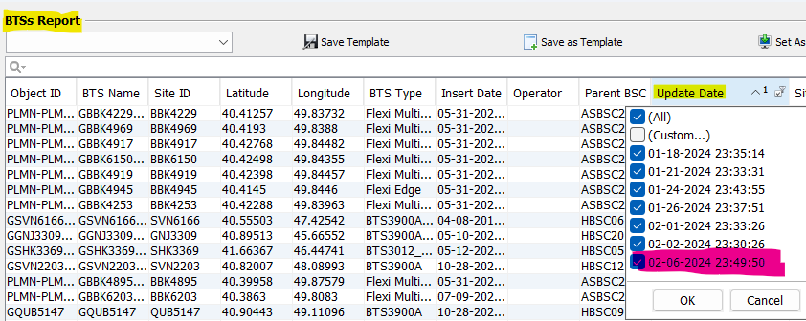
So, the Nodes other than 02-06-2024 should be deleted from NEP.
From IDUs report
The update date is as 02-06-2024. Other than this all other are outdated
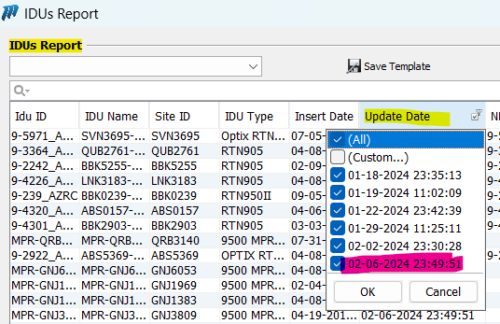
So, the Nodes other than 02-06-2024 should be deleted from NEP.
From Transmission Links Extended Report
In this report the links which are imported through “XML” or “TUNNELBUILDER” or “ROUTEBUILDER” “ARP” or “IPBased” should be selected to delete the links. The column “Link Source” where the value is as per above details should be filtered with the last update date from “Update date” column.
Here in below report, The Update date is 07-02-2024
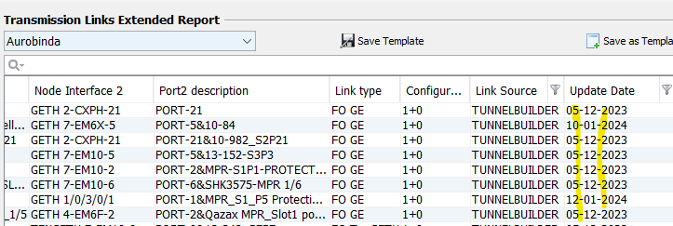
But as can be seen the update date column is having other dates also, which are outdated.
All the Reports related to this report will be synced post the deletion activity.
Report list
Below are the Reports from which the outdated Nodes/Network Elements should be deleted
Network Elements | BTSs Report
Network Elements | NodeBs Report
Network Elements | SRanBs Report
Network Elements | EnodeBs Report
Transmission Elements | IDUs Report
Transmission Elements | ADMs Report
Transmission Elements | WDMs Report
Transmission Elements | Router Reports
Transmission Links | Transmission Links Extended Report

Path for the report
Transport managerReportingNetwork Elements
Transport managerReportingTransmission Elements
Transport managerReportingTransmission Links Transmission Links

Result
This activity will delete the outdated nodes & Links from NEP.

