

NSN License Connector ZAIN-KSA

FRS (Functional Requirement Specifications)
Auto-Import connector

Change History

Version | Change Description | Author | Date
1.0 | First draft | Shamim Ahmed | 09-04-2024

License Management

Objective
We want to
  - Implement License Management module in NEP for ZAIN-KSA.

Positioning/Accessibility
- NEP – Asset & Service Management.

Problem statement

Current Problem
At Present NEP does not have feature to manage license details related to IDU.

Motivation
This FRS is to be delivered to Zain-KSA for license management. This feature will be useful to all the customers in future.

NEP GUI Requirement

License Attribute Mapping

The identifier of a license is Node name + License Identifier,.

License will be assigned to nodes based on node name during import XML and CSV.
Attribute | Description
Node Name | =SiteName_SiteID for e.g  From below dumps Node Name=JD2-32_10.1.224.113  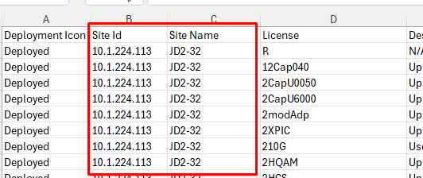
Node ID | =Node Name
Node Type | IDU
License Identifier | =Data Under License Column i.e.for Node Name:: JD2-32_10.1.224.113  Different License Identifier=R,12cap040 and so on as shown below  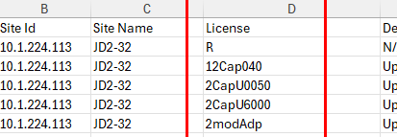
License Detail | =Value under Description Column wrt License i.e.as shown below::  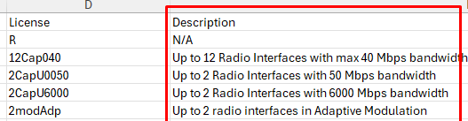
Allocated | =Value under Interface Available as shown below::  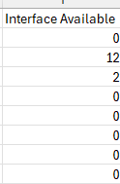
Usage | =Vlaue Under Interface Used as shown below::  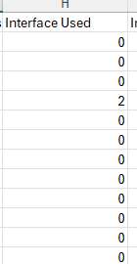
Config | =Value under Total Interface as shown below::  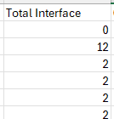
Unit | NA
Expiry Date | NA
Technology | NA

