IPV6 configuration in NEP FRS (Functional Requirements specification) Review.

Reporting
IP Data Report
- Separate tab available to include IPv6 configuration information.
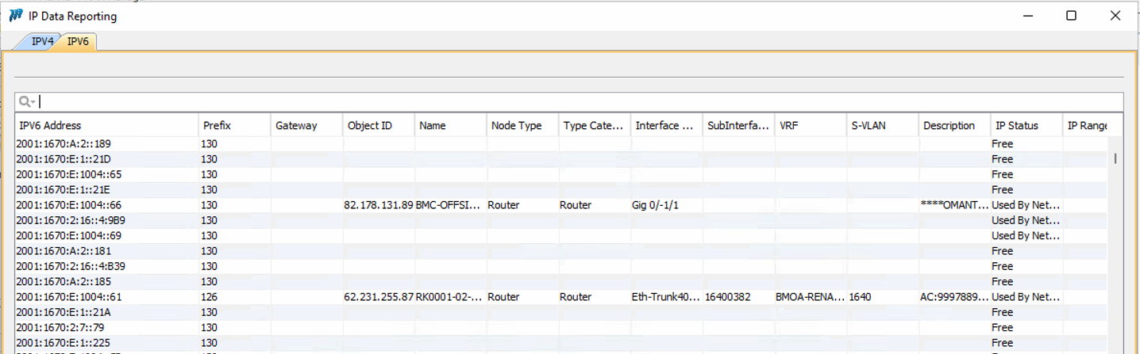

IP range
- Currently no additional tab for IPv6
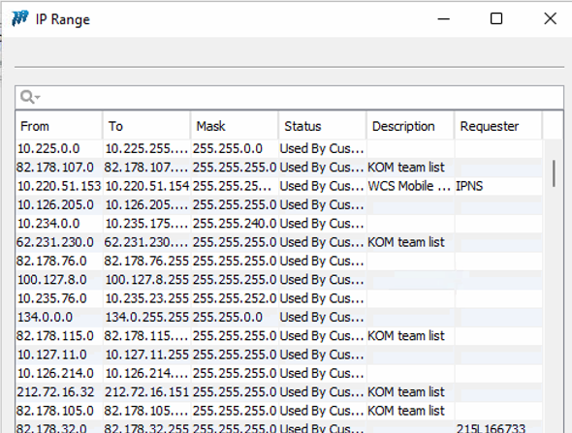

Physical configuration
Interface management and Virtual interfaces

- There is a tab to include IPv6 information for the IP configuration and sub interface tab but not for the other subsequent tabs – routing protocol configuration, other configuration, service instances MPLS configuration and service policy.
- 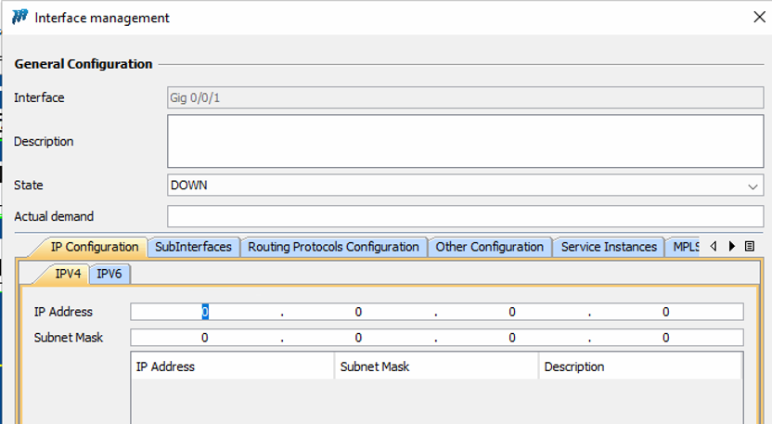

- 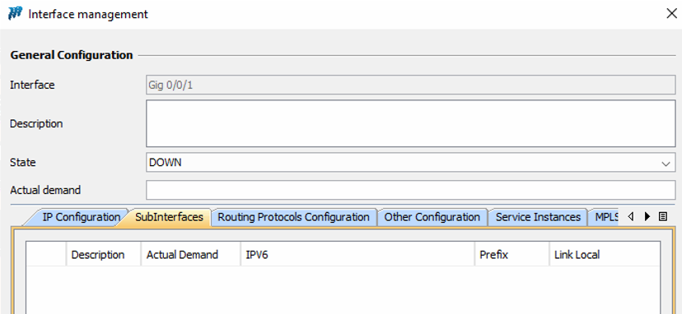
- 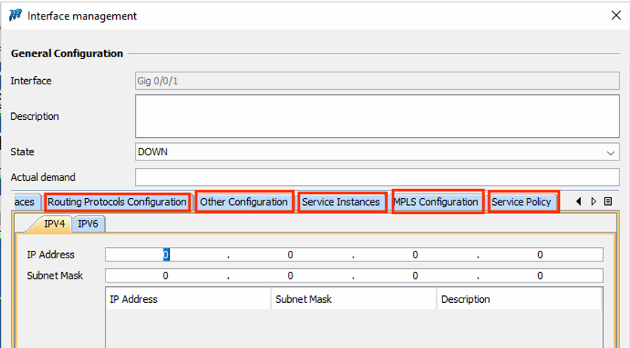

“Configure” Router Menu
Configure
- A separate new window to include IPV6 configuration information is required.
Configure IPv6 / Configure IPv4
